**Python interview**

### **Q1. Mention the differences between Django, Pyramid and Flask.**

**Ans:**

* Flask is a “microframework” primarily build for a small application with simpler requirements. In flask, you have to use external libraries. Flask is ready to use.
* Pyramid is built for larger applications. It provides flexibility and lets the developer use the right tools for their project. The developer can choose the database, URL structure, templating style and more. Pyramid is heavy configurable.
* **Django can also be used for larger applications just like Pyramid. It includes an ORM.**

### **Q2. What is the difference between list and tuples in Python?**

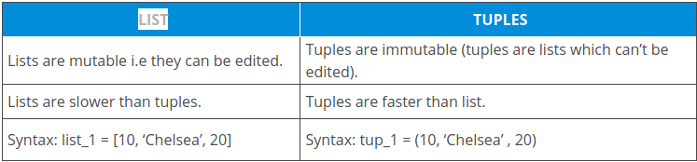

### **Q4. How is Python an interpreted language?**

***Ans:*** An interpreted language is any programming language which is not in machine level code before runtime. Therefore, Python is an interpreted language.

### **Q5.What is pep 8?**

***Ans:* PEP stands for Python Enhancement Proposal. It is a set of rules that specify how to format Python code for maximum readability.**