

Deep Learning

**Subject Code:**22CAP-771

Student Name: Vedant Saraf UID:22MCI10186

Section/Group:22MAM-1_B Semester:4th Experiment No. 8

1.) Take time series data set from Kaggle and Build RNN and LSTM models to demonstrate prediction with keras.

Implementation :-

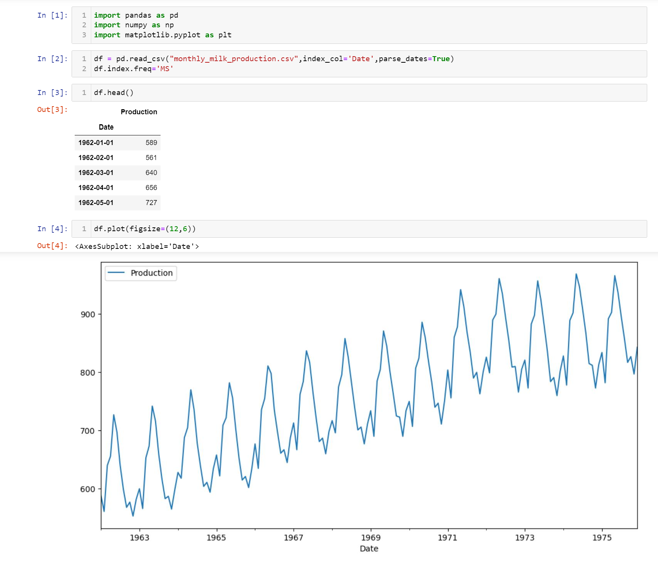

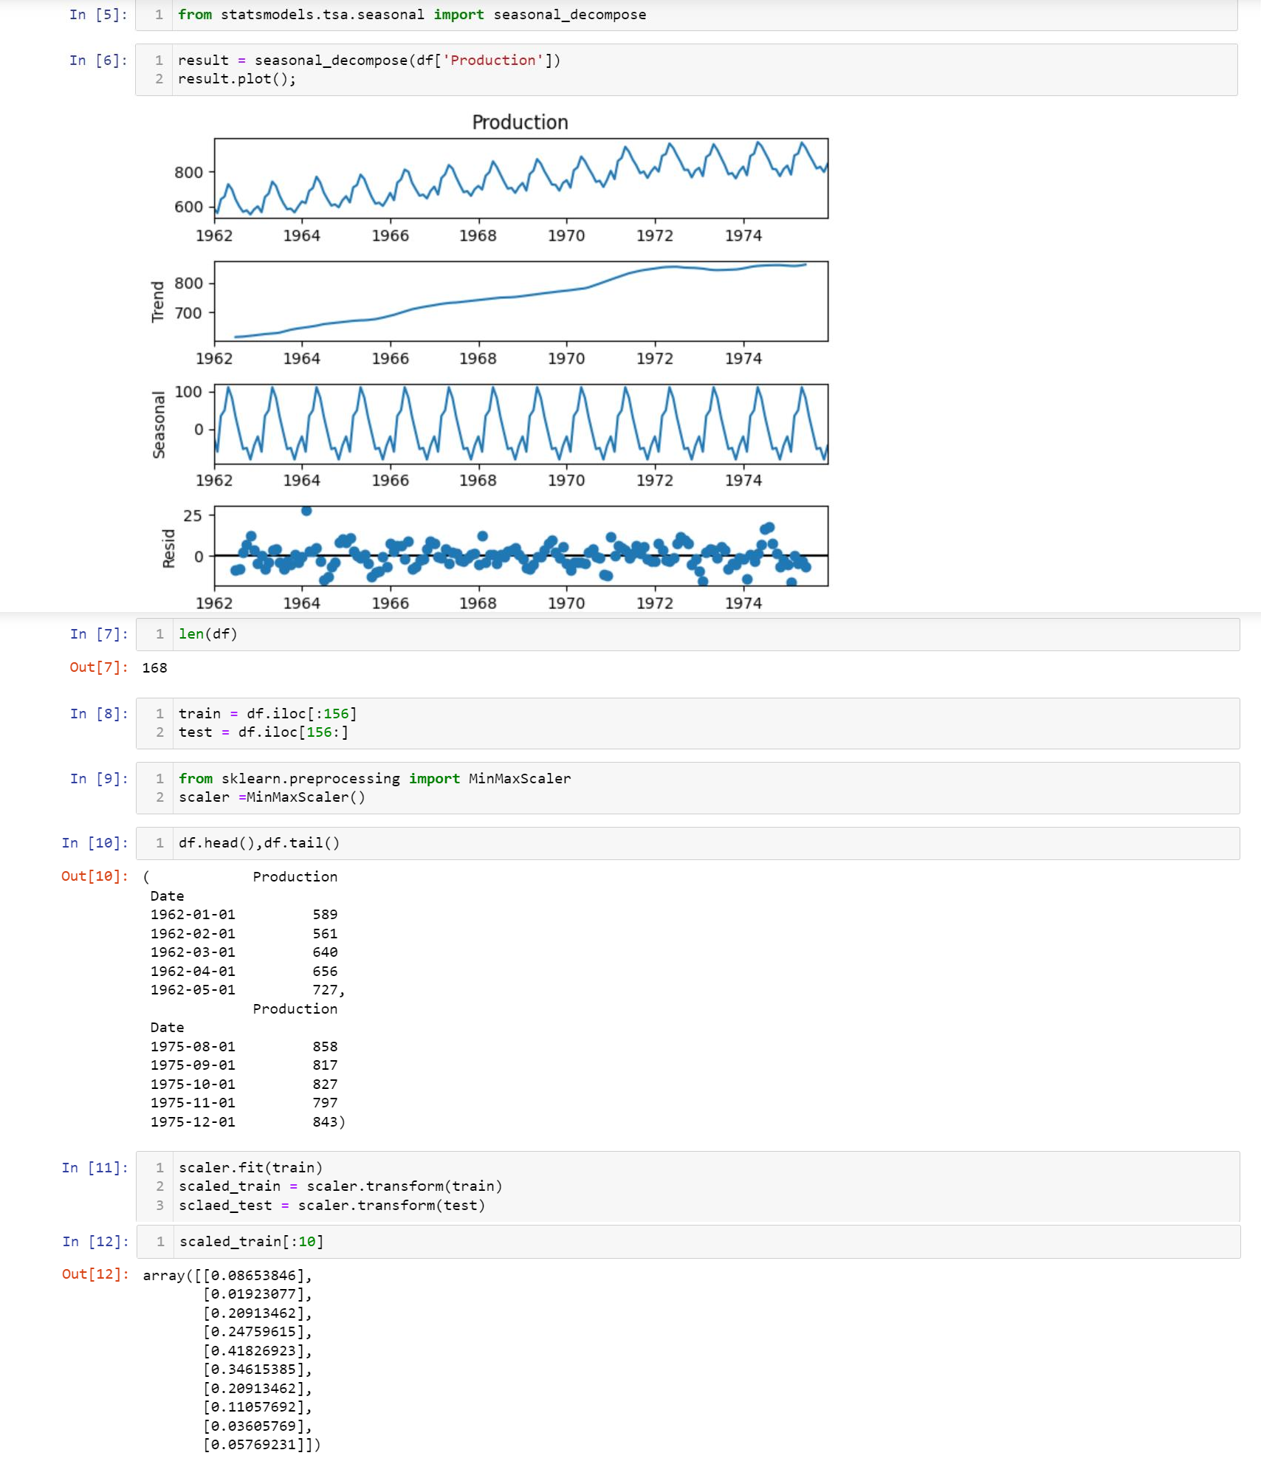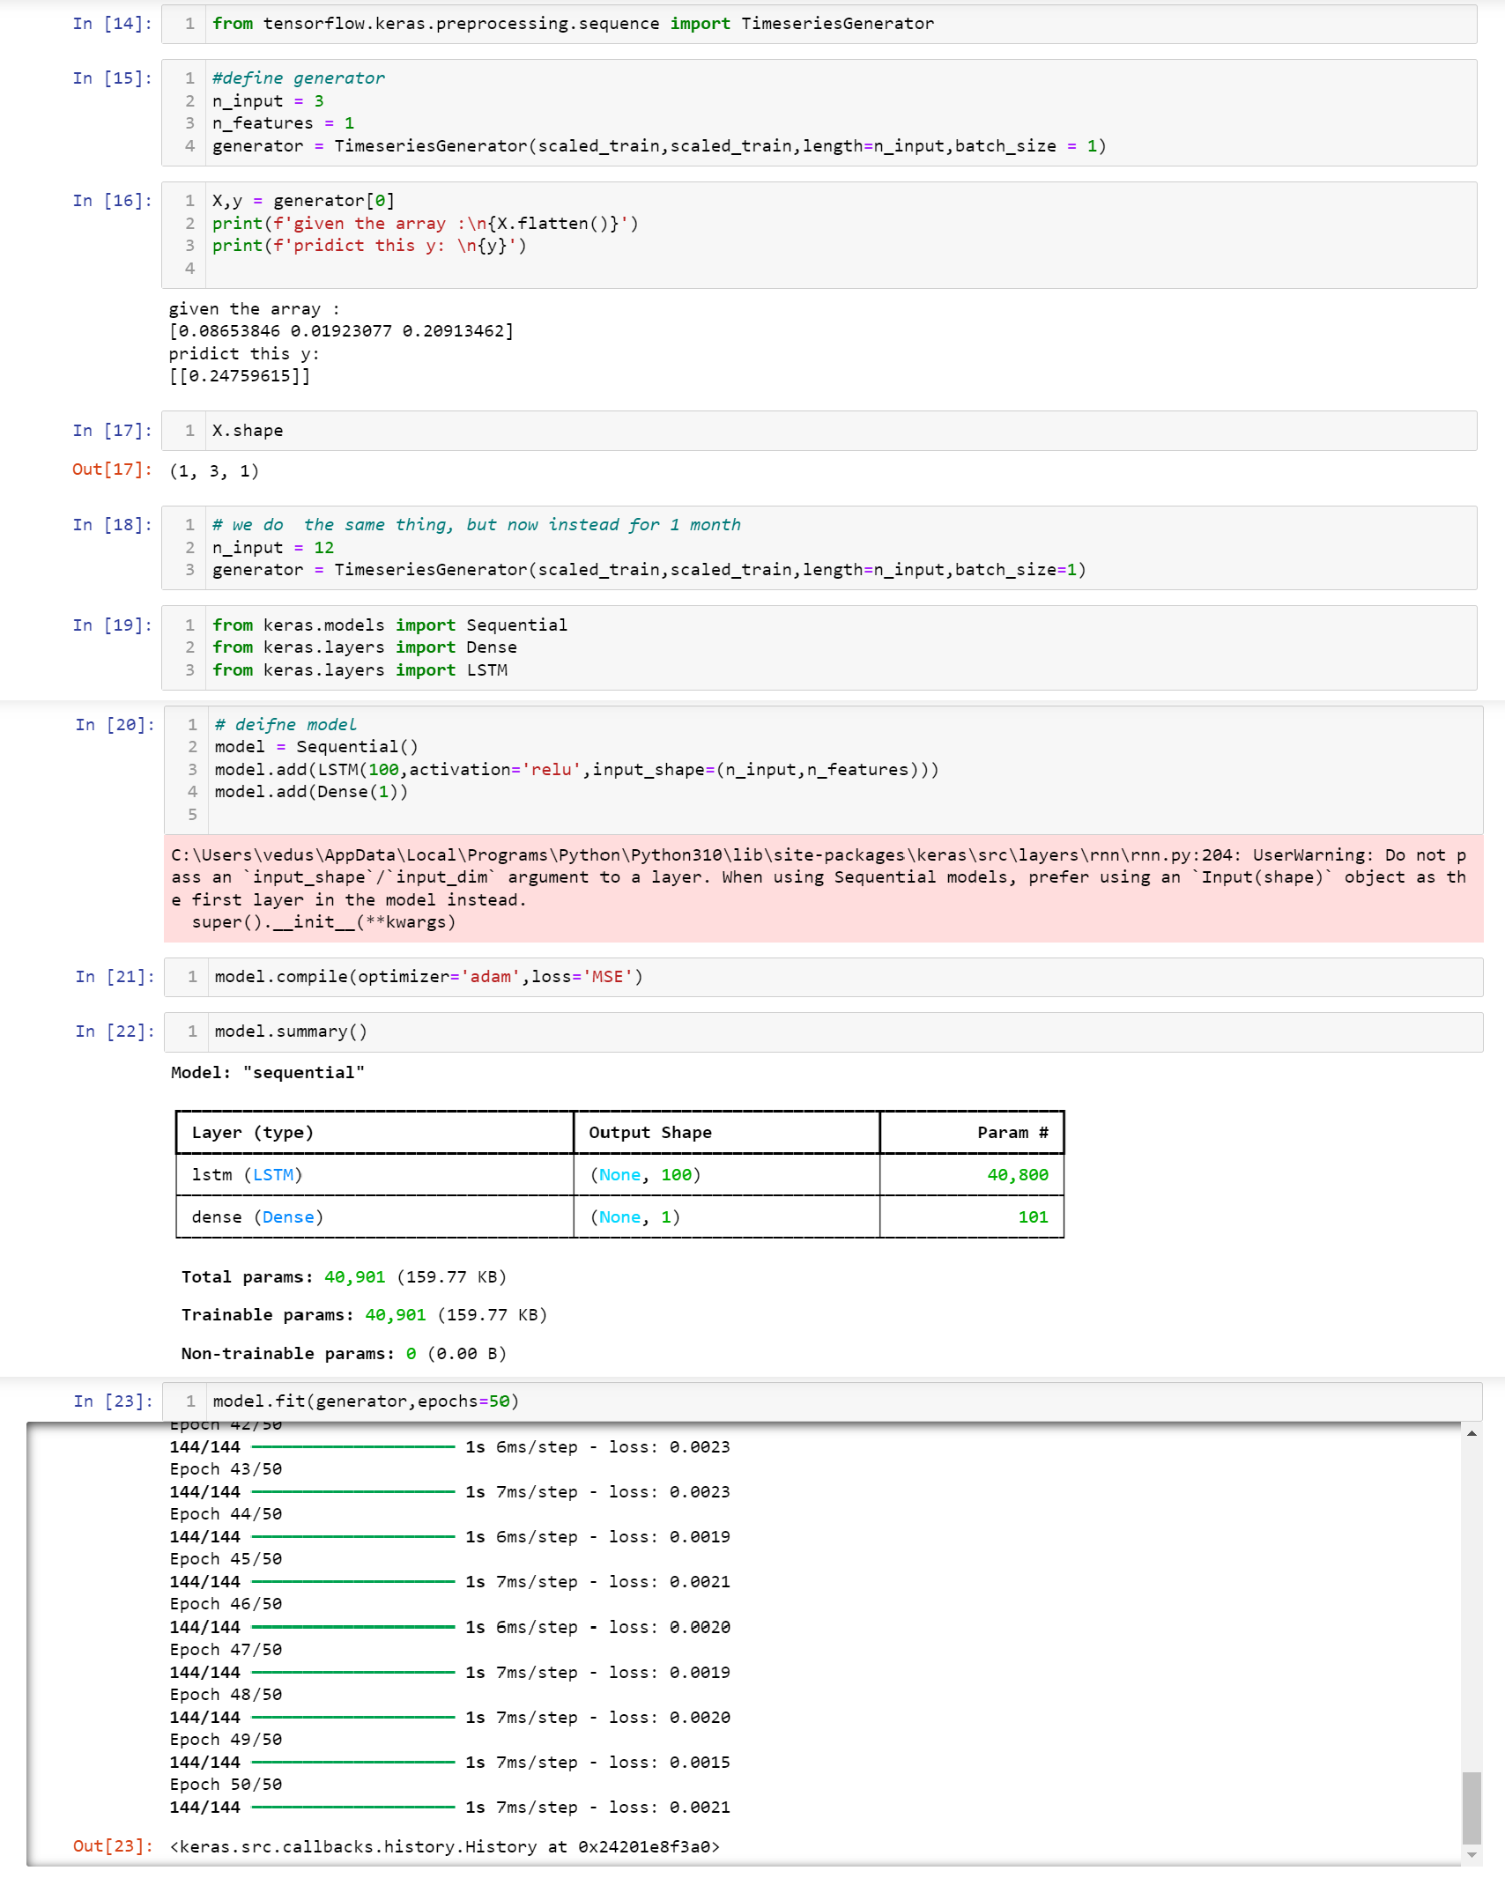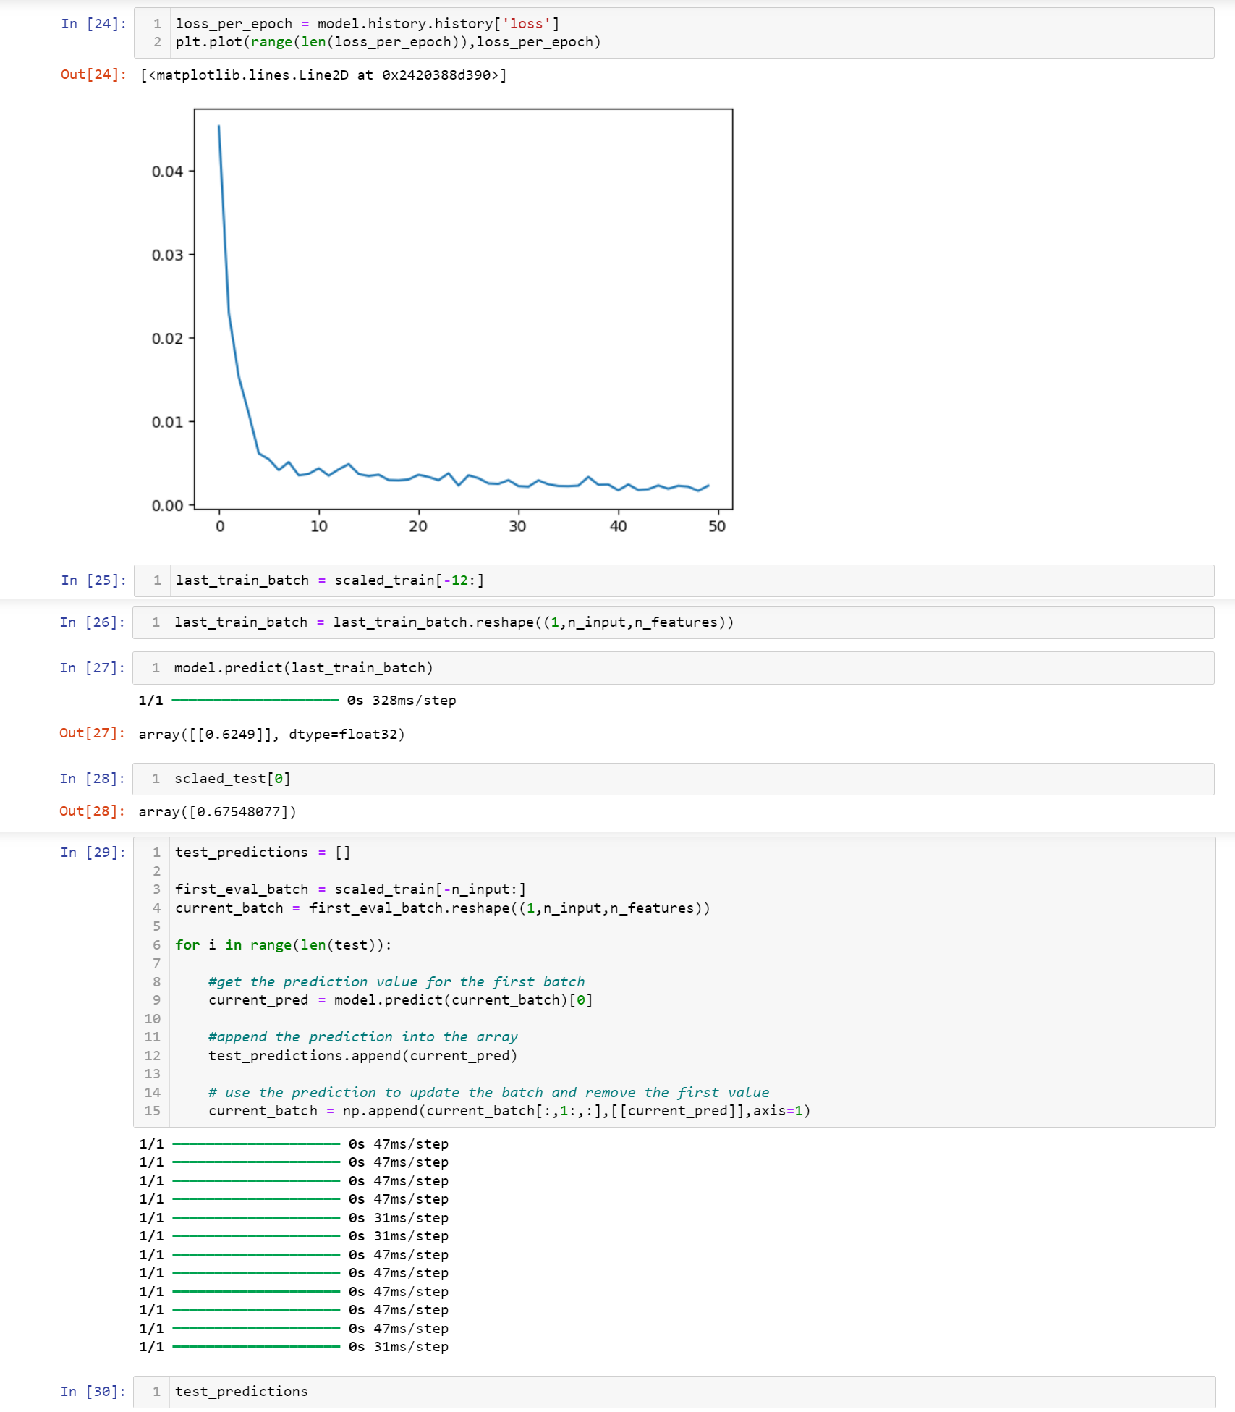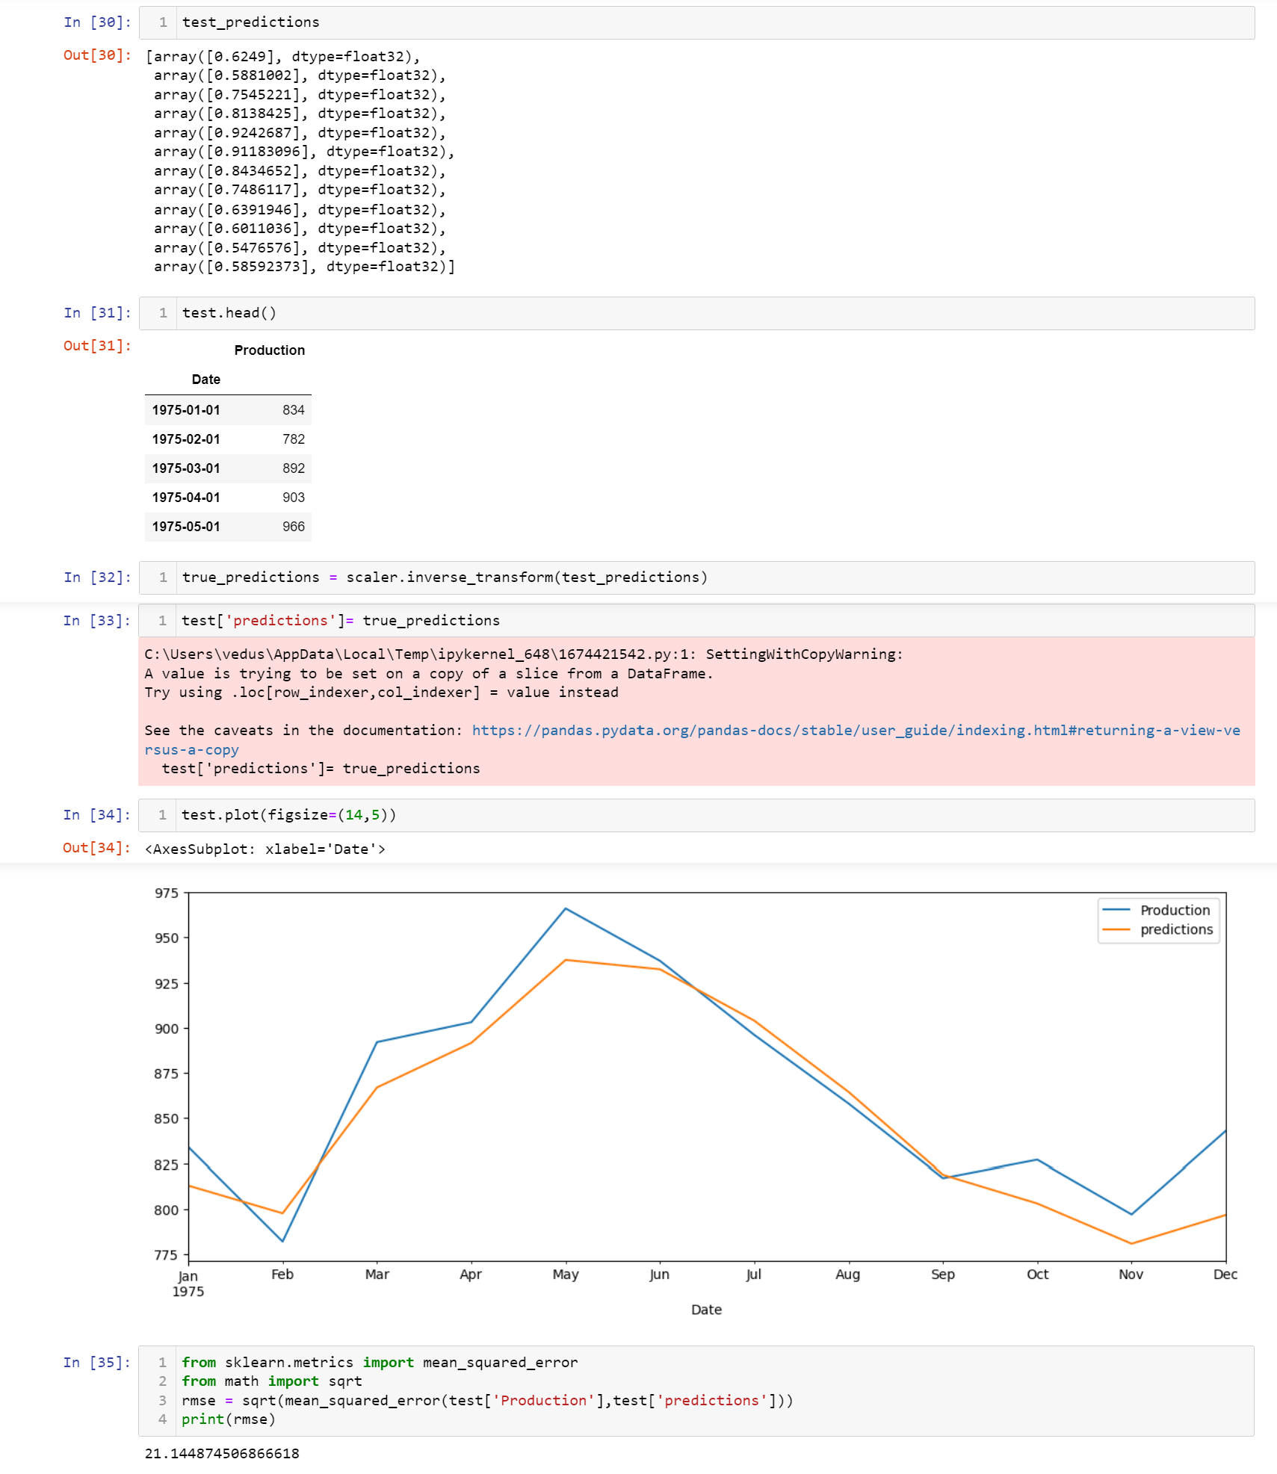

Learning outcomes (What I have learnt):

1. Learned how to import Keras and LSTM.
2. Learned how to work on Time series data.
3. Learned how to build RNN and LSTM models.
4. Learned how to handle the Time series data.
5. Understood working of LSTM and RNN.