

Deep Learning

**Subject Code:**22CAP-771

**Student Name: Shubham Kumar Dutta UID:22MCI10172**

**Section/Group:22MAM-1_B Semester:4th Experiment No. 9**

**1.) Take NLP set from Kaggle, preprocess data set (cleanse, tokenize, create vocabulary, convert to sequence, pad to fixed length) and Build RNN and LSTM models to demonstrate prediction with keras.**

**Implementation :-**

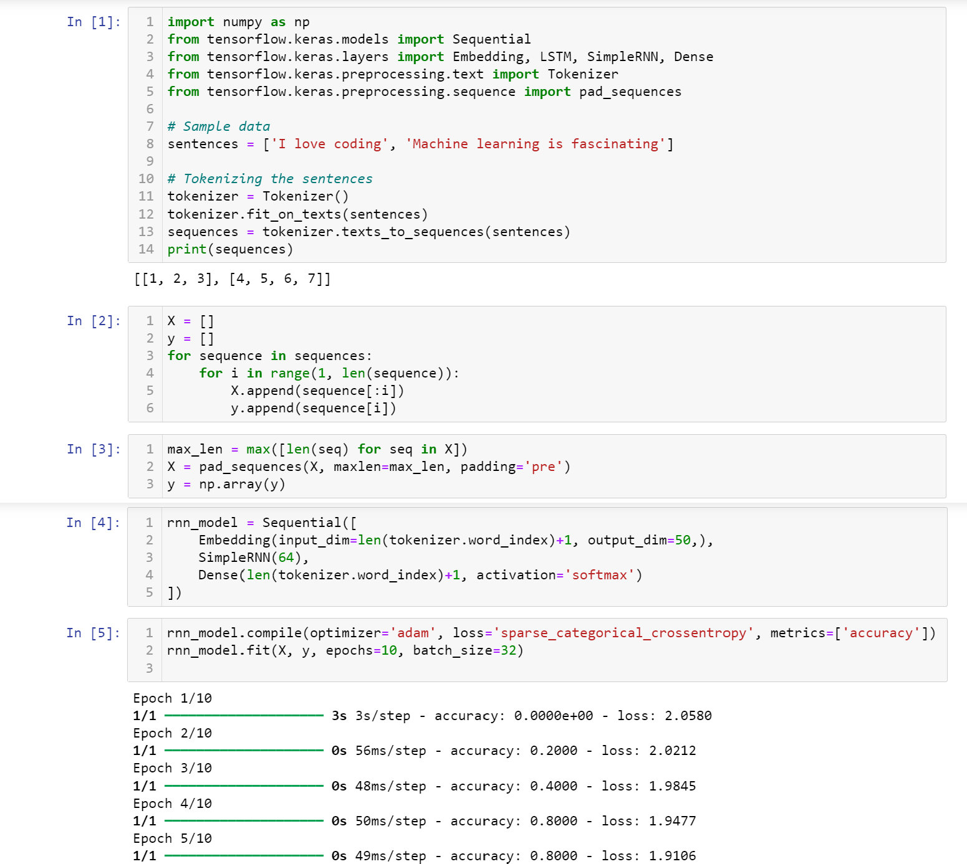

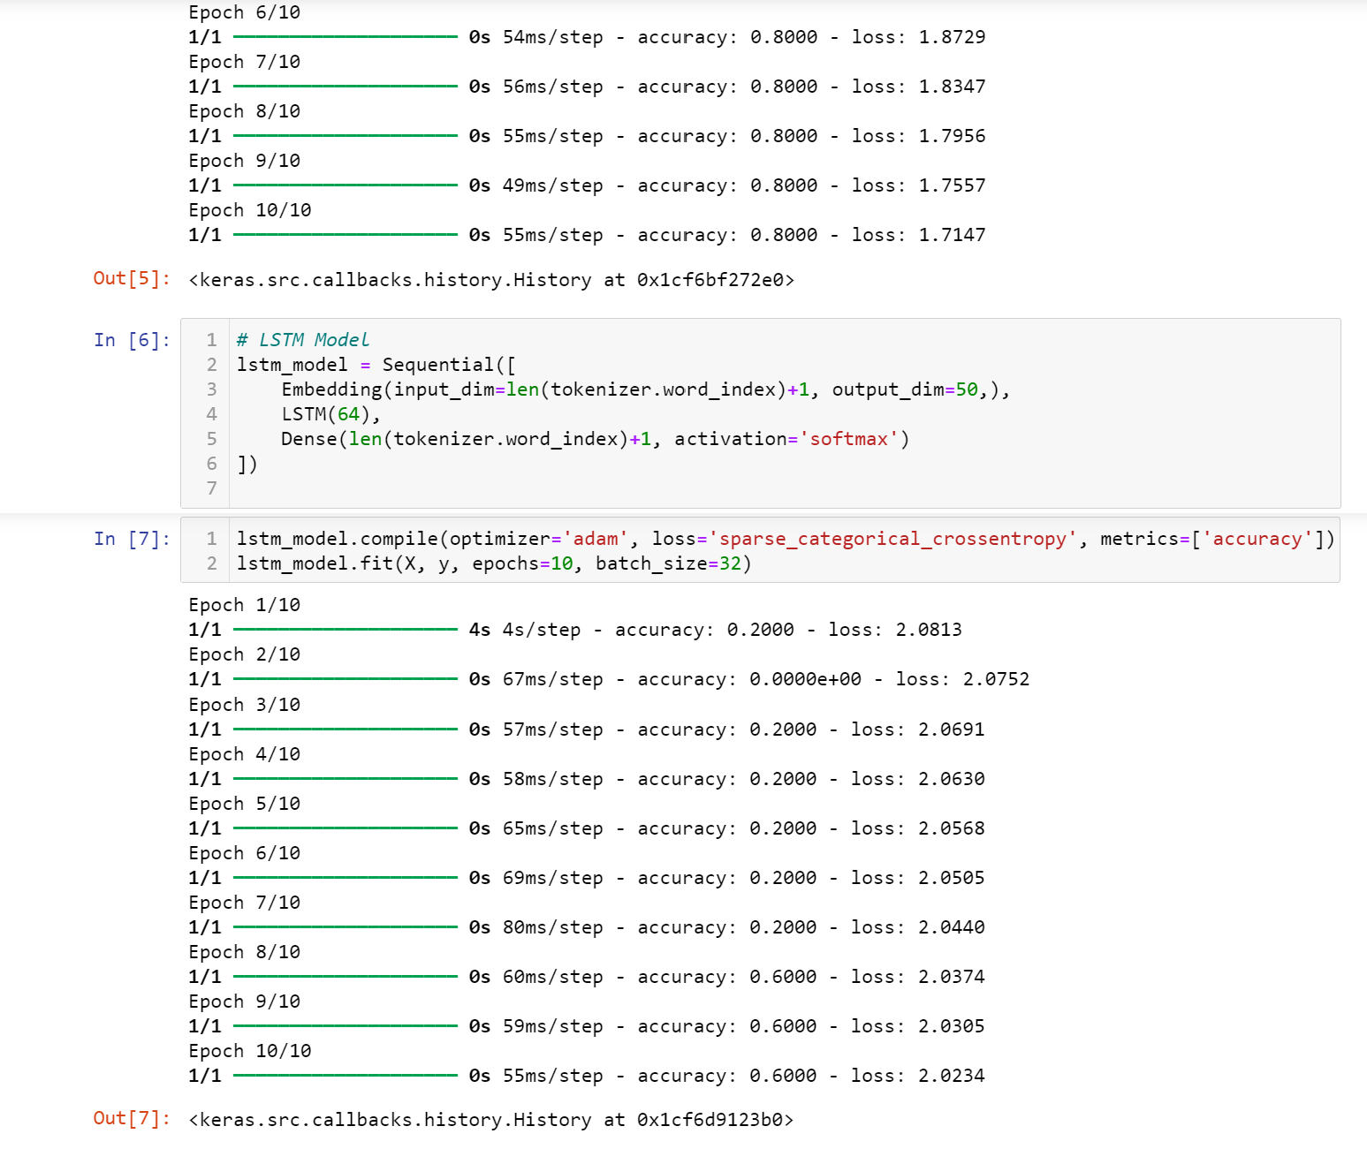

**Learning outcomes (What I have learnt):**

1. Learned how to import Keras and LSTM.
2. Learned how to Tokenize the sentence.
3. Learned how to build RNN and LSTM models.
4. Understood the concept of sparse_categorical_crossentropy.
5. Understood working of LSTM and RNN.