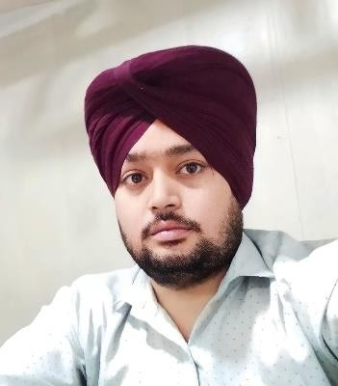

**RESUME**

**NAME: SUKHWINDER SINGH**

**ADDRESS: House No.440,Shivjot Enclave GTB Nagar Kharar PH.NO. +91-9988110506**

**EMAIL ID:** [**sukh141992@gmail.com**](mailto:sukh141992@gmail.com)

**CAREER OBJECTIVE**

Chief Manager with 7+ years of experience organizing presentations, preparing facility reports, and maintaining the utmost confidentiality. Possess a M.B.A. in Marketing and Finance and expertise in Microsoft Excel. Looking to leverage my knowledge and experience into a role as Manager.

# ACHIEVEMENTS

.

**INDUSIND BANK:** Achieving Continuum Model Get Grade/Profile Promotion, In 2020-2021 ASDM-SDM (DM Grade -Manager Grade) In 2021-2022 Get Promoted SDM - DBM (Pending),(Manager Grade – Chief Manager) And Also Achieving Monthly Contest With Certification and Trophies In ICICI Bank Also.

# ACADEMIC QUALIFICATIONS

|  |  |  |  |
| --- | --- | --- | --- |
| **Examination** | **Year** | **Institution/ University** | **Percentage** |
| MBA | 2016-2018 | PTU | 85% |
| B.Com | 2011-2014 | Panjab University | 65% |
| Class XII | 2010-2011 | CBSE | 65% |
| Class X | 2008-2009 | CBSE | 66% |

**WORK EXPERIANCE**

|  |  |  |  |
| --- | --- | --- | --- |
| **BANK** | **KEY ROLES** | **POST** | **TIME PERIOD** |
| ASHOK LEYLAND | CUSTOMER  ENGAGEMENT | EXCUTIVE RM | 1 YEAR |
| ICICI BANK | VALUE BANKER,  SALES OFFICER | ASSISTANT MANAGER | 2 YEAR 6 MONTHS |
| INDUSIND BANK | SERVICE DELIVERY  MANAGER | CHIEF MANAGER | 4 YEAR(WORKING) |

**WORKING SKILLS**

# Managing branch operations and day to day activities like electronic payments like NEFT, RTGS, Fund transfer, clearing cheques process, making demand draft. Forex and locker processing

* **Providing advice on investment to the clients. Working in cash management.**

# Handling Clients Query, Complaints and provide the best resolution.

* **Making customer more knowledgeable about the online banking, credit cards and debit cards.**

# Supervising and motivating to the new heirs to achieve the targets and drive branch revenue.

* **Increasing business through Networking, New clients prospecting and referrals**

**COMPUTER SKILLS**

* Complete Knowledge of Internet & Computers.
* Utilities: MS Office, Word pad, etc.
* Operating System: Microsoft Windows XP, 7, 8, and 10.

•

**ACTIVITIES**

* Organizer of the Parties, Trips at College level.
* Took Part in Activities at College Level.
* Achievement of Monthly Drive in bank level.
* Blood Donation Camp’s Awards
* Event Organizer

**Key Skills**

* Innovative, Positive Attitude, Enthusiastic, Target-centric and Result-oriented.
* Adaptive with changing Environment.
* Ability to carry on responsibility.
* Also possess good interactive and communication skills.
* Strong catching power.

**Personal Information**

Name : Sukhwinder Singh

Date of Birth : 1thApril, 1992

Father’s Name : Mr. Tirath Singh

Languages : English, Hindi,& Punjabi

Hobbies : Playing Cricket, Surfing Internet & Listening Music.

# I hereby declare that the details provided above are true to the best of my knowledge.

**Date:**

# Place: MOHALI

**SUKHWINDER SINGH**