FITBUDDY
AI FITNESS PLAN GENERATOR
Project Documentation

PROJECT TEAM
Team Leader • T. Sanjay
Team Member • Mithesh J
Team Member • Naveen Kumar K
Team Member • Srilrishanth

September 2026
— 1 —

. Project Overview
A concise introduction to the FitBuddy system.
PROJECT VISION
FitBuddy combines a responsive web experience, Python backend processing, database functionality and Gemini generative AI to create a structured 7-day fitness blueprint from user-provided goals and information.

Project Team
Role | Member
Team Leader | T. Sanjay
Team Member | Mithesh J
Team Member | Naveen Kumar K
Team Member | Srilrishanth

Project Identity
Component | Technology / Purpose
Project | FitBuddy
Category | AI-assisted fitness planning web application
Primary AI | Google Gemini
Backend | Python / FastAPI-based application structure
Frontend | HTML, CSS and JavaScript

— 2 —

1. Abstract
FitBuddy is an AI-powered web application designed to generate personalized fitness plans from user-provided fitness information and goals. The system collects inputs such as age, weight, fitness goal and preferred intensity, processes the information through a Python backend, and uses Google Gemini models to generate a structured 7-day fitness blueprint. The resulting plan is presented through a browser-based interface for easy review.
2. Introduction
Creating a suitable fitness routine can be difficult when users have different goals, measurements, preferences and activity levels. FitBuddy attempts to simplify this process by collecting relevant requirements and converting them into an organized fitness plan with generative AI assistance.
ACADEMIC VALUE
The project demonstrates frontend design, backend routing, database integration, API usage, testing and generative-AI integration in one practical application.

3. Problem Statement
Users may find it difficult to create a structured fitness routine that matches their personal information and fitness objective. Generic plans may not reflect individual requirements. FitBuddy addresses this by collecting user-specific inputs and generating an organized 7-day fitness blueprint through an AI-assisted workflow.
— 3 —

4. Objectives
- Provide a simple web interface for generating personalized fitness plans.
- Collect relevant user information and fitness preferences through forms.
- Generate a structured 7-day fitness blueprint using Gemini models.
- Process user requests through a Python backend.
- Support database-backed application functionality.
- Provide authentication and protected functionality where configured.
- Present generated recommendations in a clear and readable format.
- Demonstrate practical full-stack and generative-AI development.
5. Key Features
- AI-powered personalized fitness-plan generation.
- 7-day fitness blueprint generation.
- User input for age, weight, goal and intensity.
- Fitness-goal based planning support.
- Gemini AI integration.
- Python backend with API/web routing.
- Database layer for application data.
- Responsive browser-based interface.
- Testing support through a dedicated test module.
— 4 —

6. Technology Stack
Component | Technology / Purpose
Frontend | HTML, CSS and JavaScript — browser interface and user interaction
Backend | Python with FastAPI/web API architecture
AI Layer | Google Gemini generative-AI models
Database | Python application database layer
Testing | Python / pytest-based test support
Configuration | Environment variables for secrets and API credentials
Deployment | Suitable for Python web hosting such as Render

7. System Architecture
FitBuddy follows a client-server architecture. The browser provides the presentation layer. User inputs are sent to the Python backend, where routes validate and process requests. Application logic interacts with the database layer and Gemini service, and the generated fitness plan is returned to the interface.
DATA FLOW
USER → WEB INTERFACE → PYTHON / FASTAPI → ROUTES & LOGIC → DATABASE / GEMINI AI → FITNESS BLUEPRINT → USER

— 5 —

8. Module Description
User / Input Module — Collects the information required for fitness-plan generation, including personal and goal-related inputs.
Authentication Module — Handles application access and protected functionality where authentication is configured.
Fitness Plan Module — Processes fitness requirements and prepares requests for plan generation.
Gemini AI Service — Connects the backend to the configured Gemini model and converts inputs into generated plan content.
Database Module — Provides database connection and data-management functionality.
Routes & Schemas — Defines application endpoints and structured request/response data.
Testing Module — Provides automated test support for checking application behaviour.
9. Typical Workflow
- User opens FitBuddy in a web browser.
- User accesses the relevant page or authentication flow.
- User enters fitness information and selects a goal and intensity.
- Frontend submits the request to the Python backend.
- Backend routes validate and process the data.
- Application prepares a prompt for Gemini.
- Gemini generates fitness-plan content.
- Backend processes the response.
- The 7-day blueprint is displayed to the user.
— 6 —

10. Project Structure
Fit_Buddy/
├── app/
│ ├── __init__.py
│ ├── database.py
│ ├── gemini_service.py
│ ├── main.py
│ ├── models.py
│ ├── routes.py
│ ├── schemas.py
│ ├── seed.py
│ └── utils.py
├── templates/
├── static/
├── tests/
├── project-documentation/
├── requirements.txt
├── .gitignore
├── README.md
├── run.bat
└── run.sh
GITHUB NOTE
Source files, README, requirements.txt, tests and documentation can be committed. Generated files such as __pycache__, *.pyc and .pytest_cache, plus API keys and passwords, should remain excluded.

11. Installation & Setup
- Install Python 3.x.
- Download or clone the FitBuddy repository.
- Open a terminal in the project directory.
- Create and activate a virtual environment.
- Run: pip install -r requirements.txt
- Configure Gemini API keys and other secrets through environment variables.
- Start the FastAPI application using the configured run command.
- Open the local URL in a browser.
— 7 —

12. Configuration & Security
- Gemini API keys and secret credentials should never be committed to GitHub.
- Use environment variables or a local .env configuration for secrets.
- Disable development/debug settings in production.
- Protect authentication credentials and securely handle passwords.
- Validate user-provided input before processing.
- Use HTTPS and suitable production database/storage configuration when deployed.
IMPORTANT
Keep GOOGLE_API_KEY, passwords, tokens and other secrets outside the public repository.

13. Testing
Testing should cover application startup, valid and invalid inputs, fitness-plan generation, backend routes, authentication-related flows where configured, Gemini-service handling and error conditions.
Component | Technology / Purpose
Valid input | Application accepts the request and returns the intended plan.
Invalid input | Application validates or rejects the input gracefully.
AI service | Generated content is returned when the configured service is available.
AI failure | Application handles unavailable/failed AI responses without exposing secrets.
Protected routes | Unauthorized access is handled according to the configured authentication flow.

— 8 —

14. Advantages
- Personalized fitness-plan generation from user inputs.
- AI-assisted creation of structured 7-day plans.
- Simple browser-based workflow.
- Modular Python backend structure.
- Can be extended with additional fitness goals and planning features.
- Demonstrates frontend, backend, database and generative-AI integration.
15. Limitations
- AI-generated plans depend on the configured AI service and its availability.
- Generated fitness content is informational and should not be treated as medical or professional advice.
- Recommendation quality depends on the accuracy and completeness of user inputs.
- Production use requires stronger security, validation, monitoring and scalable data storage.
- AI responses may require additional validation before being treated as final recommendations.
16. Future Enhancements
- Add more fitness goals and activity categories.
- Add progress tracking and workout history.
- Add nutrition and meal-planning features.
- Add downloadable/shareable fitness plans.
- Add feedback mechanisms for generated plans.
- Add richer user profiles and preference tracking.
- Move to a managed production database.
- Add stronger automated testing and CI/CD.
— 9 —

17. Conclusion
FitBuddy demonstrates how a Python web application can combine structured user inputs, backend processing, database functionality and generative AI to create a personalized fitness-planning experience. The system is designed around the generation of a 7-day fitness blueprint and provides a foundation that can be expanded with progress tracking, nutrition planning, richer personalization and production deployment.
18. Viva / Interview Questions
- Why did you choose Python/FastAPI for the backend?
- How does user input reach the backend?
- How is Gemini integrated into FitBuddy?
- What information is used to personalize the plan?
- How do you protect the Gemini API key?
- What is the purpose of the database module?
- How is the 7-day fitness blueprint generated?
- How do you test the application?
- What happens if the Gemini service is unavailable?
- How would you deploy FitBuddy for public access?
- What security improvements are required for production?
- What features can be added in future versions?
— 10 —

Appendix A. Application Screenshots
Insert screenshots of the actual FitBuddy application in the spaces below. These sections are intentionally kept ready for your final demonstration screenshots.

A.1 Development Environment
FitBuddy source structure and development environment.
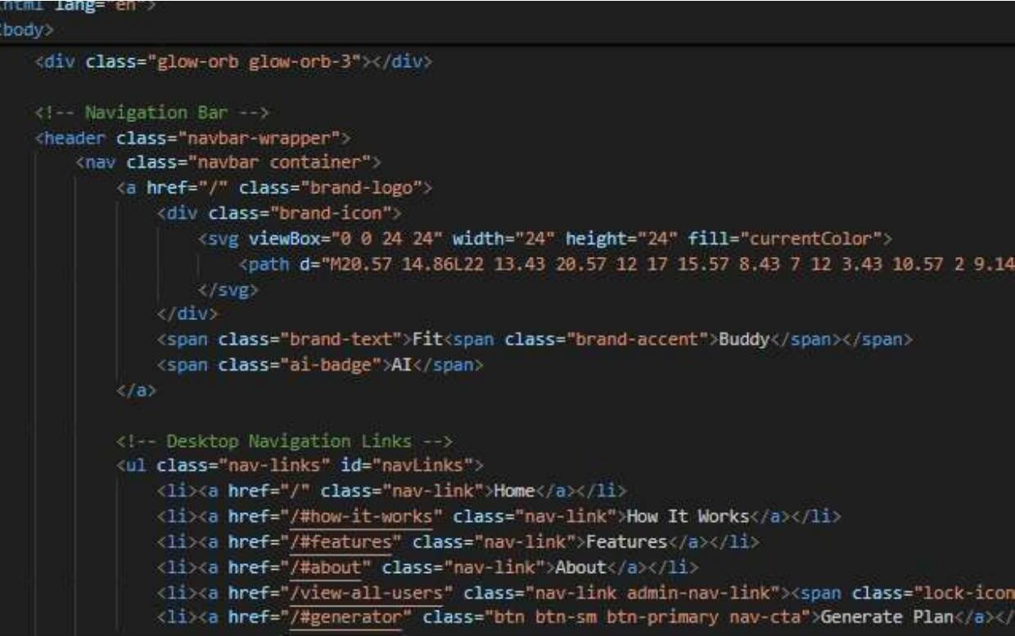

A.2 Home / Landing Page
Main FitBuddy interface.
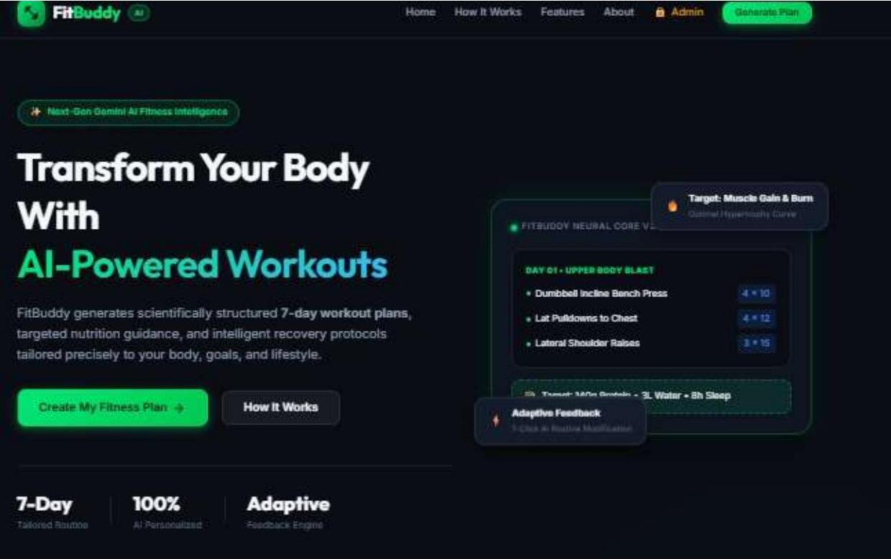

A.3 Fitness Input Form
Form for entering age, weight, goal and intensity.
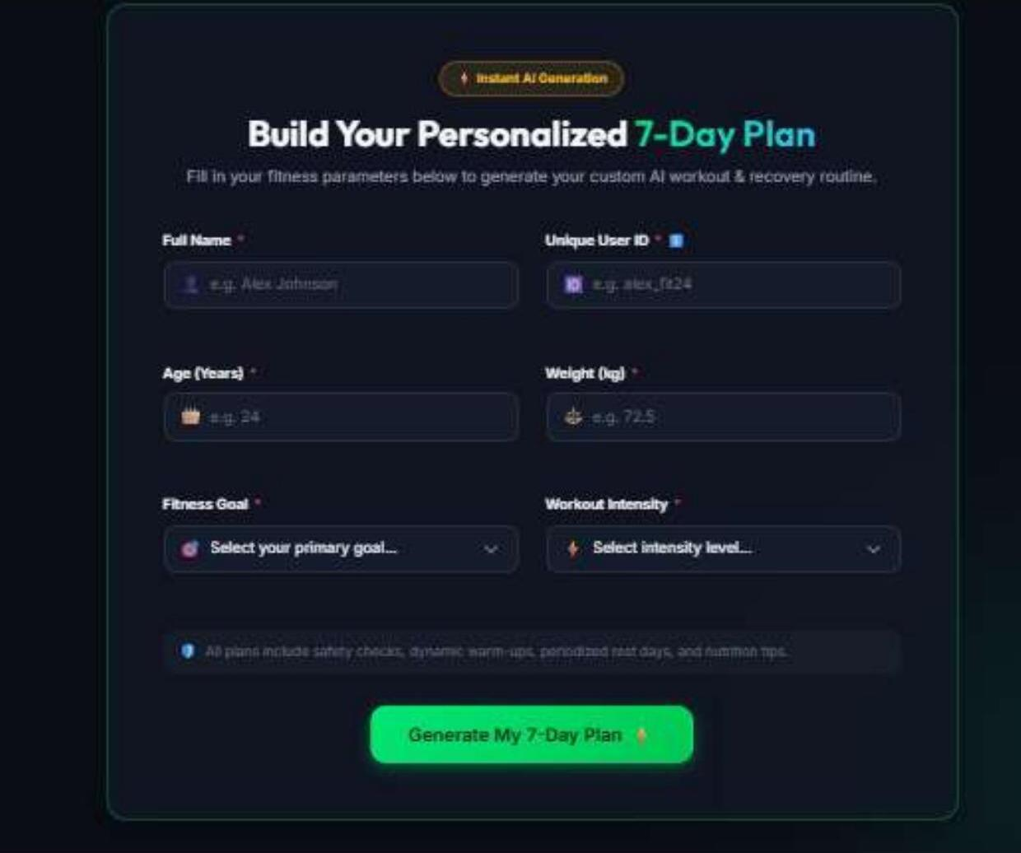

— 11 —

Appendix A. Application Screenshots — Output

A.4 Admin Dashboard & Generated Plans
Admin dashboard showing registered athletes, generated AI plan counts, and original/updated plan status.
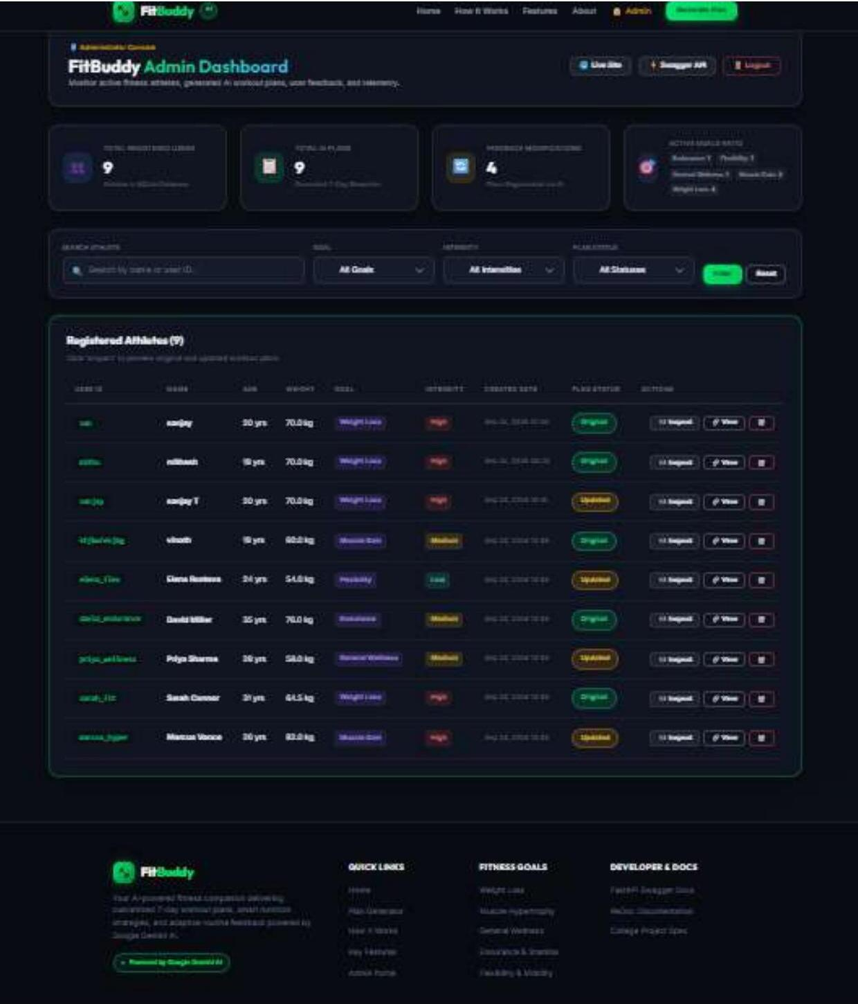

A.5 Platform Features
Key platform highlights showcased on the FitBuddy landing page.
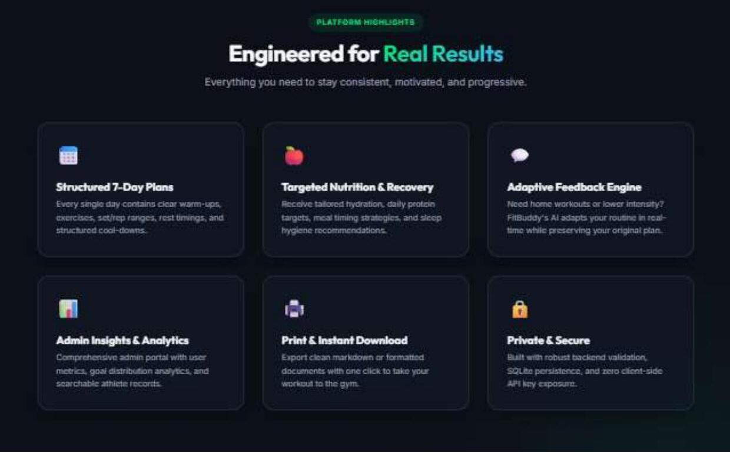

A.6 How FitBuddy Works
The 3-step process users follow to generate a plan.
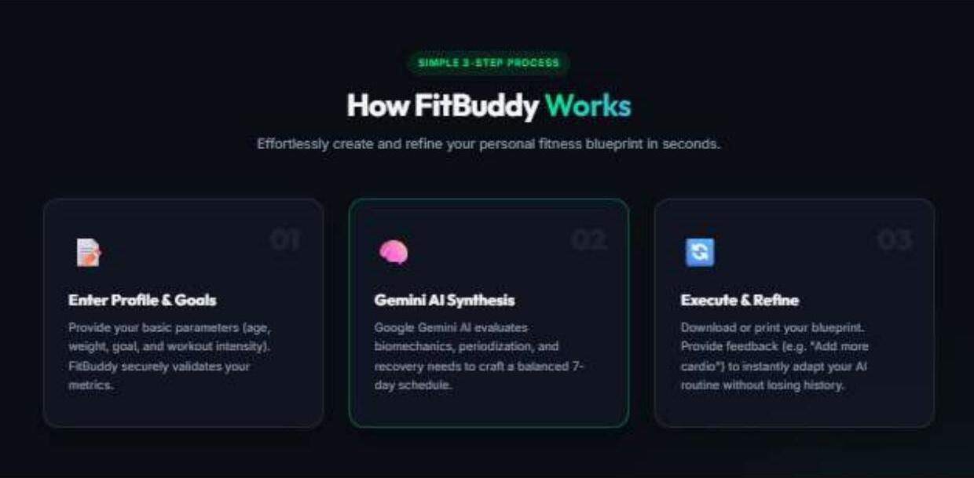

A.7 Technology Stack Highlights
Technology stack and academic architecture summary shown on the site.
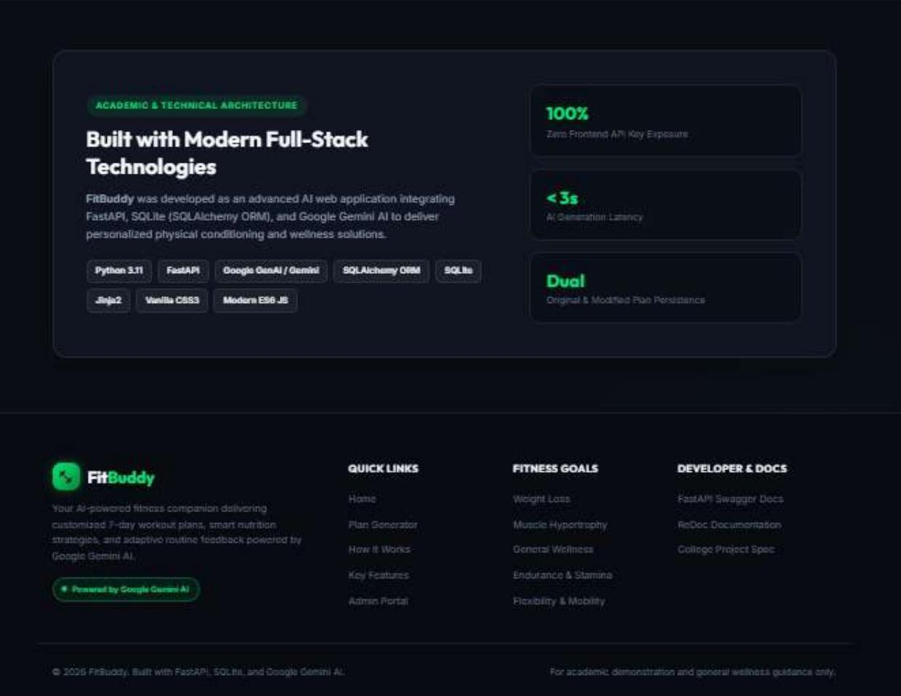

Appendix B. Generated Fitness Blueprint Example
Example project output documented during development: a personalized 7-day weight-loss fitness blueprint generated for a profile with age 20 years, weight 70.0 kg, goal Weight Loss and High intensity. This example is included as a project-output illustration rather than professional fitness advice.
Component | Technology / Purpose
Plan Title | 7-Day Weight Loss AI Fitness Blueprint
Age | 20 years
Weight | 70.0 kg
Goal | Weight Loss
Intensity | High
Duration | 7 Days

— 12 —

Appendix C. Team Responsibilities
Role | Team Member
Team Leader | T. Sanjay
Team Member | Mithesh J
Team Member | Naveen Kumar K
Team Member | Srilrishanth
Appendix D. GitHub Repository Checklist
- Application source code (.py files) — included.
- HTML/CSS/JavaScript frontend — included.
- Tests and project documentation — included.
- requirements.txt — included.
- .gitignore — included.
- README.md — included.
- run.bat and run.sh — included.
- __pycache__, *.pyc and .pytest_cache — excluded.
- API keys, passwords and secret credentials — excluded.
FINAL PROJECT
FITBUDDY — AI FITNESS PLAN GENERATOR
A full-stack academic project combining web development, Python backend processing, database functionality and Gemini generative AI.

T. Sanjay • Mithesh J • Naveen Kumar K • Srilrishanth
— 13 —

