1.import java.util.ArrayList;

class praj{

public static void main(String[] args){

ArrayList<String> obj=new ArrayList<String>();

obj.add("Lion");

obj.add("Bob Cat");

obj.add("Tiger");

obj.add(1,"DOG");

for(String i:obj){

System.out.println(i);

}

}

}

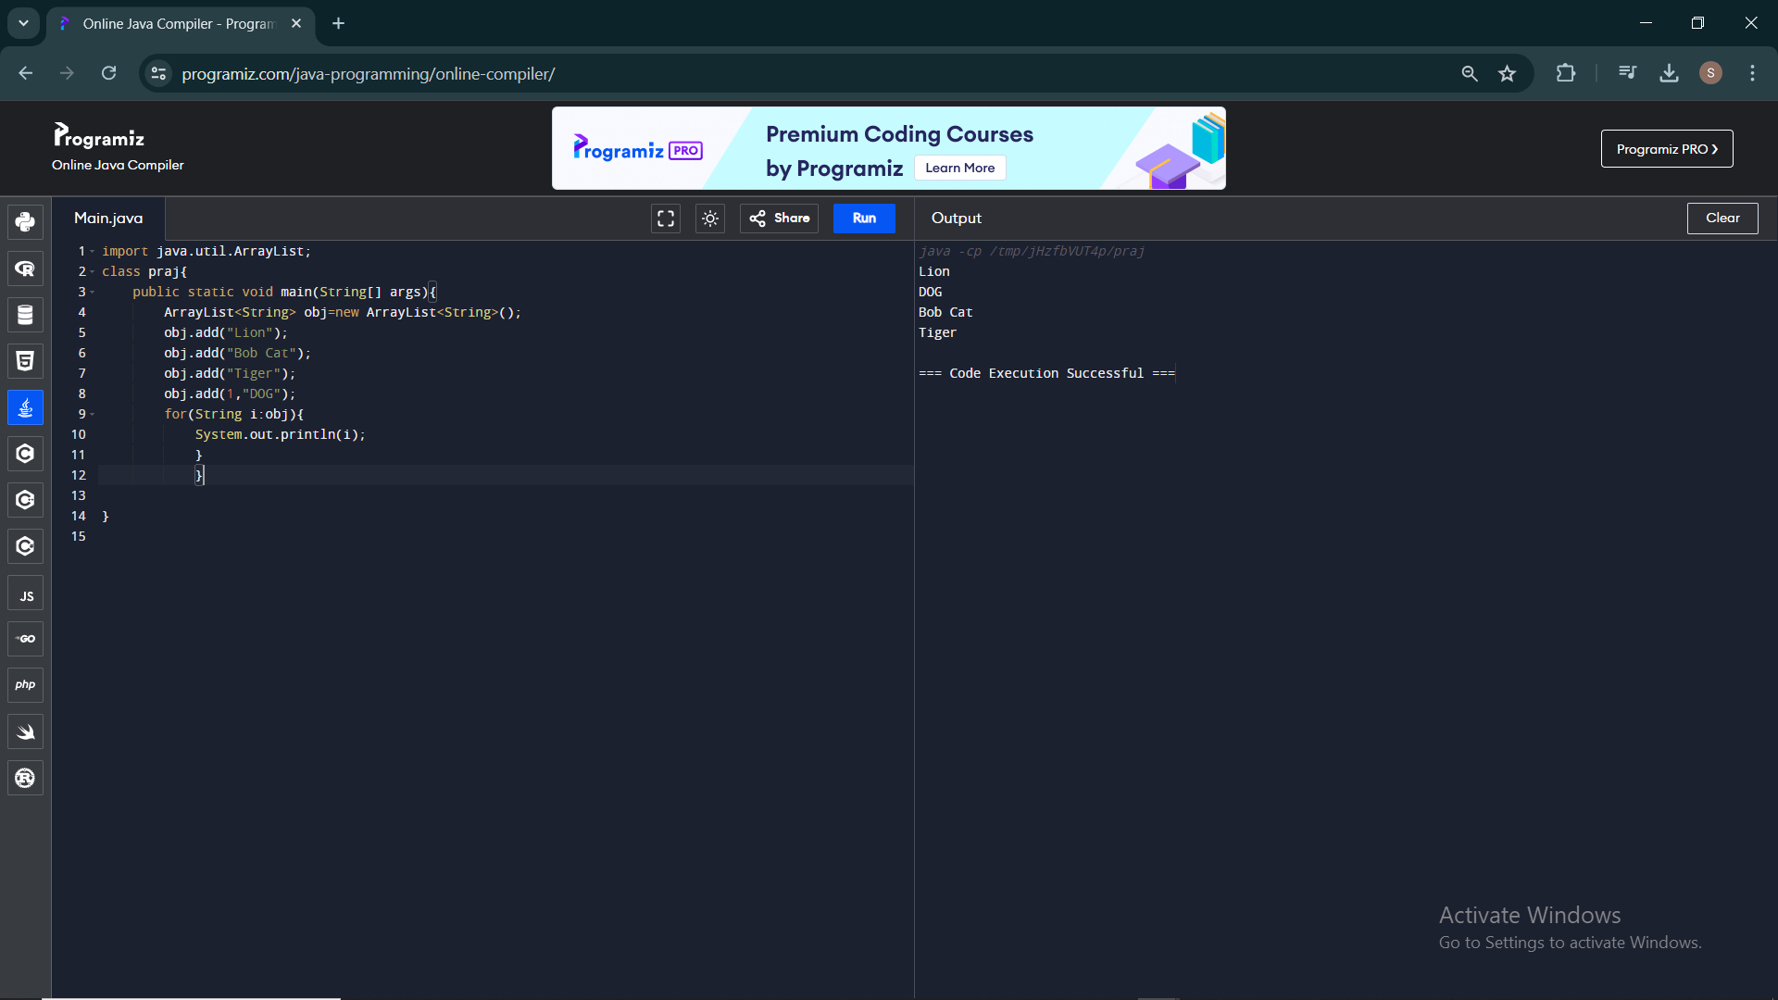

2.import java.util.ArrayList;

class praj{

public static void main(String[] args){

ArrayList<Integer> obj=new ArrayList<Integer>();

obj.add(2);

obj.add(4);

obj.add(5);

obj.add(6);

obj.add(8);

obj.add(9);

System.out.println("The size of the arraylist is "+obj.size());

System.out.println("The element in the 2nd index position by using get method is "+obj.get(2));

System.out.println("The elements before setting: ");

System.out.println(obj);

obj.set(4,20);//set method

System.out.println("The elements after setting: ");

System.out.println(obj);

}

}

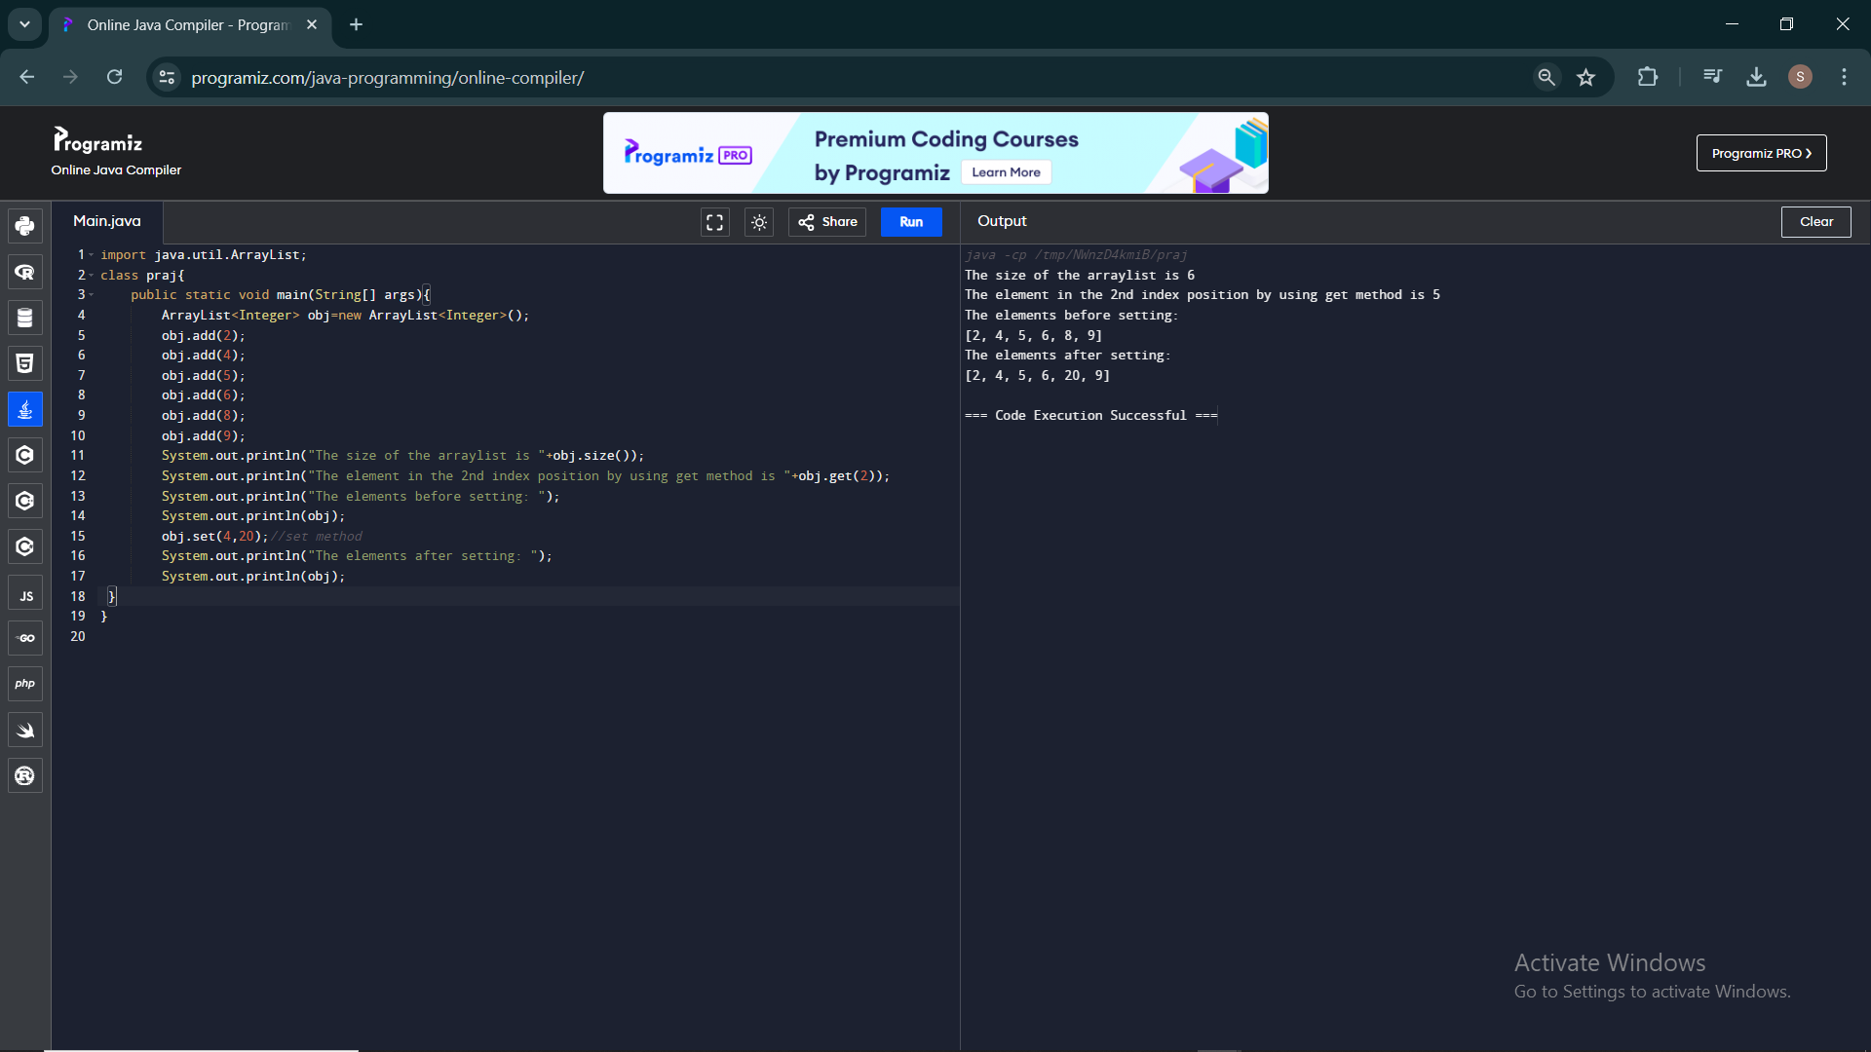

3.import java.util.ArrayList;

class praj{

public static void main(String[] args){

ArrayList<String> obj=new ArrayList<String>();

obj.add("C");

obj.add("C++");

obj.add("Java");

obj.add("Python");

obj.add("Ruby");

obj.add("Javascript");

System.out.println("The elements before removing: ");

System.out.println(obj);

obj.remove(2);

System.out.println("The elements after removing: ");

System.out.println(obj);

ArrayList<String> obj1=new ArrayList<String>();

obj1.add("Ruby");

obj1.add("Javascript");

System.out.println("The elements before removing using remove all: ");

System.out.println(obj);

obj.removeAll(obj1);

System.out.println("The elements after removing using remove all: ");

System.out.println(obj);

System.out.println("The elements before clearing: ");

System.out.println(obj);

obj.clear();

System.out.println("The elements after clearing: ");

System.out.println(obj);

}

}

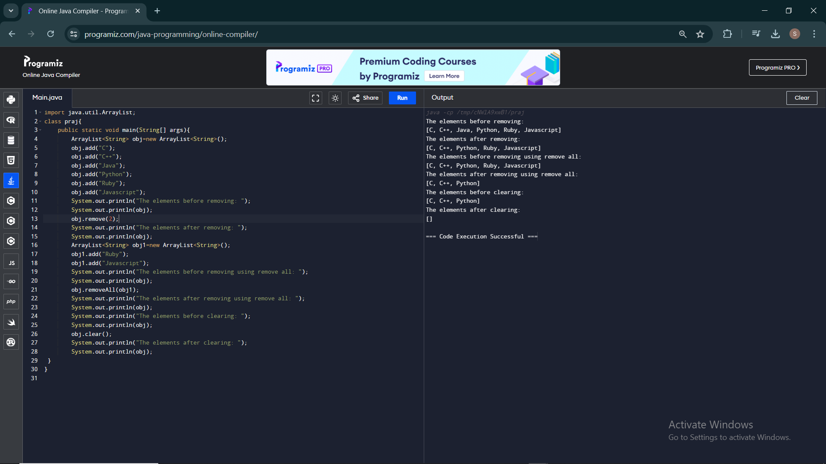

4.import java.util.ArrayList;

import java.util.Iterator;

import java.util.ListIterator;

class praj{

public static void main(String[] args){

ArrayList<String> obj=new ArrayList<String>();

obj.add("Raja");

obj.add("don");

obj.add("Ram");

obj.add("son");

obj.add("Roja");

System.out.println("Printing using for each method: ");

for(String i:obj){

System.out.print(i+'\t');

}

System.out.println();

System.out.println();

System.out.println("Printing using iterator method : ");

Iterator <String> iterator = obj.iterator();

while (iterator.hasNext()){

String Name = iterator.next();

System.out.print(Name+" ");

}

System.out.println();

System.out.println();

System.out.println("Printing using List iterator method: ");

ListIterator <String> listIterator = obj.listIterator();

while (listIterator.hasNext()){

String Name = listIterator.next();

System.out.print(Name+" ");

}

}

}

