Learning Microsoft Power BI can significantly enhance your data analysis and visualization capabilities. Here are the key areas to focus on:

**1. Getting Started with Power BI**

* **Installation and Setup:** Learn how to download and install Power BI Desktop.
* **Interface Overview:** Familiarize yourself with the Power BI interface, including the ribbon, panes, and views (Report, Data, and Model).

**2. Data Import and Transformation**

* **Data Connections:** Understand how to connect to various data sources (Excel, SQL Server, web data, etc.).
* **Power Query Editor:** Learn to use Power Query for data transformation (cleaning, merging, shaping).
* **Data Loading:** Know how to load transformed data into Power BI.

**3. Data Modeling**

* **Tables and Relationships:** Learn how to create and manage relationships between tables.
* **Calculated Columns and Measures:** Use DAX (Data Analysis Expressions) to create calculated columns and measures.
* **Hierarchies:** Create and use hierarchies for drilling down data.

**4. DAX (Data Analysis Expressions)**

* **Basic DAX:** Understand the fundamentals of DAX, including basic functions like SUM, AVERAGE, COUNT.
* **Advanced DAX:** Learn more complex DAX functions and expressions for advanced calculations and aggregations.

**5. Data Visualization**

* **Basic Visuals:** Learn to create basic visuals like bar charts, line charts, pie charts, tables, and matrices.
* **Advanced Visuals:** Understand how to use advanced visuals like maps, gauges, KPIs, and custom visuals from the marketplace.
* **Interactivity:** Implement slicers, filters, and bookmarks to add interactivity to your reports.

**6. Reports and Dashboards**

* **Report Design:** Learn best practices for designing effective reports.
* **Dashboard Creation:** Understand how to create and publish dashboards in Power BI Service.
* **Q&A Feature:** Use the Q&A feature to ask natural language questions about your data.

**7. Power BI Service**

* **Publishing Reports:** Know how to publish reports to the Power BI Service.
* **Workspaces and Apps:** Learn to create and manage workspaces, and distribute apps.
* **Data Refresh:** Understand how to set up data refresh schedules.

**8. Collaboration and Sharing**

* **Sharing Reports:** Learn the different ways to share reports and dashboards with others.
* **Comments and Annotations:** Use comments and annotations for collaborative discussions.

**9. Security and Administration**

* **Row-Level Security (RLS):** Implement RLS to restrict data access for different users.
* **Data Security:** Understand how to manage data security and compliance.

**10. Advanced Features**

* **Power BI Embedded:** Learn how to embed Power BI reports in other applications.
* **Power BI Mobile:** Explore Power BI's mobile app capabilities.
* **AI Insights:** Use AI features like key influencers and decomposition trees.

**11. Best Practices and Performance Optimization**

* **Performance Tuning:** Learn techniques to optimize the performance of your Power BI reports.
* **Best Practices:** Understand best practices for data modeling, DAX coding, and report design.

**Learning Resources**

* **Official Documentation:** Microsoft Power BI documentation.
* **Online Courses:** Platforms like Coursera, Udemy, and LinkedIn Learning offer comprehensive courses.
* **Community Forums:** Engage with the Power BI community on forums and user groups.
* **Blogs and Tutorials:** Follow Power BI blogs and tutorials for the latest tips and updates.

By mastering these areas, you can effectively leverage Power BI for powerful data analysis and business intelligence solutions.

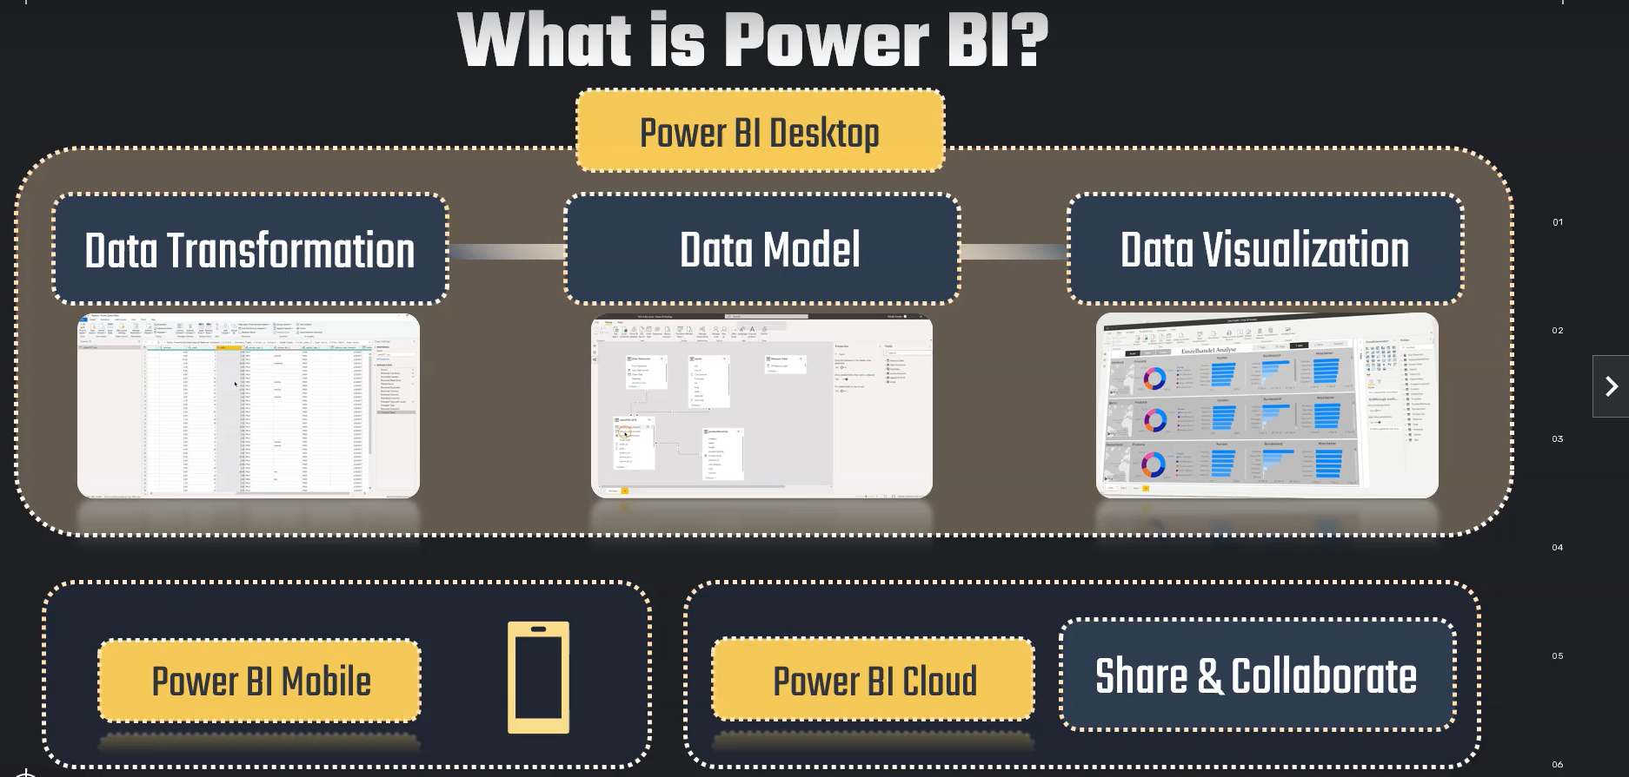

**ON OBJECT INTERACTION :**

On-object interaction is the new way to build and format a visual, directly on the visual in Power BI Desktop. It puts common actions for creating and formatting visuals on the visuals themselves, actions such as adding fields, changing visualization types, and formatting text.

**WHAT IS POWER QUERY EDITOR :**  
Tool used to transform data

**->**  In **Build a visual**, if we want to see **value then we put in Y AXIS** and if we want to see it some **column wise , we put that column in X Axis.**

**Main Components of Business Intelligence System:**

1. **Data Source**
2. **Data Mart / Data Warehouse**
3. **Data Exploration**
4. **Data Mining**
5. **Optimization**
6. **Decisions**