**Project Report**

**1. INTRODUCTION**

**1.1 Overview**

A project built using the Android Compose UI toolkit. It demonstrates how to create a simple travel app using the Compose libraries. It also features a personalized feed of recommended accommodations based on the locations.

**1.2 Purpose**

It is crucial that the travel mobile apps should be an easy-to-use booking platform for its users. Such a travel mobile app must make booking a vacation a lot easier for travelers with features like filter, price comparison, discount offers, bookmarking, push notifications, etc.

**2. Problem Definition & Design Thinking**

**2.1 Empathy Map**

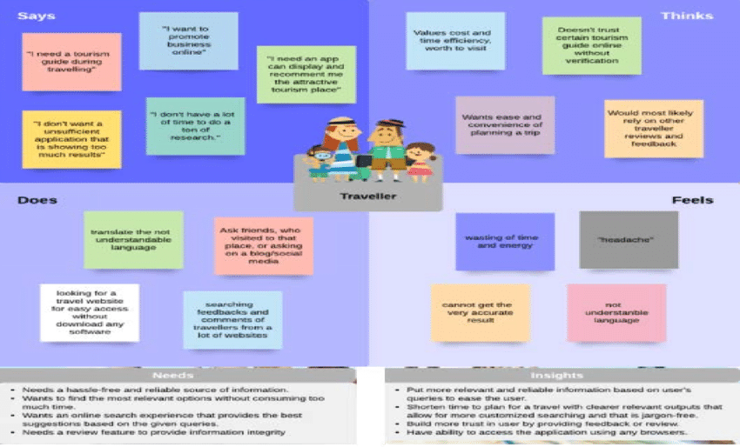

**2.2 Ideation & Brainstorming Map**

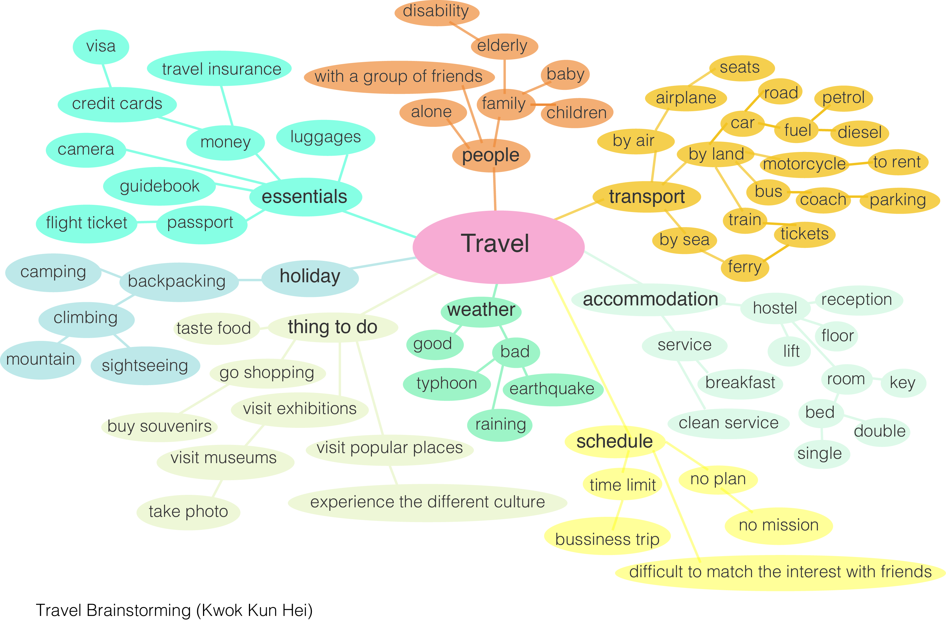

**3.Result:** 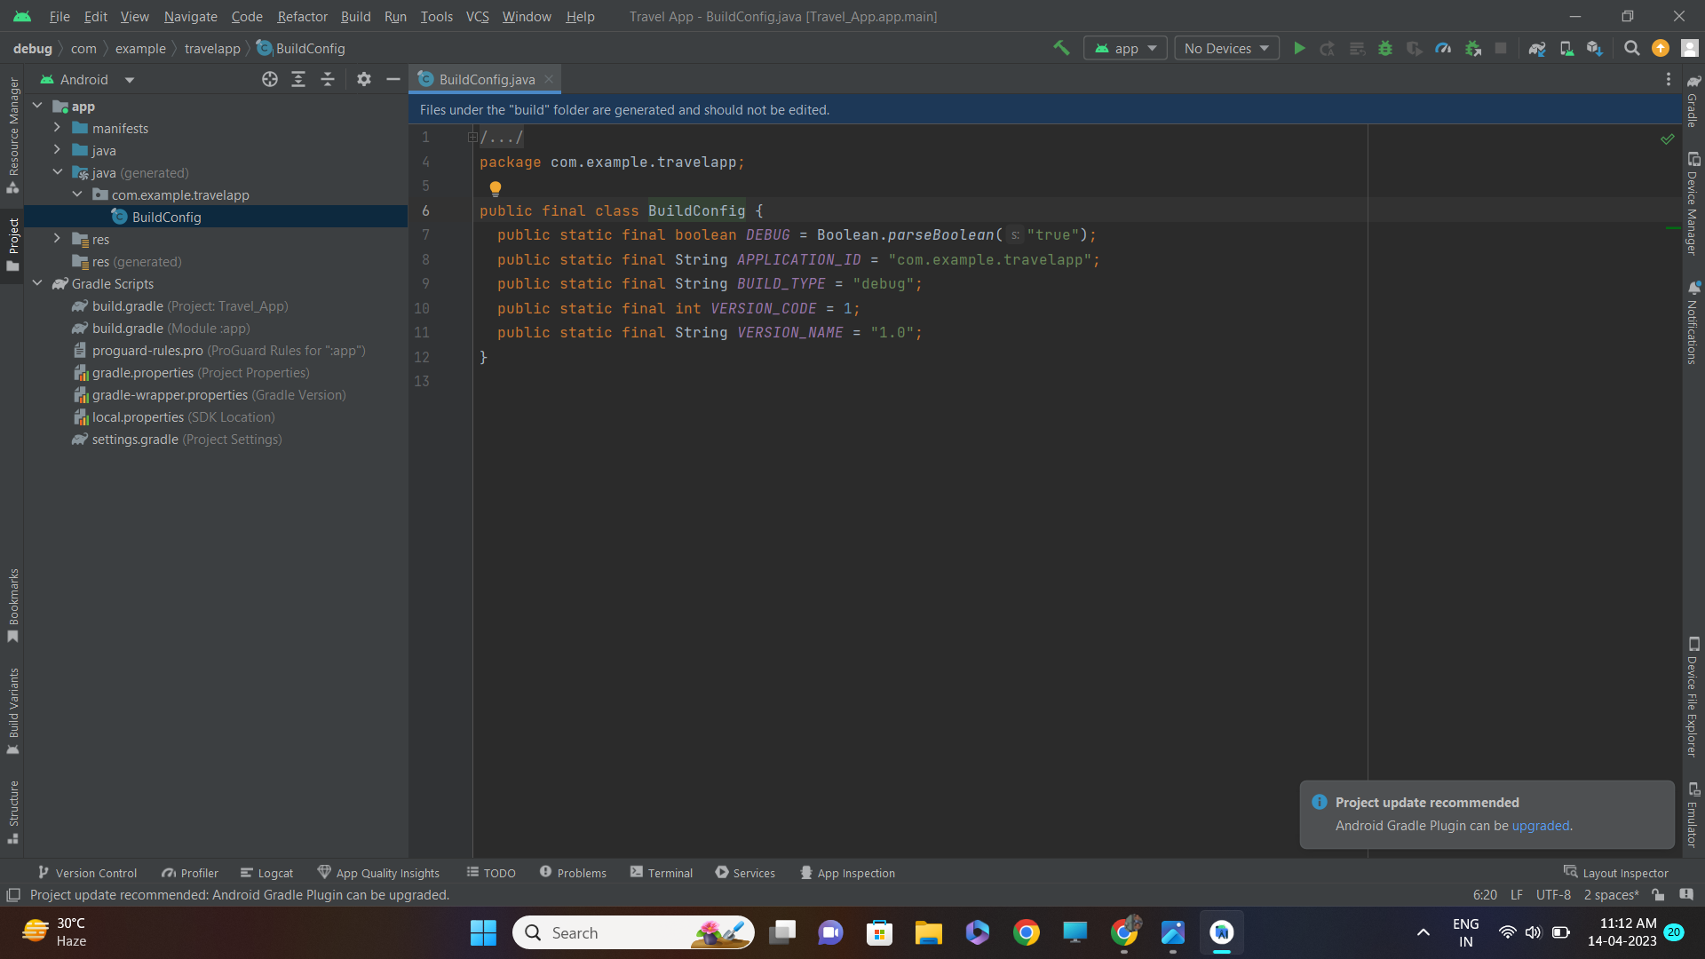

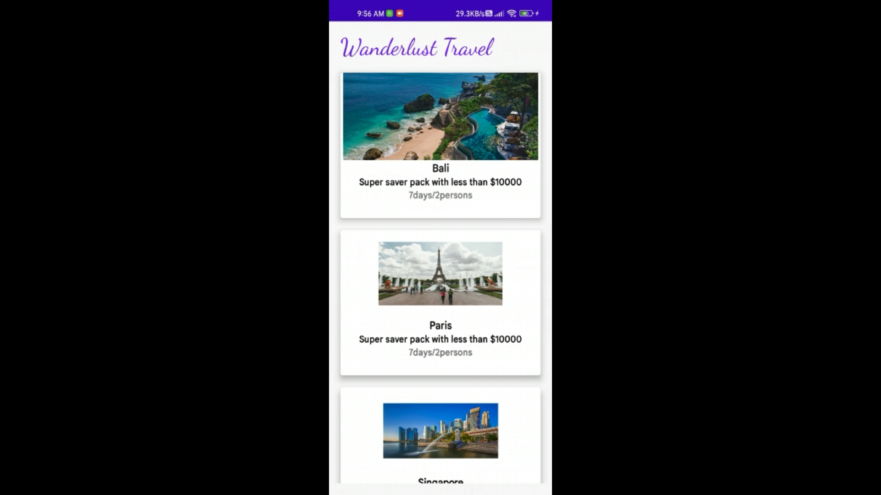

# 4. TRAILHEAD PROFILE PUBLIC URL

**Team Lead – SANJAY T -**

[**https://developers.google.com/profile/u/108687447042299885477**](https://developers.google.com/profile/u/108687447042299885477)

**MOHAMMED THAMEEM ANSARI J -**

[**https://developers.google.com/profile/u/109372730470454220312**](https://developers.google.com/profile/u/109372730470454220312)

**DINESH E -**

[**https://developers.google.com/profile/u/116257255267778152871?authuser=4**](https://developers.google.com/profile/u/116257255267778152871?authuser=4)

**5.** **ADVANTAGES & DISADVANTAGE**

Travel apps have radically changed the way we find deals, book trips, and plan our travel with just a few clicks or taps, but they're far from perfect experiences.

# 6. APPLICATIONS

Travel apps help users to research destinations, find good flight and accommodation deals, and book services.

**7. CONCLUSION**

Travel mobile apps have become an important part of the industry and are affecting the booking as well as the planning process. As the sector grows in sophistication, many new opportunities are emerging for both investors as well as service providers.

**8. FUTURE SCOPE**

Artificial technology can be embedded to identify the frequent users,frequent ordered snacks and based on this snacks recommendations feature can be added.