**ENERGY ENVIROECONOMIC AND SUSTAINABLITY ANALYSIS OF SOLAR DRYER FOR MEDIUM SCALE AGRICULTUTRAL APLLICATIONS**

Sanjay V, Viswanathan M, Ramprakash S

UG Students

*Dept of Mechanical Engineering*

*Bannari Amman Institute of Technology, India*

[*Sanjayv.me20@bitsathy.ac.in*](mailto:Sanjayv.me20@bitsathy.ac.in)*,* [*viswanathan.me20@bitsathy.ac.in*](mailto:viswanathan.me20@bitsathy.ac.in)*,* [*ramprakash.me20@bitsathy.ac.in*](mailto:ramprakash.me20@bitsathy.ac.in)*,*

*Abstract*- Energy and Enviroeconomic and Sustainability is the project that analyses drying process by utilizing solar energy effectively. This includes maximizing solar heat capture, optimizing air circulation, and ensuring uniform drying throughout the product. The application of solar dryers, however must be evaluated to determine its benefit and effectiveness. In the evaluation of solar dryer performance, three criteria which are most important to look at are thermal performance, economic cost and environmental implications. Therefore, we attempts to review the thermo-economic analysis and environmental evaluation on tunnel solar drying system. Performance equations in energy–economic–environment analyses for solar drying systems evaluation are presented. The CO2 emission, carbon mitigation, and earned carbon credit of various solar drying system are also presented.

I.INTRODUCTION

A solar dryer is a different innovation that uses solar energy to preserve harvests, fruits, and vegetables. Back in the day Traditional solar dryers were basic and inexpensive systems that used sun energy to dry agricultural products. They have been utilized for centuries in many regions of the world to preserve crops and agricultural supplies. The primary idea behind these dryers is to use the heat of the sun to evaporate moisture from harvested crops, preventing spoiling and extending shelf life. Traditional sun dryers may be less efficient than more advanced solar drying devices. Their design and construction may not maximize the use of solar energy, resulting in lengthier drying durations and reduced overall efficiency. The conventional solar dryer’s performance is greatly dependent on weather conditions. Cloudy days or periods of low sunlight can stymie the drying process, resulting in delays and severe losses. Traditional solar dryers' performance is greatly dependent on weather conditions.

II.EXISTING SYSTEM

In present’s world, there has many solar dryers, here we use solar tunnel dryer, the existing system contains only dryer here it cannot be used in rainy seasons because in rainy seasons there is no much solar radiation from the sun. So, the agriculture products get wasted by forming fungus and the products didn’t get dried properly. We modified the solar tunnel dryer assisted with heat pump. It produce the sufficient heat in rainy seasons and also reduced the drying time compared to the normal dryer.

III.PROPOSED SYSTEM

The proposed idea behind these dryers is to use the heat of the sun to evaporate moisture from harvested crops, preventing spoiling and extending shelf life. The advancement of sun drying is solar drying systems in which products are dried in a closed system in which the inside temperature is higher. Here we use a solar tunnel Dryer to preserve the agricultural Products. A forced solar dryer is a more advanced type of solar dryer, sometimes known as a solar-powered mechanical dryer or hybrid solar dryer. It includes extra features to improve the drying process, making it more efficient and dependable. Aside from natural convection and sun radiation, a forced solar dryer has a system that intentionally moves air through the drying chamber. This induced convection speeds up the evaporation of moisture from agricultural produce, resulting in shorter drying durations and more control over drying conditions. Solar-powered fans or blowers are frequently used to generate forced convection. These fans circulate air within the drying chamber, resulting in more uniform drying and a lower chance of spoiling or uneven drying

IV.WORKING

Figure 1 shows the flow diagram of the desired system.

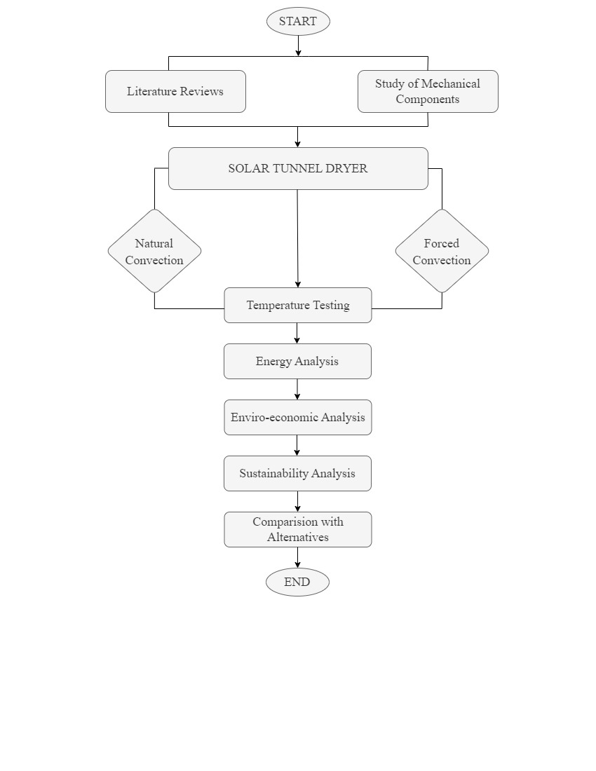

*FIGURE 1: Flow Diagram*

|  |  |
| --- | --- |
| RTD Temperature Sensor | Type of temperature sensor that works by measuring the change in resistance of a conductor as its temperature changes |
| Pyranometer | Pyranometers measure global irradiance, which is the amount of solar energy incident per unit area per unit time on a surface with a certain direction |
| Humidity Sensor | Measures the amount of water vapor in the air, relative to the amount of water vapor that the air could hold at a given temperature. |

*TABLE 1: Components*

It takes a systematic approach to develop a research methodology for an energy and environmental sustainability study of a solar dryer for medium-scale agricultural applications. I have included a step-by-step process for your research below:

1. MATERIALS AND DATA COLLECTION

1.1 RTD temperature sensor

An RTD (Resistance Temperature Detector) is a type of temperature sensor that works by measuring the change in resistance of a conductor as its temperature changes. The most common type of RTD is the platinum RTD, which uses a platinum wire as the sensing element.

1.2 Relative humidity sensor

A relative humidity sensor is a device that measures the amount of water vapor in the air, relative to the amount of water vapor that the air could hold at a given temperature. The amount of water vapor in the air is expressed as a percentage, known as relative humidity (RH).

1.3 Pyranometer

Pyranometers measure global irradiance, which is the amount of solar energy incident per unit area per unit time on a surface with a certain direction emanating from a hemispherical field of view (2 sr). The total irradiance comprises both direct and diffuse sunlight. Gather information about the technical requirements for solar dryers, such as the design criteria, the materials employed, and the operating features.

2. ENERGY ANALYSIS

2.1Analysis of Energy Input and Output.

⇒Determine the total solar energy incident on the tunnel dryer's solar collecting surface for a specified time

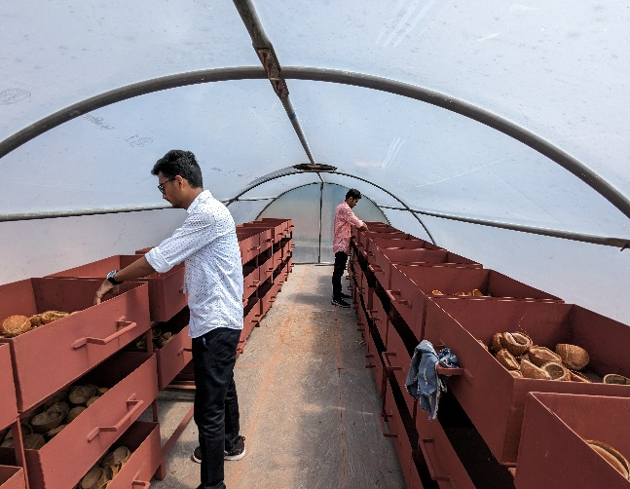⇒Calculate the energy needed to operate the tunnel solar dryer, taking into account the fan or blower power needed for air circulation and any heating components that may be present.

⇒Calculate or estimate the system's losses, such as the heat lost through the dryer's walls and the losses incurred during the conversion of solar energy to usable heat.

3. ENVIRONMENTAL AND ECONOMIC ASSESSMENT

⇒To examine the tunnel solar dryer's environmental effect, do a Life Cycle Assessment (LCA). This should include topics like greenhouse gas emissions, water consumption, energy utilization, and resource depletion. To find possible environmental advantages, compare the tunnel solar dryer's environmental effect to those of traditional drying techniques.

⇒Determine the tunnel solar dryer's total cost of ownership, taking into account the upfront investment, ongoing expenses, and maintenance expenditures over the course of the device's anticipated lifespan. Calculate the system's payback time, net present value, and internal rate of return to determine its economic viability.

4. SUSTAINABILITY ANALYSIS

4.1 Social environment

To understand the social effects of using tunnel solar dryers, conduct surveys or interviews with local stakeholders including farmers, workers, and community members. Consider elements like employment prospects, revenue generating, and neighbourhood growth. Combine the findings from the environmental, economic, and social evaluations to determine the tunnel solar dryer's overall sustainability. Utilize sustainability measurements or indicators,

Figure 1 shows Coconut drying in Tunnel dryer

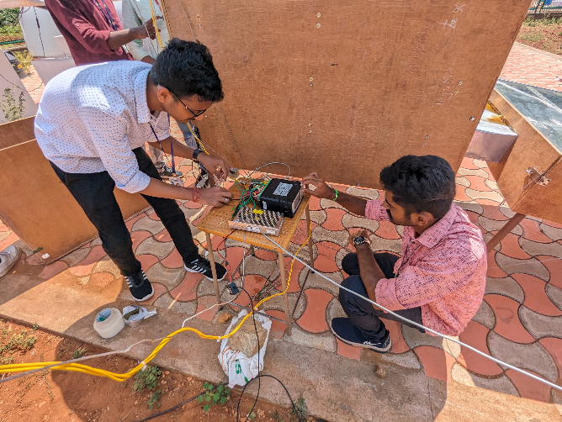

Figure 2 shows the sensor installation

V.RESULTS

Graph: 1

Graph: 2

The Above graph represents the various analysis solar dryer without heat pump (Natural Convection)

Graph: 3

Graph: 4

The Above graph represents the various analysis solar dryer with heat pump (Forced Convection)

VI.CONCLUSION

Through various studies and with systematic and through mathematical Analysis we can conclude that solar tunnel dryer assisted with heat pump is more efficient in summer and rainy seasons and also it reduces the drying time of the agricultural products.

VII.REFERENCES

1. Patchimaporn Udomkun ,Sebastian Romuli b , Steffen Schock b , Busarakorn Mahayothee “Review of solar dryers for agricultural products in Asia and Africa: An innovation landscape approach”. Journal of Environmental Management, 268, [110730].
2. G. Pirasteh , R. Saidur , S.M.A. Rahman , N.A. Rahim “A review on development of solar drying applications” journal on [Renewable and Sustainable Energy Reviews](https://www.sciencedirect.com/journal/renewable-and-sustainable-energy-reviews) [Volume 31](https://www.sciencedirect.com/journal/renewable-and-sustainable-energy-reviews/vol/31/suppl/C), March 2014.
3. Babaganagutti, Silaskiman and Ahmed M. Murtala, (2012),solar dryer an effective tool for agricultural produce, Journal of Applied Technology in Environmental Sanitation, 2 (1),31-38.
4. Varun,Sunil, Avdesh sharma,(2012), construction and performance of an indirect solar dryer integrated with solar air heater, Procedia Engineering 38,3260-3269.