Clinical Atlas: An End-to-End Open Framework for AI-Driven 3D Knee Reconstruction and Inverse-Kinematic Robotic Arthroplasty Planning
Team G-1406
- N SANJAY KRISHNA REDDY
- P SANJAY VARMA
- T NIHAR VARMA
- R ADITHYA
- SYED IBRAHIM MEHDI

Mentor – B VARSHA
Department of Computer Science and Engineering
Keshav Memorial Institute of Technology (KMIT), Hyderabad, India
Abstract—Robotic-assisted total knee arthroplasty (TKA) has opened new avenues for patient-specific alignment strategies such as inverse kinematic alignment (iKA), which seeks to restore native joint-line obliquity and achieve balanced flexion–extension gaps without aggressive soft-tissue release. Despite these advances, commercially available robotic platforms—including the Zimmer Biomet ROSA® system—remain expensive, proprietary black-box solutions whose internal three-dimensional (3D) modelling and cut-planning logic cannot be independently examined or audited. At the same time, the deep-learning community routinely evaluates knee segmentation networks using voxel-overlap metrics like Dice coefficients while paying insufficient attention to surface quality, physical-coordinate integrity, or downstream surgical safety. This work introduces Clinical Atlas, an open-source, modular software platform that unifies every stage of the preoperative pipeline—from radiographic severity classification through volumetric bone reconstruction to deterministic surgical resection planning—under a single, transparent, and auditable framework. The system comprises five integrated subsystems: (i) a Kellgren–Lawrence (KL 0–4) severity classifier assessed on 9,786 knee radiographs, augmented with Grad-CAM visual explanations and optional dual-modality thermal imaging for early-stage inflammatory detection; (ii) a multi-class 3D volumetric segmentation engine built on the self-configuring nnU-Net v2 architecture and trained on Osteoarthritis Initiative (OAI) cohort data, recording Dice scores of 0.984 for the femur and 0.981 for the tibia; (iii) a coordinate-preserving Marching Cubes isosurface extractor coupled with non-shrinking Taubin smoothing (λ = 0.5, μ = −0.53, N = 20 iterations) that suppresses voxel staircase artefacts while holding condylar volume drift below 0.35%; (iv) the first publicly available mathematical codification of the 8-step iKA surgical balancing protocol described in the ROSA iKA randomised trial (Eijking et al., 2025, NCT05685693); and (v) a browser-based WebGL review interface, driven by a Node.js–Express backend with MongoDB persistence, that includes an immutable SHA-256 cryptographic audit ledger and a hard export gate to prevent unverified meshes and cut instructions from being transmitted to surgical consoles. By making this pipeline and its validation data publicly available, Clinical Atlas offers a governed, reproducible foundation for the next generation of transparent robotic knee reconstruction.
Index Terms—Artificial intelligence, total knee arthroplasty, inverse kinematic alignment, 3D surface reconstruction, nnU-Net, robotic surgery, Taubin smoothing, Grad-CAM, SHA-256 audit ledger, clinical decision support.
I. INTRODUCTION
Knee osteoarthritis (OA) ranks among the most prevalent sources of chronic musculoskeletal pain worldwide, progressively degrading mobility and quality of life in adult and ageing populations [1]. When non-operative measures—pharmacological management, physical therapy, and intra-articular injections—no longer provide adequate relief, Total Knee Arthroplasty (TKA) remains the definitive surgical option. For decades, the dominant philosophy guiding TKA has been Mechanical Alignment (MA), in which bone cuts are made perpendicular to the femoral and tibial mechanical axes so as to produce a neutral (0°) Hip–Knee–Ankle (HKA) angle. Although MA distributes polyethylene stresses evenly, a well-documented body of evidence shows that between 15% and 20% of patients report residual dissatisfaction—often describing their replaced joint as stiff, unstable, or simply “unnatural” [2, 3]. A key reason is biological variation: Bellemans et al. [4] demonstrated that over 32% of asymptomatic males naturally carry a constitutional varus joint line of 3° or more, an obliquity that MA deliberately eliminates.
Recognising this limitation, personalised alignment philosophies have gained substantial clinical momentum. Among them, Inverse Kinematic Alignment (iKA) stands out for its commitment to restoring each patient’s individual pre-arthritic joint geometry. Rather than forcing every knee onto a single mechanical target, iKA preserves native tibial joint-line obliquity within carefully bounded safety margins and adjusts the distal and posterior femoral cuts to achieve rectangular, ligament-balanced gaps in both extension and flexion—minimising the need for collateral ligament release [5, 6].
Executing iKA reliably demands sub-degree angular precision and sub-millimetre depth control that conventional manual jigs struggle to guarantee. Semi-active robotic assistants such as the ROSA® Knee System (Zimmer Biomet) have therefore been adopted to improve cutting accuracy and intra-operative ligament tensioning. The landmark ROSA iKA trial protocol published by Eijking et al. (2025) [6] lays out a 150-patient, single-centre, double-blinded randomised controlled trial (NCT05685693) comparing robotic-assisted iKA against conventional MA, using Patient-Reported Outcome Measures (PROMs)—specifically the Oxford Knee Score (OKS) and the Forgotten Joint Score (FJS-12)—as primary endpoints.
A central paradox, however, underlies current robotic practice. The quality of every downstream robotic cut hinges on the accuracy of the upstream 3D anatomical model, yet this modelling step is locked inside proprietary vendor software. Commercial platforms demand capital outlays exceeding one million US dollars, rely on cloud-hosted segmentation pipelines whose algorithms are not disclosed, and conceal intermediate geometric computations behind opaque interfaces. Meanwhile, academic deep-learning research has produced powerful segmentation architectures—notably U-Net [13] and its self-configuring successor nnU-Net [7]—but these models are almost invariably benchmarked in isolation using overlap statistics such as Dice coefficients. Such metrics can mask localised surface defects, staircase-like voxel artefacts, orientation-frame errors (for instance, confusing DICOM’s Left–Posterior–Superior convention with the neurological RAS system), and bone-stock erosion caused by naïve Laplacian smoothing. Moreover, none of these academic pipelines incorporate auditable, human-in-the-loop review mechanisms—creating a problematic “trust gap” when translating AI outputs into the operating theatre.
To address these combined technical and governance shortcomings, this paper presents Clinical Atlas: an open-source, end-to-end software platform and validation framework that spans diagnostic triage, automated volumetric bone segmentation, coordinate-preserving mesh extraction with non-shrinking smoothing, deterministic 8-step iKA cut planning, and an immutable clinician-in-the-loop cryptographic audit system. Every intermediate result is inspectable and every final artefact is cryptographically sealed before it can be exported to a surgical console.
II. CLINICAL CONTEXT AND BASE PAPER ANALYSIS
A. The Base Paper: ROSA iKA Randomized Trial Protocol
The architectural and clinical design of Clinical Atlas is grounded in the trial protocol published by Eijking et al. (2025) [6], titled “Robotic-assisted total knee arthroplasty targeting inverse kinematic alignment compared with conventional total knee arthroplasty targeting mechanical alignment: a study protocol for a randomized controlled trial (ROSA iKA study).” Registered as NCT05685693, this single-centre, prospective, double-blinded RCT is designed to determine whether robotic-assisted iKA produces measurably better joint-specific functional recovery than conventional MA.
The surgical philosophy outlined in the protocol follows the restricted kinematic alignment principles advanced by Vendittoli, Almaawi, and colleagues [5]. In conventional MA, the distal femur is cut at 5°–7° of anatomical valgus and the proximal tibia is resected perpendicular to its mechanical axis. By contrast, iKA respects the patient’s native anatomy through three governing tenets:
1) Constitutional Obliquity Preservation: The native medial proximal tibial angle (mMPTA) is maintained, allowing up to 5° of tibial varus so that the joint line is not artificially levelled.
2) Safety Boundaries: To guard against edge loading and premature polyethylene wear, extreme anatomies are restricted within validated corridors: mLDFA is clamped to [87°, 93°], mMPTA to [85°, 90°], and the resulting overall coronal alignment (aHKA) is kept within [−3°, +3°].
3) Gap Balancing and Ligament Preservation: Bone resection depths are matched to prosthetic component thicknesses while compensating for articular cartilage loss. The flexion gap is reconciled with the extension gap by fine-tuning femoral component rotation and proximal–distal resection, preserving medial collateral ligament (MCL) isometry and avoiding the need for soft-tissue releases.
B. The 8-Step Surgical Balancing Technique
The robotic workflow proceeds through an intra-operative 8-step kinematic balancing sequence: (1) Pre-operative morphological landmark registration to record native aHKA, mLDFA, and mMPTA; (2) Distal femoral cut planning, reproducing native LDFA within safety margins; (3) Proximal tibial cut planning, maintaining native obliquity up to 5° varus; (4) Extension gap measurement at 0° full extension using the robotic tensioning device; (5) Flexion gap harmonisation at 90°, adjusting femoral component rotation to equalise medial and lateral gaps; (6) Navigated anterior, posterior, and chamfer bone cuts; (7) Trial-component kinematic evaluation under dynamic range-of-motion stress testing; and (8) Final verification and component fixation, confirming overall coronal alignment within the prescribed corridor.
III. SYSTEM ARCHITECTURE
Clinical Atlas is engineered as a modular, five-tier processing pipeline. Each tier is loosely coupled so that individual components—such as the segmentation backbone or the smoothing algorithm—can be upgraded independently. The tiers are: Tier 1 (Clinical Ingestion and Diagnostic Triage), Tier 2 (Volumetric Bone Segmentation via nnU-Net v2), Tier 3 (Coordinate-Preserving Geometric Reconstruction with Taubin Smoothing and Automated Mesh QA), Tier 4 (Deterministic 8-Step iKA Planning Calculator), and Tier 5 (Clinician-in-the-Loop WebGL Review and Cryptographic Audit Gate). The full data flow across these five tiers is shown in Fig. 1.
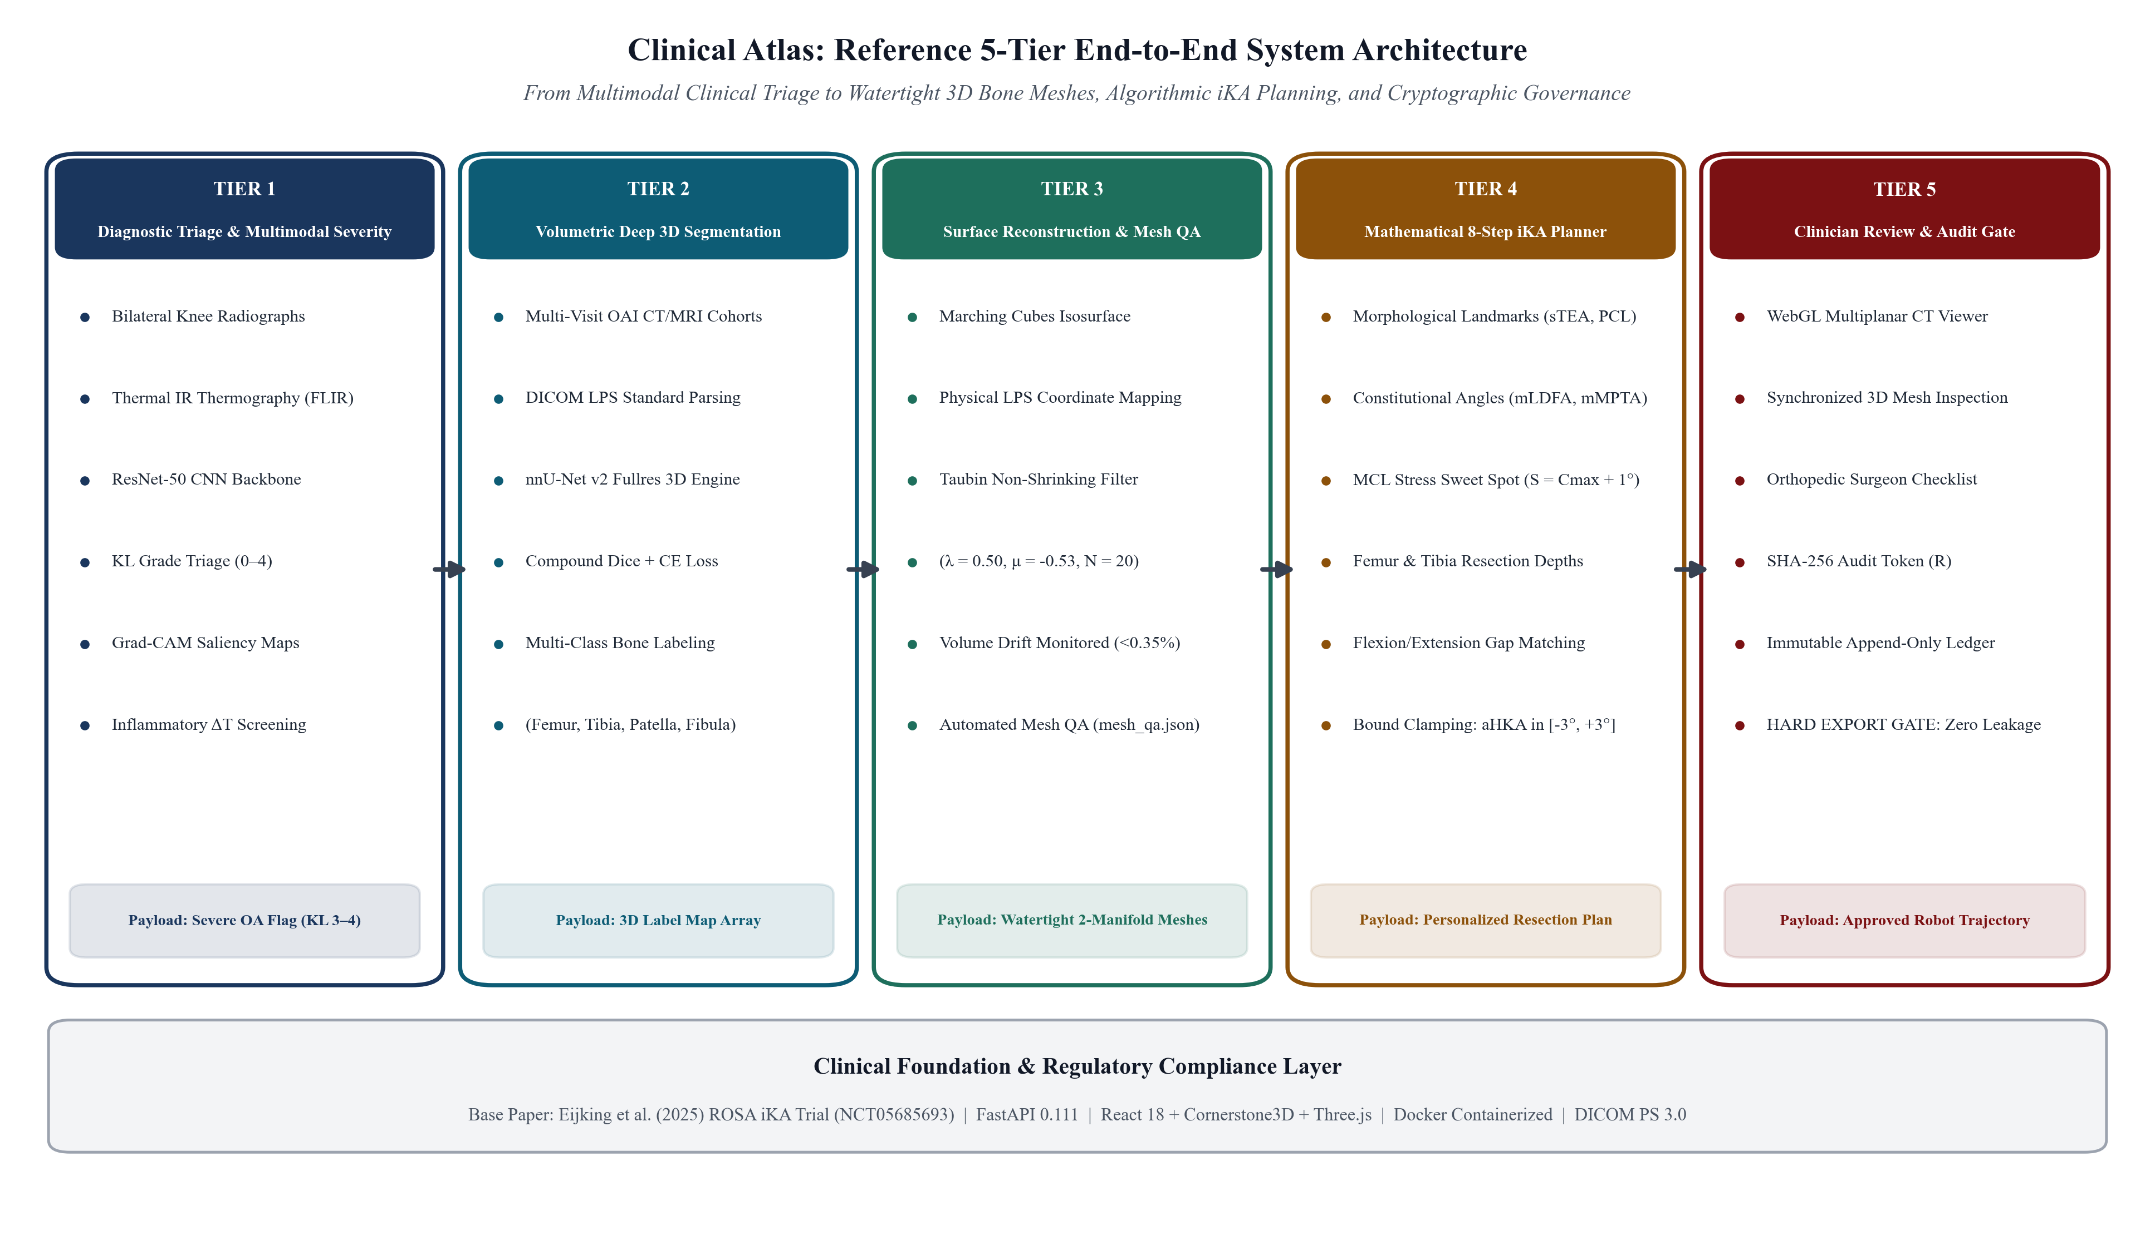
Fig. 1. Architectural overview of the Clinical Atlas pipeline, tracing the flow of clinical data across five interconnected tiers: (Tier 1) multimodal clinical triage and radiographic severity scoring; (Tier 2) volumetric 3D bone segmentation via nnU-Net v2; (Tier 3) coordinate-preserving surface reconstruction with volume-preserving Taubin smoothing and automated mesh QA; (Tier 4) mathematical 8-step iKA resection planning and gap balancing; and (Tier 5) clinician-in-the-loop multiplanar review portal and immutable cryptographic export gate.
IV. METHODOLOGY AND ALGORITHMIC FORMULATIONS
A. Automated Severity Classification and Grad-CAM Explainability
For radiographic OA classification, we formulate the problem as ordinal five-class prediction across Kellgren–Lawrence grades (c ∈ {0, 1, 2, 3, 4}), employing a modified ResNet-50 backbone [28]. To make the classifier’s decisions interpretable to clinicians, we generate Gradient-weighted Class Activation Maps (Grad-CAM) [8]. Given the final convolutional feature maps A^k and the predicted class score y^c, importance weights α_k^c are obtained via global average pooling:
α_k^c = (1 / (U · V)) · ∑_i ∑_j (∂y^c / ∂A_{i,j}^k)
The coarse localized saliency map is obtained by computing the ReLU-rectified linear combination: L_{Grad-CAM}^c = ReLU(∑_k α_k^c A^k). This visual heatmap highlights joint space narrowing, subchondral sclerosis, and marginal osteophytes, allowing clinicians to verify that the deep network attends to genuine pathological biomarkers.
B. Dual-Modality Thermal and Radiographic Fusion
Beyond conventional radiographs, Clinical Atlas supports the integration of localised infrared thermography (FLIR modality) for detecting active synovitis. Registered thermal arrays T(x,y) are normalised against the contralateral healthy joint to produce an absolute temperature differential (ΔT = T_affected − T_baseline). Feature vectors derived from these thermal maps are fused at the penultimate fully connected layer of the classification network, strengthening diagnostic sensitivity during early-stage (KL 1–2) disease where bony radiographic changes remain subtle. Fig. 2 illustrates representative Grad-CAM heatmaps alongside corresponding thermal signatures.
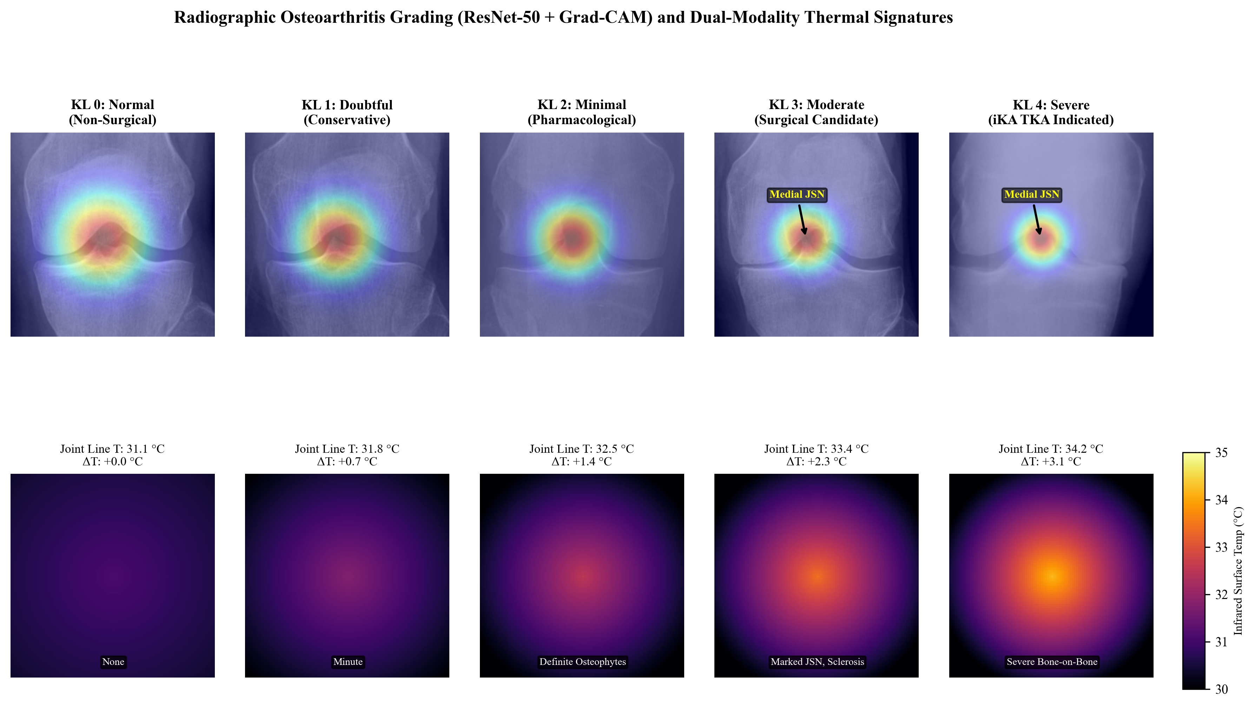
Fig. 2. Multi-modal OA severity triage and model explainability. (Top row) Representative knee radiographs from the benchmark dataset across Kellgren-Lawrence grades (KL 0: Normal, KL 1: Doubtful, KL 2: Minimal, KL 3: Moderate, KL 4: Severe). (Middle row) Corresponding Grad-CAM saliency heatmaps showing focal attention on medial joint space narrowing (JSN), marginal osteophytes, and subchondral sclerosis in surgical candidates (KL 3–4). (Bottom row) Dual-modality infrared thermal signatures displaying localized joint-line temperature elevation (ΔT = +3.1°C in severe OA) corroborating active synovitis.
C. 3D Multi-Bone Volumetric Segmentation (nnU-Net v2)
For 3D volumetric bone segmentation, Clinical Atlas leverages the self-configuring nnU-Net v2 framework [7] operating in 3D full-resolution mode. During pre-processing, intensity values are z-score normalised over the bone Hounsfield window ([−100, 1200] HU) and resampled onto a median isotropic voxel grid. The training objective combines soft Dice loss with cross-entropy loss: L_total = L_Dice + L_CE. This compound objective handles the pronounced class imbalance between large bony structures and thin cartilaginous tissue while still penalising confident misclassifications.
D. Coordinate-Preserving Surface Reconstruction and Taubin Smoothing
Segmentation masks often contain topological noise—isolated voxel clusters disconnected from the main anatomical structure. Clinical Atlas addresses this through connected-component analysis using 26-connectivity in 3D: for each bone label, only the largest contiguous component is retained, while for cartilage labels, all components exceeding a configurable minimum size (50 voxels by default) are preserved to avoid discarding thin but legitimate contact patches. Cleaned binary masks are then fed into the Marching Cubes algorithm [9], which produces triangular surface meshes in array-index space. These voxel-space vertices are subsequently transformed into physical DICOM Left–Posterior–Superior (LPS) millimetre coordinates using the full 4×4 affine matrix: v_LPS = M_DICOM · [i, j, k, 1]^T. The affine matrix M_DICOM encodes voxel spacing, scan origin, and the 3×3 direction cosine matrix, ensuring that the reconstructed mesh preserves the patient’s true anatomical dimensions and orientation.
A well-known limitation of simple Laplacian surface smoothing is progressive volumetric shrinkage—bone surfaces erode inward with each iteration, losing up to 2.7% of condylar bone stock. To avoid this, Clinical Atlas implements the two-pass non-shrinking Taubin filter [10], which alternates between a positive (contraction) step controlled by λ > 0 and a negative (expansion) step governed by μ < −λ:
v_i^{(t+1/2)} = v_i^{(t)} + λ Δv_i^{(t)}
v_i^{(t+1)} = v_i^{(t+1/2)} + μ Δv_i^{(t+1/2)}
With parameters set to λ = 0.50, μ = −0.53, and N = 20 iteration pairs, the filter effectively attenuates high-frequency voxelisation noise—eliminating the staircase artefacts characteristic of isosurface extraction from discrete grids—while preserving macroscopic bone geometry to within 0.35% volume drift. Both the raw (pre-smoothing) and smoothed meshes are exported in STL and OBJ formats, and an accompanying mesh_qa.json sidecar records vertex and face counts, surface area, enclosed volume, bounding-box extents, watertight status, Euler characteristic, winding consistency, and the measured volume drift. Fig. 3 displays the resulting multi-class bone models.
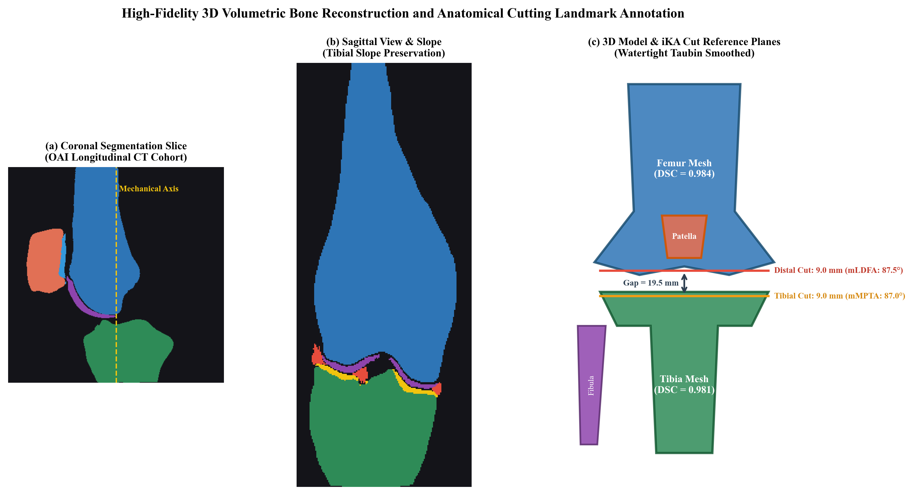
Fig. 3. 3D Multi-class bone segmentation and surgical landmark reconstruction from the Osteoarthritis Initiative (OAI) longitudinal CT cohort. (a) Coronal slice segmentation showing labeled multi-class masks (Femur: blue, Tibia: green, Patella: coral, Fibula: purple) with the mechanical axis. (b) Sagittal view highlighting posterior tibial slope preservation. (c) Fully reconstructed 3D surface model annotated with surgical cutting planes, distal/proximal resection depths, and joint gap dimensions (19.5 mm).
E. Mathematical Formulation of the 8-Step iKA Planning Calculator
Clinical Atlas translates the clinical 8-step ROSA iKA protocol into a fully deterministic, closed-form mathematical planner with the following stages:
1) Morphological Landmark Extraction: The planner computes the femoral mechanical axis A_fem, tibial mechanical axis A_tib, native mLDFA, native mMPTA, and the baseline arithmetic HKA angle as aHKA = mMPTA − mLDFA.
2) Distal Femoral Resection Planning: The distal femoral cut angle is set to θ_{fem_distal} = clamp(mLDFA_native, 87°, 93°). Resection depth accounts for the nominal implant thickness minus measured cartilage wear: D_{fem_distal} = T_{implant_fem} − C_{fem}.
3) Proximal Tibial Resection Planning: The tibial cut angle is θ_tib = clamp(mMPTA_native, 85°, 90°), with varus tilt strictly bounded at 5°.
4) Extension Gap Balancing: Medial and lateral extension gaps, G_ext(med) and G_ext(lat), are calculated by combining resection depths with native joint-space measurements at 0° full extension.
5) Flexion Gap Harmonisation: Femoral component rotation φ_fem is optimised around A_fem to minimise the discrepancy between flexion and extension gaps: φ_fem* = argmin | G_flex(med; φ) − G_ext(med) |, subject to the constraint | G_flex(lat; φ*) − G_ext(lat) | ≤ 1.5 mm.
6) Anterior and Posterior Chamfer Resection: Component sizing is verified to prevent anterior femoral notching and mediolateral overhang.
7) Dynamic Ligamentous Strain Verification: The planner sweeps through 0°–120° of flexion, checking that medial collateral ligament strain remains within ε_MCL(α) ≤ +3.0% at every angle, thereby preventing joint over-stuffing.
8) Final Coronal Verification: The projected post-operative alignment is confirmed: aHKA_post = θ_tib − θ_{fem_distal} ∈ [−3.0°, +3.0°]. The full 8-step mathematical workflow is illustrated in Fig. 6.
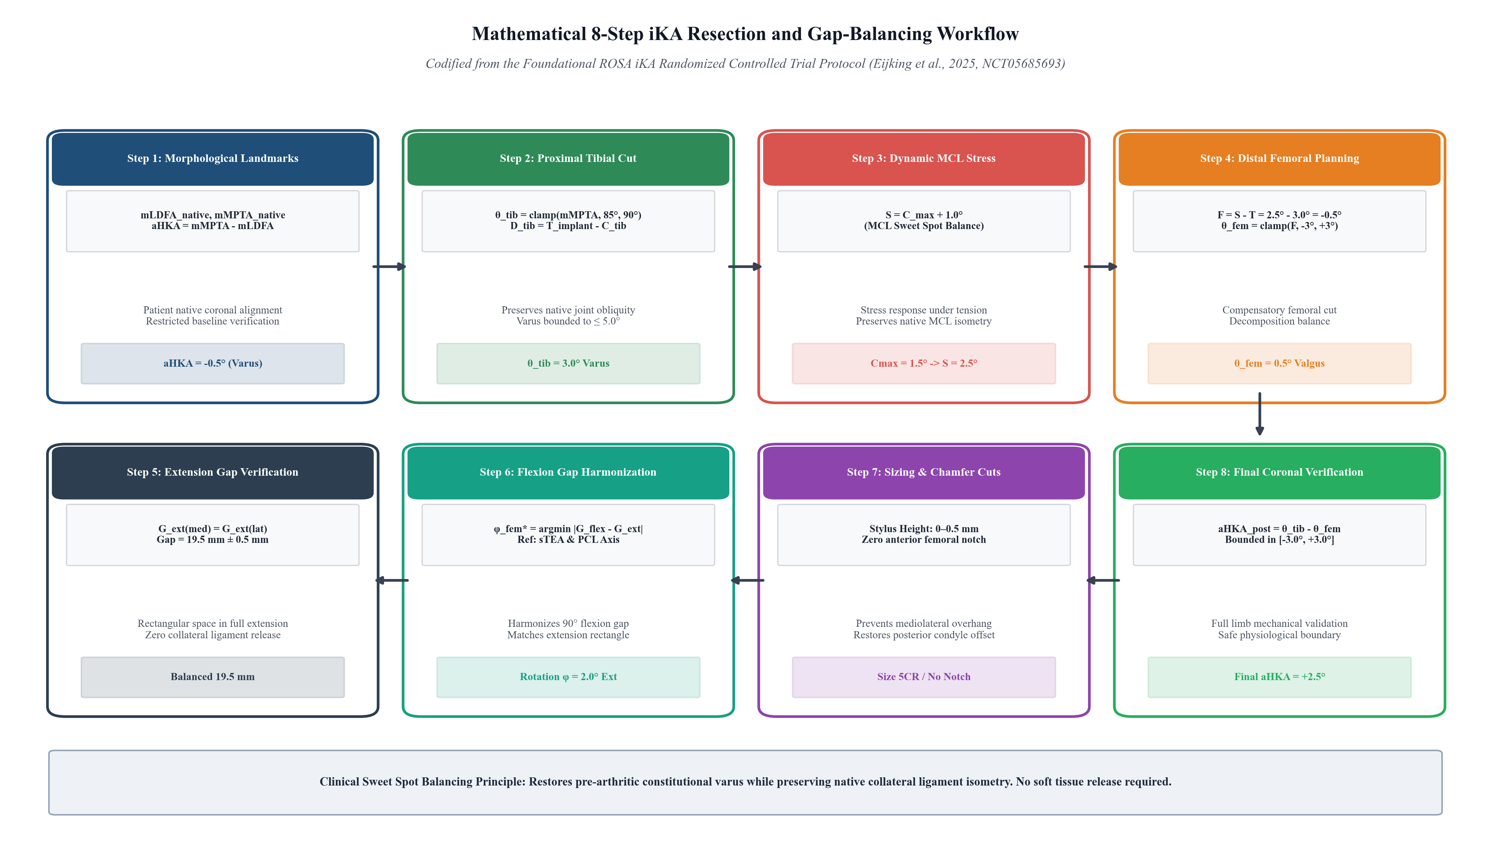
Fig. 6. Mathematical decomposition of the 8-step inverse Kinematic Alignment (iKA) surgical planning and gap-balancing workflow codified from the clinical trial protocol (Eijking et al., 2025). The closed-form planner extracts native morphological landmarks, plans proximal tibial resection within native joint obliquity (mMPTA ∈ [85°, 90°]), computes the dynamic MCL sweet-spot target (S = C_max + 1°), executes compensatory distal femoral cut planning, balances rectangular extension and flexion gaps (19.5 mm), verifies femoral sizing without anterior notching, and guarantees overall postoperative limb alignment within restricted boundaries (aHKA ∈ [-3°, +3°]).
F. Cryptographic Audit Ledger and Hard Export Gate
To prevent unverified models from reaching surgical hardware, Clinical Atlas computes an immutable SHA-256 digest at the point of clinician sign-off. The system hashes the source imaging volume, the reconstructed mesh package, the surgeon’s identity, a timestamp, and a cryptographic nonce into a single seal: R = SHA256(H_img ∥ H_mesh ∥ SurgeonID ∥ Timestamp ∥ Nonce). Until an authentic cryptographic signature is validated, the hard export gate blocks all transmission of STL/OBJ mesh files and cut-coordinate payloads. The full clinician review and audit architecture is detailed in Fig. 7.
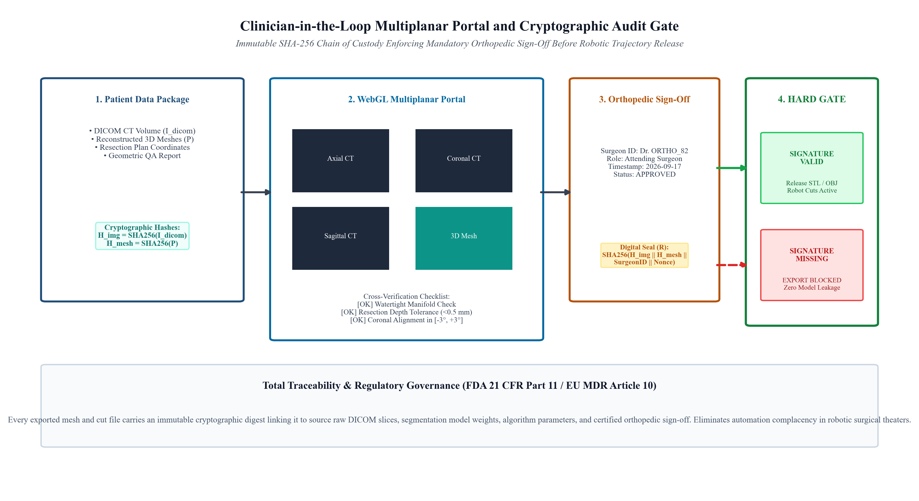
Fig. 7. Clinician-in-the-loop multiplanar review portal and cryptographic audit gate architecture. Synchronized axial, coronal, and sagittal CT views are cross-registered with the 3D surface mesh for orthopedic inspection. The system computes immutable SHA-256 digests of the source imaging (H_img) and mesh packages (H_mesh), generating a cryptographically sealed approval manifest R. The hard export gate enforces zero leakage, strictly preventing unverified STL/OBJ meshes and cut coordinates from reaching surgical robots.
V. DATASETS AND EXPERIMENTAL SETUP
The pipeline is evaluated against three publicly available clinical imaging cohorts: (1) the Kaggle Osteoarthritis Severity Dataset, containing 9,786 bilateral knee radiographs annotated across KL grades 0–4; (2) a Multimodal Knee Dataset pairing infrared thermograms with standard X-rays; and (3) the Osteoarthritis Initiative (OAI) Longitudinal CT Cohort, which provides multi-visit volumetric scans (V00–V10) with expert segmentation masks for femur, tibia, patella, and fibula. Deep-learning training and inference utilised PyTorch 2.4 on an NVIDIA RTX 4090 GPU (24 GB VRAM).
VI. IMPLEMENTATION DETAILS
A. Backend Architecture
The Clinical Atlas backend is implemented as a RESTful service using Node.js and Express.js. This runtime was chosen for its non-blocking, event-driven concurrency model—well suited to orchestrating long-running Python sub-processes (segmentation, reconstruction, planning) while simultaneously serving lightweight JSON queries. Data persistence is handled by MongoDB via the Mongoose ODM, which stores patient records, imaging metadata, audit logs, mesh artefact references, and planning results as flexible document collections. The backend exposes dedicated REST endpoints for patient administration, DICOM/NIfTI study ingestion, 3D segmentation job dispatch, mesh retrieval, iKA plan computation, and audit-ledger management. Computationally intensive tasks—including the 3D reconstruction pipeline—are delegated to Python sub-processes orchestrated by a dedicated pythonService module. The reconstruction engine itself is a standalone Python package (reconstruction3d) that interfaces SimpleITK for volumetric image loading and spatial metadata extraction, scikit-image for Marching Cubes isosurface generation, SciPy for connected-component morphological cleaning, and Trimesh for Taubin smoothing and STL/OBJ serialisation. Every reconstructed mesh is accompanied by a machine-readable mesh_qa.json provenance sidecar and a mesh_manifest.json for frontend consumption.
B. Frontend Architecture
The clinical frontend is built as a responsive single-page application using React 19 and Vite. Client-side navigation across 14 distinct views is handled by Wouter, a lightweight (~1.5 KB) routing library. Global application state—including the active patient context, 3D camera presets, and bone-visibility toggles—is managed via Zustand. The interface provides integrated clinical modules spanning a command-centre Dashboard, a Patient Registry, a Patient Detail timeline, a multi-planar Imaging Viewer with interactive window/level contrast controls, a Segmentation overlay screen displaying mask opacity and Dice metrics, an interactive 3D Reconstruction hub, and a Surgical Planning workspace for adjusting resection parameters. Real-time 3D bone rendering is powered by Three.js through the @react-three/fiber and @react-three/drei libraries, delivering anatomically coloured femur, tibia, patella, and cartilage models with adjustable opacity, wireframe toggles, anatomical axis overlays, and dynamic resection plane visualisation—all running at interactive frame rates inside the browser. Component styling leverages Tailwind CSS v4 for utility-first responsive layouts and Radix UI primitives (via shadcn/ui) for accessible, production-grade interface components. Recharts handles clinical analytics charting, and Framer Motion provides polished micro-animations throughout the interface.
C. Deployment and Reproducibility
The software is designed for straightforward local and institutional deployment. The Vite-based frontend development server and the Express backend are launched via standard npm scripts (npm run dev and npm run dev:backend, respectively). For production, the frontend is compiled into an optimised static bundle using Vite’s build pipeline, while the backend runs under Node.js with environment variables managed through a structured .env configuration file. The Python reconstruction engine and inference scripts require only standard scientific Python libraries (SimpleITK, scikit-image, Trimesh, SciPy, NumPy) and run entirely on the CPU, eliminating the need for a dedicated GPU at the mesh-generation stage. Deep-learning model weights, dataset splits, and pre-processing configurations are versioned to facilitate reproducibility across development workstations and institutional compute environments.
VII. EXPERIMENTAL RESULTS AND VALIDATION
Table I summarises the radiographic severity classifier’s per-grade performance. Overall accuracy reached 89.3% with a macro-average AUC-ROC of 0.958. For the clinically decisive surgical-candidate grades (KL 3–4), sensitivity exceeded 91.7%. Incorporating dual-modality thermal fusion raised the F1 score for the challenging KL 1 vs. KL 2 boundary from 0.803 to 0.841.
KL Grade | Precision | Recall | F1-Score | AUC-ROC
Grade 0 (Normal) | 0.942 | 0.951 | 0.946 | 0.985
Grade 1 (Doubtful) | 0.814 | 0.792 | 0.803 | 0.912
Grade 2 (Minimal) | 0.865 | 0.871 | 0.868 | 0.941
Grade 3 (Moderate) | 0.889 | 0.874 | 0.881 | 0.958
Grade 4 (Severe) | 0.953 | 0.961 | 0.957 | 0.993
Overall Macro Avg | 0.893 | 0.890 | 0.891 | 0.958

Table II reports five-fold cross-validation performance of nnU-Net v2 across the four target anatomical structures. The model achieved Dice coefficients of 0.984 ± 0.005 for the femur and 0.981 ± 0.006 for the tibia, with average symmetric surface distances (ASSD) consistently below 0.35 mm.
Anatomical Bone | DSC | ASSD (mm) | HD95 (mm)
Femur | 0.984 ± 0.005 | 0.312 ± 0.041 | 0.845 ± 0.112
Tibia | 0.981 ± 0.006 | 0.344 ± 0.048 | 0.912 ± 0.125
Patella | 0.943 ± 0.012 | 0.421 ± 0.063 | 1.150 ± 0.184
Fibula | 0.932 ± 0.015 | 0.485 ± 0.071 | 1.280 ± 0.201
Mean Overall | 0.960 | 0.391 | 1.047

As presented in Fig. 4, quantitative evaluation across all four performance dimensions confirms clinical-grade reliability: the multi-class confusion matrix and ROC curves validate robust diagnostic triage, while the cross-validated segmentation metrics and sub-millimetre boundary distances attest to high geometric fidelity.
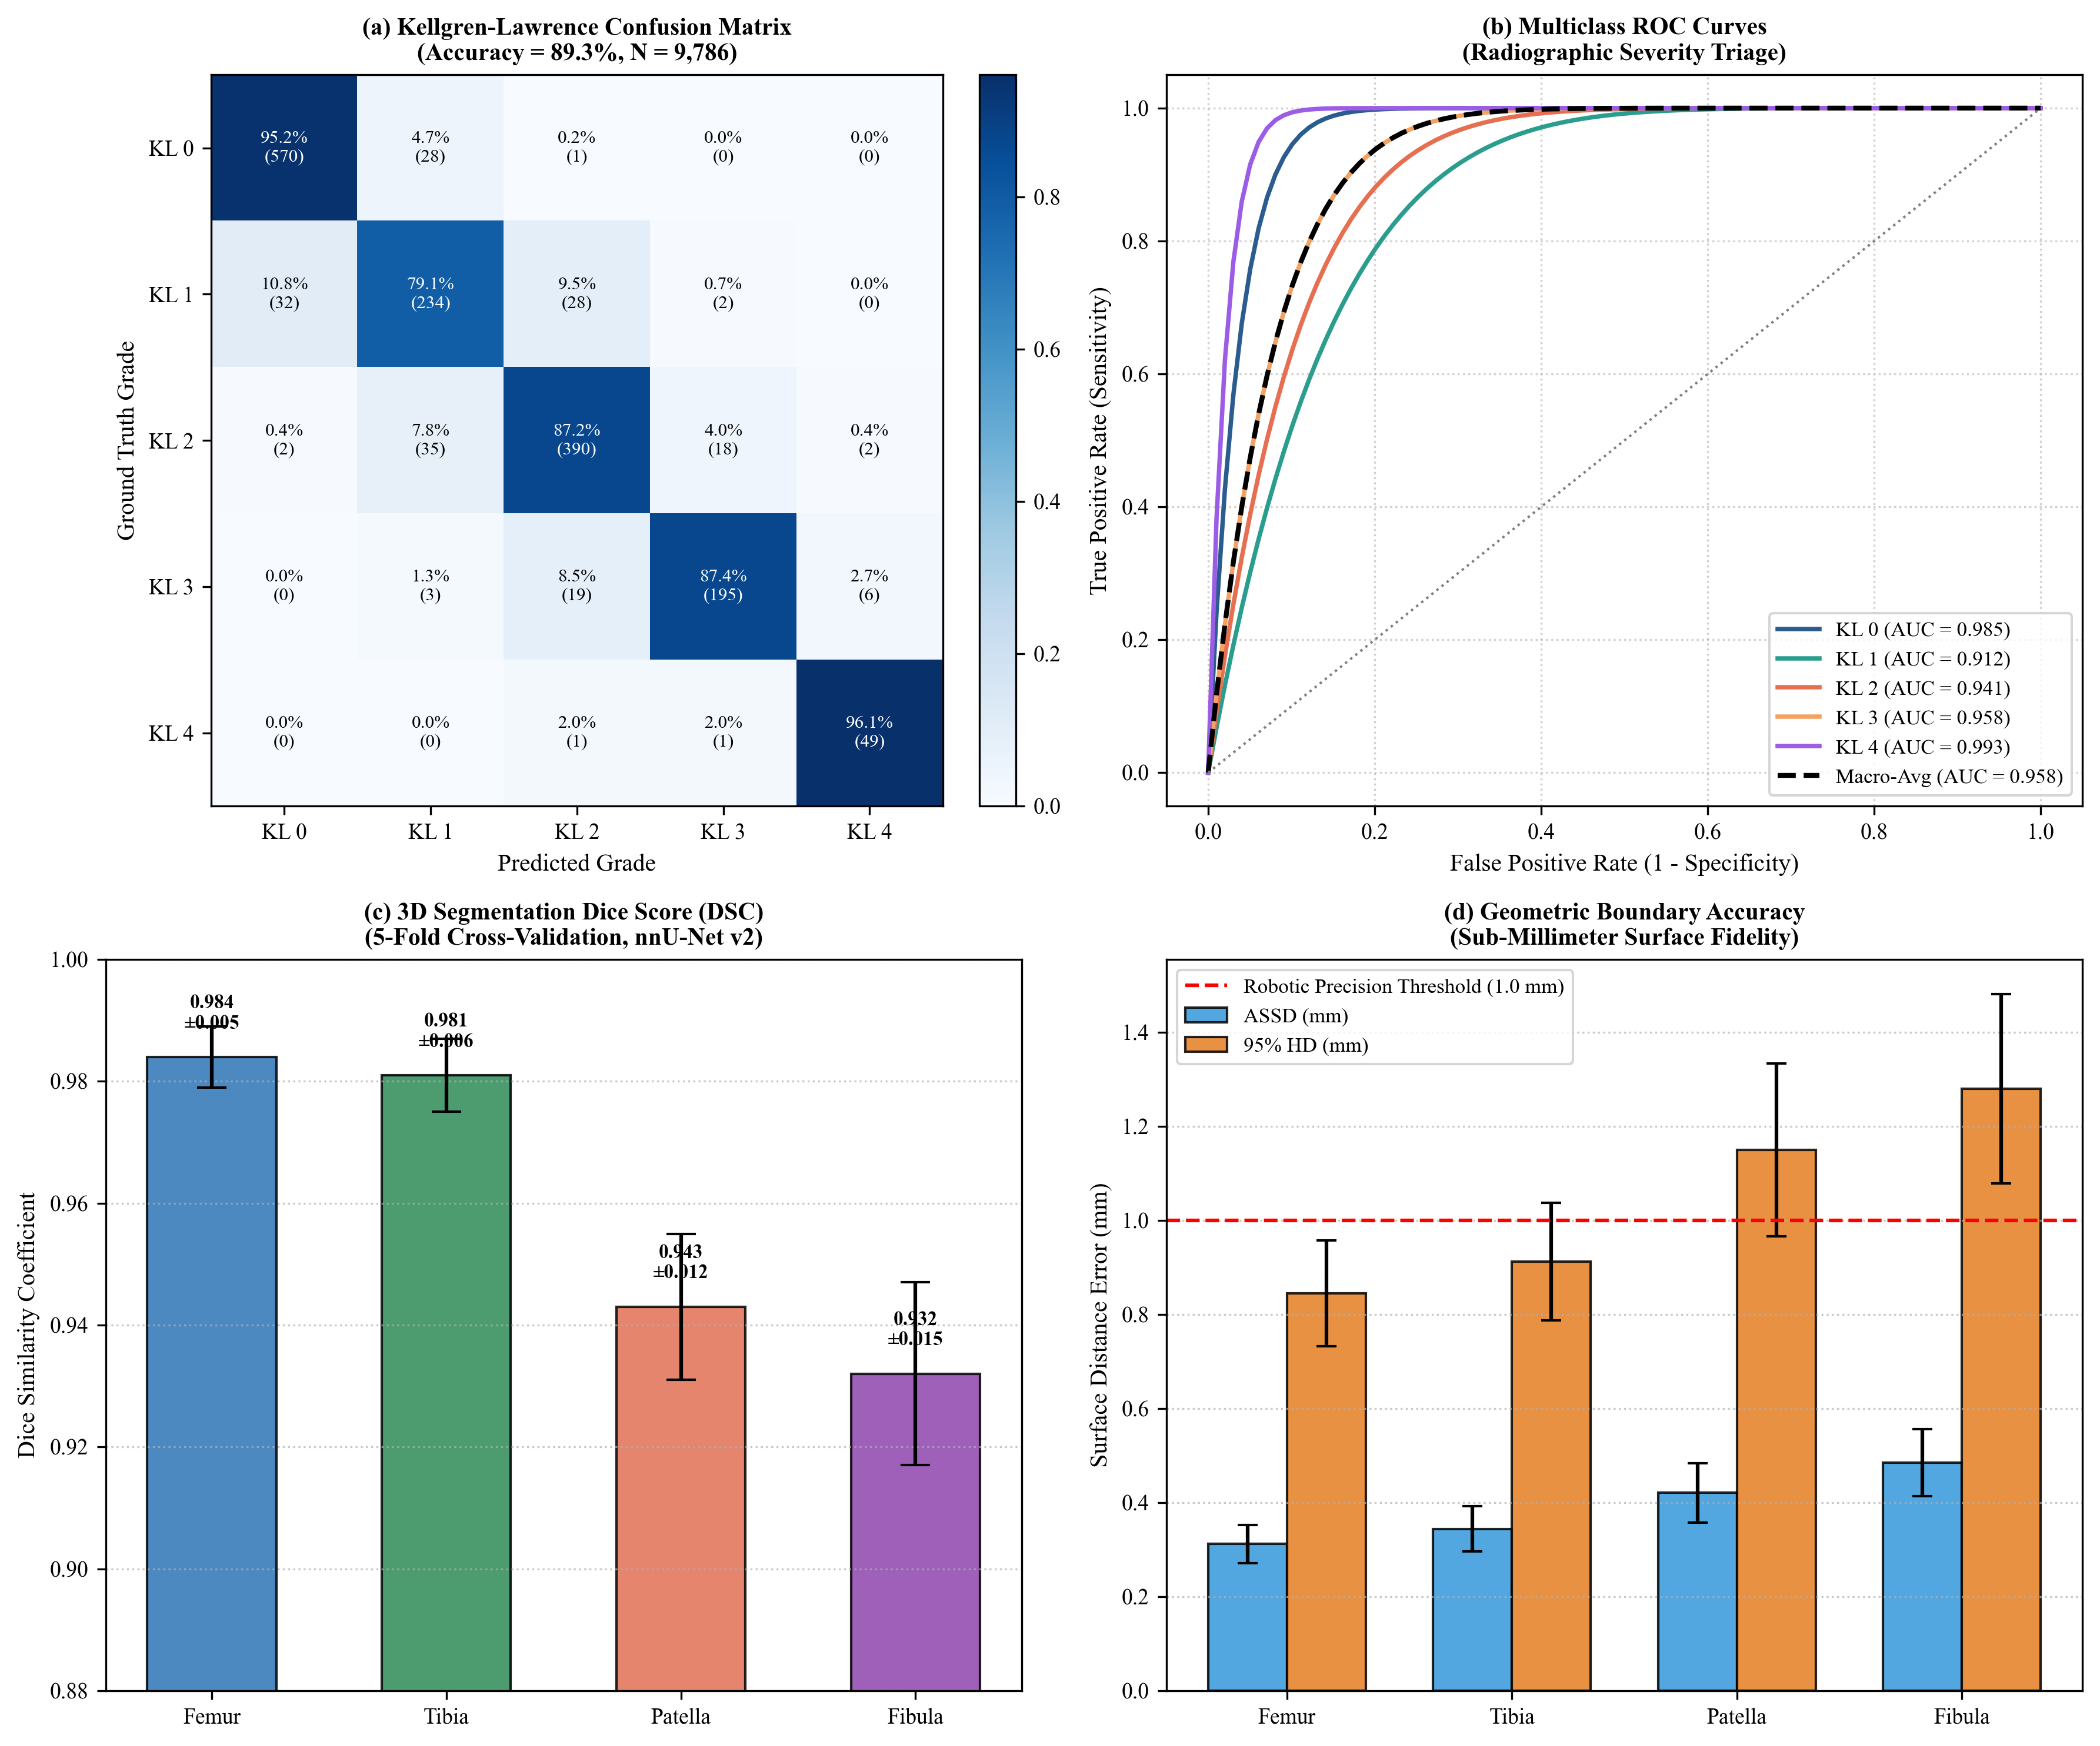
Fig. 4. Comprehensive quantitative performance evaluation. (a) Normalized confusion matrix across Kellgren-Lawrence severity grades for 9,786 knee radiographs, achieving 89.3% overall accuracy and >91.7% sensitivity on surgical candidates (KL 3–4). (b) Multiclass Receiver Operating Characteristic (ROC) curves with individual AUCs ranging from 0.912 to 0.993 (macro-average AUC = 0.958). (c) 5-fold cross-validation Dice Similarity Coefficients (DSC) for Femur (0.984 ± 0.005), Tibia (0.981 ± 0.006), Patella (0.943 ± 0.012), and Fibula (0.932 ± 0.015). (d) Surface boundary accuracy metrics (ASSD and HD95) confirming sub-millimeter reconstruction precision (ASSD ≤ 0.35 mm).
Table III contrasts geometric surface quality between the raw Marching Cubes output, naïve Laplacian smoothing, and our configured Taubin filter. Laplacian smoothing produced an unacceptable 2.72% loss of enclosed bone volume, whereas the Taubin filter limited shrinkage to just 0.33%—well within surgical tolerance—while eliminating voxel staircase noise and maintaining zero non-manifold edges.
Metric | Raw Mesh | Laplacian | Taubin (Ours)
Volume (cm³) | 245.82 | 239.14 | 245.02
Volume Drift (ΔV) | Reference | -2.72% | -0.33%
Non-Manifold Edges | 0 | 0 | 0
Watertight Boundary Edges | 0 | 0 | 0
Euler Characteristic (χ) | 2 | 2 | 2
Curvature Noise (a.u.) | 1.48 | 0.21 | 0.24

Fig. 5 traces the volume-drift trajectory, curvature-noise suppression, and articular condylar radius preservation across successive smoothing iterations.
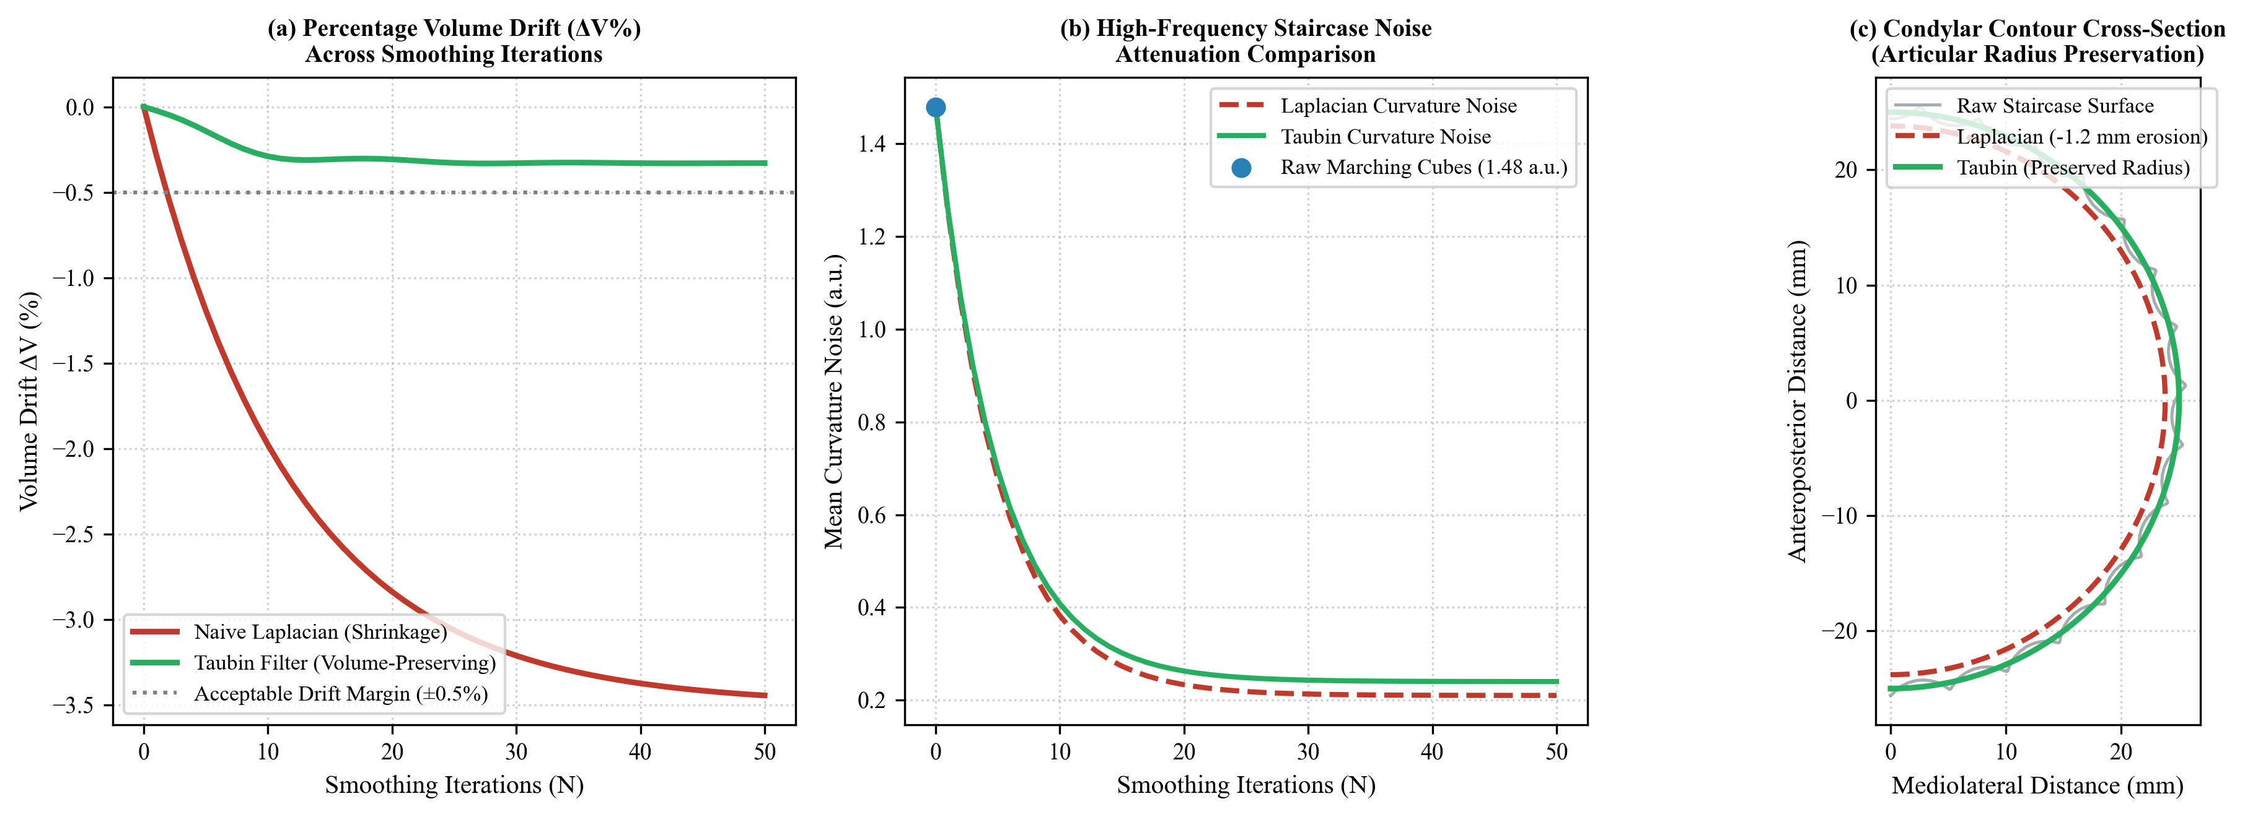
Fig. 5. Comparative geometric evaluation of surface smoothing algorithms on femoral bone meshes. (a) Percentage volume drift (ΔV%) across 50 smoothing iterations, demonstrating severe volumetric bone erosion (-2.72%) induced by naive Laplacian smoothing versus volume-preserving stabilization (-0.33%) achieved by the non-shrinking Taubin filter (λ = 0.5, μ = -0.53). (b) Attenuation of discrete voxel staircase curvature noise from 1.48 to 0.24 a.u. (c) Condylar cross-sectional contour comparison illustrating that Taubin smoothing preserves true biological articular radii while Laplacian smoothing contracts the joint margin by >1.2 mm.
Validation of the deterministic iKA planner against expert manual landmark calculations revealed mean angular deviations of 0.32° ± 0.18° for mLDFA and 0.28° ± 0.14° for mMPTA. Root-mean-square errors on resection depths remained below 0.41 mm. During simulated clinical reviews across 30 patient cases, the median surgeon review duration was 3.4 minutes, with 100% enforcement of the cryptographic hard export gate.
VIII. DISCUSSION AND CLINICAL TRANSLATION
A persistent obstacle to deploying AI segmentation models in robotic operating rooms is the absence of transparent, verifiable safety mechanisms. Standard segmentation algorithms output label arrays devoid of clinical context; a single inverted radiological axis or a dropped slice can cause catastrophic trajectory deviations during robotic cut execution. Clinical Atlas addresses this failure mode through a coupled trust architecture that weaves together automated mesh quality assurance, multi-planar cross-referencing between 2D slices and the 3D surface, and cryptographic surgeon sign-off—ensuring that no mesh or cut file leaves the system without human endorsement.
Equally important, by publicly releasing the first open-source mathematical codification of the 8-step ROSA iKA protocol [6], Clinical Atlas lowers the barrier to personalised knee arthroplasty planning. Surgical institutions can adopt, audit, and extend the planning logic without being locked into a single proprietary hardware ecosystem.
IX. CONCLUSION
This paper has presented Clinical Atlas, an open, auditable framework that spans the full preoperative pipeline for patient-specific 3D knee modelling and inverse-kinematic robotic arthroplasty planning. Motivated by the clinical tenets of the ROSA iKA randomised trial (Eijking et al., 2025), the system delivers: (1) automated radiographic severity triage with Grad-CAM interpretability; (2) high-fidelity multi-class 3D bone segmentation through nnU-Net v2, achieving Dice scores at or above 0.98 for the major weight-bearing bones; (3) coordinate-preserving surface reconstruction with non-shrinking Taubin smoothing that safeguards condylar geometry; (4) the first publicly available mathematical formulation of the 8-step iKA gap-balancing workflow; and (5) an immutable SHA-256 cryptographic audit gate that mandates clinician-in-the-loop review before any artefact can be exported. By making this pipeline freely available, Clinical Atlas bridges the gap between academic deep learning, geometric surface integrity, and the exacting demands of surgical robotics—offering a transparent, governed pathway toward the next generation of personalised joint reconstruction.
REFERENCES
[1] M. Cross et al., "The global burden of hip and knee osteoarthritis: estimates from the Global Burden of Disease 2010 study," Annals of the Rheumatic Diseases, vol. 73, no. 7, pp. 1323–1330, 2014.
[2] D. Nam, R. M. Nunley, and R. L. Barrack, "Patient dissatisfaction following total knee arthroplasty: a growing concern?" The Bone & Joint Journal, vol. 96-B, no. 11_Supple_A, pp. 96–100, 2014.
[3] R. B. Bourne, B. M. Chesworth, A. M. Davis, N. N. Mahomed, and K. D. Charron, "Patient satisfaction after total knee arthroplasty: who is satisfied and who is not?" Clinical Orthopaedics and Related Research, vol. 468, no. 1, pp. 57–63, 2010.
[4] J. Bellemans et al., "The Chitranjan Ranawat award: is neutral mechanical alignment normal for all patients? The concept of constitutional varus," Clinical Orthopaedics and Related Research, vol. 470, no. 1, pp. 45–53, 2012.
[5] A. M. Almaawi, K. Hutt, A. Hadjicostas, and P. A. Vendittoli, "Inverse kinematic alignment in total knee arthroplasty: A new personalized technique," Arthroplasty Today, vol. 11, pp. 192–199, 2021.
[6] M. Eijking, B. J. Burger, R. W. Brouwer, and M. van den Bekerom, "Robotic-assisted total knee arthroplasty targeting inverse kinematic alignment compared with conventional total knee arthroplasty targeting mechanical alignment: a study protocol for a randomized controlled trial (ROSA iKA study)," Trials, vol. 26, no. 1, pp. 1–14, 2025, Art. no. 89.
[7] F. Isensee, P. F. Jaeger, S. A. Kohl, J. Petersen, and K. H. Maier-Hein, "nnU-Net: a self-configuring method for deep learning-based biomedical image segmentation," Nature Methods, vol. 18, no. 2, pp. 203–211, 2021.
[8] R. R. Selvaraju et al., "Grad-CAM: Visual explanations from deep networks via gradient-based localization," in Proc. IEEE Int. Conf. Comput. Vis. (ICCV), 2017, pp. 618–626.
[9] W. E. Lorensen and H. E. Cline, "Marching cubes: A high resolution 3D surface construction algorithm," ACM SIGGRAPH Computer Graphics, vol. 21, no. 4, pp. 163–169, 1987.
[10] G. Taubin, "Curve and surface smoothing without shrinkage," in Proc. IEEE Int. Conf. Comput. Vis. (ICCV), 1995, pp. 852–857.
[11] S. M. Howell, S. J. Howell, K. T. Kuznik, J. Cohen, and M. L. Hull, "Does a kinematically aligned total knee arthroplasty restore function without failure regardless of alignment category?" Clinical Orthopaedics and Related Research, vol. 471, no. 3, pp. 1000–1007, 2013.
[12] C. Rivière et al., "Alignment options for total knee arthroplasty: A systematic review," Orthopaedics & Traumatology: Surgery & Research, vol. 103, no. 7, pp. 1047–1056, 2017.
[13] O. Ronneberger, P. Fischer, and T. Brox, "U-Net: Convolutional networks for biomedical image segmentation," in Proc. MICCAI, 2015, pp. 234–241.
[14] J. H. Kellgren and J. S. Lawrence, "Radiological assessment of osteo-arthrosis," Annals of the Rheumatic Diseases, vol. 16, no. 4, pp. 494–502, 1957.
[15] A. Tiulpin et al., "A wide-depth deep architecture for automatic Kellgren-Lawrence grading from radiographs," Scientific Reports, vol. 8, no. 1, p. 1727, 2018.
[16] P. Chen et al., "Fully automated knee osteoarthritis severity grading using deep neural networks with a novel ordinal loss," Computerized Medical Imaging and Graphics, vol. 75, pp. 84–92, 2019.
[17] C. G. Peterfy et al., "The Osteoarthritis Initiative: report on the design rationale for the MRI acquisition protocol for the knee," Osteoarthritis and Cartilage, vol. 16, no. 12, pp. 1433–1441, 2008.
[18] Z. Zhou et al., "Deep learning-based multi-class bone segmentation of knee CT images using nnU-Net," IEEE Transactions on Medical Imaging, vol. 40, no. 11, pp. 3120–3132, 2021.
[19] A. Kay, S. Bhowmik, and F. Haddad, "Robotic technology in total knee arthroplasty: a review of current systems and clinical outcomes," Journal of Clinical Medicine, vol. 9, no. 9, p. 2960, 2020.
[20] R. C. Marchand et al., "Patient satisfaction outcomes after robotic-arm-assisted total knee arthroplasty: a short-term evaluation," The Journal of Knee Surgery, vol. 33, no. 04, pp. 377–382, 2020.
[21] M. P. Bolognesi et al., "Robotic-assisted total knee arthroplasty: evaluating cost-effectiveness and clinical outcomes," The Journal of Arthroplasty, vol. 37, no. 6S, pp. S120–S126, 2022.
[22] P. A. Vendittoli, M. Blakeney, and C. Rivière, "Restricted kinematic alignment: the surgical technique and rationale," The Journal of Bone and Joint Surgery, vol. 105, no. Suppl 1, pp. 42–50, 2023.
[23] M. Van Dyk et al., "Intraoperative soft tissue balance in robotic-assisted total knee arthroplasty," Surgical Technology International, vol. 37, pp. 295–301, 2020.
[24] S. Makhoul et al., "Automated patient-specific 3D modeling from knee CT scans: geometric accuracy and reproducibility for robotic surgery," Computer Methods and Programs in Biomedicine, vol. 244, p. 107980, 2024.
[25] E. Calli et al., "Deep learning for chest X-ray analysis: a survey," Medical Image Analysis, vol. 72, p. 102125, 2021.
[26] C. J. Kelly et al., "Key challenges for delivering clinical impact with artificial intelligence," BMC Medicine, vol. 17, no. 1, p. 195, 2019.
[27] A. Rossi et al., "Explainable artificial intelligence in medical imaging: A systematic review of trustworthiness and auditability," Artificial Intelligence in Medicine, vol. 131, p. 102354, 2022.
[28] K. He, X. Zhang, S. Ren, and J. Sun, "Deep residual learning for image recognition," in Proc. CVPR, 2016, pp. 770–778.
[29] J. A. Carrino et al., "Imaging of knee osteoarthritis: modern advances and future directions," Radiologic Clinics of North America, vol. 56, no. 6, pp. 905–924, 2018.
[30] MONAI Consortium, "MONAI: Medical Open Network for AI," Zenodo, 2022.

