//------ data from software

machine number

machine name

worker name

buzzer (command from web to device)

buzz ack (acknowledgement from device if buzzer is working)

design_no (manually entered by user like ‘worker assignment’ )

//-----------data from device

shift

stich

thred break

head

rpm

max_rpm (calculate it from rpm in mediator file)

total_stop_time

//------ data from software or by mediator

last_stop_time (calculate it from rpm in mediator file)

as per criteria set by user for highlighting machine with last_stop_time > stoppage time limit……. Show something like

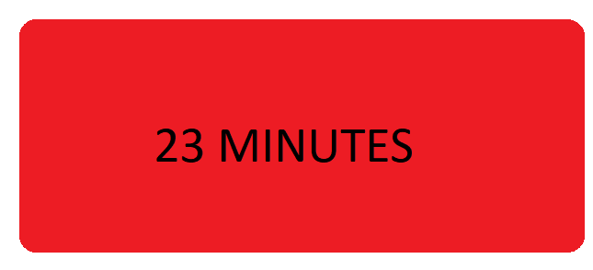

last_data_received_time (i.e. time stamp at which data received for respective machine)

if (last_data_received_time -current_server_time ) < 1 minute

then show "sync symbol with green like



or text "NOW"

else if (last_data_received_time -current_server_time ) > 1 minute and <15 minute

then text minute:seconds

else

time stamp of last data

commands to device

1. Live (device will upload data fast if web software is running on any pc or app)
2. Alert_sec (for siren to make sound for given time )

Alert_0 (for siren on till button pressed on web or app)

1. Sft_rst_1 (for resetting device data and changing shift)
2. Sft_rst_2 (for resetting device data and changing shift)

------------------------------------------------------------

1. Sft_1 (for resetting device data and changing shift)
2. Sft_2 (for resetting device data and changing shift)
3. rst_1 (for resetting device data and changing shift)
4. rst_2 (for resetting device data and changing shift)
5. cnt_stop (stop counting)

Query

-in live if I sends data for m1 row insert in live ?

- how I can calibrate head,rpm etc ?