LINUX

LINUX is an operating system or a kernel distributed under an open-source license. Its functionality list is quite like UNIX. The kernel is a program at the heart of the Linux operating system that takes care of fundamental stuff, like letting hardware communicate with software.

Linux is an operating system or a kernel which germinated as an idea in the mind of young and bright **Linus Torvalds** when he was a computer science student. He used to work on the **UNIX OS (proprietary software)**and thought that it needed improvements.

UNIX is called the mother of operating systems which laid out the foundation to Linux. Unix is designed mainly for mainframes and is in enterprises and universities. While Linux is fast becoming a household name for computer users, developers, and server environment. You may have to pay for a Unix kernel while in Linux it is free.

But the**commands used on both the operating systems are usually the same.** There is not much [difference between UNIX and Linux](https://www.guru99.com/difference-unix-vs-linux.html). Though they might seem different, at the core, they are essentially the same. Since **Linux is a clone of UNIX.**

History of Linux**:**

So, **Linus devised a Kernel** named Linux in 1991. Though he would need programs like File Manager, Document Editors, Audio -Video programs to run on it. Something as you have a cone but no ice-cream on top.

As time passed by, he collaborated with other **programmers in places like MIT** and applications for Linux started to appear. So around 1991, a working Linux operating system with some applications was officially launched, and this was the start of one of the **most loved and open-source OS options available today**.

The earlier versions of Linux OS were not so user-friendly as they were in use by computer programmers and **Linus Torvalds never had it in mind to commercialize** his product.

The main advantage of Linux was that programmers were able to use the Linux Kernel to design their own custom operating systems. With time, a new range of user-friendly OS’s stormed the computer world. Now, **Linux is one of the most popular and widely used Kernel,**and it is the backbone of popular operating systems like **Debian, Knoppix, Ubuntu, and Fedora**.

Linux OS now enjoys popularity at its prime, and it’s famous among programmers as well as regular computer users around the world. Its main benefits are –

Benefits of LINUX:

* It offers a free operating system. You do not have to shell hundreds of dollars to get the OS like Windows!
* Being open-source, anyone with programming knowledge can modify it.
* The Linux operating systems now offer millions of programs/applications and Linux software’s to choose from, most of them are free!
* Once you have Linux installed you no longer need an antivirus! Linux is a highly secure system. More so, there is a global development community constantly looking at ways to enhance its security. With each upgrade, the OS becomes more secure and robust
* Linux freeware is the OS of choice for Server environments due to its stability and reliability (Mega-companies like Amazon, Facebook, and Google use Linux for their Servers). A Linux based server could run non-stop without a reboot for years on end.

LINUX Distributions:

* **Linux is open-source, free to use kernel**. It is used by programmers, organizations, profit, and non-profit companies around the world to **create Operating systems to suit their individual requirements**.
* To prevent hacking attempts, many organizations keep their Linux operating systems private.
* Many others make their variations of Linux available publicly so the whole world can benefit at large.
* These versions/ types /kinds of **Linux operating system are called Distributions**.

How many distributions are out there?



There are**hundreds of Linux operating systems or Distributions**available these days. Many of them are designed with a specific purpose in mind. For example, to run a**web server or to run on network switches like routers, modems,**etc**.**

The latest example of one of the most popular smartphone-based**Linux Distribution is Android!**

Many of these Distributions are built to offer**excellent personal computing.**

Windows Vs. Linux File System

When we compare file system in Windows and Linux, in Microsoft Windows, files are stored in folders on different data drives like C: D: E:

**Linux, files are ordered in a tree structure starting with the root directory**.

This root directory can be considered as the start of the file system, and it further branches out various other subdirectories. The root is denoted with a forward slash ‘/’

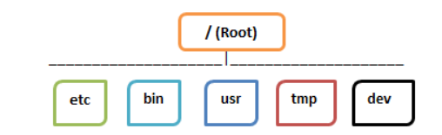

Key Difference:

* Linux is an open source operating system so user can change source code as per requirement whereas Windows OS is a commercial operating system so user doesn’t have access to source code.
* Linux is very well secure as it is easy to detect bugs and fix whereas Windows has a huge user base, so it becomes a target of hackers to attack windows system.
* Comparing Windows file system vs Linux file system, Linux runs faster even with older hardware whereas Windows are slower compared to Linux.
* Linux peripherals like hard drives, CD-ROMs, printers are considered files whereas Windows, hard drives, CD-ROMs, printers are considered as devices
* Linux files are ordered in a tree structure starting with the root directory whereas in Windows, files are stored in folders on different data drives like C: D: E:
* In Linux you can have 2 files with the same name in the same directory while in Windows, you cannot have 2 files with the same name in the same folder.
* In Linux you would find the system and program files in different directories whereas in Windows, system and program files are usually saved in C: drive.

**Windows Vs. Linux: Users**

There are 3 types of users in Linux.

* Regular
* Administrative(root)
* Service

Regular User

A regular user account is created for you when you install Ubuntu on your system. All your files and folders are stored in /home/ which is your home directory. As a regular user, you do not have access to directories of other users.

Root User

Other than your regular account another user account called root is created at the time of installation. The root account is a **superuser** who can access restricted files, install software and has administrative privileges. Whenever you want to install software, make changes to system files, or perform any administrative task on Linux; you need to log in as a root user. Otherwise, for general tasks like playing music and browsing the internet, you can use your regular account.

Service user

Linux is widely used as a Server Operating System. Services such as Apache, Squid, email, etc. have their own individual service accounts. Having service accounts increases the security of your computer. Linux can allow or deny access to various resources depending on the service.

Note:

1. You will not see service accounts in Ubuntu Desktop version.
2. Regular accounts are called standard accounts in Ubuntu Desktop

In Windows, there are 4 types of user account types.

1. Administrator
2. Standard
3. Child
4. Guest

Windows Vs. Linux: File Name Convention:

In Windows, you cannot have 2 files with the same name in the same folder.

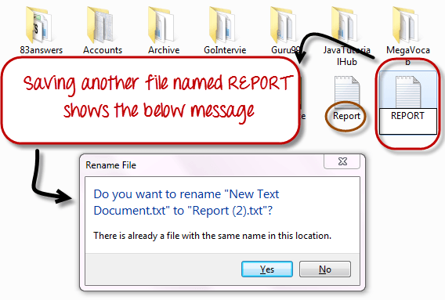

While in Linux, you can have 2 files with the same name in the same directory, provided they use different cases.

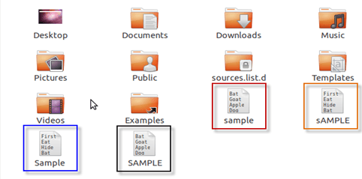

Windows Vs. Linux: HOME Directory

For every user in Linux, a directory is created as**/home/**

Consider, a regular user account “Tom”. He can store his personal files and directories in the directory “/home/tom”. He can’t save files outside his user directory and does not have access to directories of other users. For instance, he cannot access directory “/home/jerry” of another user account ”Jerry”.

The concept is similar to C:\Documents and Settings in Windows.

When you boot the Linux operating system, your user directory (from the above example /home/tom) is the **default working directory**. Hence the directory “/home/tom is also called the **Home directory** which is a misnomer.

The working directory can be changed using some commands which we will learn later.

Windows Vs. Linux: Other Directories>

Comparing Windows vs Linux for other directories, in Windows, System and Program files are usually saved in C: drive. But, in Linux, you would find the system and program files in different directories. For example, the boot files are stored in the /boot directory, and program and software files can be found under /bin, device files in /dev. Below are important Linux Directories and a short description of what they contain.

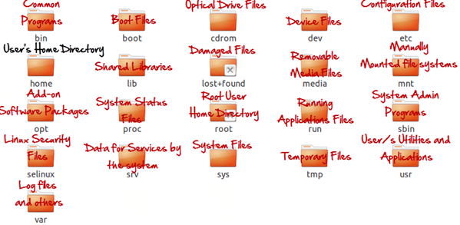

These are most striking differences between Linux and other Operating Systems. There are more variations you will observe when switching to Linux and we will discuss them as we move along in our tutorials.

Windows Vs. Linux:

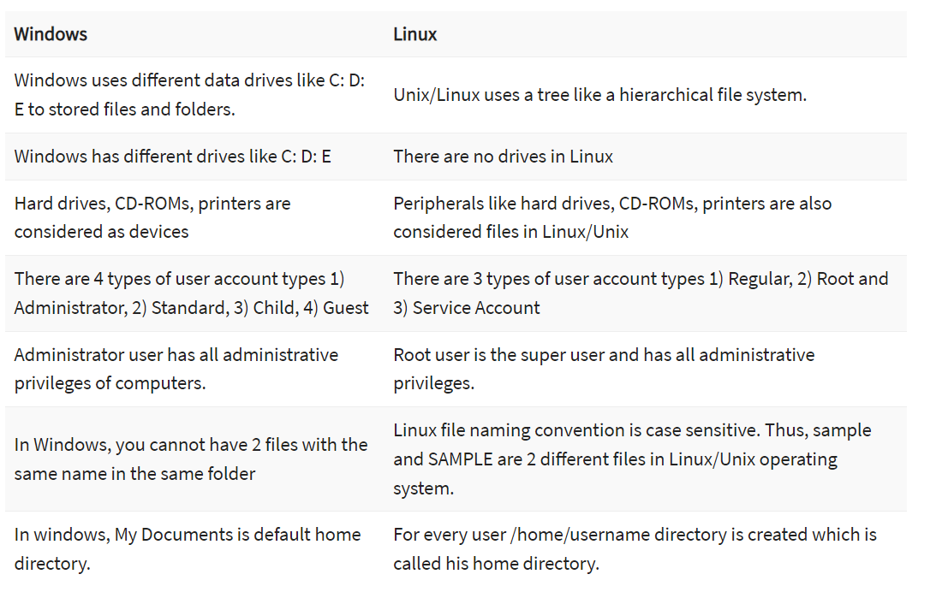

CLI:

* Commands offer more options & are flexible. Piping and stdin/stdout are immensely powerful are not available in GUI
* Some configurations in GUI are up to 5 screens deep while in a CLI it’s just a single command
* Moving, renaming 1000’s of the file in GUI will be time-consuming (Using Control /Shift to select multiple files), while in CLI, using regular expressions so can do the same task with a single command.
* CLI load fast and do not consume RAM compared to GUI. In crunch scenarios this matters.
* Both GUI and CLI have their specific uses. For example, in GUI, performance monitoring graphs give instant visual feedback on system health.

Launching the CLI on Ubuntu:

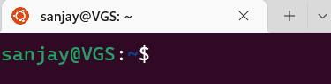

Separator: “ : “

Username: Sanjay

Computer name: VGS

Represents regular user: $

Home directory: ~

1) The first part of this line is the name of the **user** (bob, tom, ubuntu, home…)

2) The second part is the computer name or the host name. The hostname helps identify a computer over the network. In a server environment, host-name becomes important.

3) The **‘:’** is a simple separator

4) The tilde ‘~’ sign shows that the user in working in the **home directory**. If you change the directory, this sign will vanish.

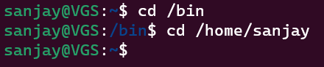

In the above illustration, we have moved from the /home directory to /bin using the **‘cd’ command**. The ~ sign does not display while working in /bin directory. It appears while moving back to the home directory.

5) The ‘$’ sign suggests that you are working as a regular user in Linux. While working as a root user, ‘#’ is displayed.



uname -a # Display Linux system information

uname -r # Display kernel release information

cat /etc/redhat-release # Show which version of redhat installed

uptime # Show how long the system has been

running + load

hostname # Show system host name

hostname -I # Display the IP addresses of the host last

reboot # Show system reboot history

date # Show the current date and time

cal # Show this month's calendar

w # Display who is online

whoami # Who you are logged in as

ls -al # List all files in a long listing (detailed) format

pwd # Display the present working directory

mkdir directory # Create a directory

rm file # Remove (delete) file

rm -r directory # Remove the directory and its contents recursively

rm -f file # Force removal of file without prompting for confirmation

rm -rf directory # Forcefully remove directory recursively

cp file1 file2 # Copy file1 to file2

cp -r source_directory destination # Copy source_directory recursively to

destination. If destination exists, copy

source_directory into destination,

otherwise create destination with the

contents of source_directory.

mv file1 file2 # Rename or move file1 to file2. If file2

is an existing directory, move file1 into

directory file2

ln -s /path/to/file linkname # Create symbolic link to linkname

touch file # Create an empty file or update the access and modification times of file.

cat file # View the contents of file

ps # Display your currently running processes

cd .. # To go up one level of the directory tree.

(Change into the parent directory.)

cd # Go to the $HOME directory

cd /etc # Change to the /etc directory

CHMOD:

A Unix/Linux command

Change Mode

Changes permissions of a given file

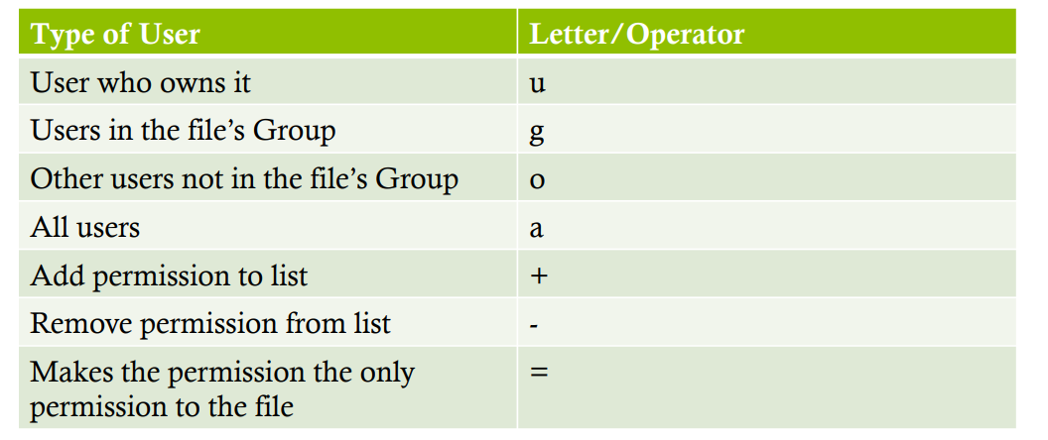

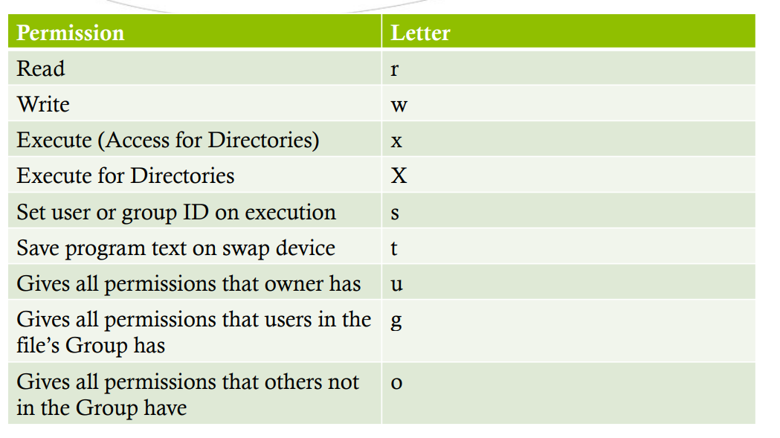

First digit (Optional)- attributes for set user ID (4), group ID (2), and save text image/sticky flags (1)

Second digit- sets permissions for the owner of the file: Read (4), Write (2), and Execute (1)

Third digit- sets permissions for users in the file’s group: Read (4), Write (2), and Execute (1)

Fourth digit- sets permissions for users NOT in the file’s group: Read (4), Write (2), and Execute (1)

Add the digits up if there are multiple permissions for a single user

Ex: To put permissions on a file to read, write, and execute, you add up the numbers– read=4, write=2, execute=1. 4+2+1=7, so you type the number 7.

Type 0’s to remove permissions

**Shell Scripting**:

**Shell Scripting**is an open-source computer program designed to be run by the Unix/Linux shell. Shell Scripting is a program to write a series of commands for the shell to execute. It can combine lengthy and repetitive sequences of commands into a single and simple script that can be stored and executed anytime which, reduces programming efforts.

**What is Shell?**

Shell is a UNIX term for an interface between a user and an operating system service. Shell provides users with an interface and accepts human-readable commands into the system and executes those commands which can run automatically and give the program’s output in a shell script.

An Operating is made of many components, but its two prime components are –

* Kernel
* Shell

User

Terminal

Kernel operating

System shell

Hardware

Components of Shell Program

A Kernel is at the nucleus of a computer. It makes the communication between the hardware and software possible. While the Kernel is the innermost part of an operating system, a shell is the outermost one.

A shell in a Linux operating system takes input from you in the form of commands, processes it, and then gives an output. It is the interface through which a user works on the programs, commands, and scripts. A shell is accessed by a terminal which runs it.

When you run the terminal, the Shell issues **a command prompt (usually $),** where you can type your input, which is then executed when you hit the Enter key. The output or the result is thereafter displayed on the terminal.

The Shell wraps around the delicate interior of an Operating system protecting it from accidental damage. Hence the name **Shell**.

**Types of Shell:**

There are two main shells in Linux:

**1**. The **Bourne Shell**: The prompt for this shell is $ and its derivatives are listed below:

* POSIX shell also is known as sh
* Korn Shell also knew as sh
* **B**ourne **A**gain **SH**ell also knew as bash (most popular)

**2.** **The C shell**: The prompt for this shell is %, and its subcategories are:

* C shell also is known as csh
* Tops C shell also is known as tcsh

**How to Write Shell Script in Linux/Unix:**

**Shell Scripts** are written using text editors. On your Linux system, open a text editor program, open a new file to begin typing a shell script or shell programming, then give the shell permission to execute your shell script and put your script at the location from where the shell can find it.

Let us understand the steps in creating a Shell Script:

1. **Create a file** **using** a **vi** editor(or any other editor). Name script file with **extension .sh**
2. **Start** the script with **#! /bin/sh**
3. Write some code.
4. Save the script file as filename.sh
5. For **executing** the script type **bash filename.sh**

“#!” is an operator called shebang which directs the script to the interpreter location. So, if we use”#! /bin/sh” the script gets directed to the bourne-shell.

Let’s create a small script –

#! /bin/bash

date

echo “hello world”

**CRONTAB IN LINUX:**

Cron is named after Greek word “Chronos” that is used for time. It is a system process that will automatically perform tasks as per the specific schedule. It is a set of commands that are used for running regular scheduling tasks. Crontab stands for “cron table”. It allows to use job scheduler, which is known as cron to execute tasks.

Crontab is also the name of the program, which is used to edit that schedule. It is driven by a crontab file, a config file that indicates shell commands to run periodically for the specific schedule.

**Linux Crontab format:**

Crontab of Linux has six fields. The first five fields define the time and date of execution, and the 6’th field is used for command execution.

Crontab syntax:

[Minute] [hour]

[Day_of_the_Month]

[Month_of_the_Year]

[Day_of_the_Week]

[command]

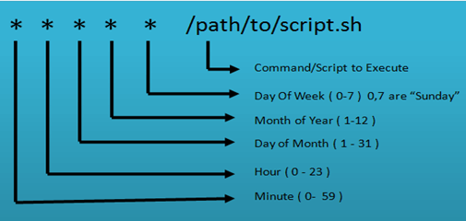

* **Astrics (*):** Use for matching
* **Define range:** Allows you to define a range with the help of hyphen like 1-10 or 30-40 or jan-mar, mon-wed.
* **Define multiple ranges:** Allows you to define various ranges with command separated like apr-jun,oct-dec.

**What is the VI editor:**

The VI editor is the most popular and classic text editor in the Linux family. Below, are some reasons which make it a widely used editor –

1) It is available in almost all Linux Distributions

2) It works the same across different platforms and Distributions

3) It is user-friendly. Hence, millions of Linux users love it and use it for their editing needs

Nowadays, there are advanced versions of the vi editor available, and the most popular one is **VIM**which is **V**i **Im**proved. Some of the other ones are Elvis, Nano, and Vile. It is wise to learn vi because it is feature-rich and offers endless possibilities to edit a file.

**VI Editing commands:**

* i – Insert at cursor (goes into insert mode)
* a – Write after cursor (goes into insert mode)
* A – Write at the end of line (goes into insert mode)
* ESC – Terminate insert mode
* u – Undo last change
* U – Undo all changes to the entire line
* o – Open a new line (goes into insert mode)
* dd – Delete line
* 3dd – Delete 3 lines.
* D – Delete contents of line after the cursor
* C – Delete contents of a line after the cursor and insert new text. Press ESC key to end insertion.
* dw – Delete word
* 4dw – Delete 4 words
* cw – Change word
* x – Delete character at the cursor
* r – Replace character
* R – Overwrite characters from cursor onward
* s – Substitute one character under cursor continue to insert
* S – Substitute entire line and begin to insert at the beginning of the line
* ~ – Change case of individual character

**Moving within a file**

* k – Move cursor up
* j – Move cursor down
* h – Move cursor left
* l – Move cursor right

You need to be in the command mode to move within a file. The default keys for navigation are mentioned below else; You can **also use the arrow keys on the keyboard**.

**Saving and closing the file**

* Shift+zz – Save the file and quit
* :w – Save the file but keep it open
* :q! – Quit vi and do not save changes
* :wq – Save the file and quit

You should be in the **command mode to exit the editor and save changes** to the file.