**Manual for LTE BandLocking in Samsung Device**

1. Run DiagAppf application in adb shell having root permission as shown below



2. Select 1 for Samsung

3. Select 3 for LTE

Here user will see new options with numbering 10th for to set band frequency and 11th for to read band frequency.

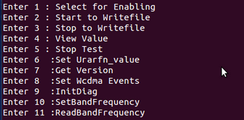

4. Now select 10

Enter value of frequency band which you want to lock in device for this you can refer interfaceapi.h file form /DMLibrary/jni/include/ directory

For Eg. Enter ‘8 ‘for Locking *E_UTRA_OPERATING_BAND_4*



If Nv written successfully then output will be as shown below

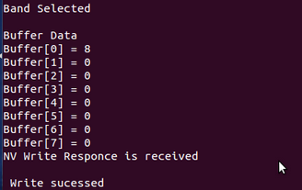

5. Now select 11 To Read Band Frequency written in previous step and output is



Now user can exit from application