
EX NO: 6 C | Interaction with the File System in Node.js
DATE:23.07.26
AIM:
To develop and execute a simple Node.js application that accepts user input and performs a basic operation.
Steps To Process:
Step 1: Create a Project Folder
•Create a new folder named SimpleNodeApp.
•Open the folder in Visual Studio Code.
Step 2: Create a JavaScript File
•Create a file named app.js.
Step 3: Write the Program
•Import the built-in readline module.
•Create an interface to accept user input.
•Prompt the user to enter their name.
•Display a welcome message using the entered input.
Step 4: Execute the Program
•Open the terminal.
•Navigate to the project folder.
•Run the application using Node.js.
Step 5: Verify the Output
•Enter a name when prompted.
•Observe the personalized greeting displayed in the terminal.

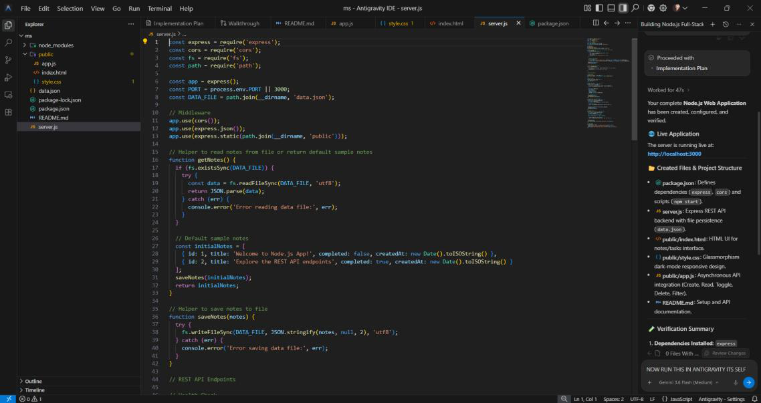
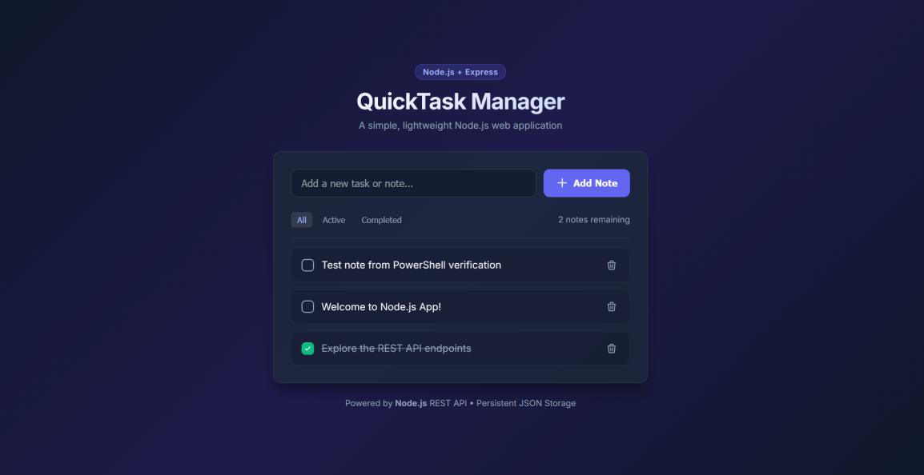

CODE:
Output:
RESULT:
A basic Node.js application was created using the built-in readline module. The program successfully

