EX NO: 6 C | Interaction with the File System in Node.js
DATE: 23.07.26

AIM:
To develop and execute a simple Node.js application that accepts user input and performs a basic
operation.
Steps To Process:

Step 1: Create a Project Folder
• Create a new folder named SimpleNodeApp.
• Open the folder in Visual Studio Code.
Step 2: Create a JavaScript File
• Create a file named app.js.
Step 3: Write the Program
• Import the built-in readline module.
• Create an interface to accept user input.
• Prompt the user to enter their name.
• Display a welcome message using the entered input.
Step 4: Execute the Program
• Open the terminal.
• Navigate to the project folder.
• Run the application using Node.js.
Step 5: Verify the Output
• Enter a name when prompted.
• Observe the personalized greeting displayed in the terminal.
SANJAY S 71812401216

CODE:
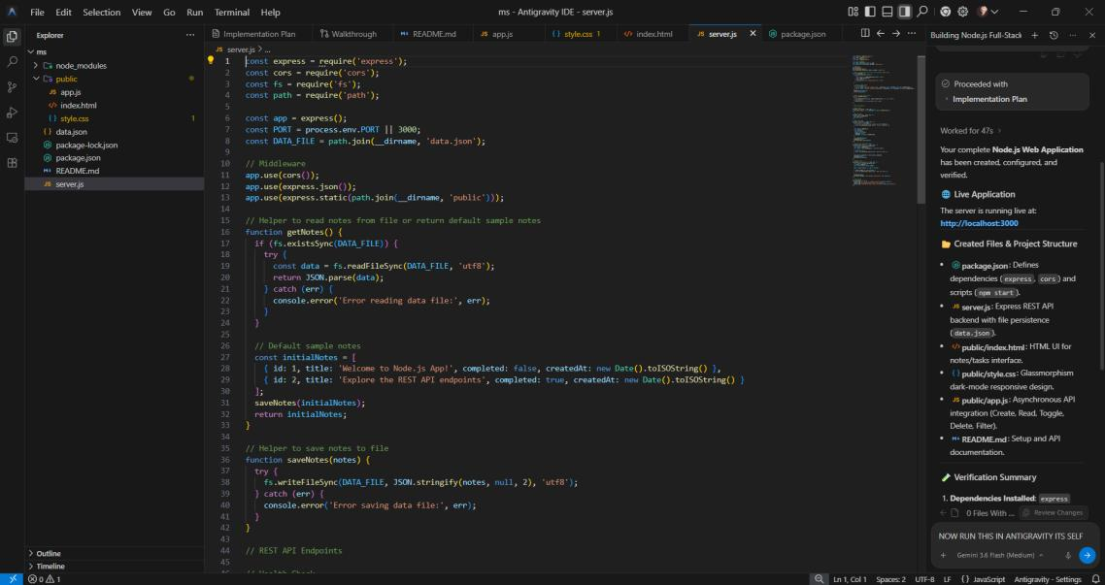

Output:

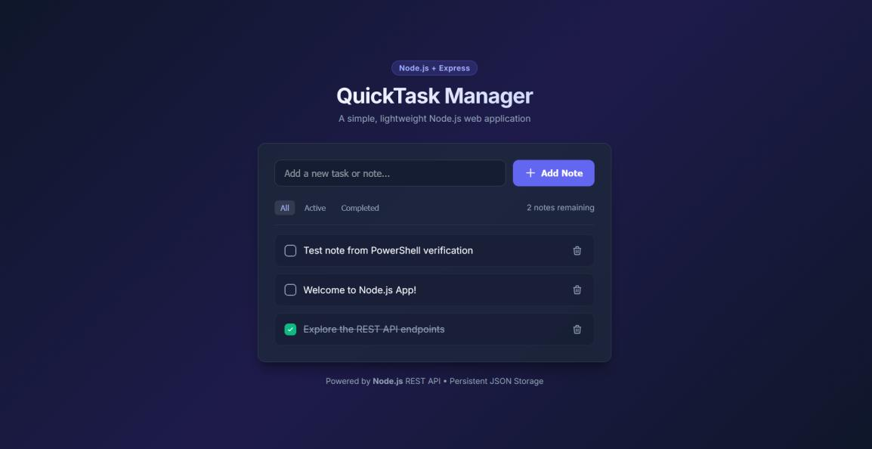

RESULT:
A basic Node.js application was created using the built-in readline module. The program successfully
SANJAY S 71812401216

