CSA1708-ARTIFICIAL INTELLIGENCE
LAB EXPERIMENTS
Program 6: Python Program for Vacuum Cleaner Problem
AIM:
To write a Python program to solve the Vacuum Cleaner Problem using a simple AI agent.
ALGORITHM:
- Initialize two rooms, A and B, as dirty.
- Check each room's condition.
- If a room is dirty, clean it.
- Repeat until all rooms are clean.
- Display the final state.
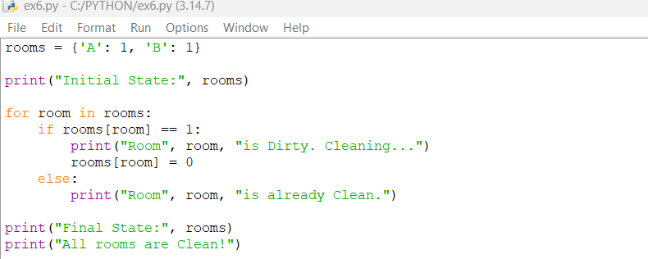
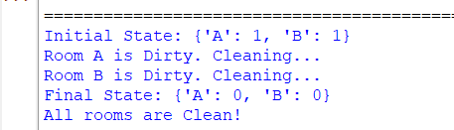
RESULT:
The Vacuum Cleaner Problem was successfully implemented in Python, and both rooms were cleaned.

