Experiment-7
Write A Python Program To Implement BFS
Aim
To write and execute a Python program to implement Breadth-First Search (BFS) for traversing a graph level by level.
Algorithm
- Start the program.
- Represent the graph using an adjacency list.
- Select the starting node.
- Initialize an empty set to store visited nodes.
- Create a queue and insert the starting node.
- Check whether the queue is empty.
- Remove the first node from the queue.
- If the node is not visited, mark it as visited.
- Display the visited node.
- Add all its unvisited neighboring nodes to the queue.
- Repeat Steps 6–10 until the queue becomes empty.
- Stop the program after completing the traversal.
Code
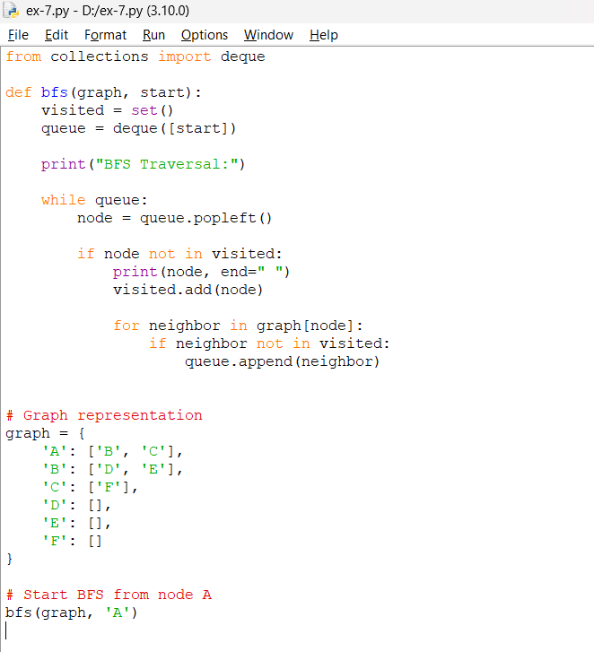
Output
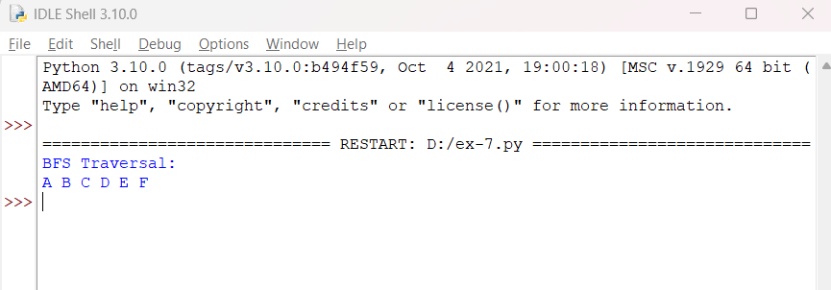
Result
The Breadth-First Search (BFS) algorithm was successfully implemented . The program traverses the graph starting from node A and produces the output:
A B C D E F

