Experiment-8
Write A Python Program To Implement DFS
Aim
To write and execute a Python program to implement Depth-First Search (DFS) for traversing a graph by exploring each branch as deeply as possible before backtracking.
Algorithm
- Start the program.
- Represent the graph using an adjacency list.
- Select the starting node.
- Initialize an empty set to store visited nodes.
- Mark the starting node as visited.
- Display the current node.
- Get the neighboring nodes of the current node.
- Check whether each neighboring node has been visited.
- If a neighbor is unvisited, recursively call DFS for that node.
- Continue exploring until no unvisited neighbors remain.
- Backtrack to the previous node and explore other unvisited neighbors.
- Stop when all reachable nodes have been visited.
Code
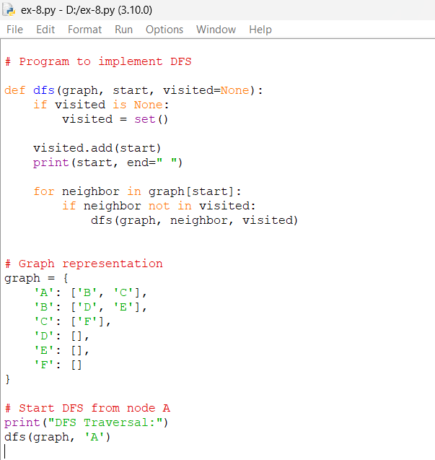
Output
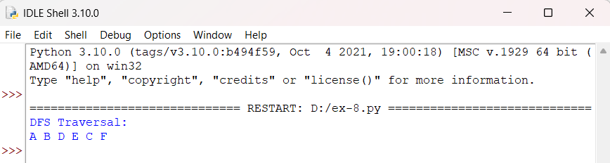
Result
The Depth-First Search (DFS) algorithm was successfully implemented . The program traverses the graph starting from node A and produces the output:

