Experiment-10
Write A Python Program To Implement A* Algorithm
Aim
To write and execute a Python program to implement the A (A-Star) Search Algorithm* to find the lowest-cost path from a starting node to a goal node using actual cost and heuristic values.
Algorithm
- Start the program.
- Define the graph with nodes and edge costs.
- Assign heuristic values to each node.
- Select the starting node and goal node.
- Initialize the open list with the starting node.
- Calculate the evaluation function \(f(n)=g(n)+h(n)\).
- Select the node with the lowest evaluation value.
- Check whether the selected node is the goal node.
- If it is the goal node, return the path and total cost.
- Otherwise, explore its neighboring nodes.
- Update the path costs and evaluation values, and repeat until the goal is reached or no path remains.
- Display the path and total cost, then stop.
Code
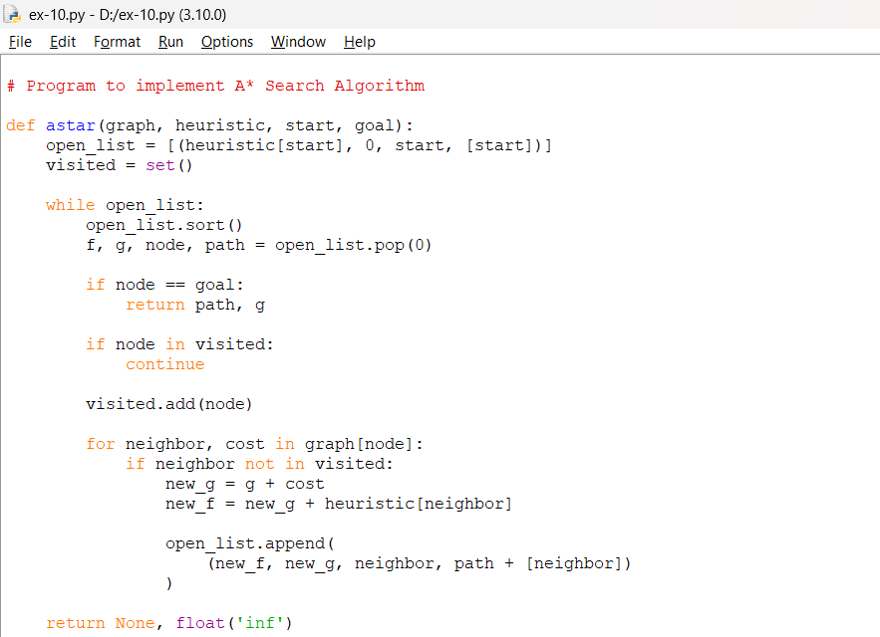
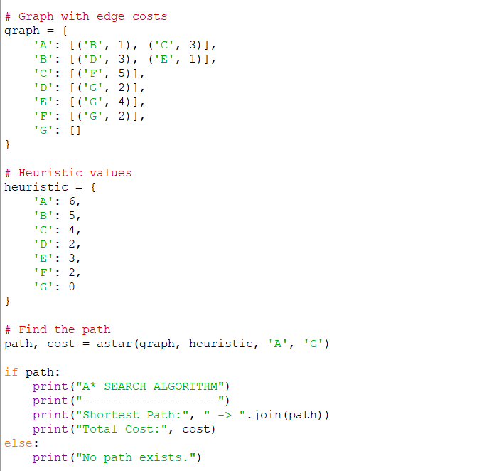
Output
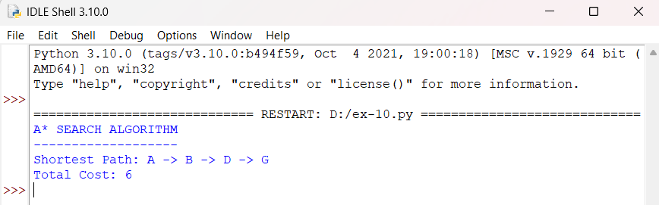
Result
The A Search Algorithm was successfully implemented . The program finds the path A → B → D → G with a total cost of 6 units.

