Experiment-11
Write A Python Program For Map Coloring To Implement CSP
Aim
To write and execute a Python program to implement Map Coloring using a Constraint Satisfaction Problem (CSP), ensuring that no two neighboring regions have the same color.
Algorithm
- Start the program.
- Define the map regions and their neighboring regions.
- Initialize the available colors as Red, Green, and Blue.
- Create an empty dictionary to store color assignments.
- Select an uncolored region.
- Choose a color from the available colors.
- Check whether the selected color conflicts with any neighboring region.
- If there is no conflict, assign the color to the region.
- Move to the next uncolored region.
- If a conflict occurs, try another color.
- Use backtracking if no valid color is available.
- Display the color assigned to each region and stop the program.

Code
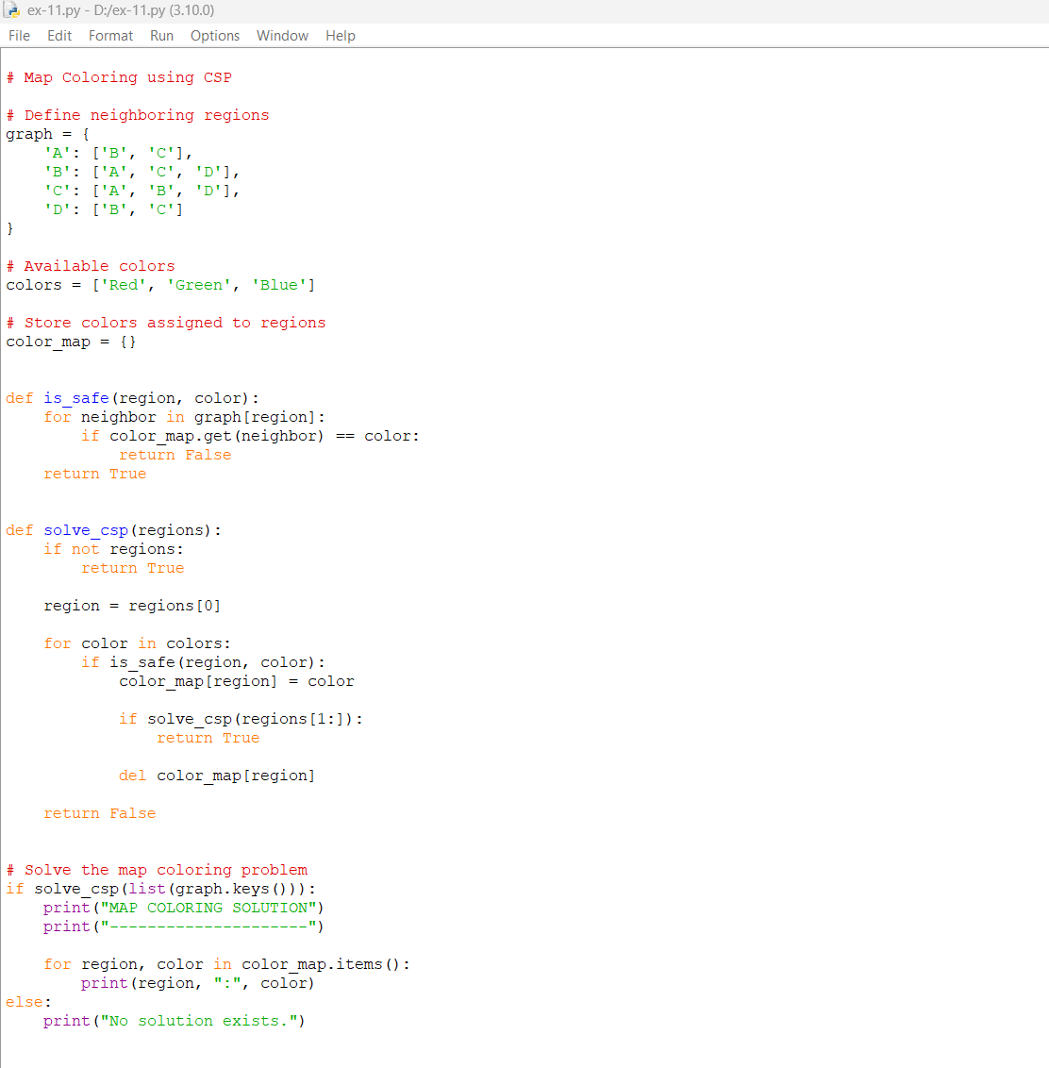
Output
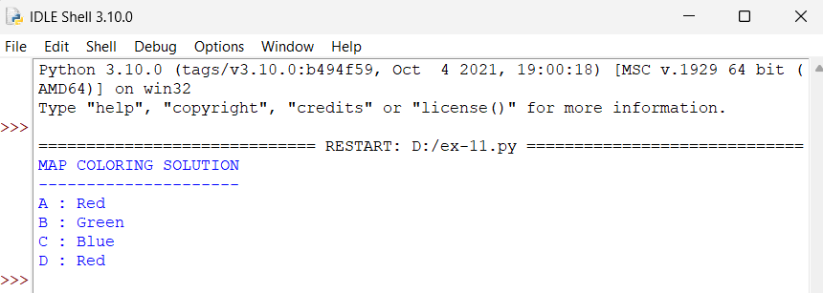
Result
The Map Coloring problem was successfully implemented using CSP and backtracking in Python 3.10. All four regions were colored so that no two neighboring regions have the same color.

