Experiment-14
Write A Python Program To Implement Alpha And Beta Pruning Algorithm For Gaming
Aim
To write and execute a Python program to implement the Alpha-Beta Pruning algorithm to find the optimal value in a game tree while reducing unnecessary searches.
Algorithm
- Start the program.
- Define the leaf node values of the game tree.
- Initialize alpha (\(\alpha\)) to negative infinity.
- Initialize beta (\(\beta\)) to positive infinity.
- Begin the search from the root node.
- If the node is a leaf node, return its value.
- If it is a maximizing node, select the maximum value.
- Update alpha with the best value found.
- If it is a minimizing node, select the minimum value.
- Update beta with the best value found.
- If alpha is greater than or equal to beta, prune the remaining branches.
- Return and display the optimal value.
Code
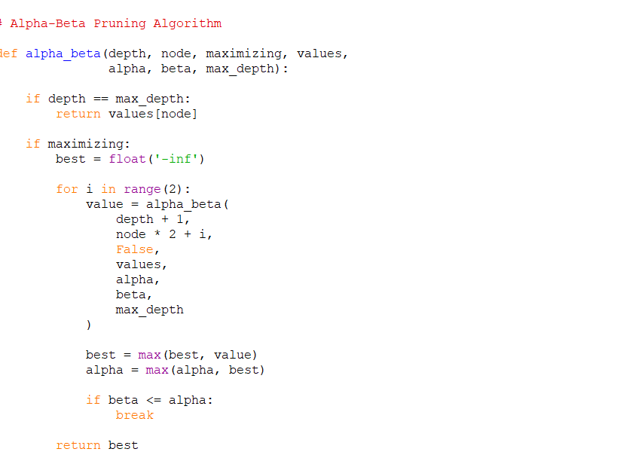
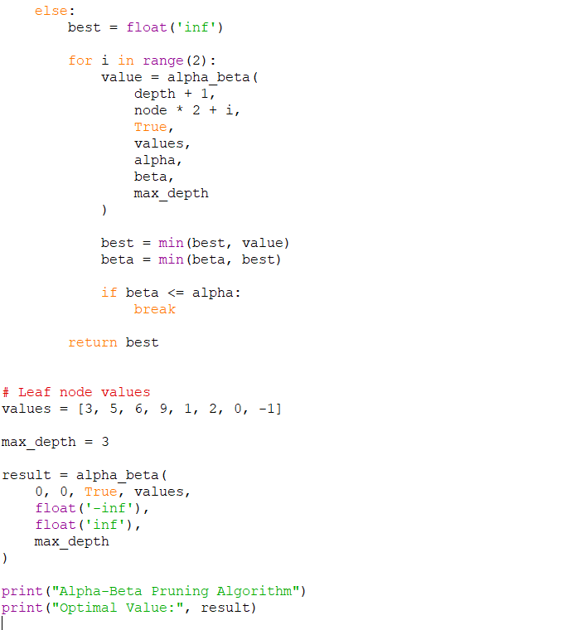Output
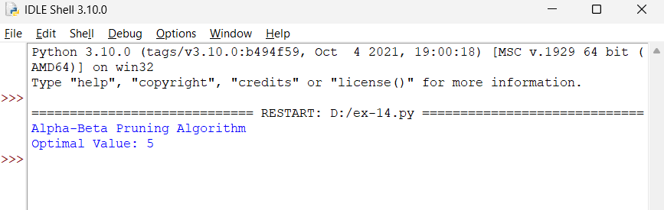
Result
The Alpha-Beta Pruning algorithm was successfully implemented. The program evaluates the game tree, prunes unnecessary branches, and obtains the optimal value of 5.

