**R & D part of Facebook and Telegram Automation**

Tools used for automation are: -

1. [Autoit](https://www.autoitscript.com/site/autoit/downloads/) , [SciTEAutoit](https://www.autoitscript.com/site/autoit-script-editor/downloads/) [AutoIt Script Editor]
2. [SelectorHub](https://chrome.google.com/webstore/detail/selectorshub/ndgimibanhlabgdgjcpbbndiehljcpfh?hl=en) [SelectorsHub helps to generate, write and verify the XPath & cssSelector.]
3. [ChroPath](https://chrome.google.com/webstore/detail/chropath/ljngjbnaijcbncmcnjfhigebomdlkcjo?hl=en-US) [ChroPath helps to generate and validate selectors like relative xpath with iframe, svg support. It also generates English testcases.]
4. [Katalon Recorder](https://chrome.google.com/webstore/detail/katalon-recorder-selenium/ljdobmomdgdljniojadhoplhkpialdid?hl=en-US) (Selenium tests generator)

SelectorHub & ChroPath screenshots:

If id looks dynamic then Uncheck the id checkbox/delete the id attribute from attribute box to generate rel xpath without id if it is generated with id.

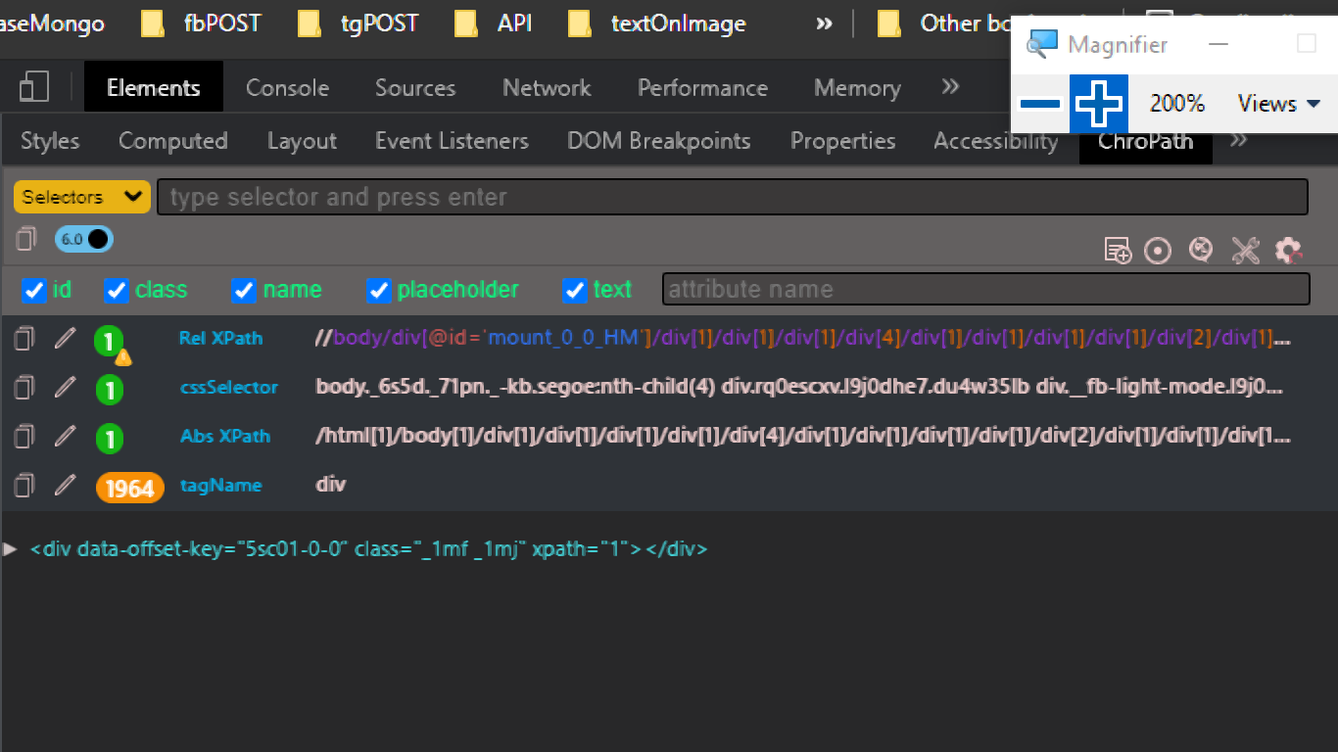

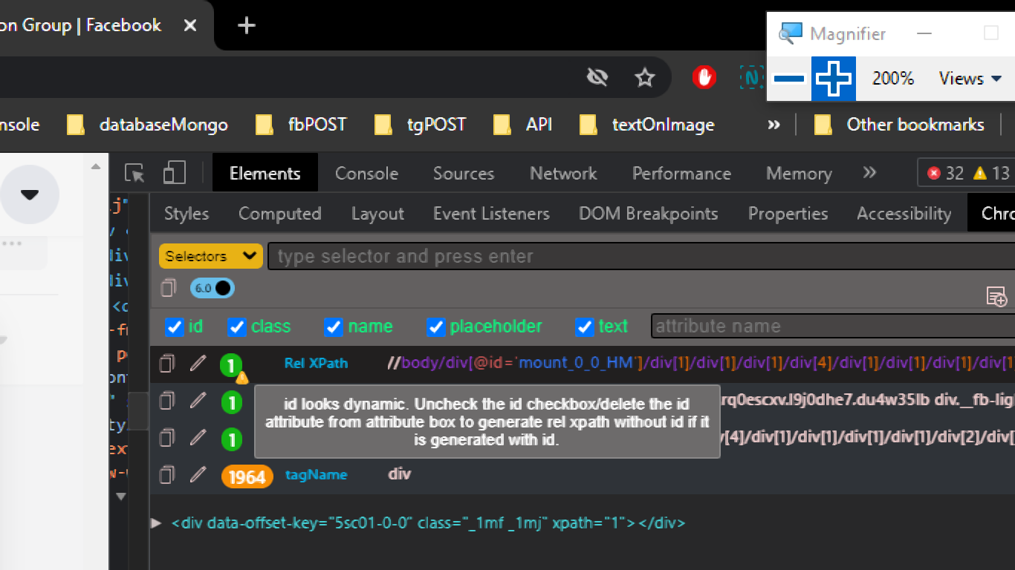

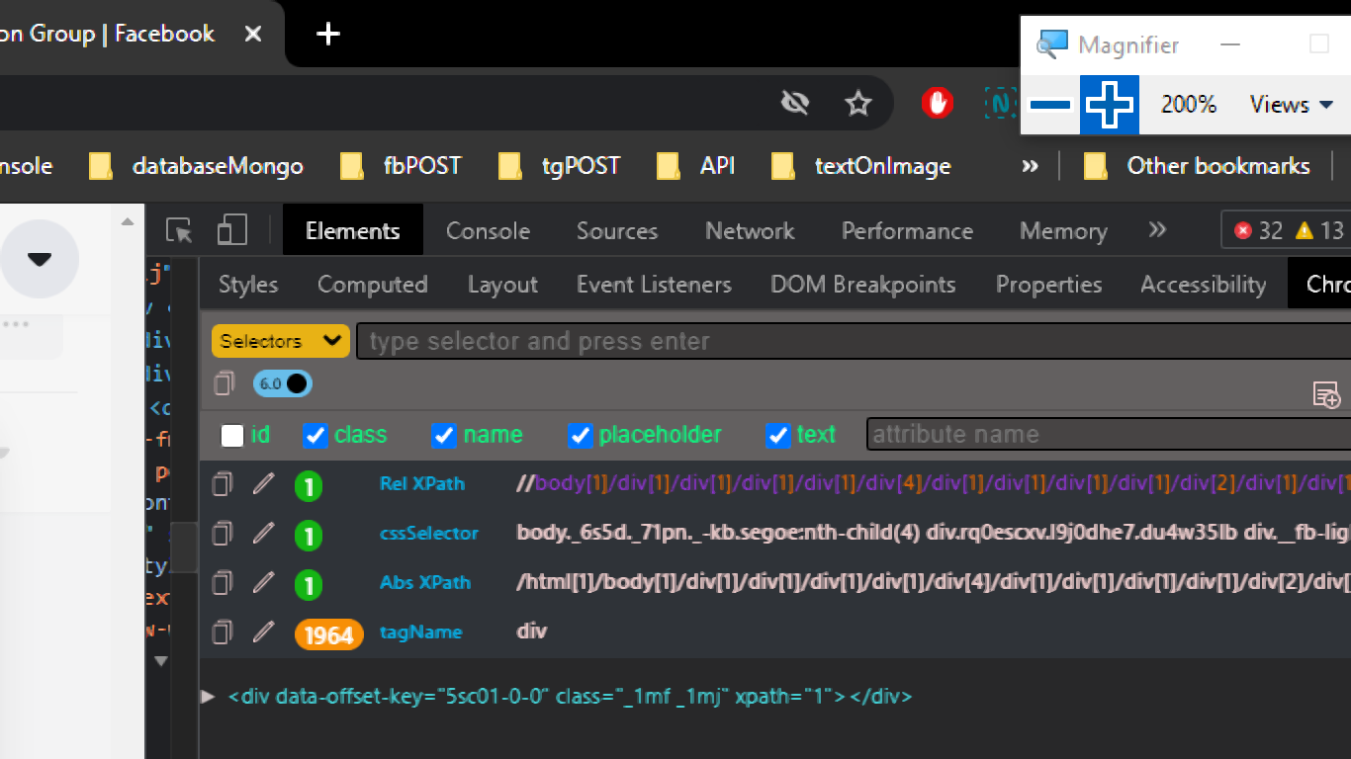

**How to use AutoIt and SciTe ?**

Source-1

[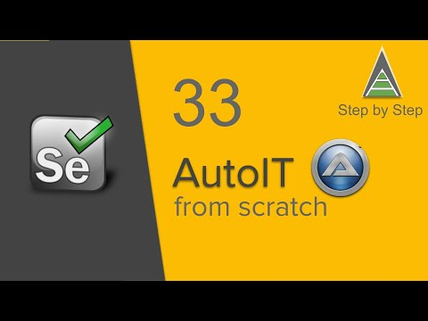](https://www.youtube.com/embed/3nPFjfpDwGU?feature=oembed)

Source-2

[How to use AutoIT with Selenium Webdriver: File Upload Example](https://www.guru99.com/use-autoit-selenium.html)

Source-3

[Why Do We Use AutoIT?](https://medium.com/chaya-thilakumara/why-do-we-use-autoit-39da30d60f23)