**INSTALLATION INSTRUCTIONS**

**Mac OS:**

1. Unzip the UMLParser.zip file and cd into UMLParser folder.
   1. cd <pathname> UMLParser
2. Run the shell script by passing the java source file path and output filename
   1. **./UMLParser.sh <javafolderpath> <outputimagename>**
   2. Sample: **./UMLParser.sh /Users/Downloads/uml-parser-test-1/ test1.png**

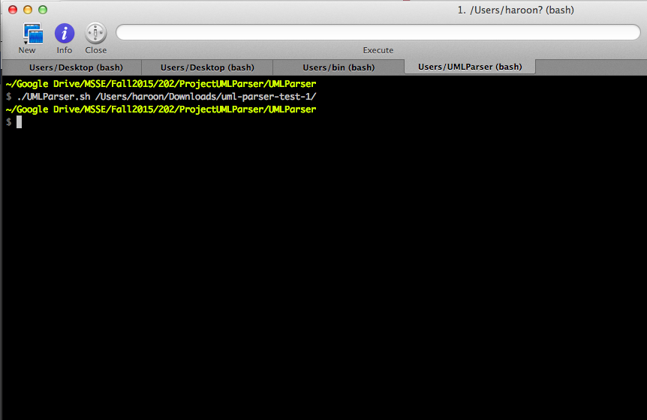

**Windows / Mac OS:**

1. Unzip the UMLParser.zip file and cd into UMLParser folder.
   1. cd <pathname> UMLParser
2. Run the jar file by passing the java source file path and output filename
   1. **java –jar UMLParser.jar <javafolderpath> <outputimagename>**
   2. Sample: **java –jar UMLParser.jar /Users/Downloads/uml-parser-test-1/ test1.png**

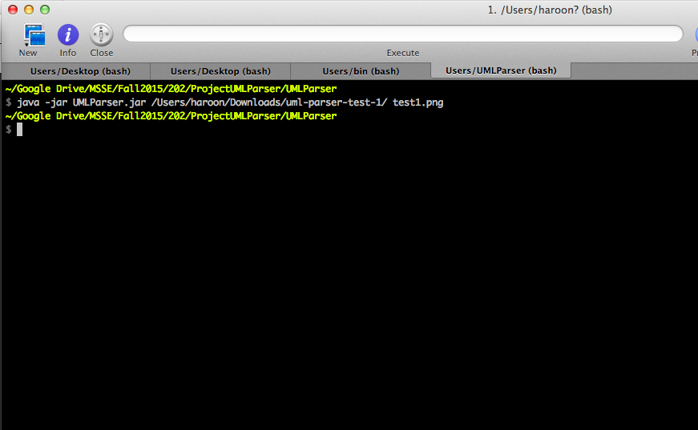

**SOFTWARE INFORMATION** (All the dependent jars can be found inside “jars” folder in the zip file):

1. **Java**: version "1.8.0_60"
2. **Javaparser**: javaparser-core-2.2.3-SNAPSHOT.jar
   1. API: <http://www.javadoc.io/doc/com.github.javaparser/javaparser-core/2.3.0>
3. **Plantuml**: plantuml.jar, plantuml4idea.jar
4. **Graphviz**: Installation instructions - <http://plantuml.com/graphvizdot.html>