Machine-Learning Prediction of Young's Modulus of Titanium Alloys from Chemical Composition
<TODO: author name>
<TODO: department, college>
Supervisor: <TODO: professor name>
Date: <TODO: date>

Abstract
Low Young's modulus in beta-titanium alloys is desirable for biomedical implants because it can reduce stress shielding. Experimental modulus measurement is slow, while literature data is scattered across sources. This study evaluated prediction of Young's modulus, E, in GPa from composition in weight percent using elemental and derived descriptors. Fifteen CSV files were merged; computed rows were removed; Ti-matrix compositions were selected; and repeated compositions were collapsed by median modulus before grouped splitting. A composition-plus-engineered feature XGBoost regressor with an absolute-error objective and default parameters was selected by five-fold grouped cross-validation. On the held-out test set of 151 rows, MAE was 9.88 GPa, RMSE was 13.00 GPa, and R2 was 0.684. The test MAE was about 1.12 times the estimated 8.78 GPa within-composition noise floor. Engineered features did not clearly improve grouped-CV error over composition alone. The results supported composition-based screening but did not establish processing-independent property prediction.

1 Introduction
Titanium alloys are used in biomedical implants, where a lower elastic modulus can reduce stiffness mismatch with bone and thereby reduce stress shielding. Beta-titanium alloys are of particular interest. Young's modulus is measured experimentally, but measurement is slow and reported values are dispersed across the literature. A composition-based predictor could help prioritize candidate compositions for measurement; it cannot replace experiments that account for processing and phase constitution. [reference needed]
The objective was to predict E in GPa from alloy composition in wt%. Elemental composition alone was compared with composition plus engineered descriptors. Model selection used only the training partition and composition-grouped folds; the held-out test partition was evaluated once.

2 Data
The initial merged table contained 897 rows from 15 CSV files, comprising literature compilations, earlier project datasets, values digitized from published figures, and density-functional-theory (DFT) values from Materials Project and two DFT figures. Figure-digitized values had an estimated reading error of approximately +/-0.5 to 2 GPa. Compositions were represented in wt% and the target was E in GPa. at% compositions were converted to wt% with standard atomic masses, and each row was normalized to 100 wt%.
Computed rows were excluded because they sat systematically apart from experimental values: 38 matched the Materials Project file and 11 matched two DFT figures, for 49 removals. Of the 848 remaining rows, 31 with atomic Ti below 60 at% were removed, leaving 817 Ti-matrix rows. This atomic-percent criterion retained heavy-element beta alloys that a wt% Ti cutoff would discard; Ti-29Nb-13Ta-4.6Zr had 53.4 wt% Ti but about 72 at% Ti.
Compositions equal after rounding all element wt% values to one decimal place were collapsed to one record with median E. The data were reduced from 817 rows to 754 composition groups. Thirty groups had repeated values; their mean within-group sample standard deviation was 8.78 GPa. This was treated as an empirical label-noise estimate, not a strict lower bound on prediction error.
An 80/20 GroupShuffleSplit with seed 42 allocated 603 rows to training and 151 to testing, with no rounded composition shared across partitions. The test partition included 46 rows with Ti below 70 wt%; this was a reported subgroup, not the inclusion criterion.
Partition | n | Mean E | SD | Min | Max (GPa)
Train | 603 | 73.1 | 19.8 | 23.0 | 157.0
Test | 151 | 75.7 | 23.2 | 29.5 | 149.0

Table 1. Young's modulus distribution by split (GPa).

3 Methods

3.1 Composition-derived descriptors
Feature set A comprised all element wt% columns. Feature set B comprised A plus VEC, atomic-size mismatch delta_r, ideal configurational mixing entropy delta_S_mix, Mo_eq, Al_eq, Morinaga Bo and Md, and the categorical phase_est screening label. The label used Mo_eq thresholds of 2.5 and 10 wt%; it was marked uncertain when Al_eq was at least 8 wt% or the alloy was Ti-poor (the operational threshold was not specified in the supplied report facts). The Appendix gives the formulas. Atomic descriptors used atomic fractions obtained from normalized wt% composition and standard atomic masses. The saved inference pipeline handled phase_est as a categorical input.

3.2 Models and validation
The evaluated models were XGBoost regressors with squared-error and absolute-error objectives, Random Forest, Ridge, and a mean-predictor baseline. Ridge results were omitted because they were unavailable in the v2 report. Five-fold GroupKFold used the training data only, with rounded composition groups. MAE was the primary selection metric; RMSE and R2 were also recorded. RandomizedSearchCV used 60 iterations for absolute-error XGBoost on sets A and B. The held-out test set was used only after selection.
The final model was the XGBoost regressor with feature set B, objective reg:absoluteerror, and default parameters. Software versions were pandas 3.1.0, NumPy 2.5.3, scikit-learn 1.9.1, and XGBoost 3.4.1. The random seed was 42.

4 Results

4.1 Cross-validation and model selection
The default set B XGBoost model with the absolute-error objective had five-fold grouped-CV MAE 10.19 +/- 0.63 GPa. Random Forest obtained 10.40 +/- 0.97 GPa for A and 10.21 +/- 1.14 GPa for B. The mean baseline obtained 15.39 +/- 1.24 GPa for both sets. Tuned absolute-error XGBoost obtained 10.59 +/- 0.77 GPa for A and 10.43 +/- 0.91 GPa for B; tuning did not improve on the selected default B model.
Set | Model | CV MAE (mean +/- SD), GPa
A | XGBoost, absolute error | 11.10 +/- 0.46
A | XGBoost, squared error | 11.20 +/- 0.29
A | Random Forest | 10.40 +/- 0.97
A | Mean baseline | 15.39 +/- 1.24
B | XGBoost, absolute error | 10.19 +/- 0.63
B | XGBoost, squared error | 10.79 +/- 0.92
B | Random Forest | 10.21 +/- 1.14
B | Mean baseline | 15.39 +/- 1.24
A | Tuned XGBoost, absolute error | 10.59 +/- 0.77
B | Tuned XGBoost, absolute error | 10.43 +/- 0.91

Table 2. Five-fold grouped-CV MAE on the training partition.
The selected model's test MAE was 9.88 GPa, RMSE was 13.00 GPa, and R2 was 0.684 (n=151). Subgroup MAE was 7.78 GPa for 28 rows labelled beta by the screening rule, 11.51 GPa for 41 rows with E below 60 GPa, and 7.80 GPa for 46 rows with Ti below 70 wt%.
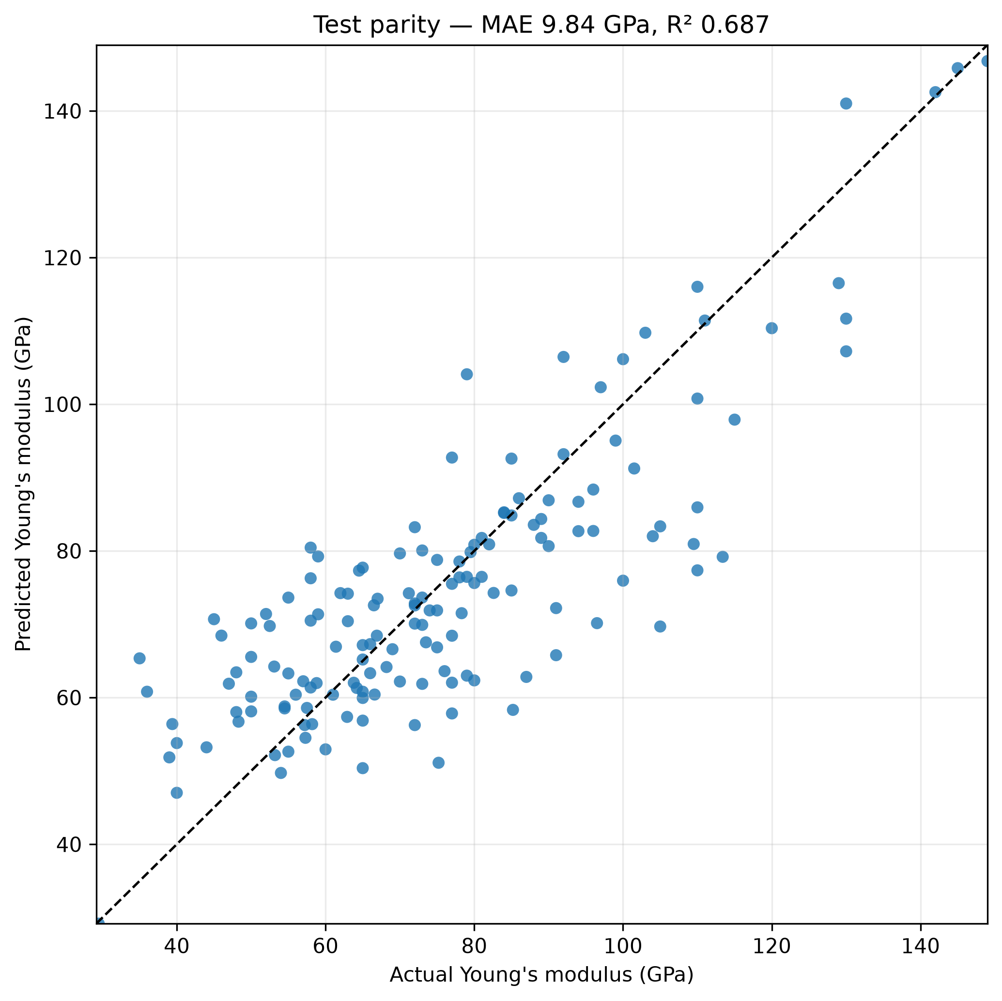
Figure 1. Held-out test parity plot; the diagonal indicates perfect agreement.

4 Results (continued)

4.2 Composition-series plots and feature comparison
The mean paired MAE gain from B over A was 0.17 GPa, smaller than one fold standard deviation for tuned B (0.91 GPa). The engineered descriptors therefore did not clearly improve performance over composition alone.
Figure 2 compares predicted curves with digitized Ti-Nb-xZr data at x=0, 4, 8, 12, and 18 at% Zr. The requested overlap check found 28 of 44 points matching training rows within 0.5 wt% composition and 0.5 GPa in E. The comparison therefore includes training observations and is a partly in-sample fit visualization, not independent validation. test_report.txt was not present; the count came from the explicit comparison against train_v2.csv.
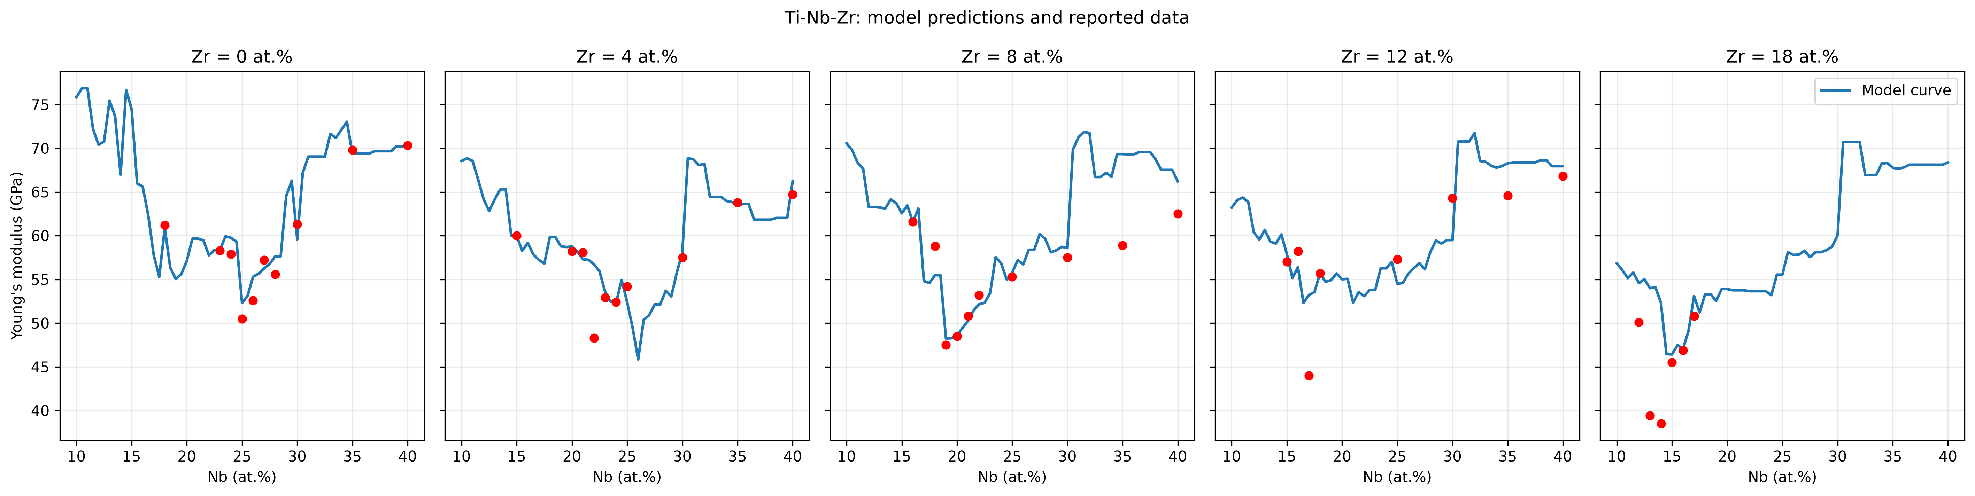
Figure 2. Predicted Ti-Nb-xZr curves and digitized points at five Zr at% levels; 28/44 points overlap training rows at the stated tolerances.
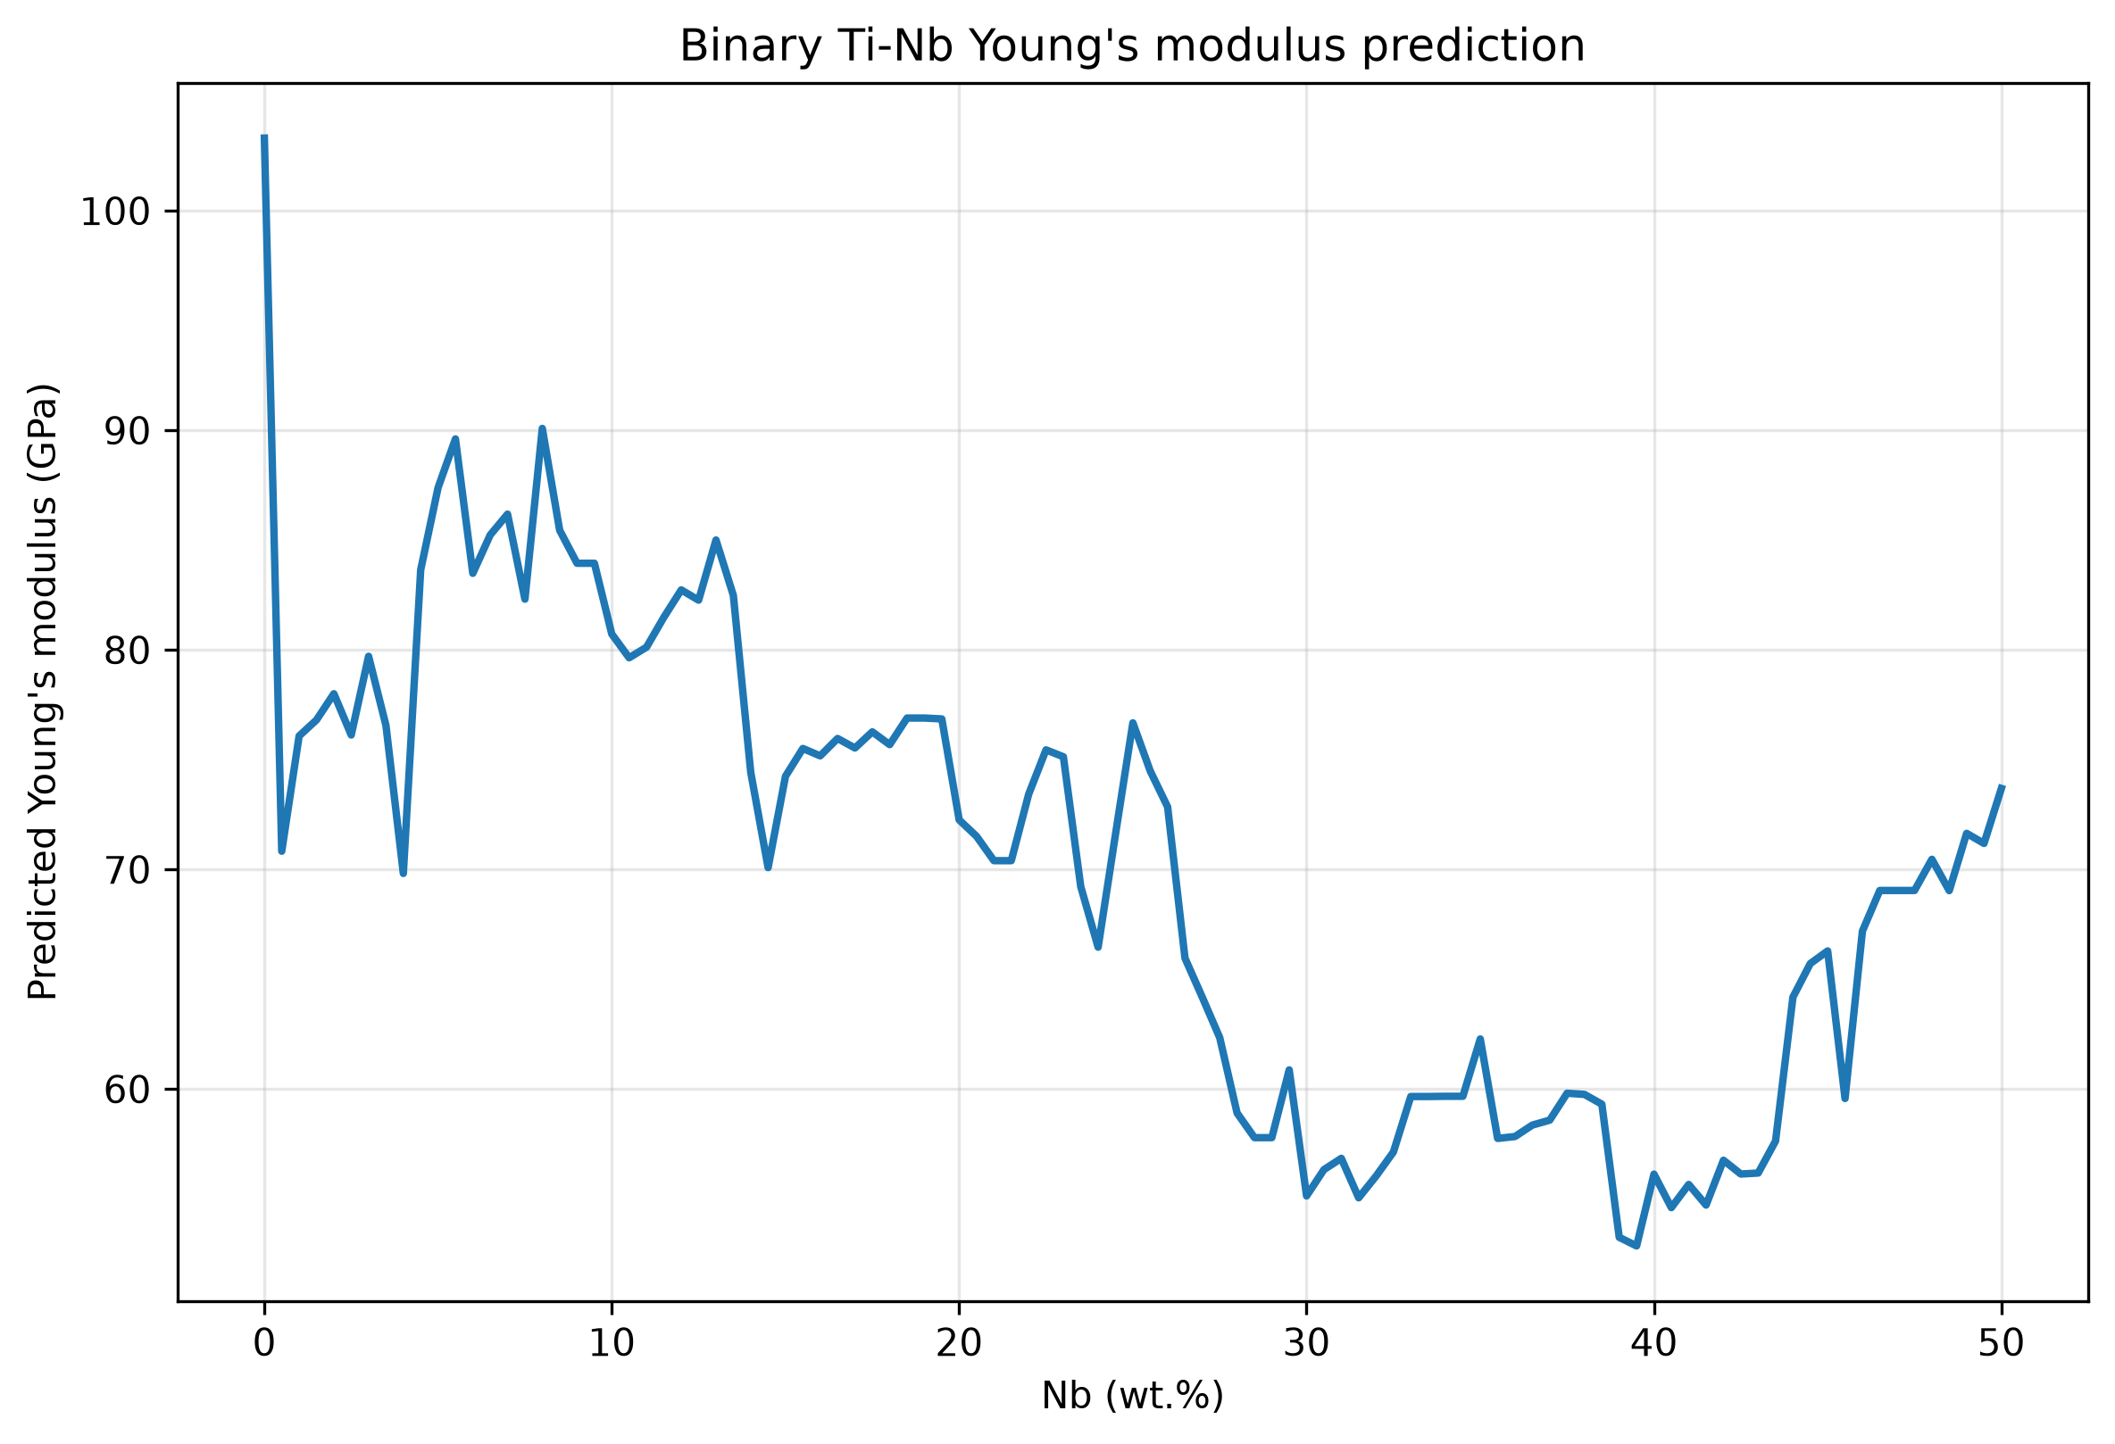
Figure 3. Predicted modulus over the binary Ti-Nb wt% sweep; this is model output, not a new experiment.

5 Discussion
The test MAE of 9.88 GPa was about 1.12 times the estimated label-noise floor of 8.78 GPa. The error scale was therefore similar to the within-composition variability observed in duplicate groups. The floor was estimated from only 30 groups with repeated values and was not a universal lower bound.
The engineered descriptors gave a small average improvement over composition alone, but it was smaller than fold-to-fold variability. The earlier model, before DFT exclusion, Ti-matrix filtering, and duplicate collapse, had test MAE 11.53 GPa and R2 0.52. Since data preparation and splitting changed, this comparison did not isolate the causal effect of any individual cleaning step.
The largest test errors were reported for dilute alloys with observed moduli around 91-113 GPa that were predicted around 66-79 GPa. Examples were Ti-3Mo-1Nb, Ti-3Mo-1Al, Ti-7.4Cr, and Ti-8Mo-1Nb. Composition did not encode processing history or retained phase. Similar chemistries after different processing, including quenched beta and annealed alpha+beta conditions, could therefore have different modulus values that the input features could not distinguish. [reference needed]

6 Limitations
The dataset mixed tensile, ultrasonic, nanoindentation, and compression measurements with values digitized from figures. Digitization carried estimated reading errors of +/-0.5 to 2 GPa, and processing histories and measurement protocols were not harmonized. No processing, heat treatment, or measured phase variable was included.
The phase label was a coarse composition-equivalent screen, not a measured phase state or thermodynamic calculation. Tree models produce stepwise responses and may not reproduce sharp phase-related dips, including the reported 38.5 GPa value at Ti-14Nb-18Zr. The low-modulus test subset had only 41 rows, so its MAE was noisy. Extrapolation beyond the training composition range was unreliable. Predictions should be treated as approximate, with expected error about +/-10 GPa, not as substitutes for measurement.

7 Conclusion
Grouped evaluation produced test MAE 9.88 GPa for the selected default XGBoost model using composition and engineered descriptors; test R2 was 0.684. Engineered features did not clearly outperform composition alone by more than fold variability. Prediction error was similar in scale to the estimated within-composition standard deviation, while process and phase information remained important limitations.
Future work should add processing and phase columns, source and measurement-method labels, more low-modulus beta-alloy experiments, and uncertainty estimates.

References
[reference needed: no bibliographic entries were supplied. Add the actual data-source papers and any standard references used before submission.]

Appendix: Feature formulas and tables
Let x_i be the atomic fraction of element i, with sum_i x_i=1, and r_i its metallic radius. Let r_mean=sum_i x_i r_i. The composition was normalized to 100 wt% and converted to atomic fractions using standard atomic masses. The formulas below were used.
VEC = sum_i (x_i * VEC_i)
delta_r (%) = 100 * sqrt(sum_i [x_i * (1 - r_i/r_mean)^2])
delta_S_mix = -R * sum_i (x_i * ln(x_i)); zero terms omitted
Mo_eq (wt%) = Mo + 0.2Ta + 0.28Nb + 0.4W + 0.67V + 1.25Cr + 1.25Ni + 1.7Mn + 1.7Co + 2.5Fe - Al
Al_eq (wt%) = Al + Zr/6 + Sn/3 + 10O
Bo = sum_i (x_i * Bo_i); Md = sum_i (x_i * Md_i)
Feature group | Definition / interpretation
A | All element composition columns in wt%.
B | Set A plus VEC, delta_r, delta_S_mix, Mo_eq, Al_eq, Bo, Md, and phase_est.
phase_est | Mo_eq < 2.5 wt%: alpha; 2.5-10 wt% inclusive: alpha+beta; >10 wt%: beta. Uncertain for Al_eq >= 8 wt% or Ti-poor alloy (threshold not specified).

Table 3. Model feature groups and phase-screen interpretation.
Mo_eq and Al_eq used wt% composition; VEC, delta_r, Bo, and Md used atomic fractions. Feature definitions and tabulated element constants require citations before external publication. [reference needed]
Numerical provenance: reported quantities were taken from the supplied task facts; the 28/44 overlap count was calculated by comparing the supplied real-point list with train_v2.csv using the specified tolerances. See number_source_audit.txt for the value-to-prompt mapping. Author, affiliation, supervisor, date, and bibliography remain TODO items.

