**Project Title: Real-Time World Clock Utility in C**

**Objective:**

Develop a **real-time World Clock Utility in C** that continuously displays the **current time, date, day, month, and year** for multiple countries by dynamically adjusting based on **UTC (Coordinated Universal Time) offsets**. The program retrieves UTC time, applies the necessary offset for each country, and updates the display every second while handling potential **day transitions (Next Day or Previous Day).**

**Tracked Countries and Time Zones:**

The program will display the **local date and time** for the following countries:

| **Country** | **UTC Offset** | **Time Zone Name** |
| --- | --- | --- |
| **China** | UTC+8 | CST - China Standard Time |
| **India** | UTC+5:30 | IST - Indian Standard Time |
| **United Kingdom** | UTC+0 / UTC+1 (DST) | GMT/BST - British Summer Time |
| **Argentina** | UTC-3 | ART – Argentina Time |
| **Saudi Arabia** | UTC+3 | AST - Arabia Standard Time |

**Project Requirements:**

✅ **Retrieve the current UTC time** from the system clock.  
✅ **Apply accurate UTC offsets** for each country (including hours and minutes).  
✅ **Handle Day transitions** when time exceeds 24 hours or moves backward.  
✅ **Display the full date (day, month, year) along with time**.  
✅ **Continuously update time in a loop every second**.  
✅ **Ensure formatted console output for readability**.

**Key Features:**

1. **Real-Time Updates** – The clock refreshes every second dynamically.
2. **Multi-Zone Display** – Shows the **local date, day, month, year, and time** for predefined countries.
3. **Day Transition Handling** – Indicates **Next Day or Previous Day** when applicable.
4. **Daylight Saving Time (DST) Consideration** – Adjusts for **regions observing DST shifts** dynamically.
5. **Formatted Console Output** – Displays **structured and readable date/time information**.

**C Programming Concepts Used:**

🔹 **Structures (struct)** → Used for storing **country details**, including UTC offsets, DST settings, and names.  
🔹 **Arrays** → Used for **managing multiple time zones**, days of the week, and months.  
🔹 **Time Handling (time.h)** → Retrieves and **processes UTC-based time dynamically**.  
🔹 **Loops (while)** → Ensures **continuous real-time updates** without manual intervention.  
🔹 **String Handling (strcpy)** → Manages country names and AM/PM formatting.  
🔹 **Pointers (*struct)** → Optimizes **memory usage and efficient data handling**.

**Expected Output Example:**

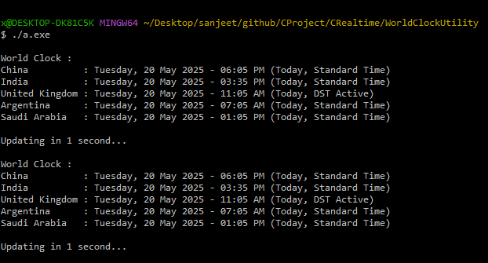

**Understanding UTC (Coordinated Universal Time):**

✅ **What is UTC?**

* UTC (**Coordinated Universal Time**) is the **global standard for timekeeping**, serving as a **fixed reference point**.
* It is **not affected** by **Daylight Saving Time (DST)** changes, unlike regional time zones.
* Local time zones are determined based on **offsets from UTC** (e.g., India follows UTC+5:30).

✅ **How UTC is Used in the Project:**

* The program **retrieves the current UTC time dynamically** using the system clock.
* It **calculates the local date and time** by **adding or subtracting** the appropriate UTC offset.
* Countries like the **United Kingdom** shift their clocks forward during DST, which the program adjusts automatically.
* The utility **handles overflow conditions**, ensuring correct **day/month transitions**.
* The **console output updates every second**, maintaining real-time synchronization.

**Future Enhancements:**

💡 **User-Defined Time Zones** – Allow users to input **custom UTC offsets** for dynamic tracking.  
💡 **Graphical User Interface (GUI)** – Convert **console output into a visually appealing clock**.  
💡 **Event Logging** – Save **historical time updates** for **record-keeping**.  
💡 **Advanced DST Handling** – Fully automate **seasonal time shifts** based on country-specific rules.

**Author & Contact Information:**

👤 **Author:** **Sanjeet Prasad**  
📧 **Email:** sanjeet8.23@gmail.com  
📱 **Mobile:** +91 9958217807