SUPPLY CHAIN PERFORMANCE REPORT
Late Delivery Analysis, Profitability Impact & Predictive Alert System
Global e-commerce fulfilment operations | 172,765 orders | January 2015 – January 2018
54.71%  Orders delivered late | $2.1M  Profit generated by delayed orders | 100%  First Class delay rate | 74%  Predictive model accuracy
Prepared by: Data Analytics
Report date: October 2026
Source: DataCo Supply Chain Dataset (cleaned), Python / pandas / scikit-learn analysis
Table of Contents
1. Executive Summary 3
2. Business Context & Objectives 4
3. Key Performance Indicators (KPIs) 5
4. Profitability Analysis 6
4.1 Profitability Distribution 6
4.2 Delay Distribution & Profit vs. Delay Days 7
5. Bottleneck Detection 8
6. Root Cause Analysis 10
7. Time-Based Delay Patterns 11
8. Machine Learning Model Results 12
9. Strategic Recommendations 14
10. Conclusion 16

1. Executive Summary
This report presents a comprehensive analysis of the delivery operations of a global e-commerce company managing end-to-end order fulfilment across multiple regions. The analysis covers 172,765 orders spanning January 2015 through January 2018, focusing on identifying root causes of chronic late deliveries, quantifying their financial impact, and establishing a data-driven framework for improvement.
The headline finding is stark: 54.71% of all orders are delivered late. Orders that were delayed generated $2.1M in profit that is now under pressure, against $7.5M of total profit across profitable orders. The persistent late-delivery problem is therefore both a significant financial drain and a major customer-experience risk. A Random Forest predictive model achieved 74% accuracy in identifying at-risk orders before they become late.
Key Finding | Metric
Overall Late Delivery Rate | 54.71%
On-Time Delivery Rate | 45.29%
Total Orders Analyzed | 172,765
Total Profit (profitable orders) | $7.5M
Profit at Risk (delayed orders) | $2.1M
Predictive Model Accuracy (RF) | 74%
First Class / Second Class delay rate | 100.0% / 79.8%
Loss-making orders | 18.7%

What the data tells us
- Shipping mode is the dominant driver. Delay rates range from 0% (Same Day) to 100% (First Class). Every other dimension tested (region, segment, department, payment type, order status) moves the delay rate by only 1–4 percentage points.
- The premium modes contradict their promise. First Class and Second Class make up about 35% of orders but roughly 57% of all late deliveries.
- Delays are a volume problem, not a unit-economics problem. Mean profit per order stays at about $20–$23 across all delay levels, so reducing the number of late orders is the highest-leverage fix.
- The pattern is systemic. The 90th-percentile delay is only 3 days, and delay rates are flat across months, weekdays and hours (roughly 52–57%), which points to process design rather than isolated incidents.
- The problem is predictable. A first-generation model flags 75% of late orders with 79% precision, using only data available at order confirmation.

2. Business Context & Objectives
The company operates a global e-commerce platform selling products across categories including sporting goods, fitness equipment, outdoor gear, footwear, and apparel across multiple international regions. It manages shipping and delivery end to end, so inconsistent delivery performance directly affects customer trust, repeat purchase behaviour and order profitability.
Actual shipping times frequently deviate from the scheduled timelines promised to customers, leading to late deliveries and unpredictable order profitability.
Objectives
- Analyse delivery operations and quantify the scale of late deliveries.
- Identify operational bottlenecks and root causes across region, shipping mode, segment, department, payment type and time.
- Measure the link between delivery delays and order profitability.
- Build a predictive system that flags at-risk orders early, so the business can reduce delays, optimise shipping decisions and improve profitability.
Data and methodology
Step | Detail
Raw dataset | 180,519 rows × 53 columns (DataCo Supply Chain Dataset); no duplicate rows.
Missing data | Product Description 100% missing; Order Zipcode 155,679 missing (86%); Customer Lname 8 and Customer Zipcode 3 missing.
Columns removed | 33 columns dropped: personal data (email, password, names, street), identifiers, empty or redundant fields, and low-value geography.
Rows removed | 7,754 orders with status "Shipping canceled" excluded, since they do not represent completed delivery behaviour. Final dataset: 172,765 rows × 20 columns.
Order period | 1 January 2015 to 31 January 2018 (order dates); last shipping date 6 February 2018.
Derived metrics | Order Processing Time = shipping date − order date (days). Delay = processing time − scheduled days. Late order = Delay > 0. Profitability flag from Order Profit Per Order (profit / break-even / loss).

● Two definitions of "late" | The headline late rate (54.71%, 94,523 orders) uses the computed definition Delay > 0. The source system’s own flag, Late_delivery_risk, marks 98,977 orders (57.29%) as late and is the target used for the predictive model. The two are close but not identical; all KPIs in this report use the computed definition unless stated.

3. Key Performance Indicators (KPIs)
The following KPIs were computed directly from the cleaned dataset to establish a performance baseline.
172,765  Total Orders | 94,523  Late Deliveries | 54.71%  Late Delivery % | 45.29%  On-Time Delivery %

$7.5M  Total Profit (profitable orders) | $2.1M  Profit at Risk (delayed orders) | 3 days  90th Percentile Delay | $22.03  Mean Profit per Order

● Late Delivery Rate at 54.71% | More than half of all orders arrive late. This is not an edge-case problem — it is the default experience for the majority of customers.

● $2.1M Profit at Risk | Orders that experienced delays collectively generated $2.1M in profit (about 54% of the $3.81M net profit across all orders) that is under constant pressure from further operational deterioration.

● 90th Percentile Delay = 3 Days | Even the most extreme cases are contained within 3 days of lateness, suggesting the problem is systemic and process-driven rather than catastrophic.

How to read the profit figures
Measure | Value | Definition
Total profit (profitable orders) | $7.5M | Sum of Order Profit Per Order for orders with profit > 0 (gross of losses).
Net profit, all orders | $3.81M | Sum across all 172,765 orders, after loss-making orders are netted off.
Implied loss on loss-making orders | ≈ $3.7M | $7.5M gross profit minus $3.81M net profit; 32,295 orders.
Profit at risk (delayed orders) | $2.06M (≈ $2.1M) | Net profit of the 94,523 delayed orders (Delay > 0).

4. Profitability Analysis

4.1 Profitability Distribution
Order-level profitability was classified into three tiers based on Order Profit Per Order. While 80.7% of orders are profitable, the 18.7% loss-making share is a meaningful drag on margin: these 32,295 orders erase roughly half of the gross profit earned on profitable orders.
Tier | Orders | Share of orders
Profit (> $0) | 139,354 | 80.7%
Loss (< $0) | 32,295 | 18.7%
Break-even ($0) | 1,116 | 0.6%
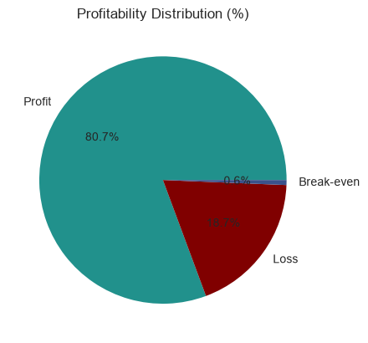
Figure 1: Profitability distribution (% of orders)
Order profit is highly skewed: the median profit per order is $31.52 but the mean is only $22.03, pulled down by a long loss tail (the worst single order lost $4,275, while the best earned $912). The bottom quartile earns $7.03 or less. A review of the extreme loss cases and of discount and pricing rules is recommended (see Recommendation 7).

4.2 Delay Distribution & Profit vs. Delay Days
The delay distribution shows that 31.0% of all orders arrive exactly 1 day late — the single largest cohort. Combined, orders delayed by 1–4 days account for 54.7% of all order volume, directly mapping to the overall late delivery rate.
Delay (days) | Orders | % of orders | Total profit | Mean profit / order
−2 (early) | 20,873 | 12.1% | $487,596 | $23.36
−1 (early) | 20,719 | 12.0% | $447,629 | $21.60
0 (on time) | 36,650 | 21.2% | $815,430 | $22.25
+1 | 53,503 | 31.0% | $1,194,895 | $22.33
+2 | 27,551 | 15.9% | $582,111 | $21.13
+3 | 6,772 | 3.9% | $135,653 | $20.03
+4 | 6,697 | 3.9% | $143,107 | $21.37
Delayed (+1 to +4) | 94,523 | 54.7% | $2,055,765 | $21.75
Not delayed (−2 to 0) | 78,242 | 45.3% | $1,750,656 | $22.37
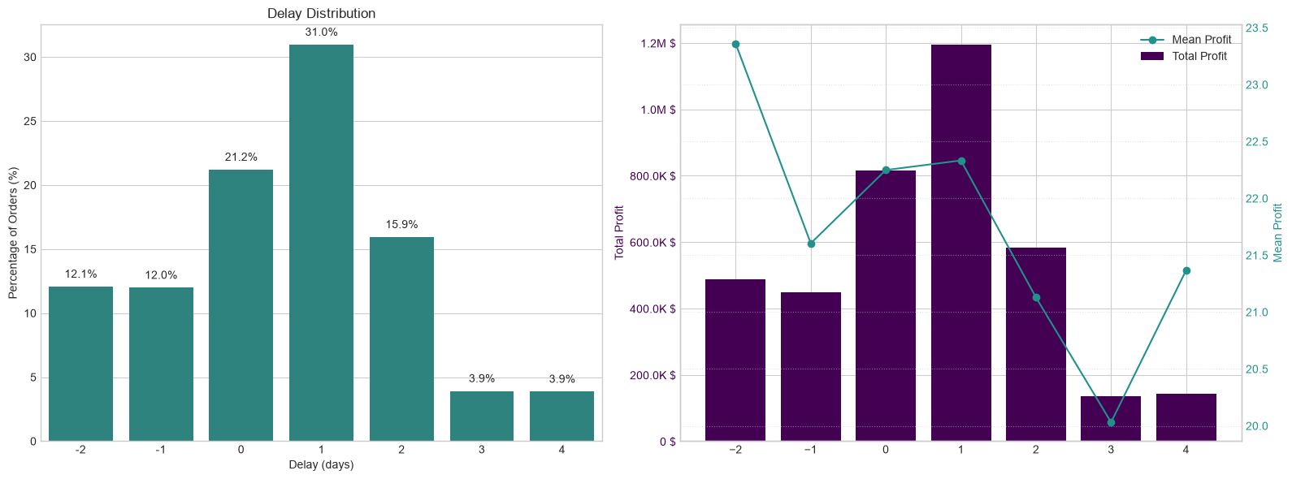
Figure 2: Delay distribution (left) and profit analysis by delay days (right)
● Critical observation | Mean profit per order remains stable at approximately $20–$23 across all delay levels (delayed orders average $21.75 versus $22.37 for on-time orders, a gap of only about 3%). The profitability problem is therefore driven by the volume of delayed orders, not by individual order economics — making systemic throughput improvement the highest-leverage intervention.

Note: the 18.7% loss-making share should be analysed separately. Because mean profit does not fall with delay, this analysis does not show that losses are concentrated among late orders; confirming or ruling that out requires a discount-by-delay cut of the data (Recommendation 7).

5. Bottleneck Detection
Delay percentage was computed across six key operational dimensions. The charts below reveal where the fulfilment process breaks down most severely.
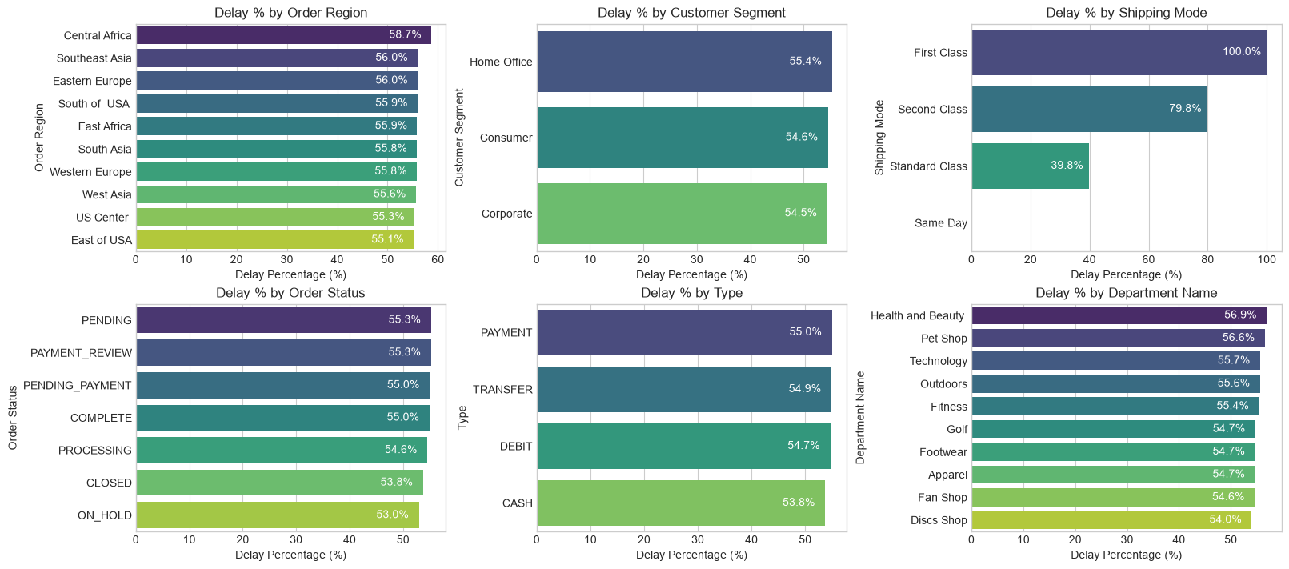
Figure 3: Bottleneck detection — delay % by category (top 10 categories per dimension)
Spread of delay rates by dimension. A bottleneck is a dimension where the delay rate differs sharply between its categories. Shipping mode is the only dimension with a large spread.
Dimension | Highest delay rate | Lowest delay rate shown | Spread
Shipping Mode | First Class 100.0% | Same Day 0.0% | 100.0 pts
Order Region | Central Africa 58.7% | East of USA 55.1% | 3.6 pts
Department | Health and Beauty 56.9% | Discs Shop 54.0% | 2.9 pts
Order Status | PENDING / PAYMENT_REVIEW 55.3% | ON_HOLD 53.0% | 2.3 pts
Payment Type | PAYMENT 55.0% | CASH 53.8% | 1.2 pts
Customer Segment | Home Office 55.4% | Corporate 54.5% | 0.9 pts

Region and department charts show the top 10 categories only; "lowest shown" is the lowest of those ten.
Shipping mode: the dominant failure
Shipping mode | Sched. days | Orders | Share of orders | Delay rate | Late orders (approx.) | Share of late orders
Standard Class | 4 | 103,153 | 59.7% | 39.8% | ≈ 41,055 | ≈ 43.4%
Second Class | 2 | 33,806 | 19.6% | 79.8% | ≈ 26,977 | ≈ 28.5%
First Class | 1 | 26,513 | 15.3% | 100.0% | 26,513 | ≈ 28.0%
Same Day | 0 | 9,293 | 5.4% | 0.0% | 0 | 0.0%

Late orders are estimated as delay rate × orders (rounded rates), so totals differ from 94,523 by a few dozen orders.
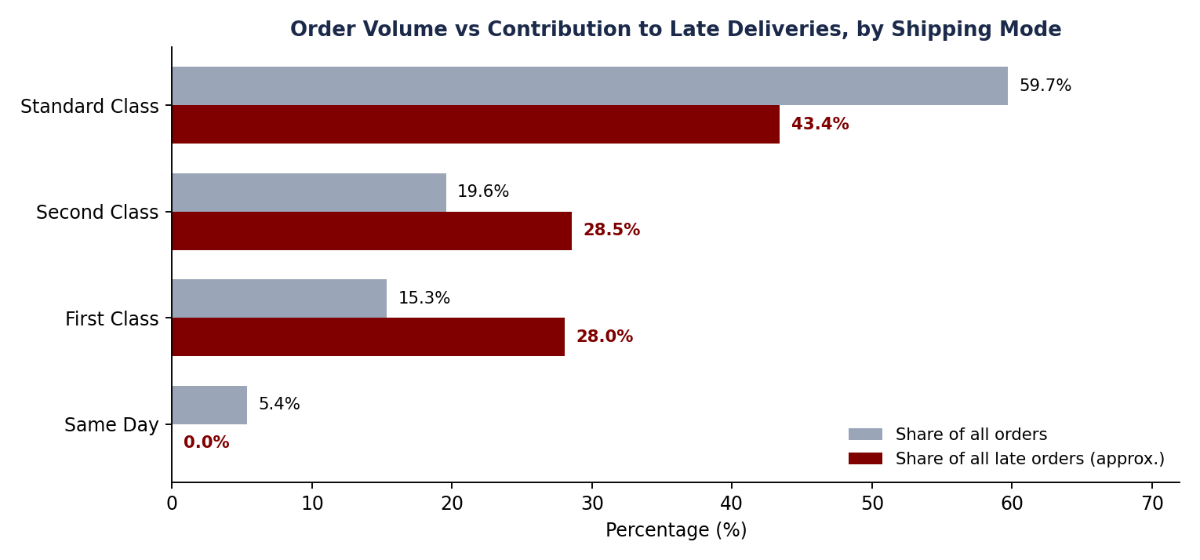
Figure 4: Share of orders versus share of late orders, by shipping mode
Key bottleneck findings
- Shipping mode: First Class is late on 100% of orders and Second Class on 79.8%, while Same Day is never late. Together the two premium modes are about 35% of orders but about 57% of all late deliveries.
- Region: Central Africa is the weakest region at 58.7%, about 4 points above the company average, but all top-10 regions sit within 55–59%.
- Payment: PENDING and PAYMENT_REVIEW orders (55.3%) run slightly above the 54.7% average; the effect is small nationally but severe in specific regions (see Section 6).
- Segment and department: Customer segment makes almost no difference (0.9 pts). Health and Beauty (56.9%) and Pet Shop (56.6%) are the most delay-prone departments.
● Structural signal | Delay rates of exactly 100% (First Class) and 0% (Same Day) are unusual for real operations. They suggest the promised delivery windows are structurally misaligned with how each mode is actually fulfilled. Validating the SLA definitions with the logistics team should be the first step of any remediation.

6. Root Cause Analysis
To understand what drives delay inside the weakest region, the top contributing factors were ranked for Central Africa (58.7% delay rate). Every factor below is the delay rate of orders within that factor level.
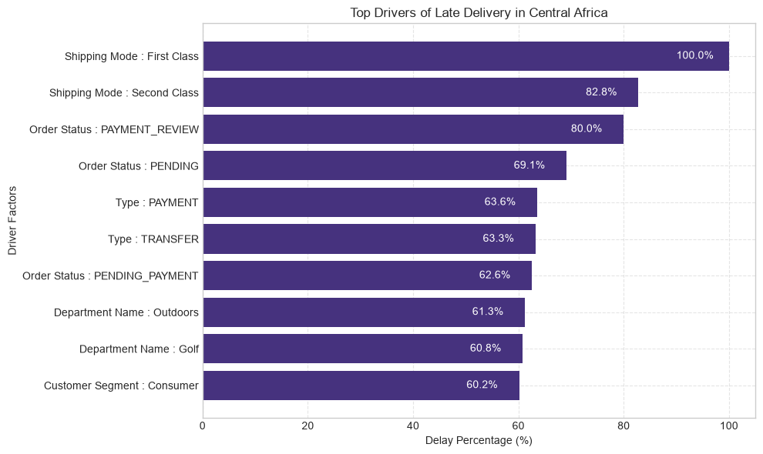
Figure 5: Top drivers of late delivery in Central Africa
Even in the worst region the same pattern holds. Shipping mode dominates (First Class 100%, Second Class 82.8%), followed by payment-related order states: PAYMENT_REVIEW orders are late 80.0% of the time and PENDING orders 69.1%. Payment type (PAYMENT 63.6%, TRANSFER 63.3%) and the Outdoors (61.3%) and Golf (60.8%) departments follow.
Root cause ranking
# | Root cause | Evidence | Strength
1 | Shipping mode misconfiguration | First Class 100% late, Second Class 79.8%; premium modes cause ≈ 57% of late orders. | Dominant
2 | Payment processing friction | PAYMENT_REVIEW 55.3% overall but 80.0% in Central Africa; PENDING 69.1% in Central Africa. | Secondary
3 | Geographic disparity | Central Africa 58.7% vs. 55–56% elsewhere; gap of roughly 3–4 pts. | Secondary
4 | Seasonal peaks | Aug–Sep 55.4% and Dec 55.2% vs. 53.7% low in July. | Minor
5 | Product department | Health and Beauty 56.9%, Pet Shop 56.6% vs. 54.0% lowest. | Minor

Caution: order status is a snapshot at the time of extraction, and some regional segments (for example PAYMENT_REVIEW, only 1,893 orders company-wide) are small. Order counts per factor level should be checked before acting on the most extreme percentages.

7. Time-Based Delay Patterns
Three temporal dimensions were analysed: month of year, day of week, and hour of day. While delay rates are relatively stable across all dimensions (roughly 52–57%), specific peaks highlight opportunities for targeted capacity planning.
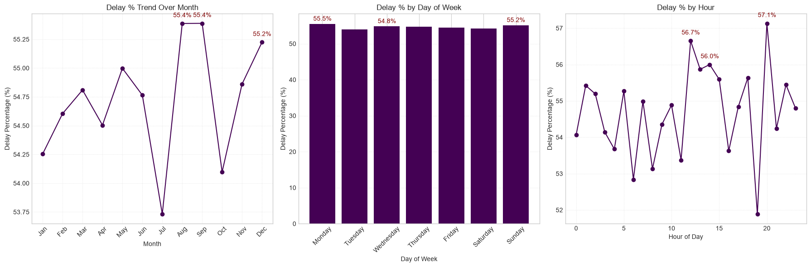
Figure 6: Delay % by month (left), day of week (centre) and hour of day (right)
Dimension | Peak periods (delay %) | Lowest period (approx.) | Reading
Month | Aug 55.4%, Sep 55.4%, Dec 55.2% | Jul ≈ 53.7% | Late-summer and December peaks, about 1.7 pts above July.
Day of week | Mon 55.5%, Sun 55.2%, Wed 54.8% | Tue / Sat ≈ 54% | Essentially flat; a spread of about 1.5 pts.
Hour of day | 20:00 57.1%, 12:00 56.7%, 14:00 56.0% | 19:00 ≈ 51.9% | Largest swings; midday and evening order peaks.

● Planning implication | Temporal effects are mild compared with shipping mode (about 2–5 pts versus up to 100 pts). Seasonal capacity measures should be treated as fine-tuning, to be done after the shipping-mode problem is resolved. The sharp one-hour jump between 19:00 and 20:00 is likely partly sampling noise and should be validated before building hour-specific rules.

8. Machine Learning Model Results
A supervised classification model was built to predict whether an individual order will be delivered late (Late_delivery_risk = 1). The pipeline included frequency encoding of categorical variables, a stratified train/test split, SMOTE oversampling to address class imbalance, and Random Forest classification.

Model inputs and set-up
Item | Detail
Features (9) | Scheduled shipment days, order month, order hour, and frequency-encoded Type, Category Name, Customer Segment, Department Name, Order Region and Shipping Mode.
Target | Late_delivery_risk (1 = late: 98,977 orders, 57.3%; 0 = on time: 73,788 orders, 42.7%).
Split | 80% train (138,212 orders) / 20% test (34,553 orders), stratified, random_state = 42.
Algorithm | Random Forest Classifier with default scikit-learn settings, trained on the SMOTE-balanced training set.
Class Imbalance Handling (SMOTE)
Split | Class 0 (On-time) | Class 1 (Late)
Before SMOTE (train) | 59,030 | 79,182
After SMOTE (train) | 79,182 | 79,182

SMOTE was applied to the training set only; the test set keeps the natural class mix.
Random Forest Classifier – Test Set Performance (34,553 records)
Metric | Class 0 (On-time) | Class 1 (Late) | Overall (Weighted)
Precision | 0.68 | 0.79 | 0.74
Recall | 0.73 | 0.75 | 0.74
F1-Score | 0.70 | 0.77 | 0.74
Accuracy | — | — | 0.74
Support | 14,758 | 19,795 | 34,553

Interpretation of the results
● 74% Overall Accuracy | The model correctly classifies nearly 3 in 4 orders — a strong foundation for production deployment as an order-level late-delivery alert system. For context, always predicting "late" would be right 57.3% of the time, so the model adds roughly 17 points of accuracy.

● Higher Precision on Late Orders (0.79) | When the model predicts an order will be late, it is correct about 79% of the time — sufficient to trigger targeted interventions without generating excessive false alarms.

● Recall for Late Orders at 0.75 | The model captures 75% of actual late orders. The 25% miss rate is acceptable for a first-generation alert system, with clear improvement potential.

Limitations and model-governance notes
- Likely reliance on shipping mode. Scheduled days map one-to-one to shipping mode, which is the dominant driver of delay. Feature importance should be reported to confirm how much of the 74% comes from this single signal and how much from other features.
- Target definition. The model predicts the system flag Late_delivery_risk (57.3% late), which differs slightly from the computed Delay > 0 used for the KPIs (54.7%). The two should be reconciled before deployment.
- Single baseline run. Results come from one default-parameter Random Forest and one split. Cross-validation, hyper-parameter tuning and alternative models (for example gradient boosting) are needed to reach the 82% target.
- Encoding. Frequency encoding was computed on the full dataset before the split. It does not use the target, so leakage risk is low, but it should be fitted on the training set only in production.

9. Strategic Recommendations
Based on the findings across all analytical dimensions, the following prioritised actions are recommended:
CRITICAL | 1. Immediately Audit First Class & Second Class Shipping Capacity  First Class shipping has a 100% delay rate and Second Class 79.8%. These modes operate in complete contradiction to their brand promise. Conduct an immediate carrier SLA audit. Until resolved, consider suspending First Class or repricing to reflect actual performance.

HIGH | 2. Deploy the Predictive Alert System  The Random Forest model (74% accuracy, 79% precision on late orders) is ready for production piloting. Integrate it into the order management system to flag high-risk orders at confirmation and trigger proactive customer communication and priority handling queues.

HIGH | 3. Resolve Payment Processing Bottlenecks  PAYMENT_REVIEW orders are late 55.3% of the time overall and 80.0% in Central Africa; PENDING orders reach 69.1% there. Introduce automated escalation for stalled payment reviews exceeding 2 hours, starting with the highest-delay regions.

MEDIUM | 4. Develop Seasonal Surge Capacity Plans  August and September (55.4%) and December (55.2%) are peak delay months. Build pre-season capacity plans including temporary logistics partnerships, inventory pre-positioning, and adjusted delivery promise windows.

MEDIUM | 5. Default to Standard Class for Eligible Orders  Standard Class achieves a 39.8% delay rate — far superior to First and Second Class. Re-evaluate shipping mode assignment logic to default eligible orders to Standard Class, particularly in regions and departments with poor premium mode performance.

MEDIUM | 6. Investigate High-Delay Departments and Regions in Africa  Health and Beauty (56.9%) and Pet Shop (56.6%) lead company-wide delay rates, while in Central Africa Outdoors (61.3%) and Golf (60.8%) are the worst departments. Run a targeted warehouse and carrier review for these department-region combinations.

LOW | 7. Reduce Loss-Making Order Share (18.7%)  The 18.7% loss-making order share warrants a separate pricing and discount review. Combine with delay analysis to identify whether discounted orders are disproportionately late, creating a compounded margin problem.

LOW | 8. Continuously Retrain the Predictive Model  Retrain the model quarterly. Explore adding carrier-level data, weather events, and warehouse utilisation features. Target a recall improvement to above 80% on late orders within 6 months.

9.1 Expected impact of the shipping-mode fixes
Using the delay rates and order volumes from Section 5, a simple scenario shows how much of the late-delivery problem the first recommendations could remove. The scenario holds order volumes and the Same Day mode constant and is illustrative, not a forecast.
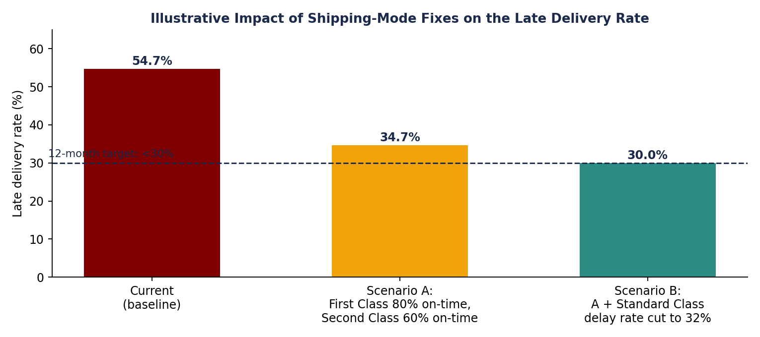
Figure 7: Illustrative late delivery rate under shipping-mode improvement scenarios
Scenario | Assumption | Late orders | Late rate
Current | Baseline delay rates by mode | 94,523 | 54.7%
A | First Class 80% on-time, Second Class 60% on-time (Standard unchanged) | ≈ 59,900 | ≈ 34.7%
B | A, plus Standard Class delay rate reduced from 39.8% to 32% | ≈ 51,800 | ≈ 30.0%

Fixing the two premium modes alone removes roughly 20 points of late-delivery rate; reaching the 12-month goal of under 30% additionally requires improving Standard Class, which carries the largest absolute volume of late orders.

9.2 Implementation roadmap
Horizon | Actions | Owner (suggested)
0–30 days | Carrier SLA audit (Rec. 1); validate delivery-promise definitions; define the alert-system pilot scope (Rec. 2). | Logistics, Data Analytics
30–90 days | Pilot predictive alerts on selected regions; payment-review escalation rule (Rec. 3); default-to-Standard rule (Rec. 5). | Operations, IT, Payments
3–6 months | Seasonal capacity plan ahead of Aug–Dec (Rec. 4); department and region reviews (Rec. 6); pricing and discount review (Rec. 7). | Operations, Finance
6–12 months | Quarterly model retraining with carrier, weather and warehouse data to reach more than 80% recall (Rec. 8); track KPIs in Section 10. | Data Analytics

10. Conclusion
This analysis has surfaced a clear and urgent picture: a global e-commerce operation where the majority of orders (54.71%) fail to meet their promised delivery windows, costing $2.1M in at-risk profit and undermining customer trust at scale.
The root causes are identifiable and addressable. Shipping mode misconfiguration (First Class at 100% late, Second Class at 79.8%) is the dominant operational failure. Payment processing friction creates a secondary bottleneck. Seasonal peaks add a modest but predictable uplift and are not yet planned for explicitly. Geographic disparities, while present, are secondary to the systemic company-wide pattern.
A Random Forest predictive model trained on readily available order features already achieves 74% accuracy in identifying at-risk orders. This is a deployable tool, not a future aspiration.
Targets and KPIs
Priority Area | Current State | Target State
Late Delivery Rate | 54.71% | < 30% within 12 months
First Class On-Time Rate | 0% | > 80%
Second Class On-Time Rate | 20.2% | > 60%
Predictive Model Accuracy | 74% | > 82% (enhanced model)
Loss-Making Orders | 18.7% | < 12%
Profit at Risk | $2.1M | Reduce by 40%

With focused execution on the eight recommendations in this report, starting with the critical shipping mode audit and predictive alert system deployment, the business can systematically recover its delivery performance, protect its $7.5M profit base, and build the operational reliability that sustained e-commerce growth demands.

