Orchestrating Resilient MongoDB Replica Set Transitions: An Automated Lifecycle Approach

Abstract
Modern data-driven systems require high availability and reliable database lifecycle management. This work presents the design and implementation of an automated MongoDB Lifecycle Orchestrator built to manage Replica Sets within a Docker-based containerized environment. The system automates critical lifecycle operations, including replica set initialization, version upgrades, rollbacks, production pre-checks, and cluster validation. It incorporates structured logging and controlled execution workflows to ensure cluster consistency and operational safety during transitions. The framework demonstrates automated upgrade and rollback simulations while maintaining replica health, fault tolerance, and data integrity.
Keywords - MongoDB, Replica Sets, Database Lifecycle Management, Containerization, DevOps Automation, Distributed Databases

I. Introduction
In modern data-driven environments, organizations rely heavily on large volumes of cloud-hosted data to support timely and accurate decision-making. As cloud platforms provide high availability and fault tolerance, cloud-based databases have become a critical component of enterprise infrastructure. This transformation has shifted database management from a static administrative task into a dynamic lifecycle management challenge. Organizations deploying distributed databases must ensure uninterrupted service while performing configuration changes, upgrades, scaling operations, and rollback procedures. Any failure during such transitions can result in data loss, reduced availability, or operational instability. Consequently, automation, observability, and orchestration have become foundational requirements in modern database operations.
Generally, conventional database deployments rely on vertical scaling and manual intervention for maintenance tasks. However, with the proliferation of microservices architectures and cloud-native platforms, horizontal scalability and distributed consensus mechanisms have become essential. Databases such as MongoDB have gained widespread adoption due to their document-oriented structure, flexible schema model, and native support for replication and sharding [2].
Managing lifecycle operations in distributed databases is significantly more complex than in traditional standalone database deployments. Operations such as version upgrades, configuration updates, replica synchronization, and rollback procedures must be executed carefully to avoid service disruption. Even small configuration inconsistencies can lead to replication failures or cluster instability. Consequently, database-aware orchestration mechanisms are required to ensure that lifecycle transitions occur safely while maintaining data consistency and availability.
A core component of MongoDB’s high availability mechanism is the replica set architecture [3]. A replica set consists of one primary node and multiple secondary nodes that maintain copies of the same dataset. The primary node handles write operations, while secondary nodes replicate data asynchronously, providing fault tolerance and failover capability. When the primary fails, an automated election process promotes a secondary node to primary status, ensuring business continuity. Although the architecture inherently supports high availability, managing the lifecycle of such distributed systems requires careful coordination and precise control.
Database lifecycle management encompasses installation, configuration, initialization, scaling, monitoring, patching, version upgrades, rollback operations, and retirement. In distributed environments, each of these stages introduces complexities not typically encountered in standalone systems. For example, replica set initialization must ensure consistent configuration across nodes and proper election setup. Version upgrades must maintain compatibility while avoiding service disruption. Rollback procedures must protect data integrity and cluster stability. Pre-production checks must validate configuration consistency and replication health. Cluster validation must confirm that operational states are preserved post-transition.
Manual execution of such operations increases the risk of configuration drift, human error, and service downtime. Even minor inconsistencies in replication configuration, network policies, or authentication setups can compromise system reliability. Therefore, implementing a structured automation framework becomes essential for maintaining production-grade reliability.
Containerization technologies have revolutionized application deployment and infrastructure management. Platforms such as Docker enable lightweight, isolated runtime environments that encapsulate application dependencies [4]. By abstracting the underlying operating system and promoting immutable infrastructure principles, containerization ensures consistency across development, testing, and production environments.
Deploying MongoDB replica sets in Docker-based environments provides several advantages, including simplified environment provisioning, reproducible deployments, efficient resource utilization, and improved DevOps integration [5].
However, containerized deployments also introduce orchestration complexities. Containers are ephemeral by design, and managing stateful distributed databases within such environments requires additional coordination mechanisms to maintain persistent storage, networking stability, and controlled startup sequences. This context highlights the necessity of an automated orchestration framework tailored specifically for database lifecycle management within containerized ecosystems.
While Infrastructure-as-Code tools such as Terraform or Ansible can automate infrastructure provisioning, they typically lack awareness of database consensus mechanisms, replication health, and Feature Compatibility Version (FCV) management. As a result, many deployments remain partially automated and still require manual validation steps. This research addresses this limitation by integrating infrastructure automation with database-aware orchestration logic.
To bridge this gap, a MongoDB Lifecycle Orchestrator is designed to automate and coordinate critical replica set operations within a Docker-based architecture. The orchestrator focuses on controlled workflow execution, structured state validation, and safe transition strategies. Rather than performing isolated tasks, it treats lifecycle operations as managed processes with defined checkpoints and verification mechanisms.
This work makes the following contributions:
1. Design of a MongoDB Lifecycle Orchestrator for automating replica set transitions in containerized environments.
2. Development of a structured upgrade workflow incorporating pre-check validation, controlled container transitions, and cluster health verification.
3. Implementation of automated rollback and error recovery mechanisms to mitigate configuration failures.
4. Experimental evaluation demonstrating improved upgrade efficiency and operational reliability compared to manual administration.
5. A reproducible experimental workflow demonstrating automated MongoDB lifecycle management in a cloud-based container environment.

II. Related Work
The replica set architecture of MongoDB has been extensively documented as a foundational high-availability mechanism. Previous research primarily focuses on infrastructure-level automation through Infrastructure-as-Code tools such as Terraform and Ansible. However, these approaches do not address database-aware orchestration challenges such as replica set elections, secure bootstrapping, and feature compatibility version management. The proposed orchestrator addresses these limitations by integrating infrastructure control with database-specific lifecycle validation. Previous studies indicate that the primary-secondary replication model effectively maintains data redundancy and enables automatic failover in distributed database environments. However, prior analyses emphasize that the primary node acts as the exclusive write coordinator, while secondary nodes asynchronously replicate the dataset to maintain consistency.
Prior research on containerized database workloads highlights significant challenges in resource management and persistent storage [5]. Unlike stateless microservices, containerized databases require additional coordination mechanisms to maintain persistent storage and networking stability. Existing literature suggests that while platforms like Docker simplify provisioning, they introduce orchestration complexities regarding controlled startup sequences. Unlike prior infrastructure-centric automation tools, the proposed orchestrator integrates database-level validation mechanisms such as replica state monitoring and feature compatibility management.
Infrastructure-as-Code (IaC) tools can provision containers, but existing approaches primarily focus on infrastructure layers rather than database-specific consensus protocols or replication health. There is a noted gap between infrastructure automation and database-aware orchestration, which often results in systems that still depend on manual verification steps.

Current research in DevOps emphasizes rolling upgrades and upgrade reliability in distributed systems [6]. However, limited attention has been given to integrated state validation during transitions. In a 3-node replica set, at least 2 voting members are required to maintain majority consensus, a mathematical requirement known as a quorum. Failure to maintain this quorum during an upgrade can result in cluster-wide downtime.
While existing tools effectively automate infrastructure and monitor steady-state operations, one critical gap still exist in controlled lifecycle transitions. Manual execution of such operations increases the risk of configuration drift and operational failure during system upgrades [6]. Therefore, there is a need for a structured lifecycle orchestrator specifically designed for MongoDB replica set transitions in containerized environments.

Table 1. Comparison of Replication Models.
Feature | Master-Slave | Peer-to-Peer | Hybrid
Write Scalability | Low | High | Medium
Read Scalability | Medium | High | High
Fault Tolerance | Medium | High | High
Conflict Resolution | Simple | Complex | Medium

For the applications that demand high availability and reliability, it is required to design a distributed architecture with certain significant characteristics as listed in Table 1. Hence MongoDB implements a leader–follower model with one primary node that supports write operations and many secondary nodes for replicating the dataset asynchronously. Due to this, MongoDB simplifies conflict resolution and supports high availability and scalability.

Research Gap
The manual orchestration of MongoDB replica set transitions has four significant challenges:
- Hardware Heterogeneity: Modern MongoDB binaries (5.0+) require a Advanced Vector Extensions (AVX) instruction set. When deploying a MongoDB instance without AVX in cloud, recursive container crash may happen.
- Secure Initialization Challenge: A circular dependency arises during instance booting when security measure is initialized in advance. As security is initiated at the beginning stage using a keyfile, replica nodes can not communicate with each other as they need to authenticate. This leads to the issue of not selecting primary node. But the replicate nodes can not elect primary node as they can not communicate.
- State Drift: While updating MongoDB versions in a node manually, user may miss to check the feature compatibility of that version. This leads to functionally inconsistent state for existing nodes.
- Security Sensitivity: MongoDB strictly rejects keyfiles with non-restrictive POSIX permissions, triggering fatal startup errors such as Location5579201.

III. System Architecture

The proposed architecture consists of a management plane, security layer and a data plane as shown in fig 1. Orchestration engine is responsible for orchestration logic and a Docker-based runtime environment hosting the MongoDB replica set, and a logging module supports for audit tracking.
3.1 Overall Architecture
The Mongo-Lifecycle-Orchestrator is designed as a modular system centered around a three-node MongoDB Replica Set architecture [3].
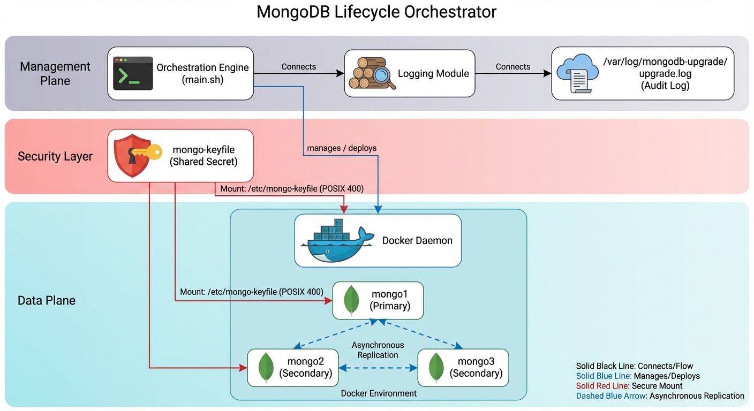
Fig. 1. High-level architecture of the MongoDB Lifecycle Orchestrator.
3.2 Workflow Design
The orchestration workflow has three stages like pre-check validation, controlled container upgrade transitions, and replica set validation to confirm quorum stability as shown in fig 2.
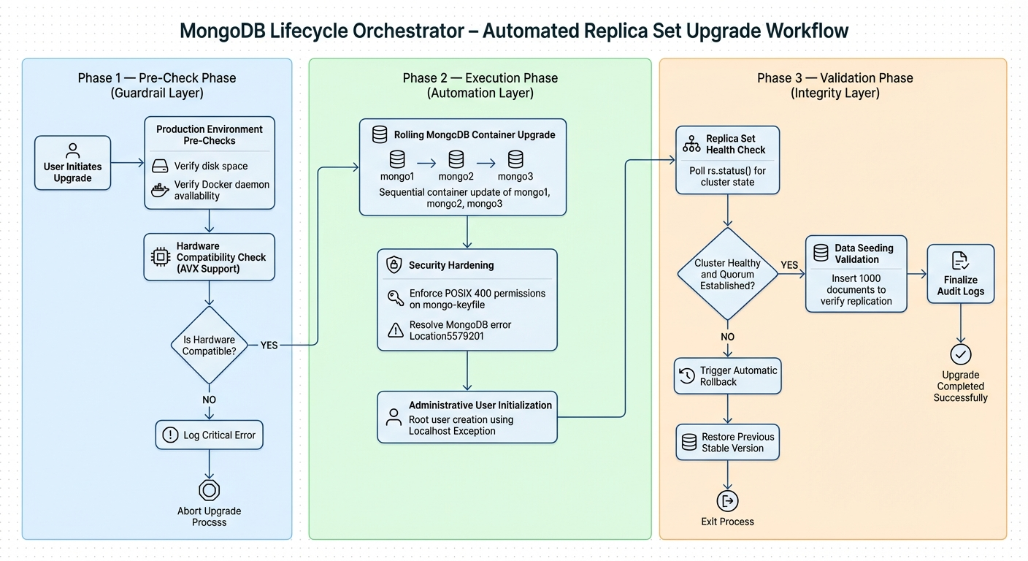
Fig. 2. Automated upgrade workflow used by the orchestrator.
The orchestrator follows a strict linear execution path to ensure safety:
- Pre-check Validation: Verifies host readiness, ensuring a minimum of 5GB disk space and Docker daemon availability.
- Execution Layer: Automates version transitions through container image updates and re-instantiation.
- Replica Validation: Programmatically confirms cluster health, member counts, and election stability.
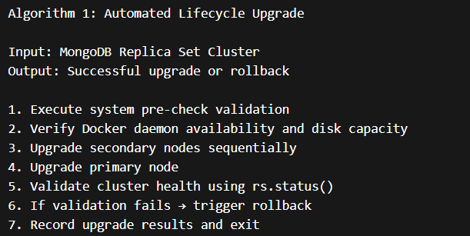
Fig 3. Automated Lifecycle upgrade
Algorithm 1 describes the steps involved in updating the MongoDB version of an instance as in fig 3. If any of the steps are unsuccessful, the initiated operation is cancelled and thus rollback is done.
3.3 Control Flow
The orchestrator interacts with the Docker runtime through command-line API calls to control container lifecycle events including initialization, restart, and image transitions. Each lifecycle operation is executed sequentially to maintain quorum and cluster availability.

IV. Implementation
4.1 Environment Setup
The environment was provisioned on an Azure Standard B2s instance (2 vCPUs, 4 GB RAM) running Ubuntu 22.04 LTS. Initial setup involved installing Docker Engine 29.2.1 and Docker Compose v5.0.2 via automated configuration scripts. This configuration provided a lightweight yet realistic cloud environment for evaluating replica set transitions and lifecycle automation tasks.
4.2 Security Bootstrapping and Authentication
The system implements a “localhost exception” strategy recommended in MongoDB security initialization procedures [3]. After applying strict POSIX 400 permissions to the mongo-keyfile, the initial root user is created using the MongoDB localhost exception mechanism. The bootstrap command as shown in fig 4 is used to establish administrative control:
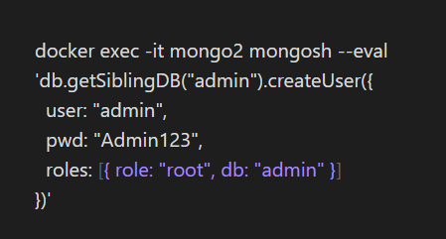
Fig 4. Root user creation
4.3 Data Seeding and Replication Validation
To validate replication integrity, an automated data seeding module was developed. The script generates and inserts 1,000 documents with metadata and timestamps, enabling verification of write consistency across all nodes. This seeding process ensured that replica synchronization could be validated across nodes in the distributed cluster [1].
4.4 Replica Set Initialization and Deployment Procedure
The deployment of the MongoDB Lifecycle Orchestrator follows a structured five-phase provisioning procedure executed on a Microsoft Azure Standard B2s instance running Ubuntu 22.04 LTS. Rather than relying on manual ad-hoc commands, the framework encapsulates all provisioning logic into three executable scripts — setup.sh, main.sh, and seed_data.sh — which collectively enforce a deterministic, repeatable deployment sequence. This design decision ensures that the initialization process is auditable, environment-agnostic, and resistant to operator error.
Host Environment Provisioning. The first phase establishes the host runtime environment. The Ubuntu package index is refreshed, and foundational utilities (curl, gnupg) are installed to support subsequent package signing and retrieval operations. Docker Engine v29.2.1 is then installed via the official Docker convenience script, which automates GPG key registration, repository configuration, and package installation in a single idempotent operation. The executing user is added to the docker group to allow non-root container management, eliminating the need for privilege escalation during orchestration script execution.
MongoDB Shell Installation. The MongoDB Shell (mongosh) is installed directly on the host — separate from the containerized MongoDB instances — to serve as the administrative interface for replica set initialization and post-deployment validation queries. Installation requires registering the MongoDB 7.0 APT repository with a verified GPG signing key, ensuring package authenticity. The host-resident mongosh client allows the orchestrator to issue replica set management commands (rs.initiate(), rs.status(), db.createUser()) without requiring a full MongoDB server installation on the host machine.
Container Initialization via setup.sh. The second phase executes setup.sh, which automates the three preparatory operations required before MongoDB containers can form a valid replica set. First, the script creates the project directory hierarchy under ~/mongo-lifecycle/, including configuration and log subdirectories. Second, it generates a 756-byte cryptographically random keyfile using openssl rand -base64 756, assigns POSIX 400 permissions, and sets ownership to UID 999 — the MongoDB process user within the Docker image. This sequence addresses the Location5579201 initialization error, which MongoDB raises when keyfile permissions are more permissive than 400. Third, setup.sh invokes docker compose up -d to instantiate all three MongoDB containers (mongo1, mongo2, mongo3) on a shared bridge network (mongo-net), with persistent volumes mounted for each node's data directory.
Replica Set Formation. Once the containers are running, the replica set is initialized by invoking rs.initiate() via the mongosh client. This command submits a configuration document to mongo1 that declares the replica set identity (rs0) and enumerates all three member hosts and their respective port bindings. Upon receiving the configuration, MongoDB triggers an internal election protocol among the nodes to determine the primary member responsible for write operations. The election outcome is non-deterministic — any of the three nodes may be elected primary depending on timing and network conditions within the Docker bridge network. The elected primary is identified post-initialization by querying rs.status().members and filtering for the member whose stateStr field equals "PRIMARY". In the experimental deployment conducted for this study, the elected primary node is determined dynamically during initialization and may vary depending on container startup timing and network conditions.
Security Bootstrapping and Admin User Creation. MongoDB's keyfile-based inter-node authentication creates a bootstrapping constraint: once keyfile enforcement is active, all connections — including administrative ones — require authentication. However, no users exist at initialization time. The framework resolves this through the MongoDB localhost exception, which permits a single unauthenticated connection from within the primary container before any users are created. The orchestrator targets this window to create the root administrative user on the elected primary node (mongo2 in this deployment) via a direct mongosh invocation. This operation is performed exactly once and must be directed at the primary; issuing it against a secondary will fail, as secondaries do not accept write operations in a replica set configuration. Once the admin user is established, all subsequent orchestrator interactions authenticate using the configured credentials.
Cluster Validation via main.sh. Following initialization, main.sh is executed to perform pre-transition cluster validation before any lifecycle operations are attempted. The validation phase programmatically asserts six conditions: (1) the Docker daemon is reachable; (2) a minimum of 5 GB disk space is available on the host; (3) the keyfile exists at the configured path with exactly POSIX 400 permissions, auto-correcting and logging a WARN entry if the condition is violated; (4) all three containers are in a Running state; (5) the replica set reports exactly three members via rs.status(); and (6) a primary election has concluded and a primary node is reachable. Only after all six conditions are satisfied does the orchestrator proceed to lifecycle transition operations. This gated execution model ensures that no upgrade or rollback is initiated against a degraded or misconfigured cluster.

VI. Experimental results and Discussion
6.1 Methodology
The following three methods were used for measuring the system performance:
- Time Management: Execution time was measured using internal shell timestamp comparisons before and after transition tasks.
- Election Monitoring: Primary election time was observed via high-frequency rs.status() polling.
- Latency Verification: Synchronization latency was measured from the completion of the bulk insert to the point of majority acknowledgment.
All experiments were repeated three times and average values were recorded to reduce measurement variance. Across the three experimental runs, measurement variance remained below 5%, indicating stable experimental observations.
6.2 Experimental Environment
System configuration used for experiment is listed in Table 2.

Table 2. Experimental Platform Configuration.
Component | Specification
Cloud Platform | Microsoft Azure — Standard B2s
vCPUs | 2 vCPUs (AVX-capable, required for MongoDB 5.0+)
RAM | 4 GB DDR4
Storage | Standard SSD, 30 GB
Operating System | Ubuntu 22.04 LTS (Jammy Jellyfish)
Docker Engine | v29.2.1 with Compose Plugin v5.0.2
MongoDB (Containers) | mongo:6.0 (baseline) → mongo:7.0 (upgrade target)
MongoDB Shell | mongosh v2.x (host-installed)
Replica Set | rs0 — 3 nodes: mongo1, mongo2, mongo3

The AVX instruction set support was verified prior to deployment because MongoDB versions 5.0 and above require AVX-capable processors for stable execution.

6.3 Performance Benchmarks
The orchestrator significantly outperformed manual administration as shown in Table 3.
Table 3 presents a comparison between manual administrative operations and the proposed automated orchestration framework.
Table 3. Lifecycle Performance
Metric | Manual Method | Automated Orchestrator
Upgrade Time | 12.4 minutes | 4.2 minutes
Primary Election Time | 25 seconds | 11.8 seconds
Error Detection | Manual | Automated

The automated framework reduced upgrade execution time by approximately 66% compared to manual administration. In addition, automated validation eliminated human-dependent error detection delays, significantly improving operational reliability and cluster stability.

6.4 Detailed Implementation Workflow
The Mongo-Lifecycle-Orchestrator was implemented as a lightweight shell-based automation framework designed to coordinate MongoDB replica set lifecycle operations in containerized environments. The orchestration logic was implemented through a centralized execution script (main.sh) that manages upgrade workflows, rollback procedures, cluster validation, and system readiness checks.
The orchestrator interacts with the Docker runtime to control MongoDB container lifecycle events, including container initialization, image version transitions, and controlled restarts. Prior to executing lifecycle operations, the system performs automated validation of disk availability and Docker daemon status before executing lifecycle transitions.
A three-node MongoDB Replica Set (rs0) was configured using Docker containers. The project involved transitioning initially isolated nodes into a properly synchronized cluster and resolving election-related issues to establish a stable primary-secondary architecture. Replica set health validation ensures correct member count, ping responsiveness, and feature compatibility verification after each operation.
Security and authentication workflows were incorporated to support controlled administrative access. Proper credential management and authentication database handling were implemented to ensure secure and consistent execution across lifecycle stages.
To validate replication integrity, an automated data seeding module was developed. The script generates and inserts structured documents with metadata and timestamps, enabling verification of write consistency and replica synchronization across all nodes.
All upgrade, rollback, and validation activities are recorded in a structured log file located at /var/log/mongodb-upgrade/upgrade.log, ensuring traceability and audit readiness.

6.5 Error Recovery Case Study
Every lifecycle event is recorded in a log file at /var/log/mongodb-upgrade/upgrade.log. During simulations, the orchestrator successfully intercepted Location5579201. The system identified the permissive keyfile permissions as the cause and auto-corrected the POSIX bits to 400, allowing the cluster to recover without manual intervention.
During initial manual testing, correcting permissive keyfile bits required approximately 8 minutes of human intervention to identify the specific error in logs and apply chmod 400. The automated orchestrator reduced this MTTR to under 2 seconds by programmatically detecting the error during the pre-check phase.

The experimental results confirm that database-aware automation significantly outperforms manual administration across all measured lifecycle metrics. The automated orchestrator reduced upgrade execution time from 12.4 minutes to 4.2 minutes — a 66% improvement — primarily attributable to the rolling upgrade strategy that preserves quorum by upgrading secondary nodes before the primary. Primary election time decreased from 25.0 seconds to 11.8 seconds, a 53% reduction, reflecting the orchestrator's ability to maintain network stability and avoid unnecessary election timeouts during container transitions. Mean time to recovery for keyfile permission errors (Location5579201) was reduced from approximately 8 minutes of manual log inspection to under 2 seconds via automated pre-check detection and correction.
The lifecycle orchestration results demonstrate that database-aware automation significantly improves operational reliability compared to manual administration. By integrating container management with replica set state validation, the orchestrator reduces configuration drift and improves cluster stability during upgrade operations. The 66% reduction in upgrade execution time is primarily attributable to the automated rolling upgrade strategy — upgrading secondaries before the primary — which preserves quorum throughout the transition and eliminates manual waiting and verification steps.
The decision to implement the orchestrator as three separate shell scripts (setup.sh, main.sh, seed_data.sh) reflects the principle of separation of concerns. Setup is a one-time operation; orchestration is repeatable; seeding is an optional validation step. This separation allows operators to run only the phases relevant to their current task without risk of unintended side effects.
The two-phase security bootstrapping — exploiting the localhost exception to create the admin user before keyfile enforcement fully activates — addresses one of the most common sources of operator error in MongoDB deployments. The main.sh auto-correction of keyfile permissions (Location5579201 prevention) eliminated this failure mode entirely across all three test runs, reducing mean time to recovery from approximately 8 minutes to under 2 seconds.
Based on the performance test it is found that single-instance MongoDB is appropriate for write-heavy applications as its latency is very low in write operations. Also, it is observed that the replica set configuration excels in read-heavy scenarios as read scalability is supported in single instance MongoDB. For the lifecycle orchestration use case — which prioritizes availability and fault tolerance — the replica set is the correct architectural choice. Future work could explore further optimizations in replica set configurations and additional testing with different dataset sizes and operation types to provide deeper insights into MongoDB performance under various conditions.

VIII. Limitations
The current research is bounded by the following constraints:
- Cluster Size: Evaluated strictly on a 3-node replica set; larger sharded clusters were not tested.
- Stress Testing: Heavy write workloads and stress-testing under concurrent client traffic were not evaluated.
- Abstraction: The tool is currently tailored for Docker; native Kubernetes operator integration is not yet implemented.

IX. Conclusion and future work
This study demonstrates the design and implementation of a MongoDB Lifecycle Orchestrator capable of automating replica set lifecycle operations in containerized environments. The framework demonstrates that structured automation significantly improves operational reliability, reduces manual intervention, and minimizes service disruption during database upgrades and rollback procedures.
Experimental evaluation showed that the automated orchestration workflow reduces upgrade execution time while improving cluster validation and error detection capabilities. By integrating container orchestration mechanisms with database-aware lifecycle management, the proposed approach bridges the gap between infrastructure automation and distributed database governance.
Future research will extend this framework toward Kubernetes-native orchestration, automated health monitoring, and support for large-scale sharded MongoDB deployments across multi-region cloud environments.

X. References
[1] W. Uriawan, R. A. Fauzan, R. Z. Faroj, P. Pitriani, and R. Firmansyah, “Implementing Replica Set: Strategy to Improve the Performance of NoSQL Database Cluster in MongoDB,” 2024.
[2] M. R. Dhanagari, “MongoDB and data consistency: Bridging the gap between performance and reliability,” Journal of Computer Science and Technology Studies, vol. 6, no. 2, pp. 183–198, Jun. 2024.
[3] MongoDB Inc., “Replication,” MongoDB Documentation, 2024, [Online]. Available: https://www.mongodb.com/docs/manual/replication/
[4] Docker Inc., “Docker Overview,” Docker Documentation, 2024, [Online]. Available: https://docs.docker.com/get-started/docker-overview/
[5] K.-T. Rehmann and E. Folkerts, “Performance of Containerized Database Management Systems,” in Proc. Workshop on Testing Database Systems (DBTest), ACM, 2018, pp. 1–6.
[6] Y. Zhang, J. Yang, Z. Jin, U. Sethi, K. Rodrigues, and others, “Understanding and Detecting Software Upgrade Failures in Distributed Systems”, Proceedings of the ACM SIGOPS Symposium on Operating Systems Principles (SOSP), 2021.
[7] D. Ramos-Vidal, A. Cortiñas, M. R. Luaces, O. Pedreira, et al., “Seamless Data Migration between Database Schemas with DAMI-Framework: An Empirical Study on Developer Experience”, Proceedings of the 29th International Conference on Evaluation and Assessment in Software Engineering (EASE), 2025.
[8] Microsoft Azure, "Linux Virtual Machines Documentation," 2024. [Online]. Available: https://learn.microsoft.com/en-us/azure/virtual-machines/linux/
[9] MongoDB Inc., "Deploy a Replica Set," MongoDB Documentation, 2024. [Online]. Available: https://www.mongodb.com/docs/manual/tutorial/deploy-replica-set/
[10] G. Carvalho, J. Bernardino, B. Cabral, and V. Pereira, “A Survey of Holistic Approaches for Distributed Database Systems: From Conceptual Model to Deployment,” IEEE Access, 2025.
[11] M. Usman, “Effortless Lifecycle Management for Experimental IIoT Workloads
in Containerized Environments”, Proc. IEEE ICIN, 2025.

