⚡ MongoDB: 15 Hands-On Problems to Practice
1. Write a query to find the second-highest salary from an employee collection.
2. Fetch all users who don’t have an email field or whose email is null.
3. Get all distinct department names from the employee collection.
4. Find all users who have placed more than 5 orders.
5. Perform a join across three collections – users, orders, and products – to get user order details.
6. Find documents where an array field contains duplicate values.
7. Get the top 3 product categories by total sales amount.
8. Update the user’s status field conditionally based on their points or age.
9. Find all products that no user has ever ordered.
10. Implement efficient pagination for a large dataset without using .skip().
11. Explain how sharding works in MongoDB and when it should be used.
12. Find all users where the skills array is missing or empty.
13. Write a query to rename a field (e.g., fullname → name) in all documents.
14. Use aggregation to merge processed results into another collection.
15. How would you analyze and optimize a slow-running query in MongoDB?

MongoDB is a popular NoSQL database that uses a document-oriented data model. Unlike traditional SQL databases that store data in tables with rows and columns, MongoDB stores data in flexible, JSON-like documents called BSON. This allows for more complex data structures and scalability.
Key Features of MongoDB
- Schema-less Design:
MongoDB allows for a flexible schema, meaning documents in the same collection can have different structures.
- High Availability:
Through replica sets, MongoDB ensures data is replicated across multiple servers.
- Horizontal Scalability:
MongoDB supports sharding, enabling the database to scale out across multiple servers.
Why Choose MongoDB?
MongoDB is particularly useful for applications that require:
- Rapid development cycles
- Large-scale, real-time data processing
- Flexibility in schema design
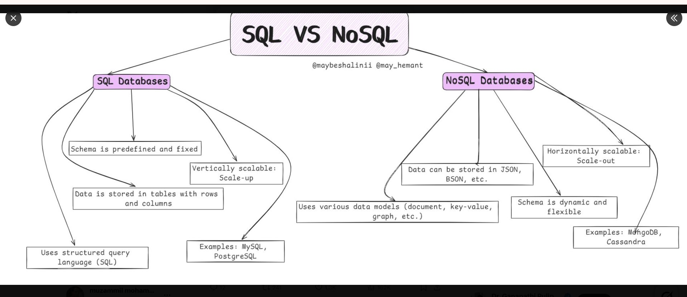
When it comes to databases, the NoSQL vs SQL debate never gets old — especially between MongoDB and PostgreSQL. Both are powerful, but they shine in different ways
MongoDB
Document-based (NoSQL) — stores data in flexible JSON-like documents
Great for high-speed development and scalability
Ideal for unstructured or rapidly changing data
Dynamic schemas = easy to adapt as your project grows
PostgreSQL
Relational (SQL) — stores data in structured tables with relationships
Strong data integrity and ACID compliance
Perfect for complex queries, analytics, and financial systems
Extensible with support for JSON, geospatial data, and more
Choose MongoDB for flexibility and speed
Choose PostgreSQL for structure and reliability
At the end of the day, the best database is the one that fits your project’s needs — not the trend.

