Power BI Dashboard: Build Guide
IPL Phase-Performance and Style-Drift Data Warehouse | Data Wrangling group project
This guide turns the exported workbook into the required Power BI file (IPL_DW_Dashboard.pbix) with three report pages: an overview, a detail / drill-down page and a model-insights page. Every number on the pages comes from the wrangled warehouse and the model outputs, so nothing is typed in by hand. Allow about 45 minutes.
You need: Power BI Desktop (free, Windows only: use a college lab PC or a group member's Windows laptop), and the file data/export/powerbi/IPL_PowerBI_Data.xlsx. If the pipeline is re-run, run python -m src.powerbi again and press Home > Refresh in Power BI.

1. Load the data
- Open Power BI Desktop > Home > Get data > Excel workbook > select IPL_PowerBI_Data.xlsx.
- In the Navigator tick the 18 sheets (green sheet icons, not the tbl... table items): Season, Phase, Venue, Franchise, Team, Player, Role, Matches, TeamMatches, InningsPhase, PlayerSeasonPhase, PhaseSpells, PhaseChanges, FeatureSet, Model, ModelMetrics, TestPredictions, FeatureImportance.
- Click Transform data. For each table check that the first row was used as headers and that key columns are Whole number (all *_key columns, season, year columns), match_date is Date, and rates and probabilities are Decimal number. Close & Apply.
Table | Rows | Grain / use
Season, Phase, Venue, Franchise, Player, Role | 17, 3, 36, 15, 741, 2 | Dimensions for slicers
Matches | 1,095 | One row per match: teams, toss, Powerplay stats, totals, result
TeamMatches | 2,190 | One row per team per match (team win %)
InningsPhase | 6,443 | Match x innings x phase: runs, legal balls, wickets, boundaries, dots
PlayerSeasonPhase | 13,695 | Player x season x role x phase, with the phase index
PhaseSpells / PhaseChanges | 1,187 / 540 | SCD Type 2 spells and the transitions between them
FeatureSet, Model | 2, 6 | Slicer tables for the model page
ModelMetrics, TestPredictions, FeatureImportance | 10, 1,420, 75 | Test-season metrics, predicted vs actual per match, feature importance

2. Relationships (Model view)
Delete any relationship Power BI detected automatically, then create exactly these (all one-to-many, single cross-filter direction, from the first table to the second):
From (one side) | To (many side)
Season[season_key] | Matches[season_key], TeamMatches[season_key], InningsPhase[season_key], PlayerSeasonPhase[season_key]
Venue[venue_key] | Matches[venue_key], TeamMatches[venue_key], InningsPhase[venue_key]
Phase[phase_key] | InningsPhase[phase_key], PlayerSeasonPhase[phase_key]
Franchise[franchise_id] | TeamMatches[franchise_id], InningsPhase[batting_franchise]
Player[player_key] | PlayerSeasonPhase[player_key], PhaseSpells[player_key], PhaseChanges[player_key]
Role[role_type] | PlayerSeasonPhase[role_type], PhaseSpells[role_type], PhaseChanges[role_type]
FeatureSet[feature_set] | ModelMetrics[feature_set], TestPredictions[feature_set], FeatureImportance[feature_set]
Model[model] | ModelMetrics[model], TestPredictions[model], FeatureImportance[model]
Team is kept only as a reference list of name spells and needs no relationship. Do not relate Matches to TestPredictions: it would create a second filter path from Season and Power BI would make one of them inactive.

3. Measures (DAX)
Home > Enter data > create an empty table named _Measures, then add each measure below with New measure (set the format shown in brackets).
Matches = COUNTROWS ( Matches )
Avg First Innings = CALCULATE ( AVERAGE ( Matches[inn1_total_runs] ), Matches[match_status] = "completed" ) [0 dp]
Run Rate = DIVIDE ( SUM ( InningsPhase[runs] ) * 6, SUM ( InningsPhase[legal_balls] ) ) [2 dp]
Powerplay Run Rate = CALCULATE ( [Run Rate], Phase[phase] = "Powerplay" ) [2 dp]
PP Run Rate (Last Season) = VAR y = MAX ( Season[season] ) RETURN CALCULATE ( [Powerplay Run Rate], Season[season] = y )
PP Run Rate (First Season) = VAR y = MIN ( Season[season] ) RETURN CALCULATE ( [Powerplay Run Rate], Season[season] = y )
PP Run Rate Change % = DIVIDE ( [PP Run Rate (Last Season)], [PP Run Rate (First Season)] ) - 1 [%]
Boundary % = DIVIDE ( SUM ( InningsPhase[boundaries] ), SUM ( InningsPhase[balls_faced] ) ) [%]
Dot Ball % = DIVIDE ( SUM ( InningsPhase[dots] ), SUM ( InningsPhase[legal_balls] ) ) [%]
Toss Winner Win % = AVERAGE ( Matches[toss_winner_won] ) [%, 1 dp]
Bat First Win % = AVERAGE ( Matches[bat_first_won] ) [%, 1 dp]
Team Win % = AVERAGE ( TeamMatches[won] ) [%, 1 dp]
Phase Index = AVERAGE ( PlayerSeasonPhase[phase_index] ) [2 dp]
Phase Changes = COUNTROWS ( PhaseChanges )
Predictions = COUNTROWS ( TestPredictions )
Test Matches = DISTINCTCOUNT ( TestPredictions[match_key] )
Model Accuracy = AVERAGE ( TestPredictions[correct] ) [%, 1 dp]
Model ROC-AUC = MAX ( ModelMetrics[roc_auc] ) [2 dp]
Baseline Accuracy = CALCULATE ( MAX ( ModelMetrics[accuracy] ), ModelMetrics[is_baseline] = 1,
ModelMetrics[model] <> "baseline_majority", REMOVEFILTERS ( Model ) ) [%, 1 dp]
AVERAGE ignores blanks, so ties and no-results (blank win columns) drop out of the win percentages automatically.

4. Page 1: Overview ("How the IPL changed, 2008-2024")
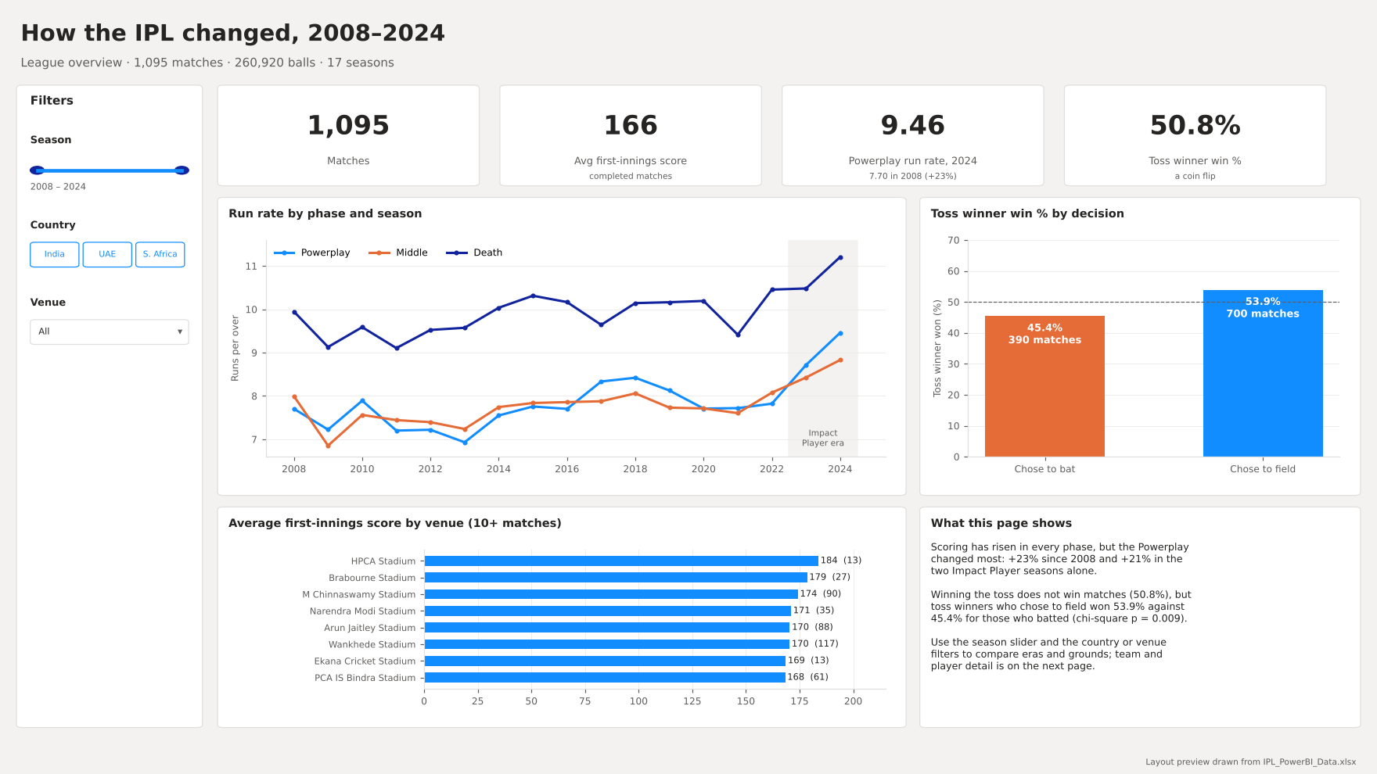
Page 1 layout: build it to look like this.
Visual | Fields and settings
Title text box | "How the IPL changed, 2008-2024"; subtitle "League overview: 1,095 matches, 260,920 balls, 17 seasons"
Slicers (left) | Season[season] (style Between, a slider); Venue[country] (style Tile); Venue[venue_short] (Dropdown, search on)
4 cards (new Card visual) | [Matches]; [Avg First Innings]; [PP Run Rate (Last Season)] titled "Powerplay run rate, last season" with [PP Run Rate Change %] as a reference label; [Toss Winner Win %]
Line chart | X: Season[season] (continuous), Y: [Run Rate], Legend: Phase[phase]. Markers on. Analytics pane > X-axis constant line at 2022.5 labelled "Impact Player era"
Column chart | X: Matches[toss_decision], Y: [Toss Winner Win %]; data labels on; Y-axis constant line at 0.5 (dashed)
Bar chart | Y: Venue[venue_short], X: [Avg First Innings]; visual filter [Matches] is greater than or equal to 10; Top N = 8 by [Avg First Innings]; sort descending
Narrative text box | The three-sentence summary shown in the layout (Powerplay +23% since 2008; toss 50.8% overall but 53.9% field vs 45.4% bat)

5. Page 2: Detail and drill-down ("Teams and players")
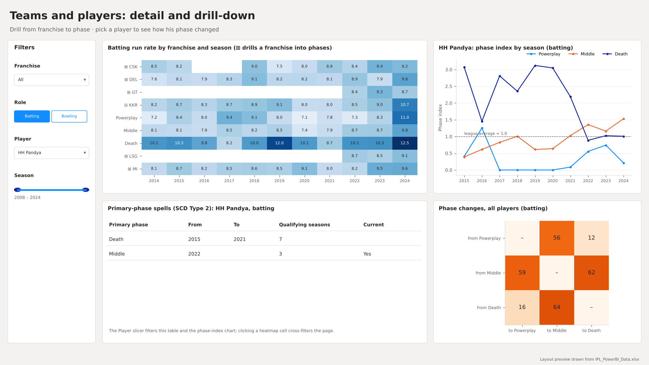
Page 2 layout. The HH Pandya example is the Player slicer's default selection.
Visual | Fields and settings
Slicers (left) | Franchise[franchise_id] (Dropdown); Role[role_type] (Tile, single select, default batting); Player[player] (Dropdown, single select, search on, default HH Pandya); Season[season] (Between)
Matrix (heatmap) with drill-down | Rows: Franchise[franchise_id], then Phase[phase] (two levels, so each franchise expands into its three phases); Columns: Season[season]; Values: [Run Rate]. Format > Row headers > +/- icons on. Cell elements > Background color on (gradient light to dark blue). This is the drill-down: click ⊞ to open a franchise.
Line chart | X: Season[season], Y: [Phase Index], Legend: Phase[phase]; constant line at 1.0 (league average). Filtered by the Player and Role slicers.
Table | PhaseSpells[primary_phase], [valid_from_season], [valid_to_season], [qualifying_seasons], [is_current] (all set to Don't summarize); sort by valid_from_season
Matrix | Rows: PhaseChanges[from_phase], Columns: PhaseChanges[to_phase], Values: [Phase Changes]; background colour on. Format > Edit interactions: set the Player slicer to None for this visual so it always shows all players for the selected role.
Optional drill-through page: add a page "Player detail", put Player[player] in its Drill-through well and copy the line chart and spells table onto it. Right-clicking a player anywhere then offers Drill through > Player detail.

6. Page 3: Model insights ("Can the Powerplay predict the winner?")
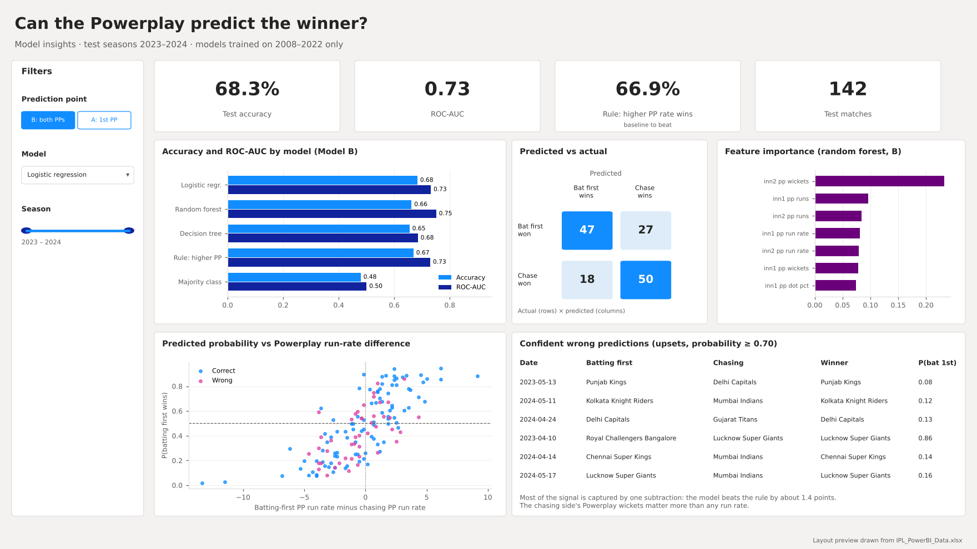
Page 3 layout, showing Model B (both Powerplays) with logistic regression selected.
Visual | Fields and settings
Slicers (left) | FeatureSet[prediction_point] (Tile, single select, default B); Model[model_label] (Dropdown, single select, default Logistic regression); TestPredictions[season] (Tile)
4 cards | [Model Accuracy]; [Model ROC-AUC]; [Baseline Accuracy] titled "Rule: higher PP rate wins"; [Test Matches]
Clustered bar chart | Y: ModelMetrics[model_label], X: Max of ModelMetrics[accuracy] and Max of ModelMetrics[roc_auc]. Edit interactions: Model slicer > None (the chart compares all models).
Matrix (predicted vs actual) | Rows: TestPredictions[actual_label], Columns: TestPredictions[predicted_label], Values: [Predictions]; background colour on. This is the confusion matrix.
Bar chart | Y: FeatureImportance[feature], X: Max of FeatureImportance[value]; visual filter FeatureImportance[model] = random_forest; Top 7. Edit interactions: Model slicer > None.
Scatter chart | X: TestPredictions[pp_run_rate_diff], Y: TestPredictions[prob_bat_first_wins] (both Don't summarize), Values: TestPredictions[match_key], Legend: TestPredictions[correct]. Constant lines at Y = 0.5 and X = 0. (Baselines have no probability, so the chart is empty for them.)
Table (upsets) | TestPredictions[match_date], [bat_first_team], [chase_team], [winner_team], [prob_bat_first_wins]; visual filters correct = 0 and confidence >= 0.7; sort by confidence descending
Narrative text box | Model B logistic regression: 68.3% accuracy, ROC-AUC 0.73, only 1.4 points above the one-line rule; the chasing side's Powerplay wickets matter more than any run rate.

7. Finish and export
- Rename the pages "Overview", "Teams and players" and "Model insights". Keep the default theme or pick one theme for all pages; use the same phase colours everywhere (Powerplay, Middle, Death).
- Check the numbers against the report: 1,095 matches; Powerplay run rate 9.46 in 2024 (7.70 in 2008); toss winner win 50.8%; Model B logistic regression 68.3% accuracy, ROC-AUC 0.73.
- File > Save as > IPL_DW_Dashboard.pbix. Then File > Export > Export to PDF > IPL_DW_Dashboard.pdf (the PDF fallback the guidelines ask for). Replace the layout images in the report and the deck with screenshots of the finished pages.
- For the viva, record a 60-90 second screen capture of the slicers and the drill-down in use (Windows: Win + Alt + R starts the Xbox Game Bar recorder).

