SYNOPYSIS

PRESENTING A WELL-DEFINED MODULES OF PROJECT

Referred To : Enroll No:
Training Head Student Name :
Rahul Soni College Name :
--------------------------------------------------------------------------------------------- SYNOPYSIS OF QUIREX

Description Of Project:
Quirex is a user-friendly platform designed to make the process of buying, selling, and renting properties simple and convenient. Whether you're looking for a dream home, planning to sell your property, or searching for rental spaces, this platform connects users with trusted property listings and verified agents. With features like location-based search, detailed property information, and high-quality images, Quirex offers a smooth and reliable experience for everyone involved in Quirex transactions.

Aim of Project
- Property Options for Everyone: The platform provides different types of properties like houses, flats, shops, and land for buying, selling, or renting.

- Verified Listings: All property details are checked and uploaded by trusted owners and agents to ensure safe and correct information

- Easy Search and Filters: Users can search properties by location, budget, type (rent/buy), and number of rooms to save time.

- Clear Pricing: Property prices are shown clearly without any hidden charges, so users know exactly what to expect.

- User-Friendly Platform: The website/app is simple to use where users can view photos, read property details, and contact owners easily.

- Customer Feedback: Users can see reviews or ratings given by others to help them choose the right property or agent.

Decided Zones For Project
2. User Property Buyer
Real Estate
1. General Zone
3. Admin Zone

Project Slot – 1 (Working with General Zone)
1. Home
2. About Us
3. Services
4. Login
6.Property

General Zone
5.SignUp

Project Day 1& 2: (Designing of General Zone’s Home Page)
Home page designing will continue till 2nd day of project session. Home page will contain:
- Menus and Slider (as described above)
Sample design of Menu and Slider:-

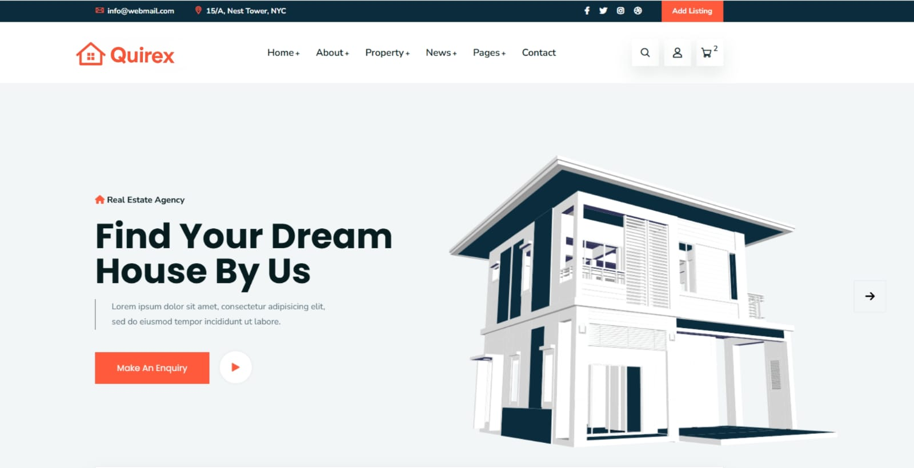

- Counter page :-
Sample design of Counter page:-

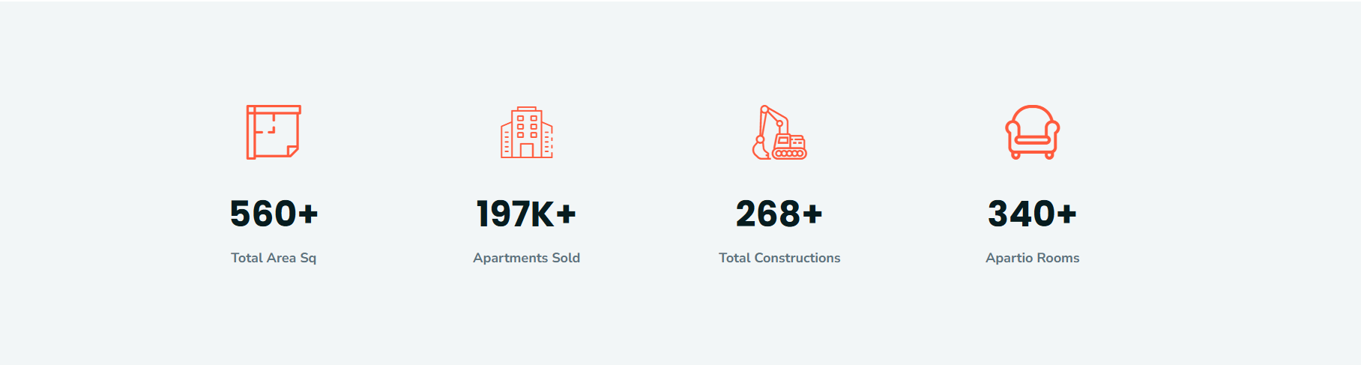

- Our Services
Sample design of Our Service:-

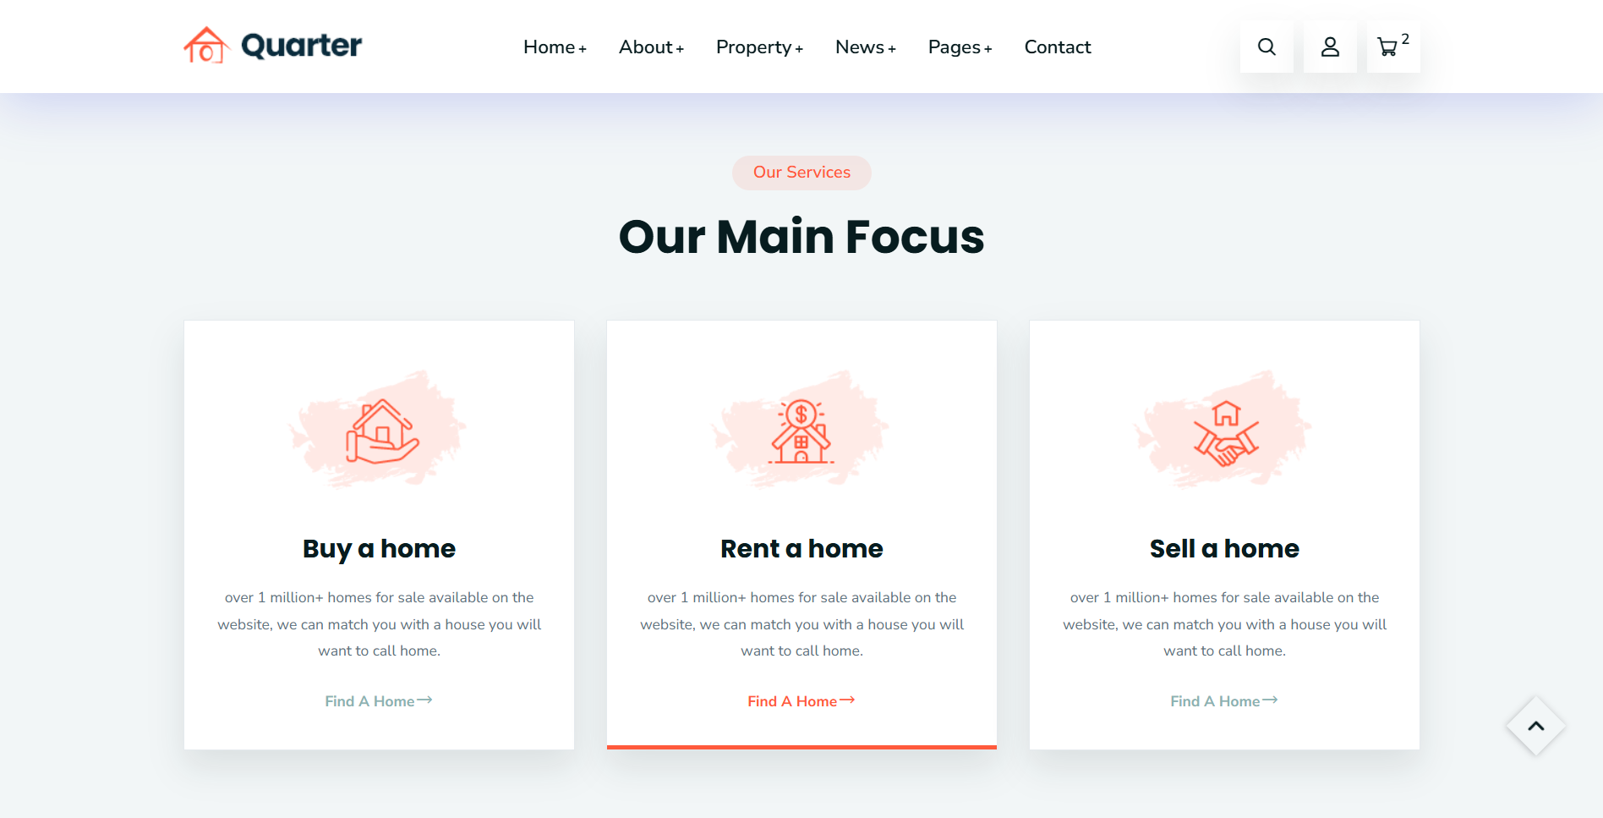

- Properties page :-
Sample design of Properties page:-
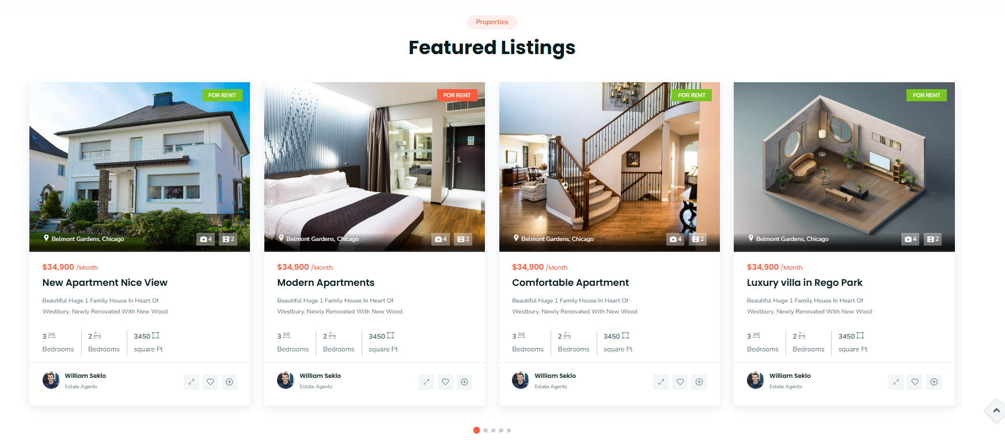

- Building Aminities page :-
Sample design of Building Aminities page:-

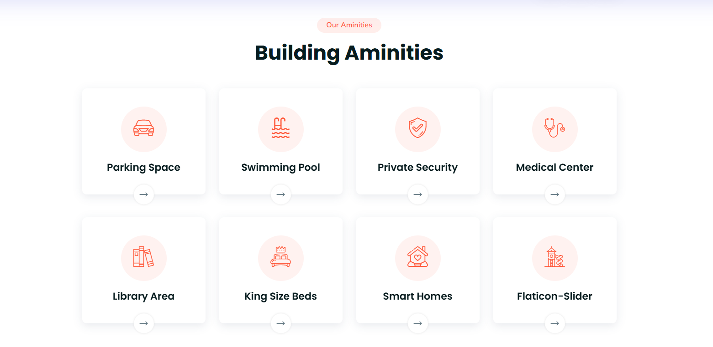

- Feedback page :-
Sample design of Feedback page:-

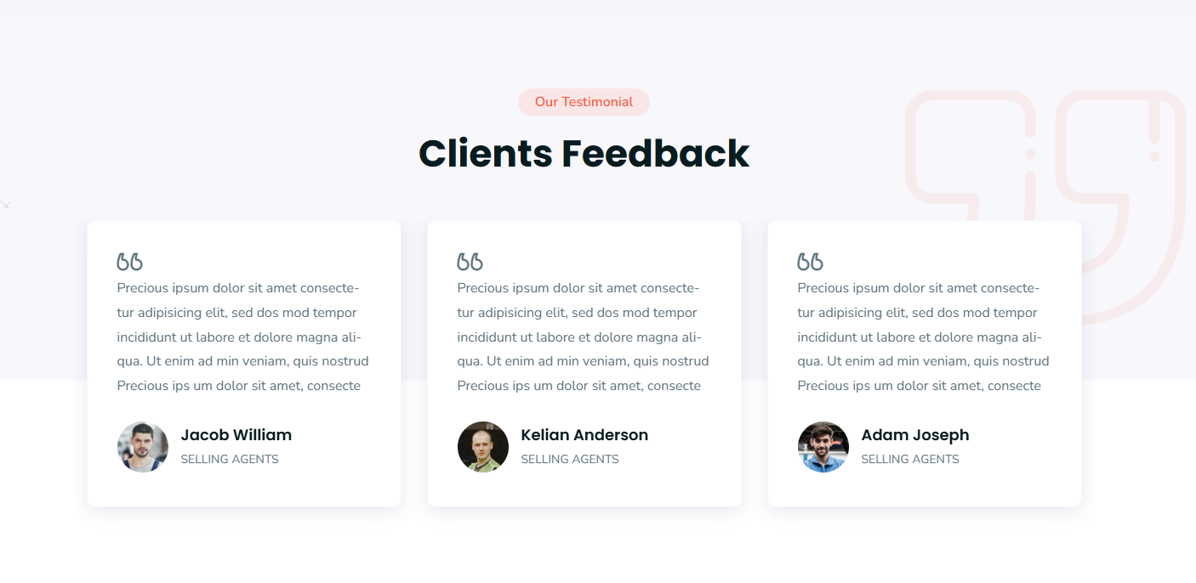
- Footer (Contain address, Quick Links, Copyright & Developed By)
Sample design of footer:-

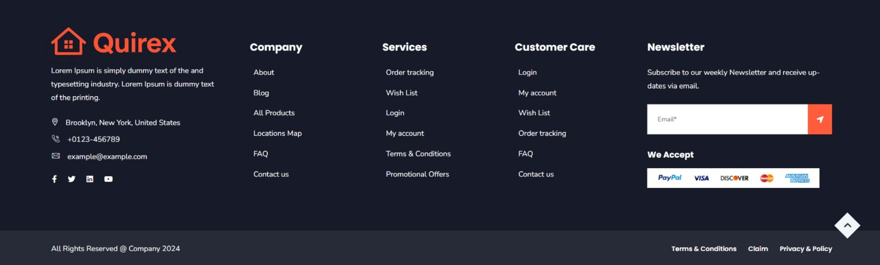


Project Day 3: (Designing of General Zone’s Contact Us , About Us Page)
Contact us page will contain :

- Name, Email, Messages
Sample design of Contact us:-

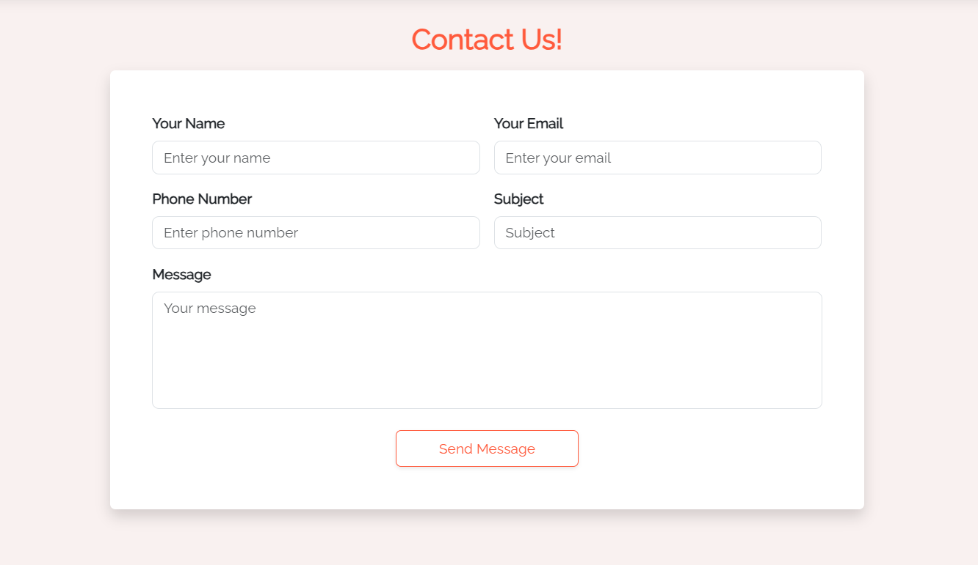

- About Us

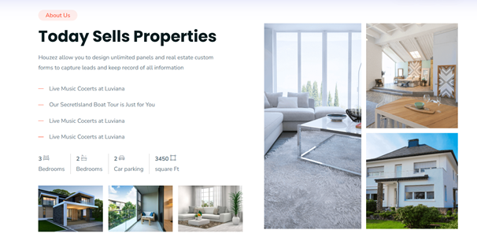

Project Day 4 : (Designing of General Zone’s Category page)
Category page is dynamic page where all category will be displayed on the basis of filters. Admin will add Category and Service providers details.

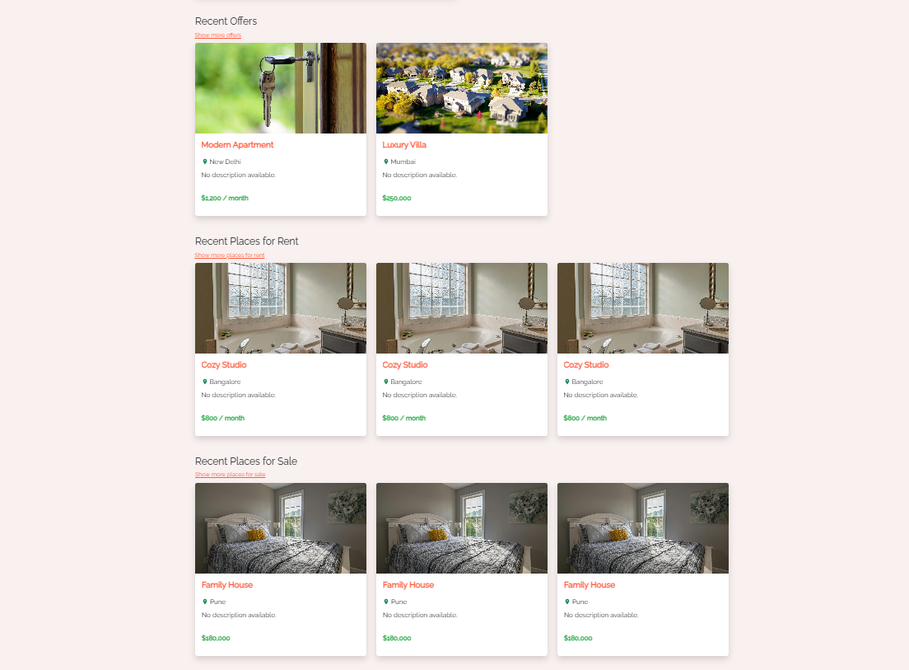

Project Day 5 : (Designing & Coding of Admin Login & User Login and Sign Up)
Login page will design with the following fields :
- UserId (Textbox)
- Password(Textbox with TextMode Password)
Sample design of Admin Login:-

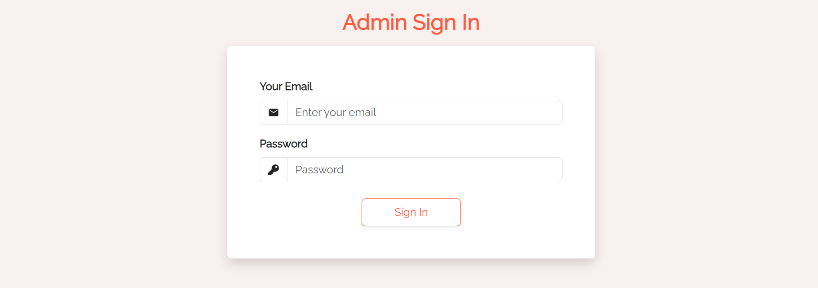

Now a prepared design of Login Page is present, further you have to code for Login so that a authorised admin can login and enter in the Admin Zone of Project.

- Sample design of User SignUp page:-
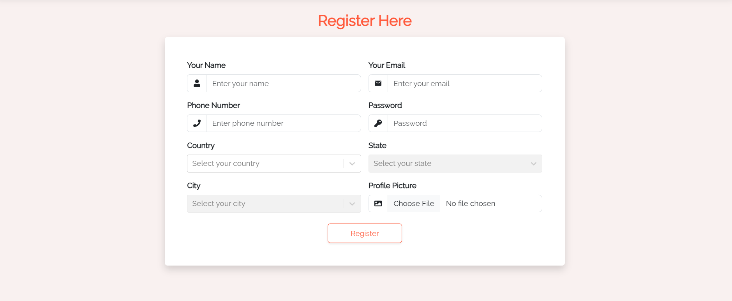

- Sample design of User Login page:-
Now a prepared design of Login Page is present, further you have to code for Login so that a authorised User can login and enter in the User Zone of Project.

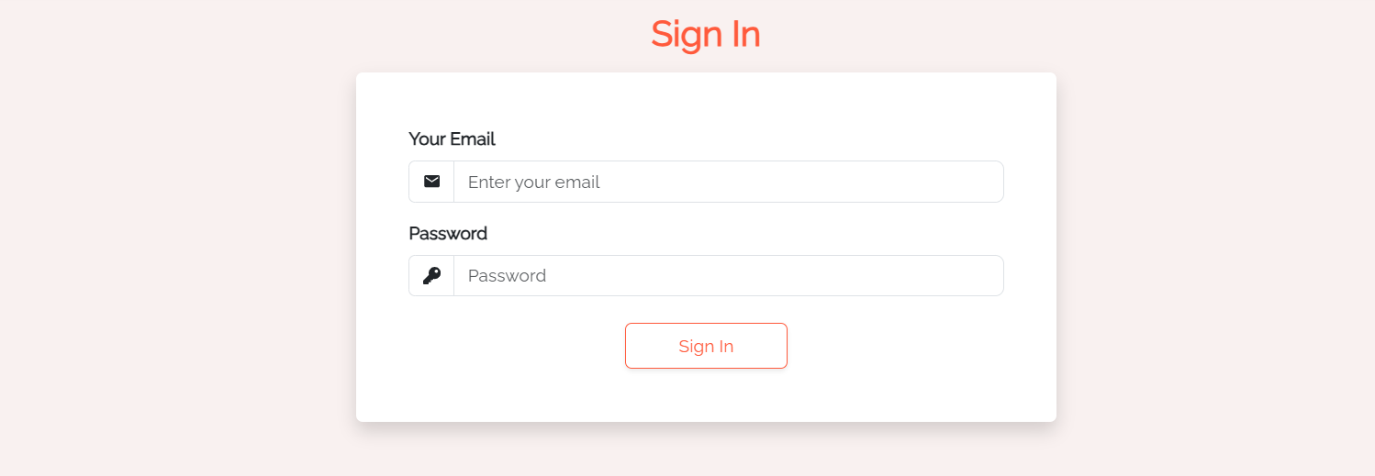
Project Slot – 2 (Working with Admin Zone)

Admin Zone
1.Dashboard
5.Edit Profile
6. Login
7. Contact Us
8. Logout
2. Users
3. Add Properties

Project Day 6: (Designing Of Master Page & Dashboard of Admin Zone)
Master page for Admin Zone will be designed that will contain some common part of all pages of Admin Zone that may be header (containing logo and menus discussed above) and footer.
Dashboard of Admin zone is a static page containing a well displayed menu of Admin Zone with the active hyperlink to related pages. You can use some special effects and animation to make it more interactive.
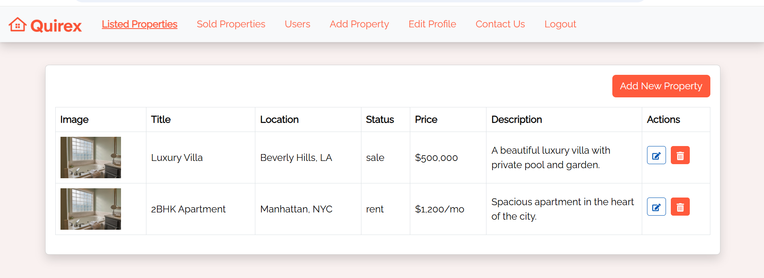

Project Day 7: (Designing & Coding of Add Property and Sold Property)
Add Property is page from here admin can add Property that will show in the general zone’s category menu page:

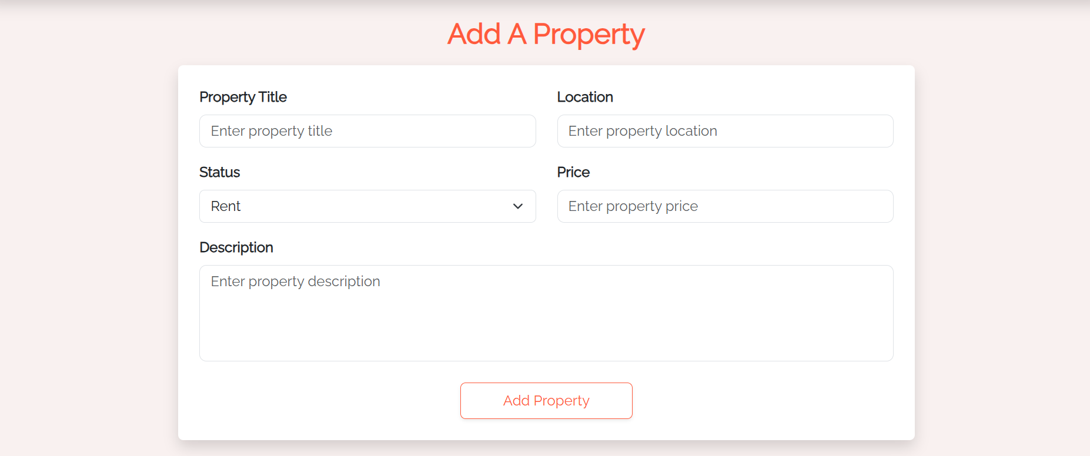

All the sold properties will be display on this page:

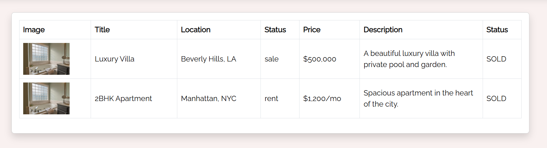

Project Day 8: (Working with Contact Us Management And Edit Profile And All Users List)
All enquiries done with the end of user will display on this page.

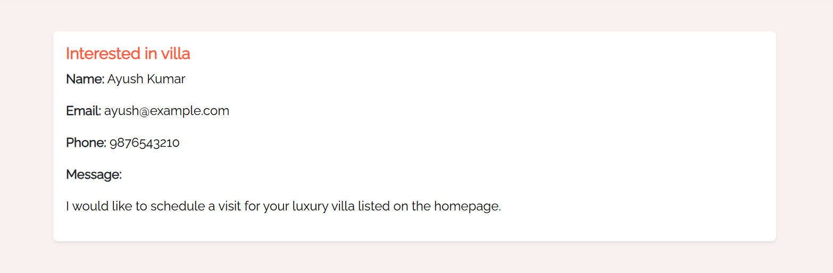

All Users will be display on this page, Admin can block and unblock them:

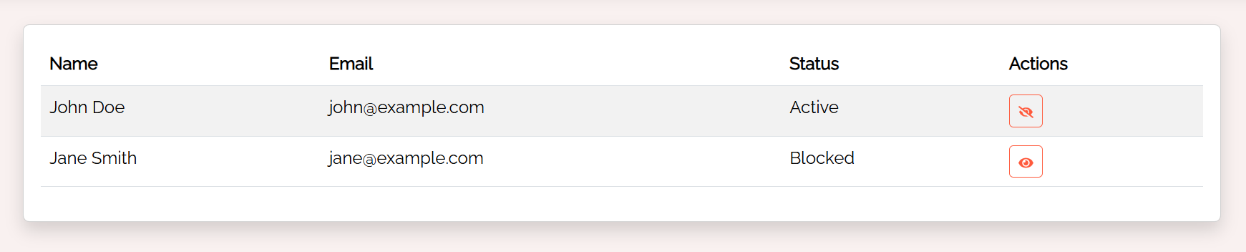
Admin will be updating his details on this page.

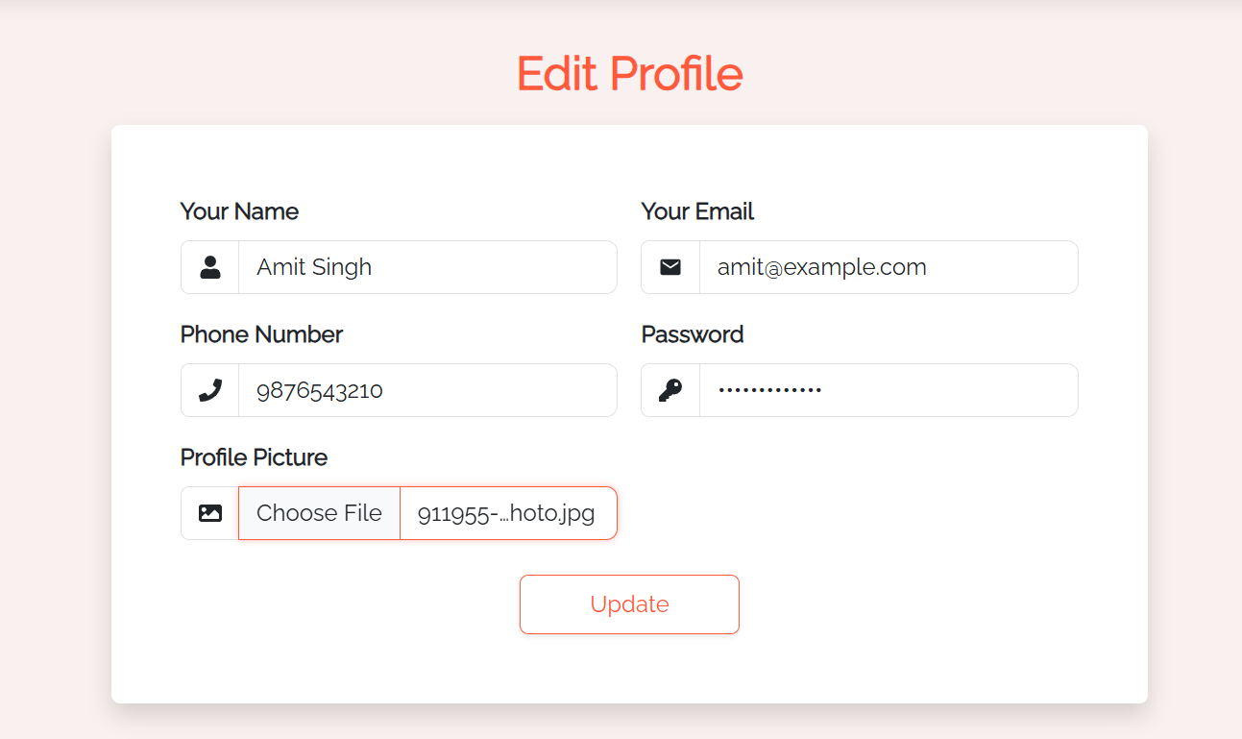

Project Day 10 :(Logout, Login)
Logout page will destroy the created session at the time of login in Admin Zone and redirect at login page.

Project Slot – 3 (Working with User Zone)

User Zone
1. Home
4. Profile
5. Logout

2. Property
3. Bought

Project Day 11 :(Home)
After successful Login user will redirect here.

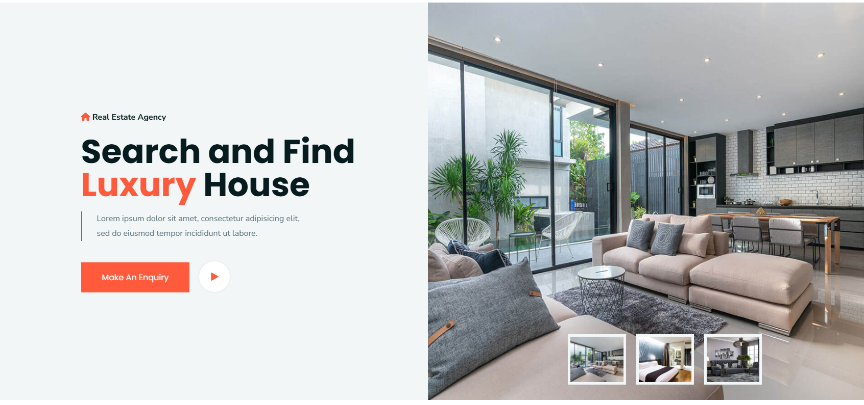
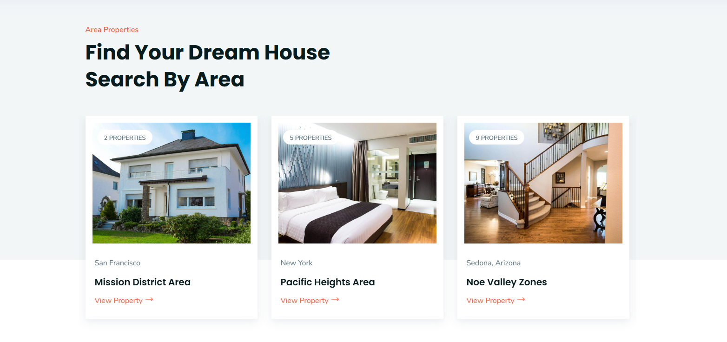

Project Day 12 :(Property)
All the listed properties of all categories will be display here, User can buy property from here.



Project Day 13 :(Bought)
If user has bought any property, then it will be display on this page.
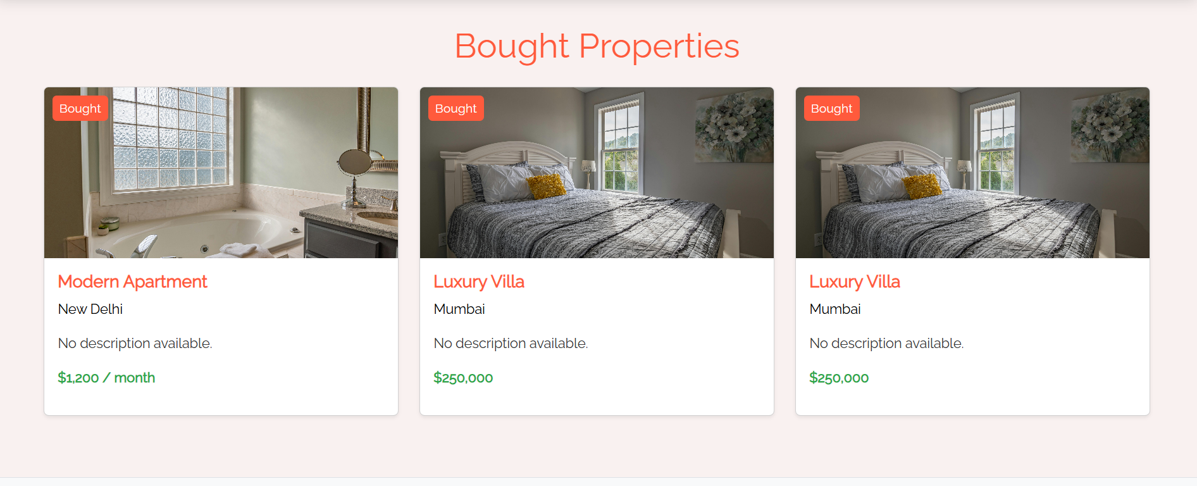

Project Day 14 :(Profile)
Profile and all the details of logged in user will display on this page, User can edit their profile from here.

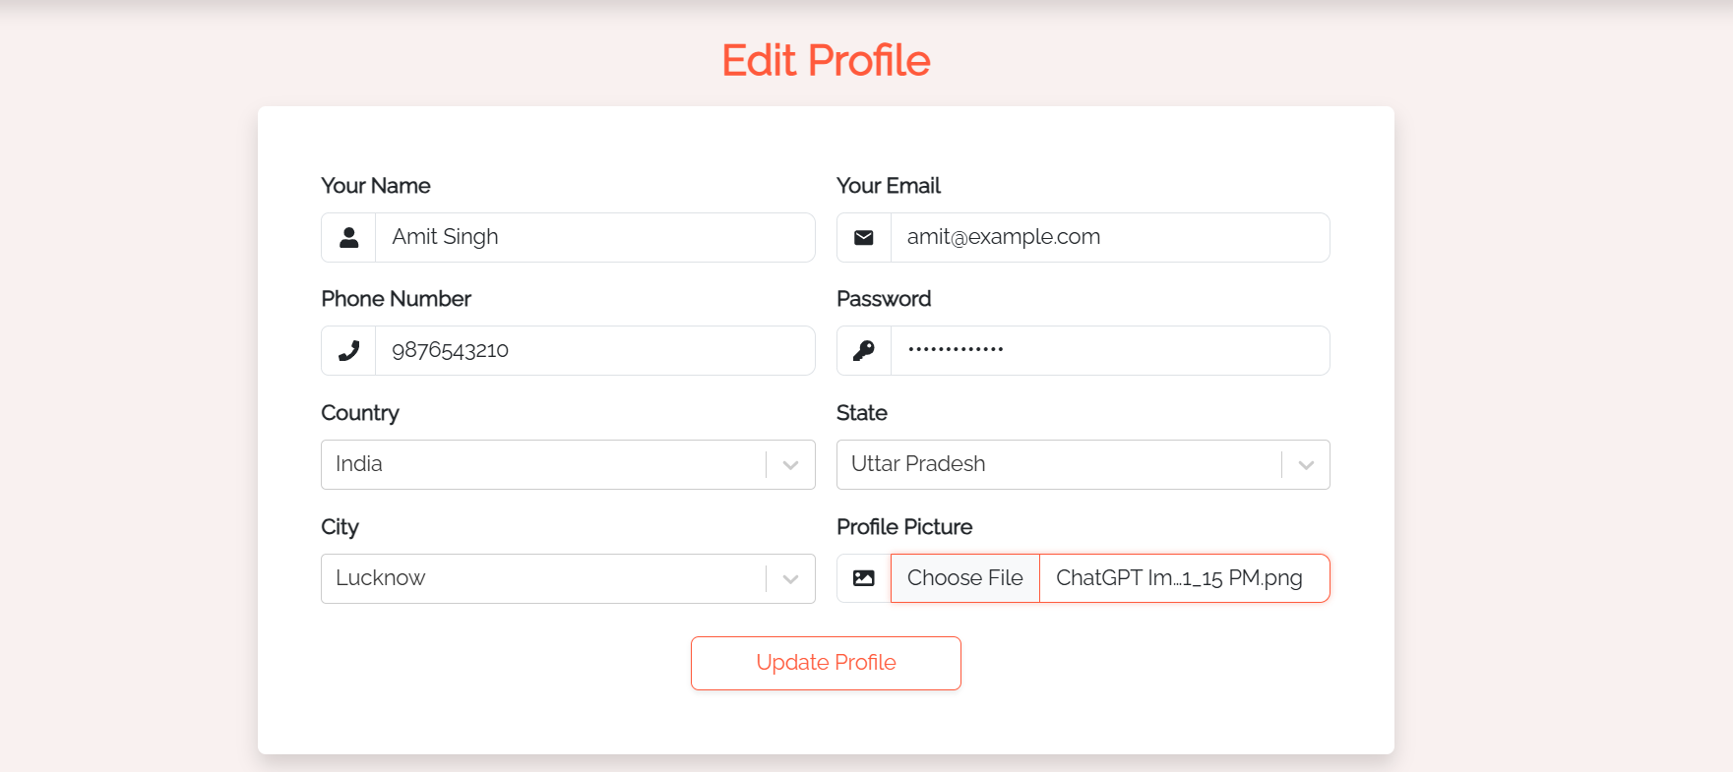

Project Day 15 :(Logout, Login)
Logout page will destroy the created session at the time of login in User Zone and redirect at login page.
Data Dictionary :

Models and ER-Diagram

