**Developing a Backend Admin for Learner’s Academy.**

**Developer Details: Name – Sanjeev Sagar** [**Email-sanjeevsagar013@gmail.com**](mailto:Email-sanjeevsagar013@gmail.com)

**githubLink:**

**Problem statement**

● Set up a master list of all the subjects for all the classes  
● Set up a master list of all the teachers  
● Set up a master list of all the classes  
● Assign classes for subjects from the master list  
● Assign teachers to a class for a subject (A teacher can be assigned to different classes for different subjects)  
● Get a master list of students (Each student must be assigned to a single class)

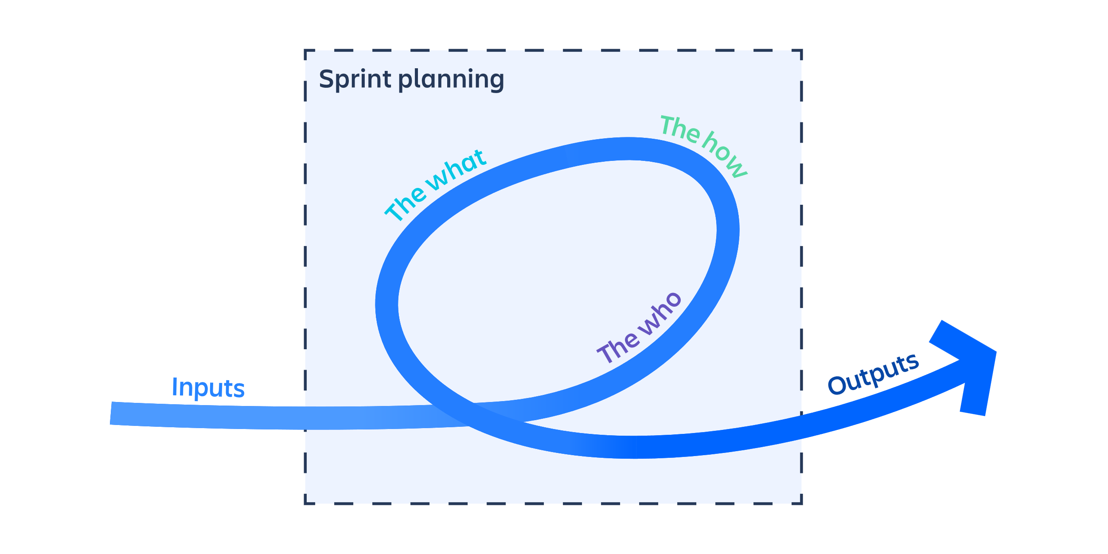**Sprint Planning**

Sprints Cycle 🡪12 days

Total number of Sprint🡪3

**It will take 2 sprint**

**Step1**

Create the classes of Student,class,teacher and Subject.

Make the respective connectiontion such as one to one,one to many,many to many relationships

Declare the necessary attribute fields as private and enable the setters and getters function

**Step 2:**

Create the index.jsp in which we are giving anchor tag for respective servlets

**Step 3:**

Frame the necessary servlets for adding new students ,subjects,teachers and classes.

Create the session .

Make the relation among teachers,class,student,subject

**Step4 :**

Create the Hibernate.cfg.xml

In which give the URL,Root,Password of your Sql

Enable the necessary mappings.