**Moving Jenkins from Local to Mounted Storage.**

To Move Jenkins to a mounted Storage you need to change the home directory The Jenkins home directory

contains a subdirectory for each Jenkins build job being managed by this instance of Jenkins. Each job

directory, in turn, contains two subdirectories, builds and workspace, along with some other files.

It contains the build job config.xml file, which contains, as you might expect, the configuration details

for this build job.

1. Click on Manage Jenkins in the left corner on the Jenkins dashboard.

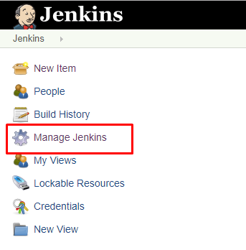

2. Select the System Information tab.

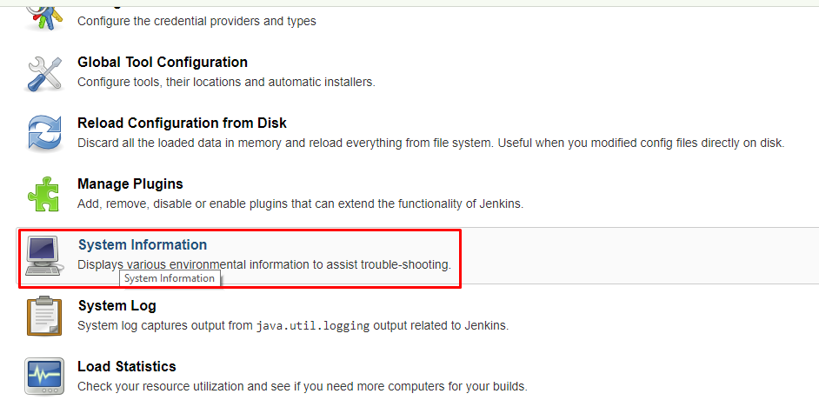

3. Scroll down to the Environment Variables section and you will see JENKINS_HOME

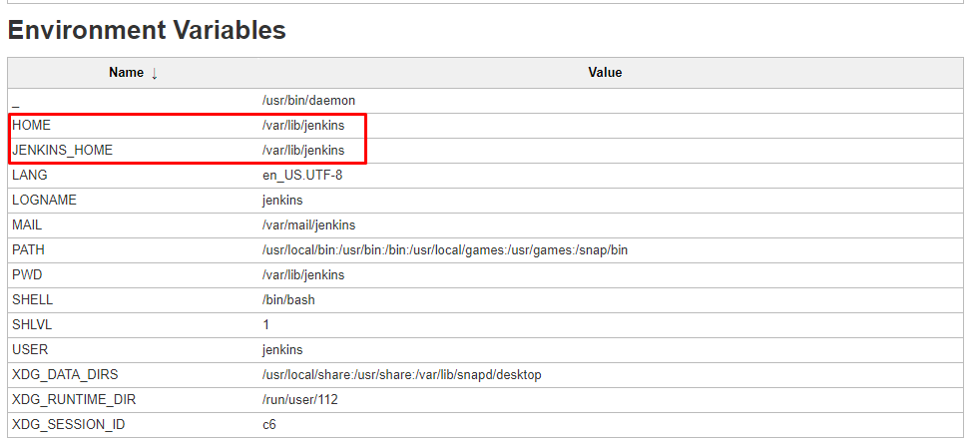

4. Change the Jenkins home login to Jenkins server instance using Putty.

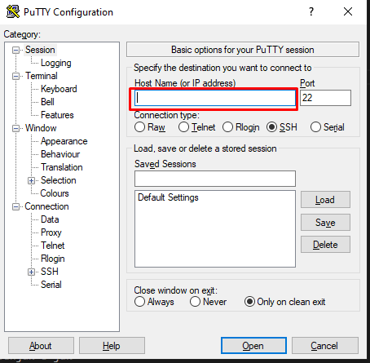

5. Navigate to the root user using the following command.

sudo -i

6. Before changing anything on the Jenkins master we have to stop the Jenkins server.

sudo service jenkins stop

7. Create a new directory where ever you want to move the Jenkins home to. For example I am creating a new directory in the /homepath.

mkdir /home/new_home

8. We need to change the ownership of a created directory by using the chown command to change the user and group ownership of the created directory.

sudo chown jenkins:jenkins /home/new_home/

9. Copy the content from old Jenkins home directory, /var/lib/jenkins , to the new Jenkins home directory, /home/new_home/ , using the following command.

sudo cp -prv /var/lib/jenkins /home/new_home/

10. Next, change the Jenkins user home by using the following command.

sudo usermod -d /home/new_home/ jenkins

11. Update the new Jenkins home directory path in /etc/default/jenkins.

sudo vi /etc/default/jenkins

12. Scroll down to the Jenkins home location and update the new home directory path.

# defaults for Jenkins automation server

# pulled in from the init script; makes things easier.

NAME=jenkins

# arguments to pass to java

# Allow graphs etc. to work even when an X server is present

JAVA_ARGS="-Djava.awt.headless=true"

#JAVA_ARGS="-Xmx256m"

# make jenkins listen on IPv4 address

#JAVA_ARGS="-Djava.net.preferIPv4Stack=true"

PIDFILE=/var/run/$NAME/$NAME.pid

# user and group to be invoked as (default to jenkins)

JENKINS_USER=$NAME

JENKINS_GROUP=$NAME

# location of the jenkins war file

JENKINS_WAR=/usr/share/$NAME/$NAME.war

# jenkins home location

JENKINS_HOME=/home/new_home

?

13. Start the Jenkins service by using the following command.

sudo service jenkins start

14. Then we need to update the admin password that can be found in a new Jenkins home directory.

cat /home/new_home/secrets/initialAdminPassword

15. Copy and paste the Admin Password in the Administrator Password field. Click the continue button.

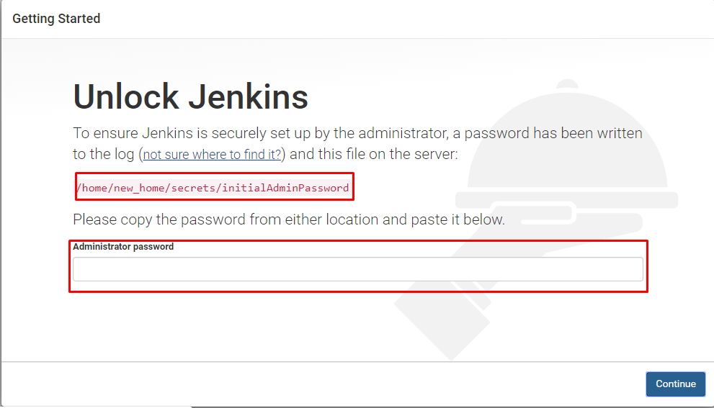

Unlock Jenkins

16. Next, you will be prompted to set up the first admin user. Fill out all required information and click the Save and Continue button.

17. Set the URL for your Jenkins instance. The URL will be generated automatically. Confirm the URL by clicking the Save and Finish button.

18. Once all configuration is done, you can see the "Jenkins is ready" screen. Click Start using Jenkins and you will be redirected to the Jenkins dashboard.

19. Click on Manage Jenkins in the left corner on the Jenkins dashboard, then select System Information.

20. Scroll down to the Environment Variables section, you will see the new JENKINS_HOME.

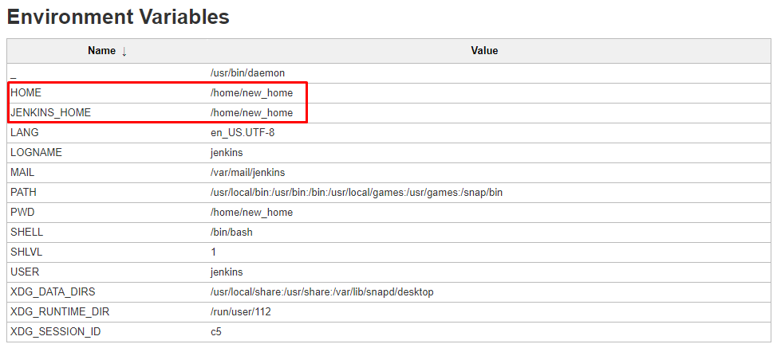

New JENKINS_HOME

Create a Freestyle Project

Once the Jenkins home directory is changed, we can test previously created or new jobs. For the sake of this article, I created a new freestyle project.

1. Select New Item in the top left-hand corner on the dashboard.

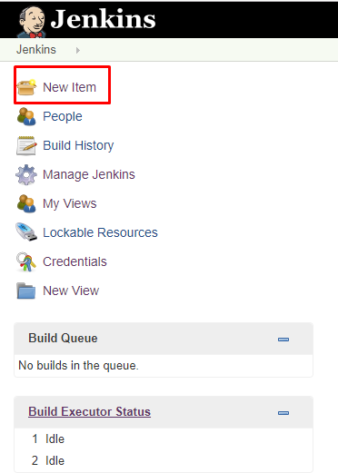

New item

2. Enter the name of your project in the Enter an item name field, and select Freestyle Project, and click the OK button.

3. Enter a description (optional).

4. Go to the Build section and click on the Add build step.

5. Select Execute Shell as a build step.

6. Copy and paste the following command into a command field.

echo $HOME

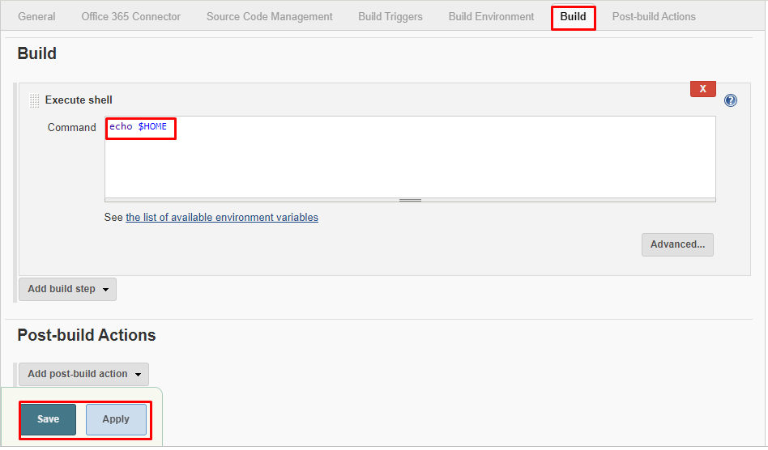

Execute shell

7. Click on Save, it will redirect to the job's view page.

8. On the left pane, click the Build Now button to execute your job.

9. We can verify the history of executed build under the Build History by clicking the build number, which is #1 in this case.

10. Click on build number and select Console Output. Here, you can see the Jenkins user home and Jenkins home directory.  
