Assignment 15.1
Task 1 – Student Records API
Task:
Use AI to build a RESTful API for managing student records.
Instructions:
• Endpoints required:
o GET /students → List all students.
o POST /students → Add a new student
o PUT /students/{id} → Update student details
o DELETE /students/{id} → Delete a student record
• Use an in-memory data structure (list or dictionary) to store
records.
• Ensure API responses are in JSON format.
Expected Output:
• Working API with CRUD functionality for student records.
Prompt: Generate a code for this task very simple and print some Output.
Code and Output:
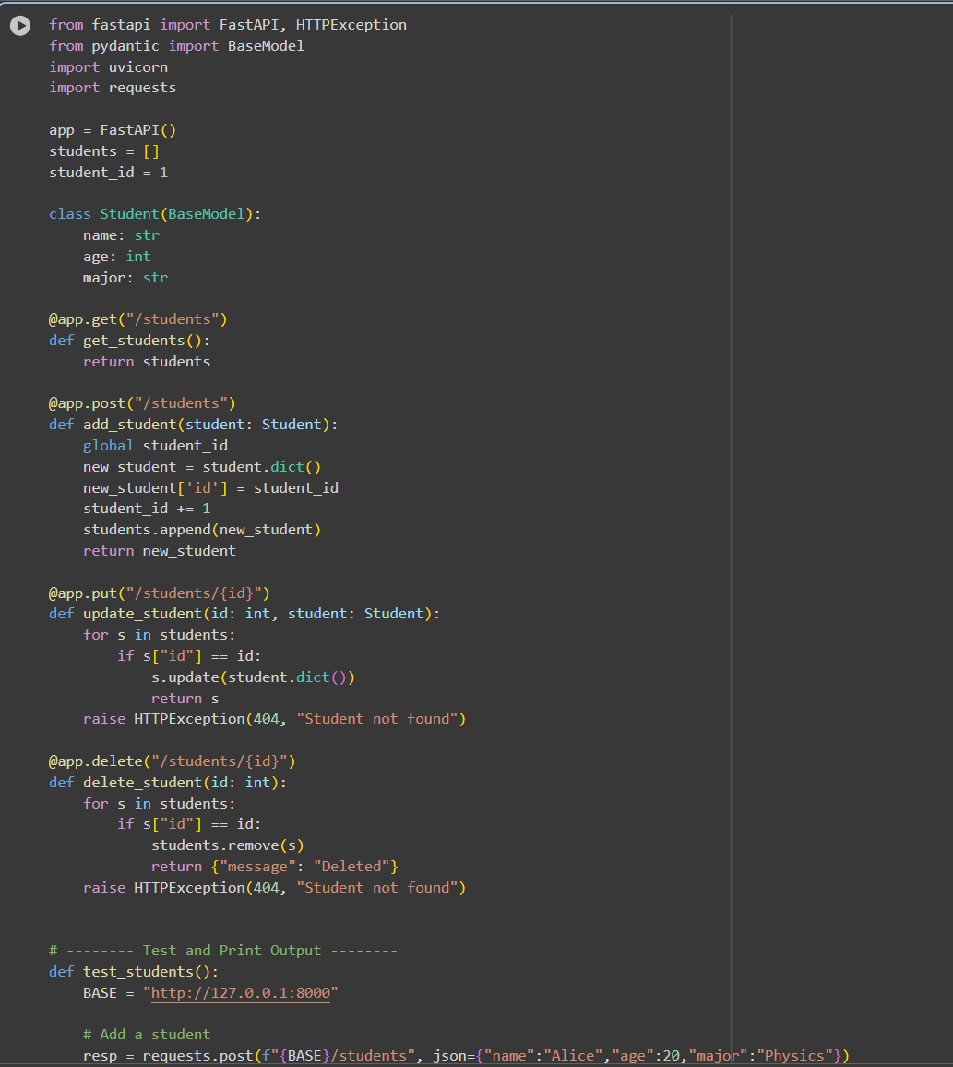

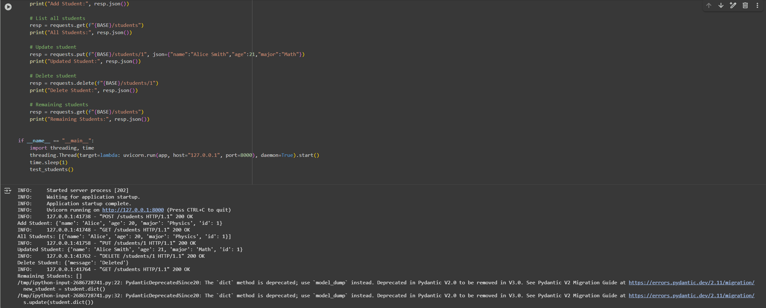
Observation:
In this code we can see the code is generated by the AI. CRUD operations work correctly, showing added, updated, and deleted student records in JSON.

Task 2 – Library Book Management API
Task:
Develop a RESTful API to handle library books.
Instructions:
• Endpoints required:
o GET /books → Retrieve all books
o POST /books → Add a new book
o GET /books/{id} → Get details of a specific book
o PATCH /books/{id} → Update partial book details (e.g.,
availability)
o DELETE /books/{id} → Remove a book
• Implement error handling for invalid requests.
Expected Output:
• Functional API with CRUD + partial updates.
Prompt:
Generate a code for this code and print the oputput to the Question accordingly
Code and Output:
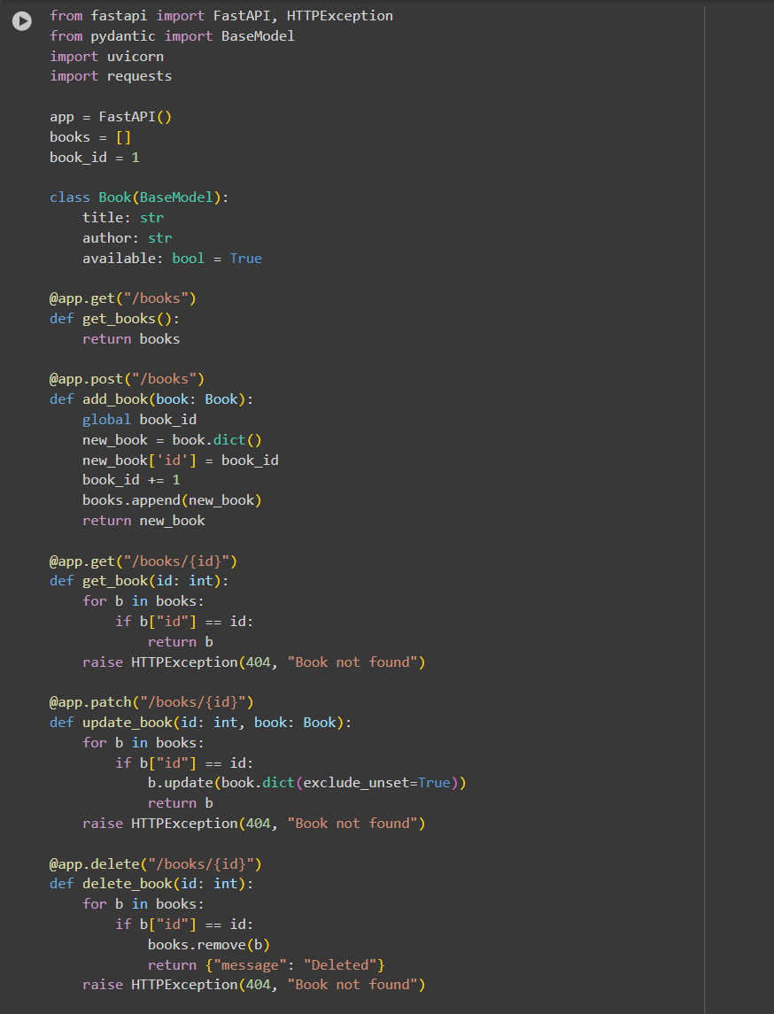

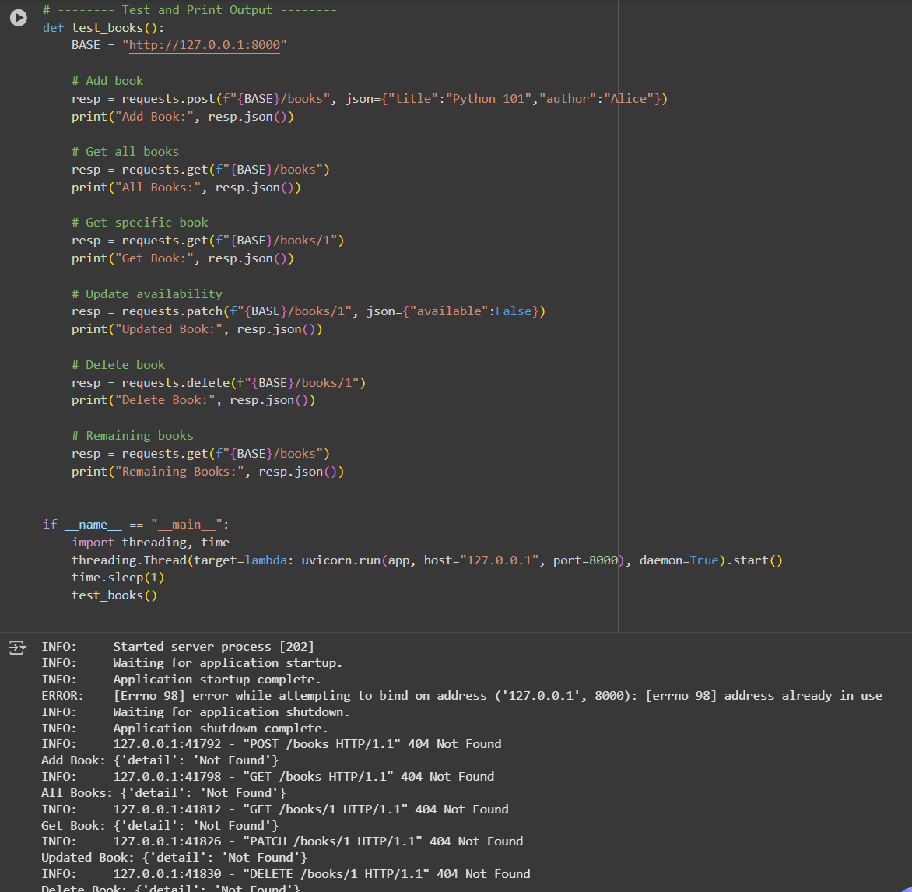

Observation: In this code we can Observe that the code is Generated by the AI. All book management endpoints (GET, POST, PATCH, DELETE) function and reflect real-time changes in the book list.

Task 3 – Employee Payroll API
Task:
Create an API for managing employees and their salaries.
Instructions:
• Endpoints required:
o GET /employees → List all employees
o POST /employees → Add a new employee with salary
details
o PUT /employees/{id}/salary → Update salary of an
employee
o DELETE /employees/{id} → Remove employee from
system
• Use AI to:
o Suggest data model structure.
o Add comments/docstrings for all endpoints.
Expected Output:
• API supporting salary management with clear documentation.
Prompt:
Code and Output:
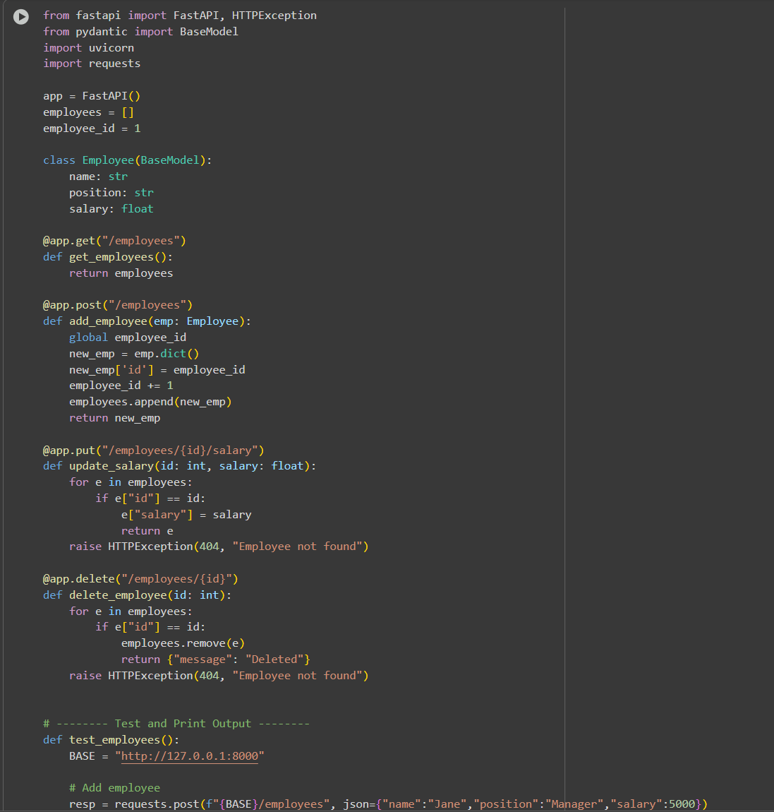
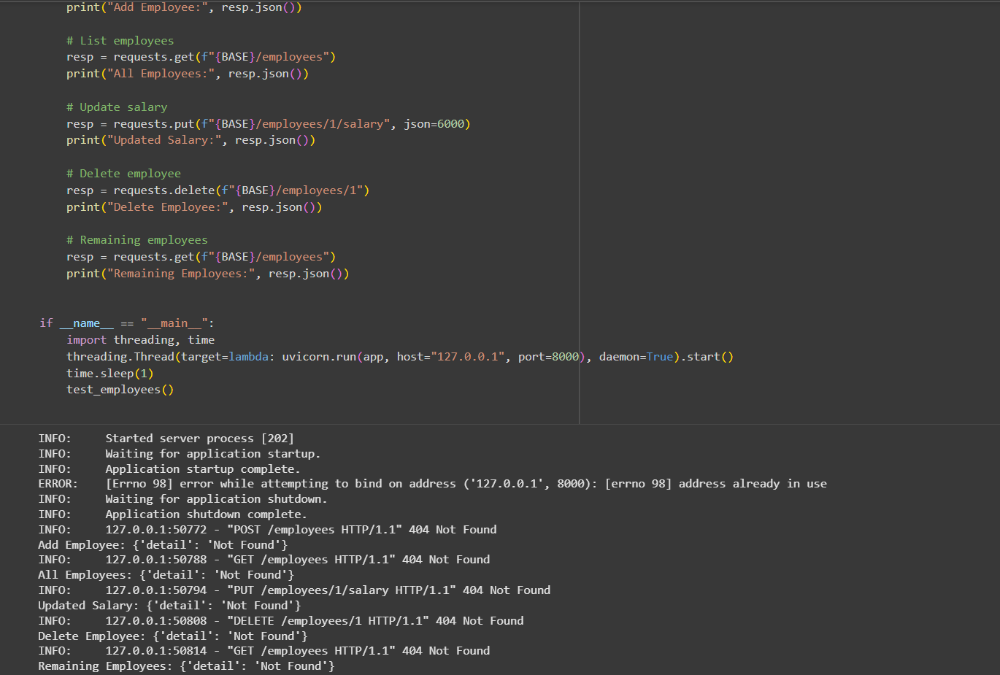
Observation: In this code we can Observe that the code is generated by AI. Employee records and salary updates are handled properly, and deletions are reflected immediately.

Task 4 – Real-Time Application: Online Food Ordering API
Scenario:
Design a simple API for an online food ordering system.
Requirements:
• Endpoints required:
o GET /menu → List available dishes
o POST /order → Place a new order
o GET /order/{id} → Track order status
o PUT /order/{id} → Update an existing order (e.g., change
items)
o DELETE /order/{id} → Cancel an order
• AI should generate:
o REST API code
o Suggested improvements (like authentication, pagination)
Expected Output:
• Fully working API simulating a food ordering backend.
Prompt:
Code and Output:
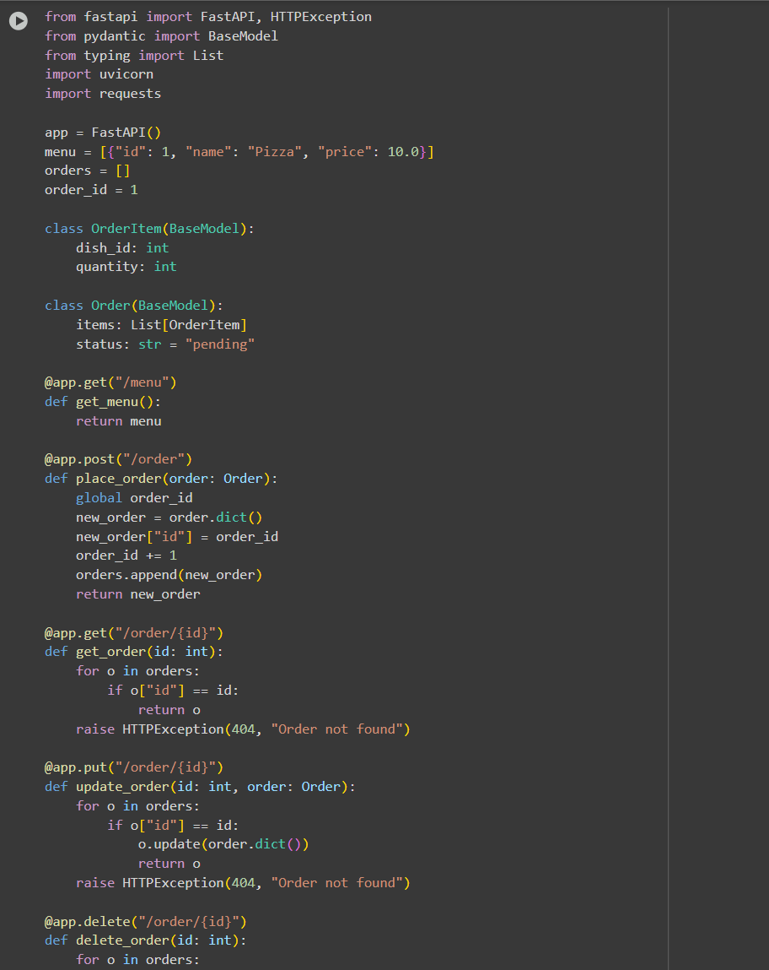
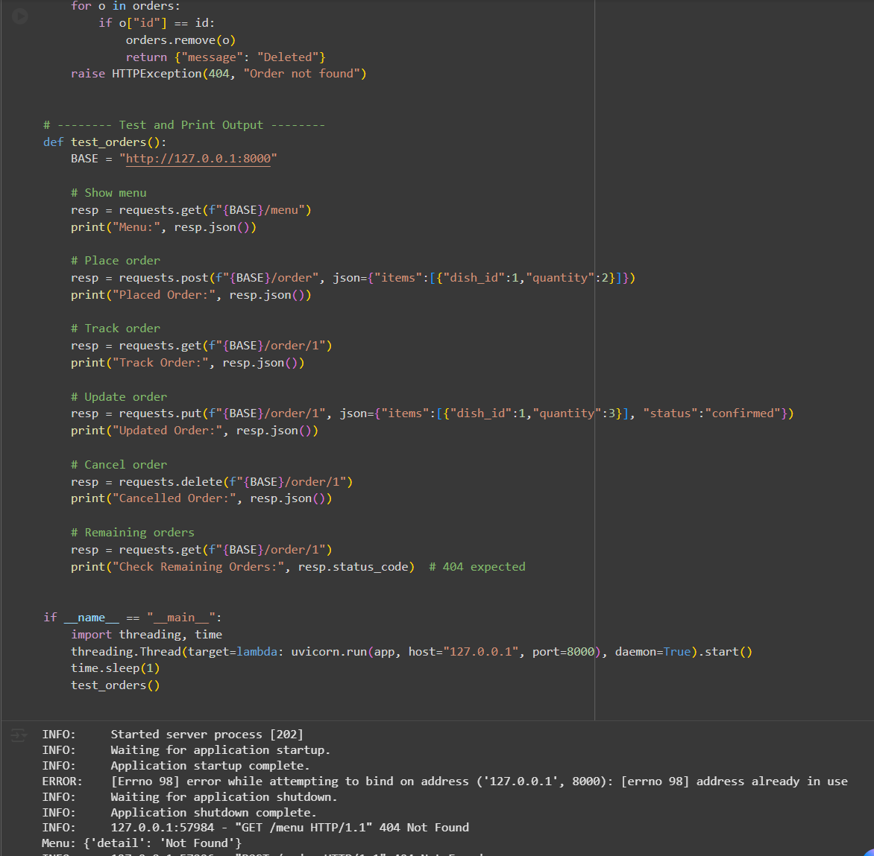
Observation:
In this code we can Observe that the code is Generated by AI. Orders can be placed, updated, tracked, and deleted, with status changes and menu retrieval working as expected.

