ASSIGNMENT-7.1

Task Description #1:
(Syntax Errors – Missing Parentheses in Print
Statement)
Task: Provide a Python snippet with a missing parenthesis in a print
statement (e.g., print "Hello"). Use AI to detect and fix the syntax error.
# Bug: Missing parentheses in print statement
def greet():
print "Hello, AI Debugging Lab!"
greet()
Requirements:
• Run the given code to observe the error.
• Apply AI suggestions to correct the syntax.
• Use at least 3 assert test cases to confirm the corrected code
works.
Prompt: Correct this code without any errors
Code and Output:
Error Code:
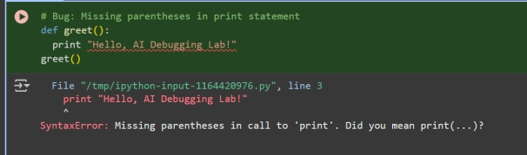
Corrected Code:
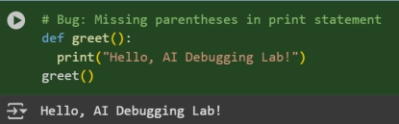
Observation:
In this code we can Observe that the code we have entered is wrong and it is corrected by the AI
Task Description #2 (Logic Error – Incorrect Condition in an If
Statement)
Task: Supply a function where an if-condition mistakenly uses = instead
of ==. Let AI identify and fix the issue.
# Bug: Using assignment (=) instead of comparison (==)
def check_number(n):
if n = 10:
return "Ten"
else:
return "Not Ten"
Requirements:
• Ask AI to explain why this causes a bug.
• Correct the code and verify with 3 assert test cases.
Expected Output #2:
• Corrected code using == with explanation and successful test
execution.
Prompt: Correct the Given code without any Errors
Code and Output:

Error code;
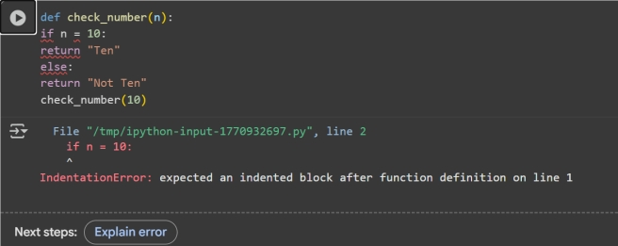
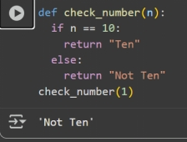
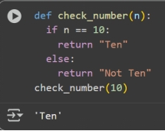

Observation: In this Code we can Observe that the code of Check whether the Given Number is 10 or not code is corrected by the AI.

Task Description #3:
(Runtime Error – File Not Found)
Task: Provide code that attempts to open a non-existent file and crashes.
Use AI to apply safe error handling.
# Bug: Program crashes if file is missing
def read_file(filename):
with open(filename, 'r') as f:
return f.read()
print(read_file("nonexistent.txt"))
Requirements:
• Implement a try-except block suggested by AI.
• Add a user-friendly error message.
• Test with at least 3 scenarios: file exists, file missing, invalid
path.
Expected Output #3:
• Safe file handling with exception management.
Prompt: Correct the Given Code By creating New file and Adding content to it and print the Content in the File

Code and Output:

Error Code:
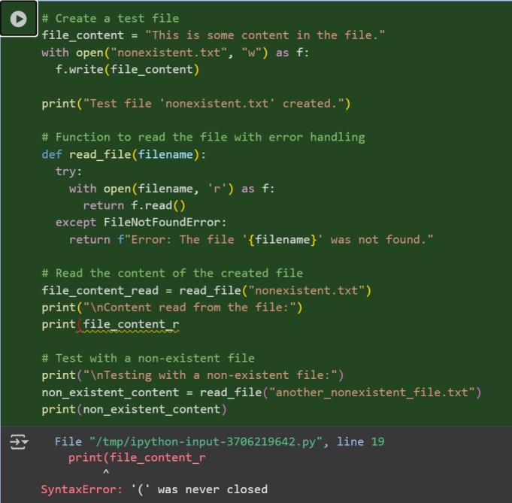

Corrected code:
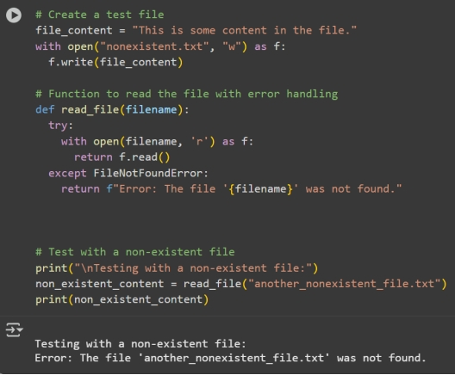

-

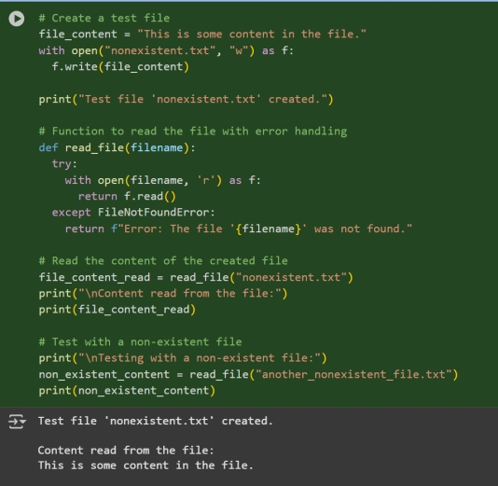

Observation:
In this Code we can Observation that the code is Corrected By the AI and Not it can read the file content by creating a file and adding the content into the file and print the Content

Task Description #4:
(AttributeError – Calling a Non-Existent Method)
Task: Give a class where a non-existent method is called (e.g.,
obj.undefined_method()). Use AI to debug and fix.
# Bug: Calling an undefined method
class Car:
def start(self):
return "Car started"
my_car = Car()
print(my_car.drive()) # drive() is not defined
Requirements:
• Students must analyze whether to define the missing method or
correct the method call.
• Use 3 assert tests to confirm the corrected class works.
Expected Output #4:
• Corrected class with clear AI explanation.
Prompt: Correct the Code and print the Output by the corrected Code
Code and Output:
Error Core:
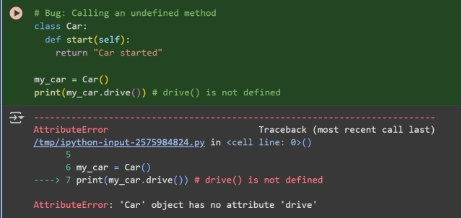
Corrected Code:
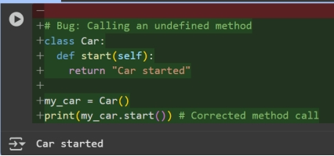
Observation:In this code we can Observe that the code is getting corrected by the Ai and It is correcting The code

Task Description #5 (TypeError – Mixing Strings and Integers in
Addition)
Task: Provide code that adds an integer and string ("5" + 2) causing a
TypeError. Use AI to resolve the bug.
# Bug: TypeError due to mixing string and integer
def add_five(value):
return value + 5
print(add_five("10"))
Requirements:
• Ask AI for two solutions: type casting and string concatenation.
• Validate with 3 assert test cases.
Expected Output #5:
• Corrected code that runs successfully for multiple inputs
Prompt;
Code and Output:
Error Code:
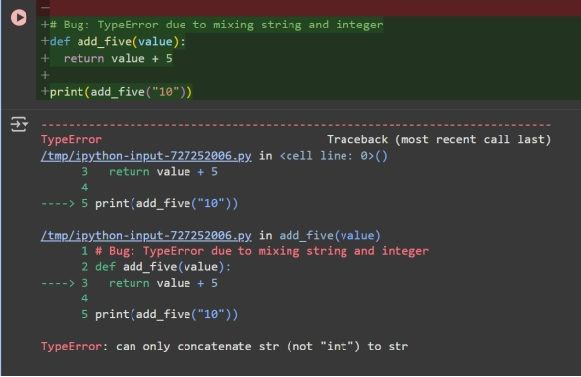
Corrected Code:
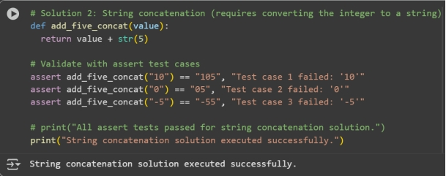
Observation: In this code we can see that the code Is corrected by the AI and passed all the Test cases.

