ASSIGNMENT-10.1

Task Description#1
AI-Assisted Code Review (Basic Errors)
• Write python program as shown below.
• Use an AI assistant to review and suggest corrections.
Expected Outcome#1: Students need to submit corrected code with comments

Given Code:

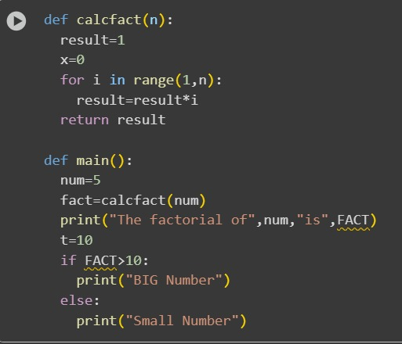

Modified code:
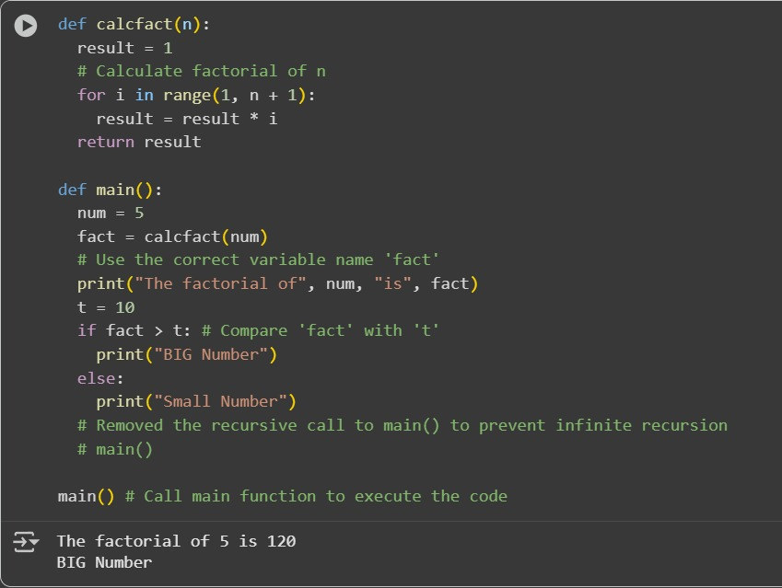
Observation: In this code we can observe that the code is corrected and modify the code in better way and also gave comments for easy understanding

Task Description#2:
Automatic Inline Comments
• Write the Python code for Fibonacci as shown below and execute.
• Ask AI to improve variable names, add comments, and apply PEP8 formatting
(cleaned up).
• Students evaluate which suggestions improve readability most. one.
Expected Output#2: Clean format python code with much readability.

Given code:
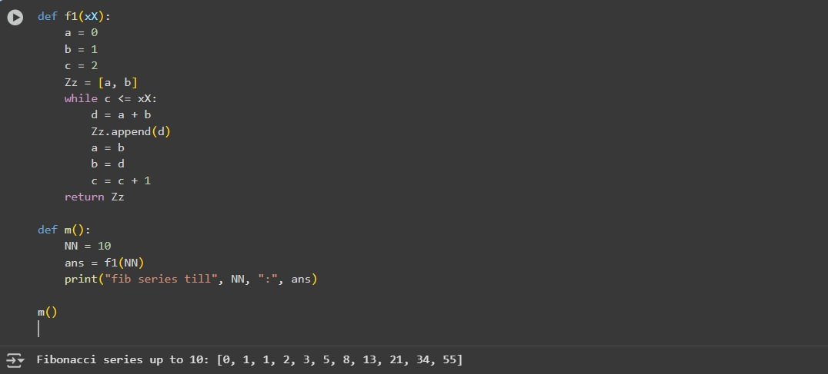
Modified code:
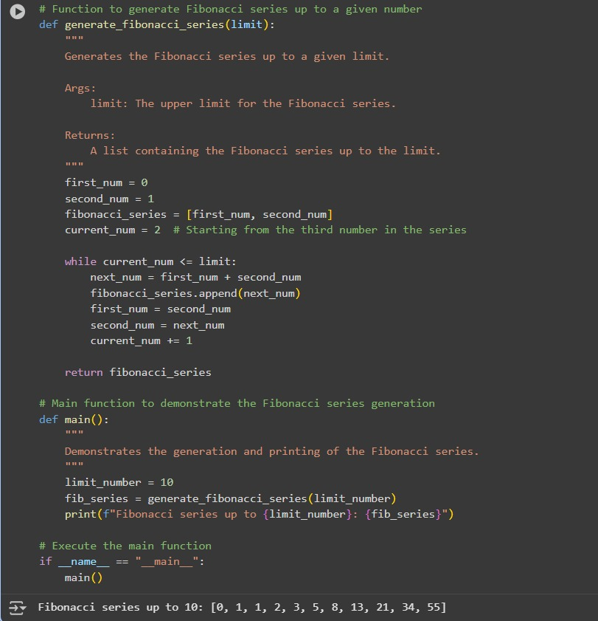
Observation:In this code we can see that the code is modified and made the code more understandable.

Task Description#3:
• Write a Python script with 3–4 functions (e.g., calculator: add, subtract, multiply,
divide).
• Incorporate manual docstring in code with NumPy Style
• Use AI assistance to generate a module-level docstring + individual function
docstrings.
• Compare the AI-generated docstring with your manually written one.

Given code:
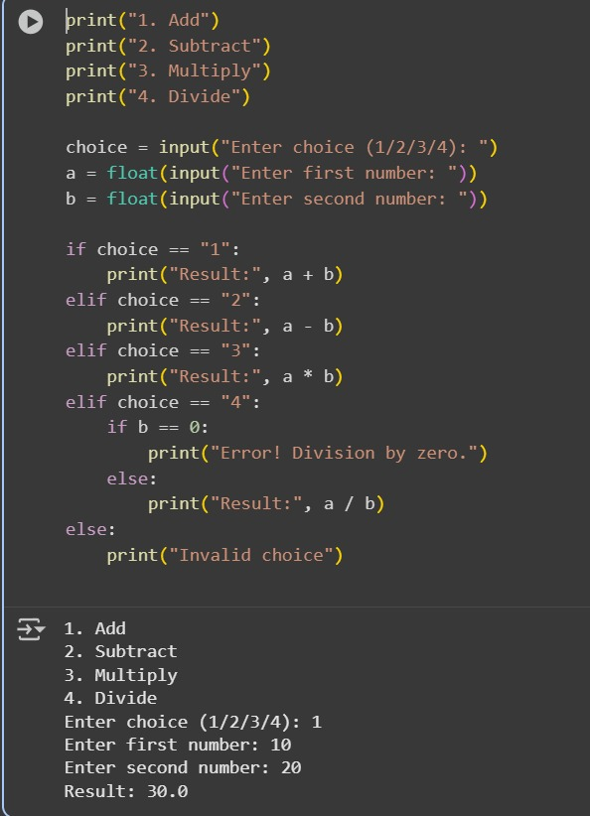
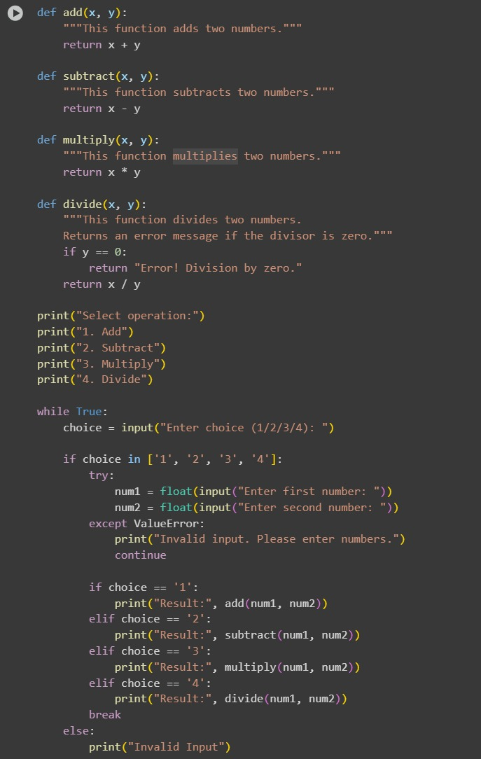
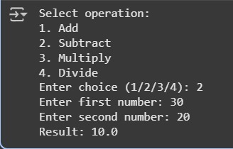
Observation: In this question I have made a code with comments and I gave my code to AI to modify the code so it modified my code by using the functions . it made code simple

