Assignment – 6.4
Task Description #1:
• Start a Python class named Student with attributes name, roll_number, and marks. Prompt
GitHub Copilot to complete methods for displaying details and checking if marks are above
average.
Expected Outcome #1:
• Completed class with Copilot-generated methods like display_details() and is_passed(),
demonstrating use of if-else conditions
Prompt: Task Description #1:
• Start a Python class named Student with attributes name, roll_number, and marks. Prompt
GitHub Copilot to complete methods for displaying details and checking if marks are above
average.
Expected Outcome #1:
• Completed class with Copilot-generated methods like display_details() and is_passed(),
demonstrating use of if-else conditions also print the Output
Code and Output:
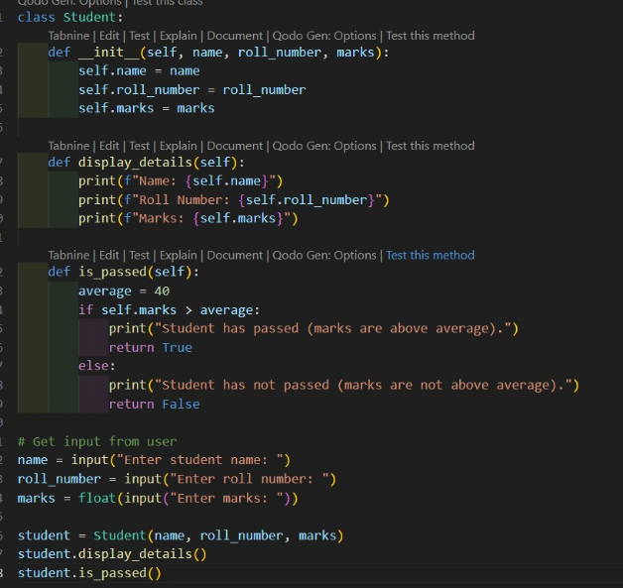
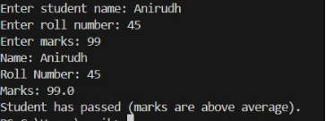
Observation:In this Code We can Observe that the code is calculating the marks of the student to check whether the student is pass or not

Task Description #2:
• Write the first two lines of a for loop to iterate through a list of numbers. Use a comment
prompt to let Copilot suggest how to calculate and print the square of even numbers only.
Expected Outcome #2:
• A complete loop generated by Copilot with conditional logic (if number % 2 == 0) and
appropriate output
Prompt:
Task Description #2:
• Write the first two lines of a for loop to iterate through a list of numbers. Use a comment
prompt to let Copilot suggest how to calculate and print the square of even numbers only.
Expected Outcome #2:
• A complete loop generated by Copilot with conditional logic (if number % 2 == 0) and
appropriate output also print the Output
Code and Output:
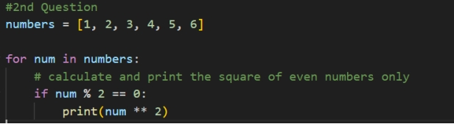
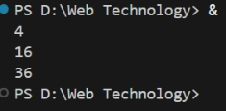
Observation:In tnis code we can Observe that the code is printing the square of even numbers given in the list

Task Description #3:
• Create a class called BankAccount with attributes account_holder and balance. Use Copilot to
complete methods for deposit(), withdraw(), and check for insufficient balance.
Expected Outcome #3:
• Functional class with complete method definitions using if conditions and self attributes. Code
should prevent overdrawing
Prompt: • Create a class called BankAccount with attributes account_holder and balance. Use Copilot to
complete methods for deposit(), withdraw(), and check for insufficient balance.
Expected Outcome #3:
• Functional class with complete method definitions using if conditions and self attributes. Code
should prevent overdrawing also take input in the code and Print the Output

Code and Output:
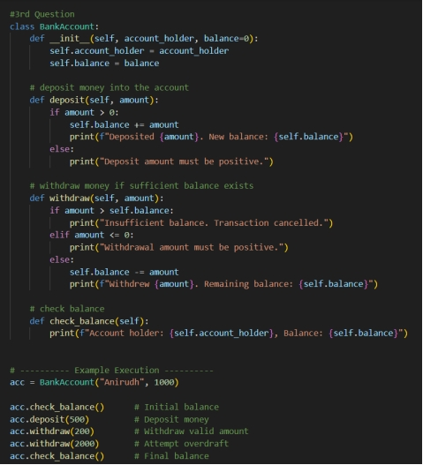
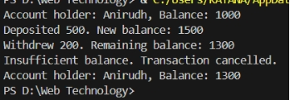
Observation:
In this Code we can observe that the code Is about banking and we can check balance,deposite,withdraw .

Task Description #4:
• Define a list of student dictionaries with keys name and score. Ask Copilot to write a while
loop to print the names of students who scored more than 75.
Expected Outcome #4:
• A complete while loop generated by Copilot with proper condition checks and formatted
output

Prompt: • Define a list of student dictionaries with keys name and score. Ask Copilot to write a while
loop to print the names of students who scored more than 75.
Expected Outcome #4:
• A complete while loop generated by Copilot with proper condition checks and formatted
output also print the Output.

Code and Output:
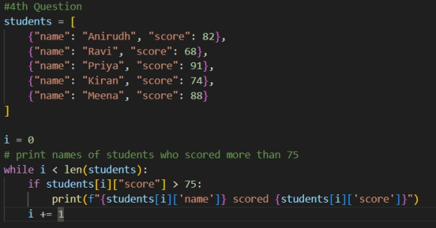

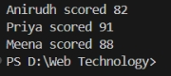
Observation: In this code we can observe that the code is checking that the students has scored more than 75 or not

Task Description #5:
• Begin writing a class ShoppingCart with an empty items list. Prompt Copilot to generate
methods to add_item, remove_item, and use a loop to calculate the total bill using conditional
discounts.
Expected Outcome #5:
• A fully implemented ShoppingCart class with Copilot-generated loops and if-else statements
handling item management and discount logic
Prompt: • Begin writing a class ShoppingCart with an empty items list. Prompt Copilot to generate
methods to add_item, remove_item, and use a loop to calculate the total bill using conditional
discounts.
Expected Outcome #5:
• A fully implemented ShoppingCart class with Copilot-generated loops and if-else statements
handling item management and discount logic also print the Output
Code and Output:
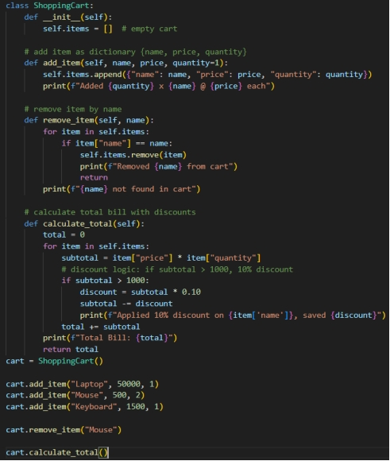
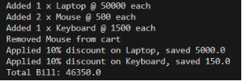
Observation:In this code we can see the code about the Shopping bill code consists of adding item, remove item, discount , total bill.

