**Topics: Descriptive Statistics and Probability**

1. Look at the data given below. Plot the data, find the outliers and find out $μ, σ, σ^{2}$

|  |  |
| --- | --- |
| **Name of company** | **Measure X** |
| Allied Signal | 24.23% |
| Bankers Trust | 25.53% |
| General Mills | 25.41% |
| ITT Industries | 24.14% |
| J.P.Morgan & Co. | 29.62% |
| Lehman Brothers | 28.25% |
| Marriott | 25.81% |
| MCI | 24.39% |
| Merrill Lynch | 40.26% |
| Microsoft | 32.95% |
| Morgan Stanley | 91.36% |
| Sun Microsystems | 25.99% |
| Travelers | 39.42% |
| US Airways | 26.71% |
| Warner-Lambert | 35.00% |

Ans:

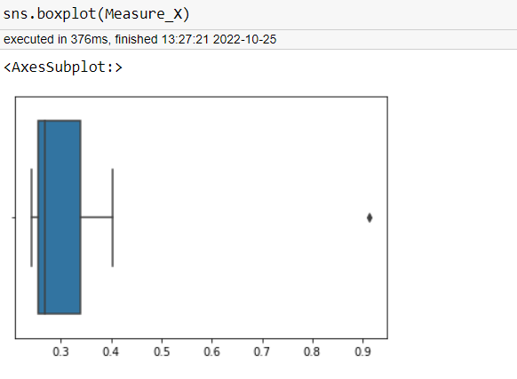

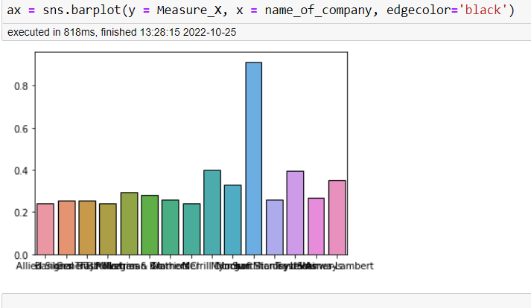

First Quantile= 25.47 Second Quantile= 26.71 Third Quantile= 33.975 Inter-Quartile Range= 8.505000000000003 Upper Whisker= 46.7325 Lower Whisker= 12.712499999999995

The outlier in the boxplot: 10 91.36

dtype: float64

The outlier in the boxplot: 10 91.36

dtype: float64

count 15.000000

mean 33.271333

std 16.945401

min 24.140000

25% 25.470000

50% 26.710000

75% 33.975000

max 91.360000

dtype: float64

Variance= 287.1466123809524



Answer the following three questions based on the box-plot above.

1. What is inter-quartile range of this dataset? (please approximate the numbers) In one line, explain what this value implies.

Ans:As per Boxplot approxmitely

Frist Quartile Range(Q1)=5,Third Quartile Range(Q3)=12,and Median(Q2)=7

inter-quartile range(IQR)=Q3-Q1=12-5=7

1. What can we say about the skewness of this dataset?

Ans: Right-Skewed median is towards the left side it is not normal distribution

1. If it was found that the data point with the value 25 is actually 2.5, how would the new box-plot be affected?

Ans: in that case there would be no Outliers on the given dataset because of the outlier the data had positive skewness it will reduce and the data will normal distributed



Answer the following three questions based on the histogram above.

1. Where would the mode of this dataset lie?

Ans: The Mode of the Data Set Lie between 5 to 10

1. Comment on the skewness of the dataset.

Ans:Right Skewness

1. Suppose that the above histogram and the box-plot in question 2 are plotted for the same dataset. Explain how these graphs complement each other in providing information about any dataset.

Ans:Both are Right Skewness,and both have outlayer

1. AT&T was running commercials in 1990 aimed at luring back customers who had switched to one of the other long-distance phone service providers. One such commercial shows a businessman trying to reach Phoenix and mistakenly getting Fiji, where a half-naked native on a beach responds incomprehensibly in Polynesian. When asked about this advertisement, AT&T admitted that the portrayed incident did not actually take place but added that this was an enactment of something that “could happen.” Suppose that one in 200 long-distance telephone calls is misdirected. What is the probability that at least one in five attempted telephone calls reaches the wrong number? (Assume independence of attempts.)

Ans: IF 1 in 200 long-distance telephone calls are getting misdirected.

probability of call misdirecting = 1/200

Probability of call not Misdirecting = 1-1/200 = 199/200

The probability for at least one in five attempted telephone calls reaches the wrong number

Number of Calls = 5

n = 5

p = 1/200

q = 199/200

P(x) = at least one in five attempted telephone calls reaches the wrong number

P(x) = ⁿCₓ pˣ qⁿ⁻ˣ

P(x) = (nCx) (p^x) (q^n-x) # nCr = n! / r! * (n - r)!

P(1) = (5C1) (1/200)^1 (199/200)^5-1

P(1) = 0.0245037

1. Returns on a certain business venture, to the nearest $1,000, are known to follow the following probability distribution

|  |  |
| --- | --- |
| x | P(x) |
| -2,000 | 0.1 |
| -1,000 | 0.1 |
| 0 | 0.2 |
| 1000 | 0.2 |
| 2000 | 0.3 |
| 3000 | 0.1 |

1. What is the most likely monetary outcome of the business venture?

Ans: The most likely monetary outcome of the business venture is 2000$

1. Is the venture likely to be successful? Explain

Ans: Yes, the probability that the venture will make more than 0 or a profit

p(x>0)+p(x>1000)+p(x>2000)+p(x=3000) = 0.2+0.2+0.3+0.1 = 0.8 this states that there is a good 80% chances for this venture to be making a profit

1. What is the long-term average earning of business ventures of this kind? Explain

Ans: The long-term average is Expected value = Sum (X * P(X)) = 800$ which means on an average the returns will be + 800$

1. What is the good measure of the risk involved in a venture of this kind? Compute this measure

Ans: Var (X) = E(X^2) –(E(X))^2

= 2800000 – 800^2

= 2160000

Mathematics Calculation

E(X) =Sum( X.*P(X) )

E(-2000)=(-2000)*0.1=-200

E(-1000)=(-1000)*0.1=-100

E(0)=(0)*0.1=0

E(1000)=(1000)*0.2=200

E(2000)=(2000)*0.3=600

E(3000)=(3000)*0.1=300

E(X)=800

E(X^2) =X^2*P(X)

E(-2000^2)=(-2000^2)*0.1=400000

E(-1000^2)=(-1000^2)*0.1=100000

E(0^2)=(0^2)*0.1=0

E(1000^2)=(1000^2)*0.2=200000

E(2000^2)=(2000^2)*0.3=1200000

E(3000^2)=(3000^2)*0.1=900000

E(X^2)=2800000