**Topics: Normal distribution, Functions of Random Variables**

1. The time required for servicing transmissions is normally distributed with *μ* = 45 minutes and *σ* = 8 minutes. The service manager plans to have work begin on the transmission of a customer’s car 10 minutes after the car is dropped off and the customer is told that the car will be ready within 1 hour from drop-off. What is the probability that the service manager cannot meet his commitment?
2. 0.3875
3. 0.2676
4. 0.5
5. 0.6987

ANS : - mean = 45 , standared deviation = 8

As per given condition the work will start after 10 min so mean will be 45+10 = 55

asked customer the car will be ready after 1 hour(x) = 60

Z = (60 – 55) / 8 = 0.625

From z table Z value will be 0.73237

the probability that the service manager cannot meet his commitment = 1 – 0.73237 = 0.2676

1. The current age (in years) of 400 clerical employees at an insurance claims processing center is normally distributed with mean *μ* = 38 and Standard deviation *σ* =6. For each statement below, please specify True/False. If false, briefly explain why.
2. More employees at the processing center are older than 44 than between 38 and 44.

Ans:

X = 44 , mean = 38, std = 6

. the probability for employees older than 44 :

1 - Stats.norm.cdf ( 44 , 38 , 6 ) = 1- 0.8413 = 0.1587

Now find the probability of employees between 38 and 44 :-

Stats.norm.cdf ( 44 , 38 , 6 ) - stats.norm.cdf (38,38, 6)

= 0.8413 - 0.5

= 0.3413

So the given statement is False

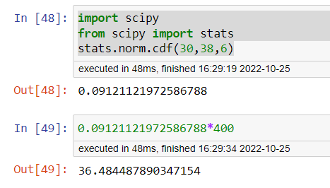

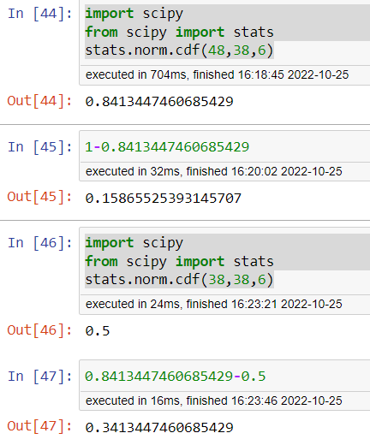

1. A training program for employees under the age of 30 at the center would be expected to attract about 36 employees.

Ans:

X = 30 , mean = 38, std = 6

the probability of employees age under 30 :

Stats.norm.cdf ( 30 , 38 , 6 ) = 0.0912

So the total number of emplyees age under 30 is 0.0912*400 = 36.48



So we can say that the statement is True.

1. If *X1* ~ *N*(μ, σ2) and *X*2 ~ *N*(μ, σ2) are *iid* normal random variables, then what is the difference between 2 *X*1 and *X*1 + *X*2? Discuss both their distributions and parameters.

Ans/:

x1 and x2 are random variables which have same distribution and independent of each other

find the sum of the mean and the variance

Sum of mean = 2 μ

Sum of the variance = 2 σ 2

There is no any difference between 2x1 and x1+x2 as both of them have same distribution

1. Let X ~ N(100, 202). Find two values, *a* and *b*, symmetric about the mean, such that the probability of the random variable taking a value between them is 0.99.
2. 90.5, 105.9
3. 80.2, 119.8
4. 22, 78
5. 48.5, 151.5
6. 90.1, 109.9

Ans:

Mean = 100

std = 20

probability of the random variable taking a value between them is 0.99

Z value at 99 % = Stats.norm.ppf (0.995) = 2.5758

1 st value will be 2.5758*20 + 100 == 151.51 2

2nd value will be (-2.5758)*20 + 100 = 48.484

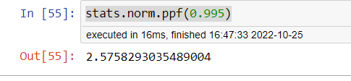

1. Consider a company that has two different divisions. The annual profits from the two divisions are independent and have distributions Profit1 ~ N(5, 32) and Profit2 ~ N(7, 42) respectively. Both the profits are in $ Million. Answer the following questions about the total profit of the company in Rupees. Assume that $1 = Rs. 45
2. Specify a Rupee range (centered on the mean) such that it contains 95% probability for the annual profit of the company.
3. Specify the 5th percentile of profit (in Rupees) for the company
4. Which of the two divisions has a larger probability of making a loss in a given year?

ANS :- Total profit = profit 1 + profit 2

Mean = profit 1 (mean) + profit 2 (mean) = 5 + 7 = 12

Std = sqrt (9+16)

= sqrt (25) = 5

Mean in rs = 12*45 = 540

Std in rs = 5* 45 = 225

A ) Range for 95 % :-

Stats.norm.interval ( 0.95 , 540 , 225) =( 99.008 , 980.991 )

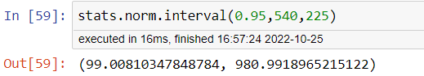

B ) the 5th percentile :-

From z score we need to find the value of 0.5000-0.050 = 0.4500

We are getting the value of -1.645

the 5th percentile of profit = mean + (-1.645)*std

= 540 – (1.645 * 225 )

= 540 – 370.125 = 169.87 = 170 in million

C ) Probability of 1st division making loss = stats.norm.cdf ( 0, 5 , 3 ) = 0.0479

Probability of 2nd division making loss = stats.norm.cdf ( 0, 7, 4 ) = 0.04005

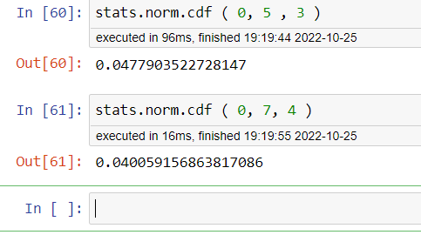

We can see that 1st division can make more loss compared to 1st division.