A Project Report
On
Prediction of Burned Area in Forest Fire

Submitted in Partial Fulfillment for the Award of

Degree of Bachelor of Technology
In
Computer Science and Engineering

By

Sanjeev Kumar (1406027)

Kuldeep Mahawar (1406025)

Sourabh Kori (1206031)

Under the Supervision of:

Dr. Ditipriya Sinha


Department of Computer Science & Engineering National Institute of Technology Patna (Jan–May 2018)



DEPARTMENT OF COMPUTER SCIENCE & ENGINEERING
NATIONAL INSTITUTE OF TECHNOLOGY PATNA
JAN-MAY 2018

CERTIFICATE

This is to certify that Sanjeev Kumar (1406027), Kuldeep Mahawar (1406025) and Sourabh Kori (1206031) has completed “Prediction of Burned Area in Forest Fire” as his Major Project (8CS195) under my supervision.

I hereby recommend that this project is accepted as per the requirements of evaluation and for the award of B.Tech Degree in Computer Science & Engineering.

____________________ ____________________
Dr. Ditipriya Sinha Dr. Prabhat Kumar
Assistant Professor Head of Department,
CSE Department, CSE Department,
NIT Patna NIT Patna


DECLARATION

We hereby declare that this project work entitled “Prediction of Burned Area in Forest Fire” has been carried out by us in the Department of Computer Science and Engineering of National Institute of Technology, Patna under the guidance of Dr. Ditipriya Sinha, Assistant Professor. No part of this work has been submitted for the major project of degree or diploma to any other institute.

 |  | _____________________
Sanjeev Kumar |  | Kuldeep Mahawar
B. Tech - C.S.E, 8thsem |  | B. Tech - C.S.E, 8thsem
1406027 |  | 1406025

Sourabh Kori

B. Tech – C.S.E, 8thsem

1206031

Place: Patna
Date: ___/___/___

ACKNOWLEDGEMENT

We would like to take this opportunity to thank all our sources of aspirations during this project. First and foremost, I would like to thank our project Internal Guide, Dr. Ditipriya Sinha, for his continuous support during this project and related research, and for his patience, motivation, and immense knowledge. And during the most difficult times when writing this report, he gave us the moral support and the freedom we needed to move on.

In addition, I would like to thank my colleagues and project partners for their valuable contributions. Some of the open source contributions helped us to understand the platform better and finish this challenge. Last but not the least, I would like to thank the God, the Almighty.

 |  | _____________________
Sanjeev Kumar |  | Kuldeep Mahawar
B. Tech - C.S.E, 8thsem |  | B. Tech - C.S.E, 8thsem
1406027 |  | 1406025

Sourabh Kori

B. Tech – C.S.E, 8thsem

1206031

ABSTRACT

Prediction of Burned Area in Forest Fire

Machine learning is a core sub-area of artificial intelligence. It enables computers to get into a mode of self-learning without being explicitly programmed. When exposed to new data, these computer programs are enabled to learn, grow, change and develop by them. Similarly, Predicting natural disasters like hailstorm, fire, rainfall etc. are infrequent and stochastic. Detection of these disasters should be fast and accurate as they may cause damage and destruction at large scale.

In this paper, We have calculated the values of area by using the Keras Libraries. Also, comparison of various machine learning techniques such as SVM, Linear Regression, Ridge, Lasso etc. has been done for prediction of forest fires. The proposed approach in this paper presents the approach and method for the calculation of area of forest fires.

Table of Contents

- Introduction………………………………………….……7

- Attribute Information………………………………….…..9

- Classes Description…………………………….……..….11

- Flow of the work……………………………………..…..12

- Sensor Deployment……………………………………....13

- Zone Division…………………………………………….15
.
- Correlation….………………………………..……….….16

- Feature Selection…………………..……………………..18

- Scatter Matrix……………………...………………….….19

- Selection of Best Model…………...…………….…….....21

- Keras Libraries………………………………………..….23

- Results………..…………………………………….…….27

- Code Sections………………………………..…………..28

- Conclusion ……..….……………………………….…....30

- References.………………………………………….……31

I. INTRODUCTION

Forest fire also known as bush fire or hill fire is an uncontrolled fire occurring wild or forest areas. It is very important to detect these kinds of fires as early as possible so as to prevent the damage from it to ecological system. Every year millions of acres of forest are burnt down. The land were forest is burnt it becomes impossible to grow vegetation over there. This is because soil becomes water repellent and accepts no more water, leading to reduction in ground water level. The Global Warming Report 2008 mentions forest fire as one of the major cause behind increase in global warming.

In recent year 2016 more than 4000 hectares of forest were burnt in the hills of Uttarakhand. Common causes of forest fire are lightning, extreme hot and arid weather and human carelessness. The use of wireless sensor in this paper presents one of the techniques for early forest fire detection.

Many solutions for detection of forest fire are presented and implemented in past few years. Video Surveillance System is most widely used for detection of forest fire[1]. It is divided into four categories : Video Cameras sensitive in visible spectrum based on recognition of smoke during day light and fire flames at night, Infrared(IR) Thermal Imaging cameras based on detection of heat flux from the fire, IR Spectrometer which identify spectral characteristics of smoke gases and Light Detection and Ranging (LIDAR) system which measures the laser light backscattered by smoke particles. The limitation of these systems was high false alarm rate due to atmospheric conditions such as presence of fog, shadows, dust particles etc.

Forest fires cause major damage to the environment, human health and property, and endanger life. Fires can be monitored and analyzed over large areas in a timely and cost-effective manner by using satellite sensor imagery in combination with spatial analysis as provided by Geographical Information Systems (GIS). In this study, the forest area damage caused by a large fire which occurred in the Marmaris, province of Mugla in July 1996 was analyzed using satellite sensor images. Digital image processing methods, such as spectral profile analysis, vegetation indices and multispectral classification, were applied to the satellite sensor images acquired before and after the forest fire. Besides the conventional maximum likelihood classification algorithm, multilayer feed-forward neural network architecture was also used for comparison and evaluation of its effectiveness. A GIS database was constructed from the raster (satellite sensor data), vector (the forest type and topographical maps) and ancillary data (meteorological data). The GIS is being used to develop an information and decision support system to monitor and predict forest fire activity, and to enhance fire management efficiency.

Forest fires represent one of the most critical issues in global change. They are responsible of several devastating damages like loss of biodiversity, decrease in forests, alteration of landscape, soil degradation, increase in greenhouse effect, etc. Every year, around 45,000 forest fires break out in Europe causing the destruction of about 2.6 million hectares. Nevertheless, there are many natural factors, above all summer drought, that strongly influence fire ignition and spread.

II. Attribute Information

1. X - x-axis spatial coordinate within the Montesano park map: 1 to 9
2. Y - y-axis spatial coordinate within the Montesinho park map: 2 to 9
3. Month - month of the year: 'Jan' to 'Dec'
4. Day - day of the week: 'mon' to 'sun'
5. FFMC - FFMC index from the FWI system: 18.7 to 96.20
6. DMC - DMC index from the FWI system: 1.1 to 291.3
7. DC - DC index from the FWI system: 7.9 to 860.6
8. ISI - ISI index from the FWI system: 0.0 to 56.10
9. Temp - temperature in Celsius degrees: 2.2 to 33.30
10. RH - relative humidity in %: 15.0 to 100
11. Wind - wind speed in km/h: 0.40 to 9.40
12. Rain - outside rain in mm/m2: 0.0 to 6.4
13. Area - the burned area of the forest (in ha): 0.00 to 1090.84
(This output variable is much skewed towards 0.0, thus It may
make sense to model with the logarithm transform)

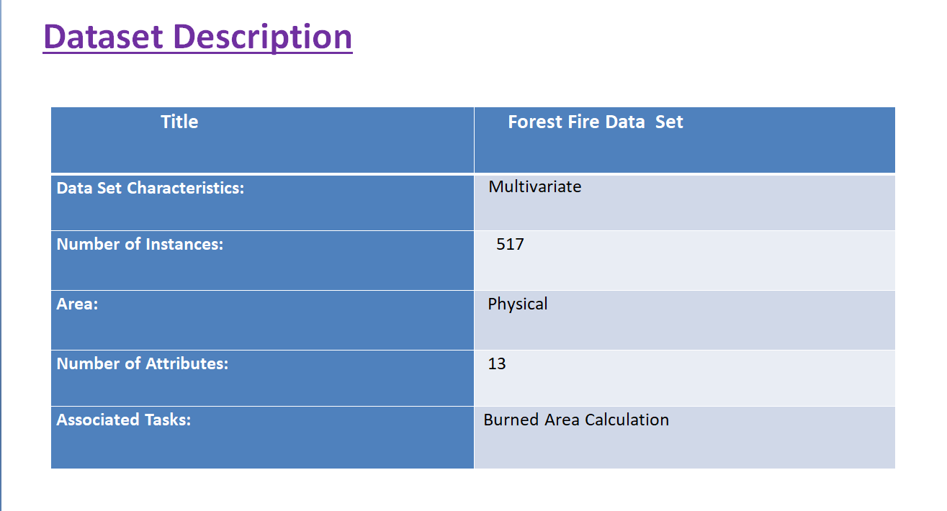

III. Classes Description

Active High
  - It includes the most affected region by fire.
  - Highest number of sensor to be deployed here.

Active Medium
  - It includes the moderate affected region by fire.
  - Lesser number of sensors to be deployed here.

Active Low
  - It includes the least affected region by fire.
  - Very few numbers of sensors to be deployed here.

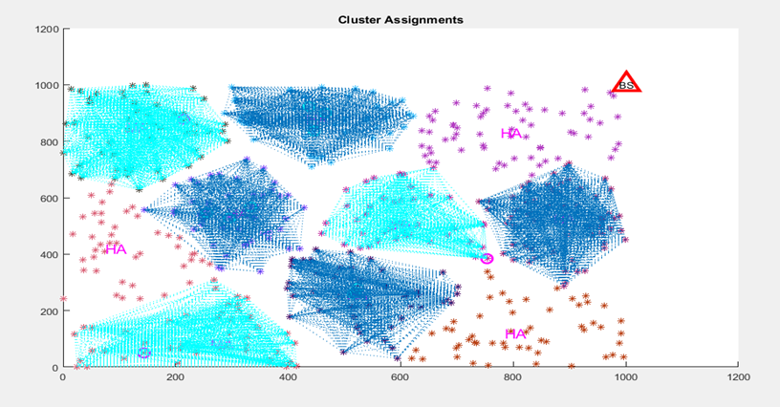

IV. Flow of Work

There are many steps to find the most burnt area by using given attributes which are as follows:

- First of all, the data is collected from the references.
- Then, the collected dataset is pre-processed before applying any further operations.
- Again, correlation is calculated to know how one attributes vary & relate to one another.
- Further, finding the features and get ranking of variables.
- After that, area is calculated using Keras API.
- Finally, the graph is plotted to get the view of burnt area.

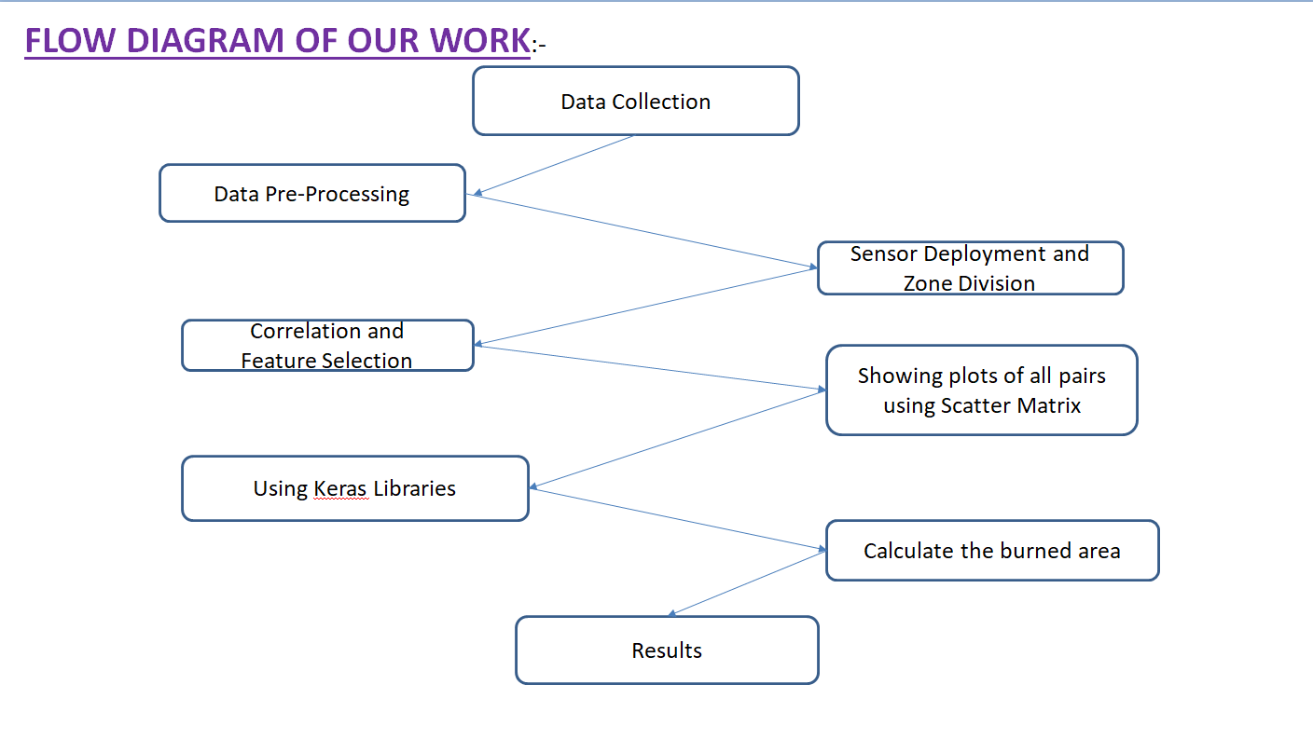

V. Sensor Deployment:

Wireless sensor networks have been attracting many research efforts during the past few years. Sensor networks, usually composed of a few sinks and a large quantity of inexpensive and small sensor nodes, have been deployed in a variety of applications such as habitat monitoring
forest fire detection, etc.

We propose a new real-time forest fire detection method by using wireless sensor networks. Our goal is to detect and predict forest fire promptly and accurately in order to minimize the loss of forests, wild animals, and people in the forest fire. In our proposed paradigm, a large number of sensor nodes are densely deployed in a forest. Sensor nodes collect measured data (e.g., temperature, relative humidity) and send to their respective cluster nodes that collaboratively process the data by constructing a neural network. The neural network takes the measured data as input to produce weather index, which measures the likelihood for the weather to cause a fire. Cluster headers will send weather indexes to a manager node via the sink. Then the manager node concludes the forest fire danger rate based on received weather indexes and some other factors.

We apply the neural network method to the data processing in the cluster header in our design. The neural network has been applied to a lot of application in the past two decades, including satellite-based forest fire detection. To our best knowledge, there exists no previous work that has proposed in-network processing using neural network in wireless sensor networks.

Sensor Deployment

- We randomly deploy Sensor in the required area so that we don’t get any continuity.

Size of Area:
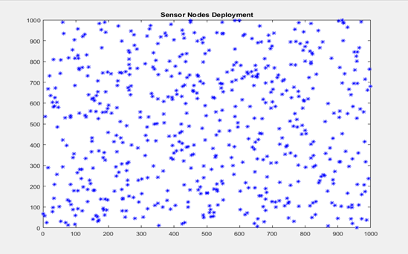

VI. Zone Division:

The incidence of forest fire depends on many factors, which play a significant role in the spread of forest fires.

- We use the equilatory distance to divide the area in different zones.

- We can calculate the whole area into sub area ,it will lead our problem to sub problems.

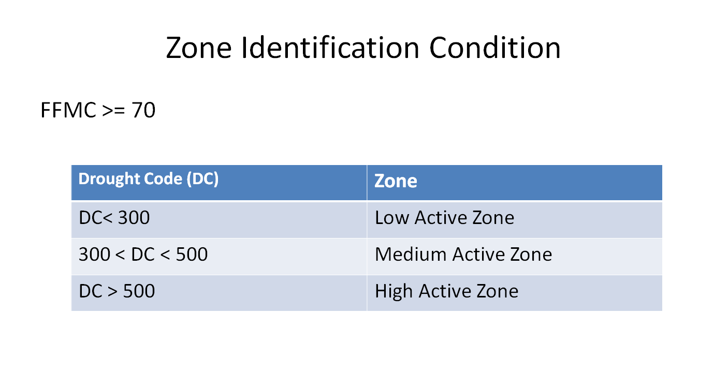

VII. Correlation

A correlation is a number between -1 and +1 that measures the degree of association between two Attributes (call them X and Y). A positive value for the correlation implies a positive association. In this case large values of X tend to be associated with large values of Y and small values of X tend to be associated with small values of Y. A negative value for the correlation implies a negative or inverse association. In this case large values of X tend to be associated with small values of Y and vice versa.

Correlation is any of a broad class of statistical relationships involving dependence, though in common usage it most often refers to how close two variables are to having a linear relationship with each other.
Correlation coefficients are used in statistics to measure how strong a relationship is between two variables. There are several types of correlation coefficient: Pearson’s correlation (also called Pearson’s R) is a correlation coefficient commonly used in linear regression. If you’re starting out in statistics, you’ll probably learn about Pearson’s R first. In fact, when anyone refers to the correlation coefficient, they are usually talking about Pearson’s.
Correlation coefficient formulas are used to find how strong a relationship is between data. The formulas return a value between -1 and 1, where:
- 1 indicates a strong positive relationship.
- -1 indicates a strong negative relationship.
- A result of zero indicates no relationship at all.

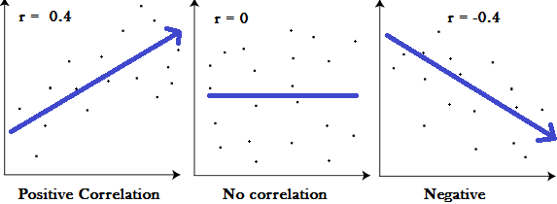

- A correlation coefficient of 1 means that for every positive increase in one variable, there is a positive increase of a fixed proportion in the other. For example, shoe sizes go up in (almost) perfect correlation with foot length.

- A correlation coefficient of -1 means that for every positive increase in one variable, there is a negative decrease of a fixed proportion in the other. For example, the amount of gas in a tank decreases in (almost) perfect correlation with speed.

- Zero means that for every increase, there isn’t a positive or negative increase. The two just aren’t related

VIII. Feature Selection

.
In machine learning and statistics, feature selection, also known as variable selection, attribute selection or variable subset selection, is the process of selecting a subset of relevant features(variables, predictors) for use in model construction.

Top reasons to use feature selection are:
- It enables the machine learning algorithm to train faster.
- It reduces the complexity of a model and makes it easier to interpret.
- It improves the accuracy of a model if the right subset is chosen.
- It reduces overfitting.

In our project, we have calculated the feature selection as:

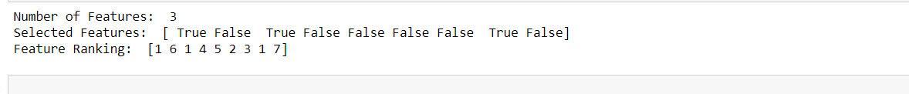
IX. Scatter Matrix

In multivariate statistics and probability theory, the scatter matrix is a statistic that is used to make estimates of the covariance matrix, for instance of the multivariate normal distribution.

Scatter plot matrices (SPLOMS) enable us to check pairwise relationships between features and look for things like covariance, linear, quadratic, and exponential relationships.
Plot all pairwise scatter plots of the features in a single matrix. The diagonal can be used for feature labels, histograms, densities.

A scatter plot matrix can be formed for a collection of variables where each of the variables will be plotted against each other. The Scatter Matrix function helps in plotting the preceding figure. It takes in the data frame object and the required parameters that are defined to customize the plot. You would have observed that the diagonal graph is defined as a histogram, which means that in the section of the plot matrix where the variable is against itself, a histogram is plotted.

Below Pictures showing the scatter plots of all pairs of given variables:

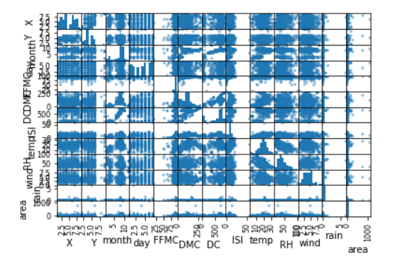

X. Selection of the best Model

1. Support Vector Machine (SVM): An SVM model is a representation of the examples as points in space, mapped so that the examples of the separate categories are divided by a clear gap that is as wide as possible.

2. ExtraTreesRegressor: Extra-trees differ from classic decision trees in the way they are built. When looking for the best split to separate the samples of a node into two groups, random splits are drawn for each of the max_features randomly selected features and the best split among those is chosen. When max_features is set 1, this amounts to building a totally random decision tree.

3. DecisionTreesRegressor: These are a non-parametric supervised learning method used for classification and regression. The goal is to create a model that predicts the value of a target variable by learning simple decision rules inferred from the data features.

We will choose the best model for prediction of burnt area with a high accuracy.

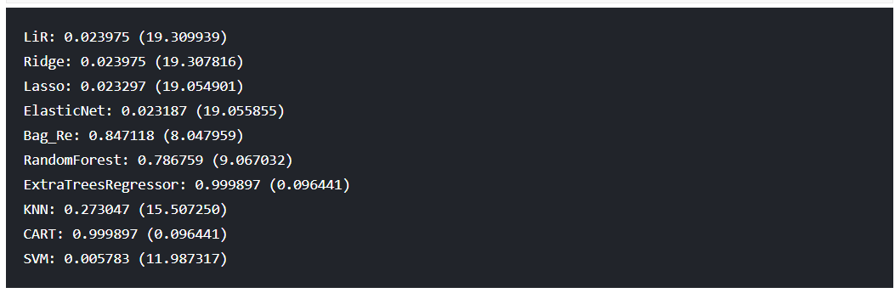

XI. Keras Libraries

Keras is a high-level neural networks API, written in Python and capable of running on top of TensorFlow, CNTK, or Theano. It was developed with a focus on enabling fast experimentation.
With the functional API, it is easy to reuse trained models: you can treat any model as if it were a layer, by calling it on a tensor. Note that by calling a model you aren't just reusing the architecture of the model, you are also reusing its weights.

Useful attributes of Model
- model.layers is a flattened list of the layers comprising the model graph.
- model.inputs is the list of input tensors.
- model.outputs is the list of output tensors.
The Sequential model is probably a better choice to implement such a network, but it helps to start with something really simple.
- A layer instance is callable (on a tensor), and it returns a tensor
- Input tensor(s) and output tensor(s) can then be used to define a Model
- Such a model can be trained just like Keras Sequential models

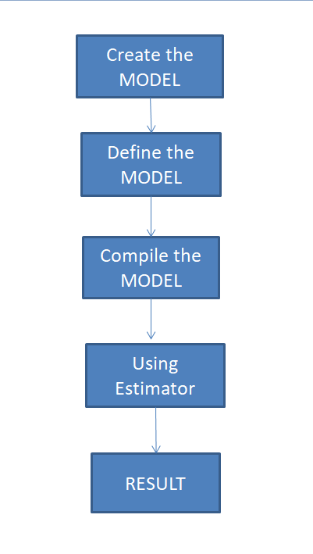
Workflow to predict the burned area using Keras API

The Steps involving involving in the prediction of the burned area using Keras API are as follows:-

1.Creation of model: We create a Sequential model by passing a list of layer instances to the constructor. The model needs to know what input shape it should expect. For this reason, the first layer in a Sequential model

2.Defining the model: The Keras functional API is the way to go for defining complex models, such as multi-output models, directed acyclic graphs, or models with shared layers.
The Sequential model is probably a better choice to implement such a network, but it helps to start with something really simple.
- A layer instance is callable (on a tensor), and it returns a tensor
- Input tensor(s) and output tensor(s) can then be used to define a Model
- Such a model can be trained just like Keras Sequential models.
3.Compilation of model: Before training a model, you need to configure the learning process, which is done via the compile method. It receives three arguments:
- An optimizer. This could be the string identifier of an existing optimizer (such as rmsprop or adagrad), or an instance of the Optimizer class. See: optimizers.
- A loss function. This is the objective that the model will try to minimize. It can be the string identifier of an existing loss function (such as categorical_crossentropy or mse), or it can be an objective function. See: losses.
- A list of metrics. For any classification problem you will want to set this to metrics=['accuracy']. A metric could be the string identifier of an existing metric or a custom metric function.

4. Estimators/Models: An estimator is a predictor found from regression algorithm. The process of training an ML model involves providing an ML algorithm (that is, the learning algorithm) with training data to learn from. The term ML model refers to the model artifact that is created by the training process.

5. Getting the Results: Finally, the outputs will be range of values where the fire is active in the region.

X. Results:

The final output of the areas are as follows:

Cluster | Area (in Hectares)
High Active-1 | 3.66
High Active -2 | 4.95
High Active -3 | 5.53
High Active -4 | 3.09

XI. Code Section:

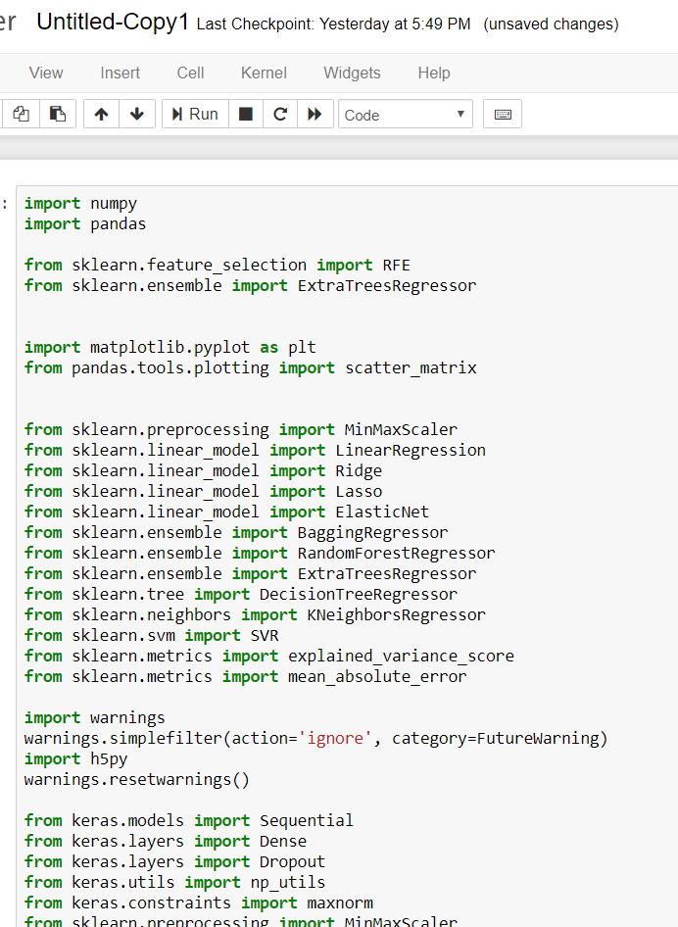

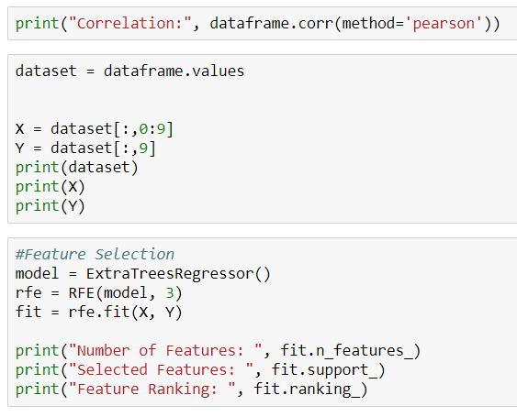

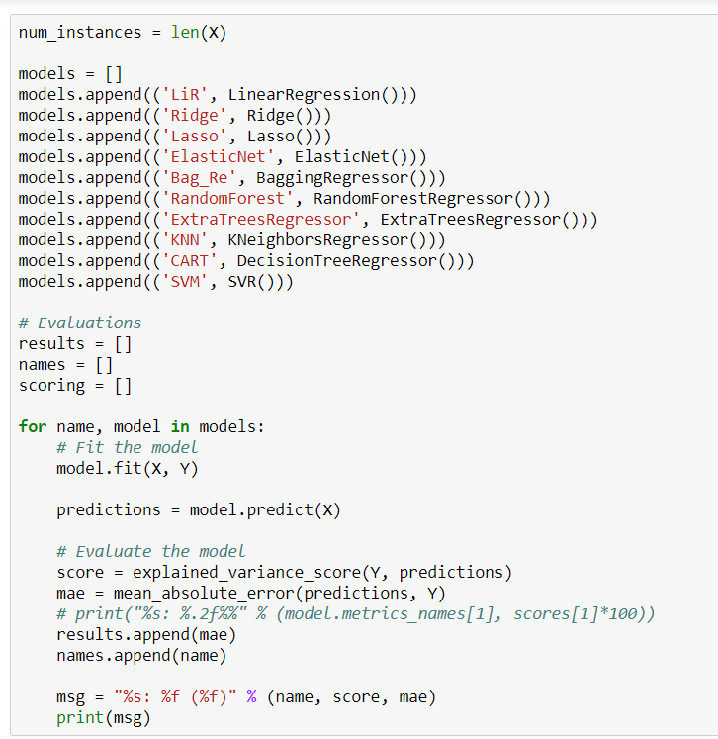

XII. Conclusion

- Reducing the area being affected by fire.

- Helping in predicting the intensity of forest fires.

- Balancing economic problems as well as ecological damage.

- Working with Local People, a way forward in containing Forest Fires.

XIII. References

- Y. G. Sahin and T. Ince, “Early forest fire detection using radio-acoustic sounding system,” Sensors, vol. 9, no. 3, pp. 1485–1498, 2009.

- M. Hefeeda and M. Bagheri, “Forest fire modeling and early detection using wireless sensor networks,” Ad-Hoc and Sensor Wireless Networks, vol. 7, no. 3-4, pp. 169–224, 2009.

- U. Ganesh, M. Anand, S. Arun, M. Dinesh, P. Gunaseelan, and R. Karthik, “Forest fire detection using optimized solar-powered Zigbee wireless sensor networks,” International Journal of Scientific and Engineering Research, vol. 4, pp. 586–596, 2013

- ZHANG J G, LI W B, K J M. Forest fire detection system based on ZigBee wireless sensor network [J], Journal of Beijing Forestry University, v 29, n 4, July, 2007, p 41-45

- J. Fernandez-Berni, J. F. Martinez, "Early forest fire detection by vision-enabled wireless sensor networks", International Journal of Wildland Fire, vol. 21, no. 8, pp. 938-949, 2012.

