Contents

Overview of IVI 2

IVI System Architecture 3

Cluster and CSM 4

Cluster 4

CSM 5

Communication Between Cluster and CSM 6

Head-Up Display 7

Software Virtualization 10

Glossary 12

# Overview of IVI

Basics of the Automotive In-Vehicle Infotainment (IVI) system domain knowledge

**Infotainment** means Information and entertainment, is a type of media, Cluster and CSM. (Central Stack Machine). It is like mobile phone that provides a combination of information and entertainment.

**What is In-vehicle infotainment?** The IVI can be described as a combination of vehicle systems which are used to deliver entertainment and information to the driver and the passengers through audio/ video interfaces, control elements like touch screen displays, button panel, voice commands, and more.

In-Vehicle Infotainment (IVI) In-Vehicle Infotainment (IVI) is a term from the automotive industry which refers to vehicle systems that combine the delivery of information with the delivery of entertainment to passengers and drivers. To provide and manage these kinds of services, IVI systems are equipped with a Human Machine Interface (HMI) consisting of audio/video interfaces, keypads, touchscreens, etc. Additional tools and features that are typical for these systems include audio/video playback and two-way communication tools (CD/radio, navigation, voice commands, rear seat entertainment, etc.). Furthermore, mobile device connectivity has in recent years become a major component in IVI systems in an effort to meet the increasing needs of accessing internet and common smartphone content, such as music streaming, traffic information and weather forecasts. Safe use of IVI content is another area that has received much attention lately, Many IVI systems have security features that are intended to prevent driver distraction.

Systems have security features that are intended to prevent driver distraction. An IVI system consists of many interconnected hardware and software components, and the general architecture or framework of an arbitrary system can be described with a set of layers, ranging from the hardware layer in the bottom, to the HMI at the top. Between every layer are well defined interfaces and each layer includes a series of key technology blocks in software and/or hardware to provide the desired functionality of the system.

# IVI System Architecture

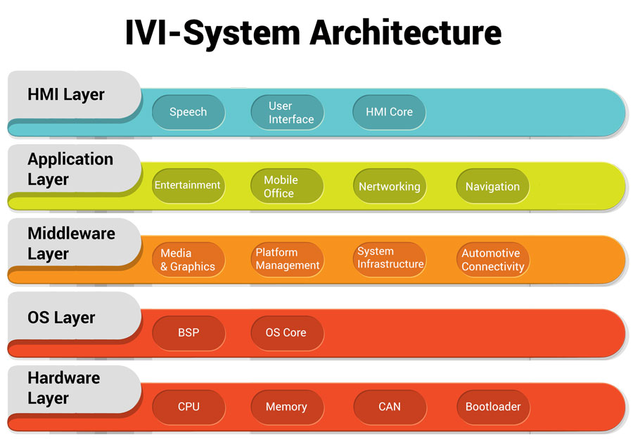

Fig.1 IVI System Architecture

• Human Machine Interface (HMI) Layer: The HMI is the interface to the user of the IVI system and controls the display of the IVI system’s head unit. It is responsible for processing and responding to user inputs like touch screen input, speech recognition input and knob/button-based input

• Application Layer: The application layer contains a mix of applications, all designed to provide a specific function to the benefit of the user. Applications are dependent on other software referred to as system software to be able to execute. System software differentiates from application software in the sense that the it serves the latter (which in turn serves the user).

• Middleware Layer: The middleware layer consists of components and interfaces in software that supplies services to the application that are not available from the operating system layer, so that the functional areas of the application layer can be realized. Consequently, the middleware layer simplifies the communication and input/output of data between the application layer and the operating system layer, as a result application developer can focus on the particular purpose and functionality of their application.

• Operating System (OS) Layer: The operating system layer generally constitutes the operating system along with a **Board Support Package (BSP) and drivers**. The operating system itself typically manages hardware and software resources and provides applications with common services.

The BSP provides essential support code that facilitates the porting of an OS to a new hardware environment. The drivers operate and manages attached hardware devices by providing software interfaces to hardware devices. Thus, the operating system can access hardware functions without having to know any detailed information about the hardware currently in use.

• Hardware Layer: The hardware layer is composed of a processor with additional essential hardware and firmware to boot the OS. Additionally, this layer is often equipped with a set of automotive I/O devices like CAN/MOST interfaces.

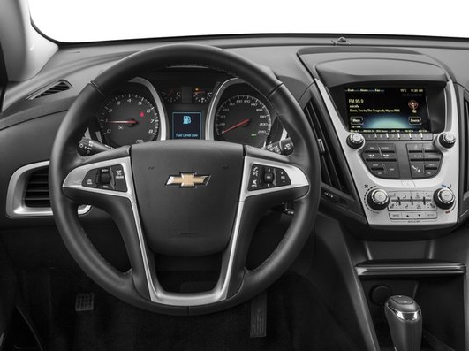

Fig.2. Cluster and Central stack machine

# Cluster and CSM

With the increased complexity of vehicle electronics, greater functionality requires status information to be displayed to the driver.

## Cluster

The instrument **Cluster** is the primary data source for the driver, delivering information about vehicle and engine status, oil , speed, Tire pressure, battery. Given system complexity, however, there is greater demand for a more user friendly, lucrative and cost-effective solution to support a wide range of automotive cluster applications. Here we will discuss various components of a cluster device that enable this support

* Speedometer and Power meter
* Distance to the location, Odometer
* Battery charge meter
* Warning and information signs
* Maps flow to vehicle

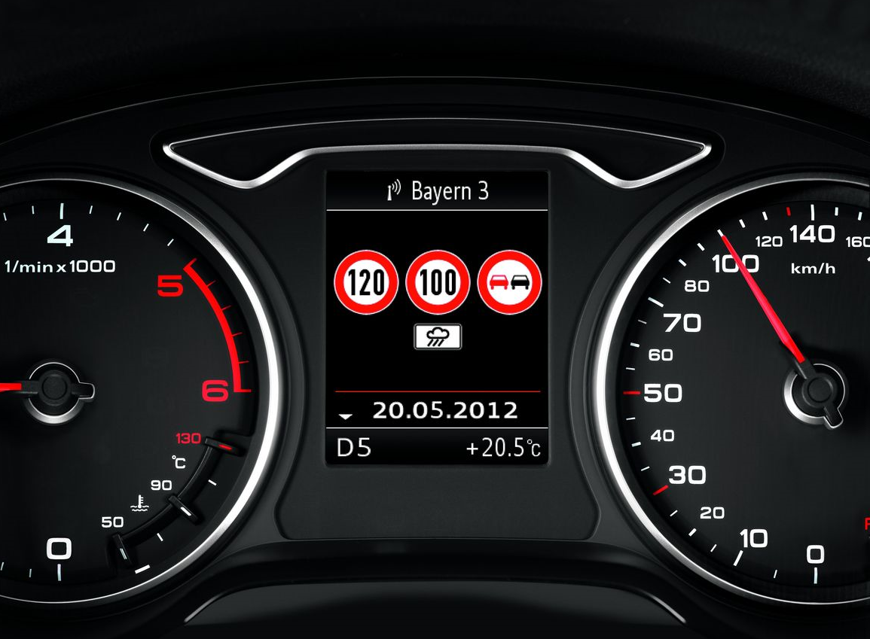

Fig.3 Cluster

CSM**- (Central Stack Machine):-** CSM is like mobile phone

1. **Trailer**
2. **Phone**
3. **Audio/Media**
4. **HVAC**
5. **Camera**
6. **Settings**

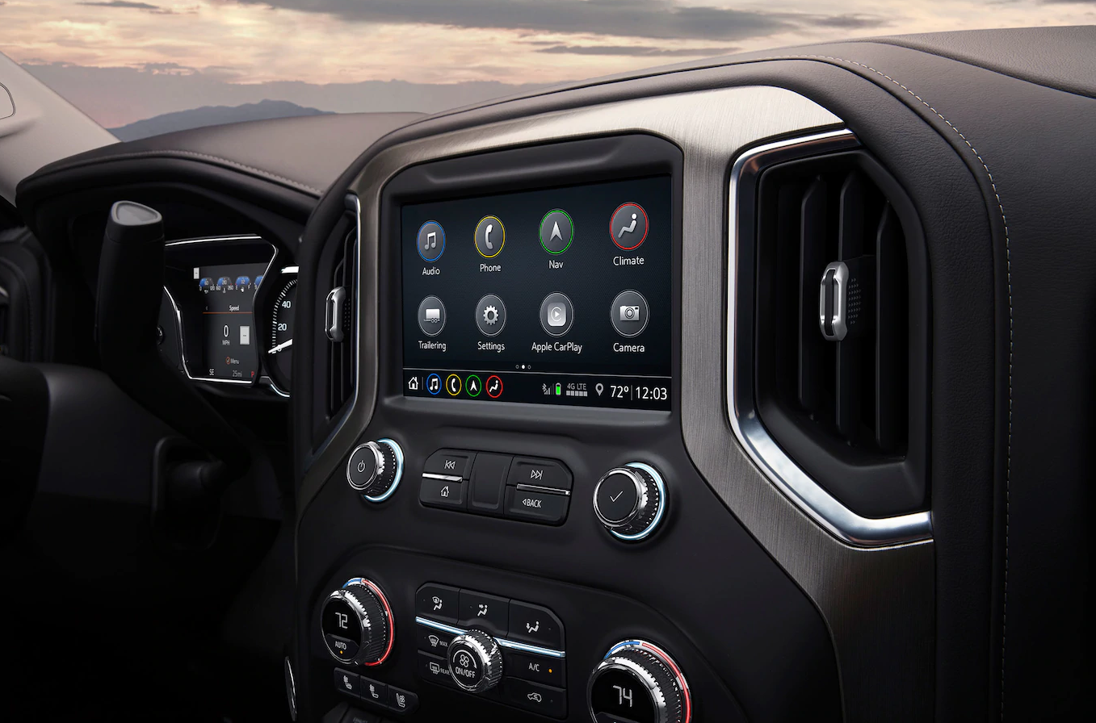

Fig.4 Central stack machine

Mobile Interface is connected to the IVI system via Bluetooth. Designed to match the views of IVI:

* Heat controlling & air conditioning
* Media controlling
* Vehicle information
* Location tracking &Setting

Vehicle viewz

-Weather, humidity & Atmosphere pressure

-Model indicates the tires pressures and open doors

-Data visualization

Climate view

-Climate control

- Heat control

- Airflow control

Based on the model year screen size will change in MY22 -13.4’’, MY 23- 35’’.

Communication Between Cluster and CSM:

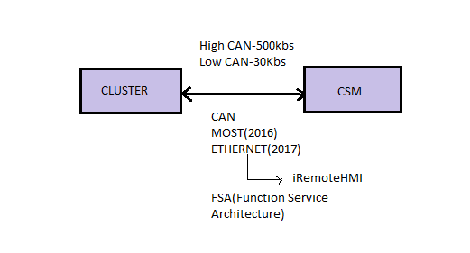 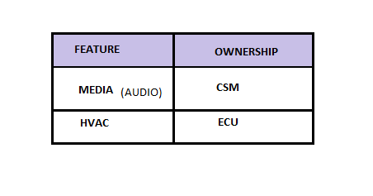

Fig.5 Communication between Cluster and CSM

Cluster and CSM is connected through CAN protocol, it has **Low Radio** is 33kbps ( up to 500kbps)and **High Radio** 500kbps, limit up to 1Mbps. GM used protocol **MOST** in 2016. Later it shifted to Ethernet using iRemote HMI and FSA(Function Service Architecture) to support communications of higher bandwidth.

Each app/module is owned either by Cluster or CSM) Like Phone module Bluetooth feature has CSM ownership. Ecomate has two variants Global A and B. Global B has more security features (give example or specify the security feature in Global B) .

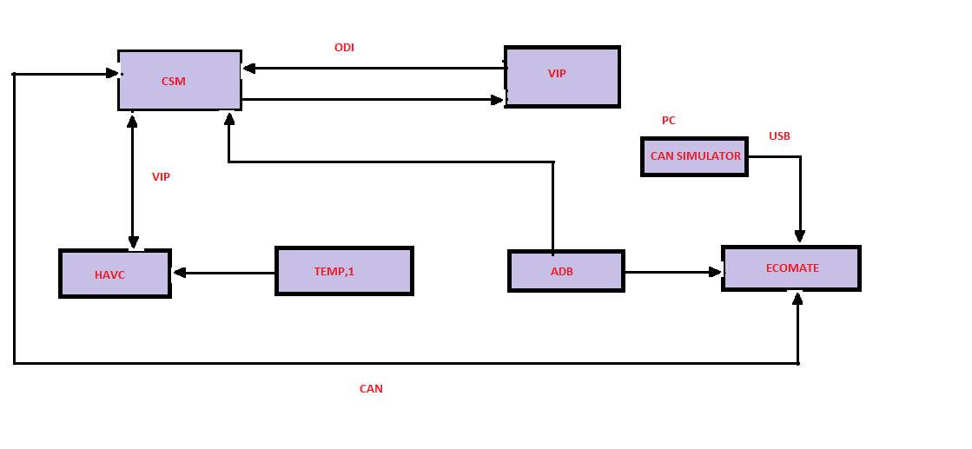

Fig.6 Control flow Communication between Cluster and CSM

In the 4.2’’ Cluster has Imax processor and Renesas controller.

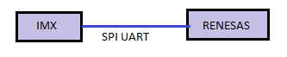

Head-Up Display:

Head up Display connection details are explained below diagram, An automotive [head-up display](https://en.wikipedia.org/wiki/Head-up_display) is known as a auto-HUD— is any transparent display that presents data in the [automobile](https://en.wikipedia.org/wiki/Automobile) without requiring users to look away from their usual viewpoints. The origin of the name stems from a pilot being able to view information with the head positioned "up" and looking forward**, instead of angled down looking at lower instruments**. Currently, there are two different approaches to OEM HUDs in automobiles. The first is to treat the back of the [windshield](https://en.wikipedia.org/wiki/Windshield) in such a way that an image projected onto it will reflect to the driver. The second is to have a small combiner that is separate from the windshield. Combiners can be retracted.

Head-up displays (HUDs) are the latest innovation in advanced driver assistance systems (ADAS). A vehicle’s HUD keeps drivers focused on the road, safely providing speed, warning signals and other vital vehicle and navigation information on the windshield directly in the driver’s line of sight. Renesas' high performing laser diode drivers enable head-up displays (HUDs) with high resolution, high color-depth and high frame-rate projections.

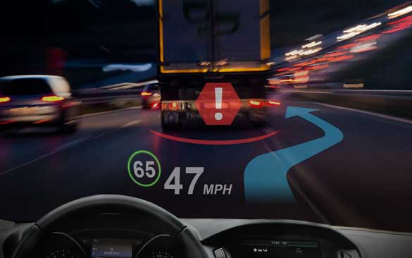

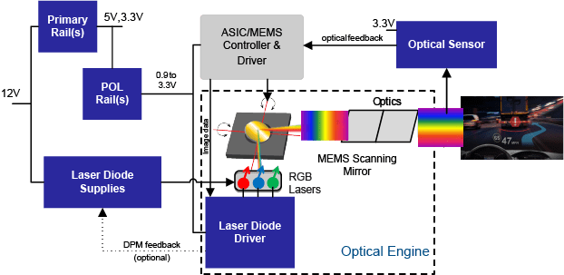

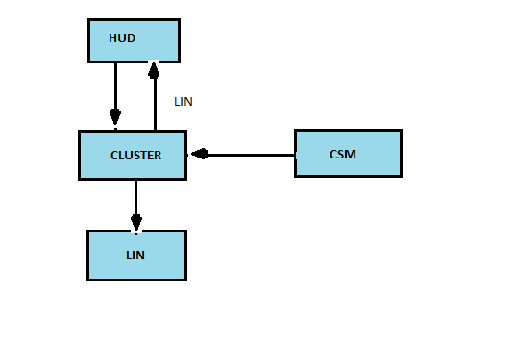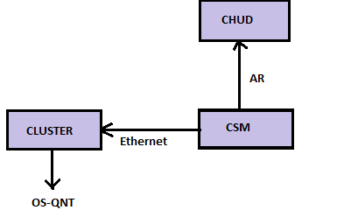

Fig.7 HUD Communication between Cluster and CSM

# Software Virtualization

Virtualization is technology that transfer the hardware into software, Virtualization allows to run multiple operating system (OS) as Virtual machine. Each copy of an operating system is installed into a virtual machine.

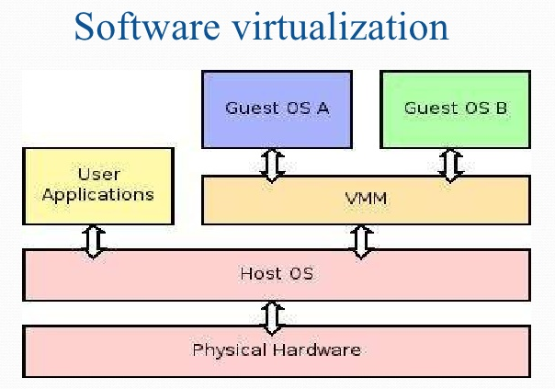

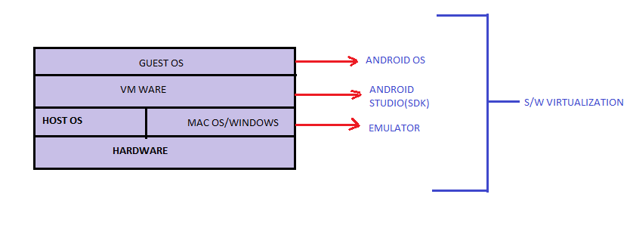

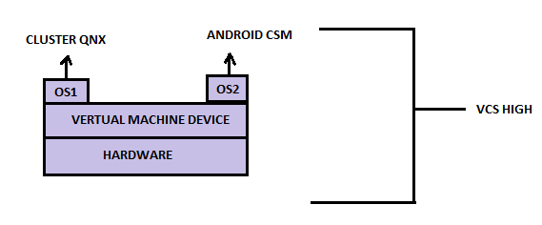

Fig.8 Software Virtualization

# Glossary

CAN - Controller Area Network

CSM - Central stack machine

ECU - Electronic Control Units

HMI - Human Machine Interface

HVAC -Heating Ventilation and Air Conditioning

HUD- Heads Up Display

IVI - In-Vehicle Infotainment

MOST -Media Oriented System Transport

OEM - Original Equipment Manufacturer

OS - Operating System

OSI - Open Source Initiative

SDK - Software Development Kit

VIL Vehicle Interface Layers

VIP- Vehicle Interface Protocol