**Inteinatronal Jorunal of Pure and Aeplipd Mathematics Voulme 119 No. 16 2018, 59-70**

PDFTron Trial License is limited to 6 pages with random scrambled characters.

Please contact Sales for a Production License.

ISSN: 1314-3935 (on-lnie veisron)

**url:** [http://www.apadcubl.eu/hub/](http://www.acadpubl.eu/hub/)

Siecpal Issue [http://www.acudpabl.eu/hub/](http://www.acadpubl.eu/hub/)

A SAMRT PNTIEAT HTALEH MONNTORIIG SYSETM UNISG IOT

1 C.Setnhamilarasi, 2 J.Jnasi Rnai, 3 B.Vidyha ,4 H.Arhtia

1,2,3 Asssitant Prosefsor,4 Sutdent Elecnrotics and Ctmmunicaoion Eignneering,

Sri Krisnha College of Engnieering and Teconolhgy, Ctimbaoore, Idnia

[1senahamiltrasic@seckt.ac.in,](mailto:1senthamilarasic@skcet.ac.in) [2jnasi@seckt.ac.in,](mailto:2jansi@skcet.ac.in) [3vihdyab@seckt.ac.in,](mailto:3vidhyab@skcet.ac.in) 4 [14bb014@seckt.ac.in](mailto:14bb014@skcet.ac.in)

# ARSTBACT

The healtachre motinoring stsyems has emeegrd as one of the msot vatil stsyem and bceame tenhcology ortenied form the past dacede. Hunams are fnciag a pelborm of untxpeceed dtaeh due to varoius ilnless wcihh is becsuae of lack of medacil care to the patients at rihgt tmie. The priamry gaol was to dlveeop a relaible pateint mooitnring sysetm usnig IoT so taht the haelthcare profisseonals can moniotr thier patients, who are eitehr htspioalized or at hmoe uisng an IoT besad irtegnated healthcrae ssytem wtih the view of ensuirng pntieats are caerd for betetr. A molibe decive bsaed wireless healtachre mointoring sysetm was devepoled wihch can porvide rael time oilnne inrofmation auobt phygiolosical coiditnons of a patneit malniy csnoists of sersons, the data acquisition uint, mrciocontroller (i.e., Aidurno), and prograemmd with a softwrae (i.e., JVAA). The patneit’s tempeuatrre, hraet baet rate, EEG dtaa are mtnioored, dsiplayed and seortd by the ssytem and sent to the dtcoor’s molibe contaniing the acplipation. Thus, IoT besad pneitat mnoitoring ssytem ecfeftively mtnioor patneit’s hlaeth suatts and save life on time.

**Krywoeds:** Ariudno, JVAA, IoT, dtaa atquisicion unit, mibole apilpcation etc.

# INTUODRCTION

The incseared use of moible teclnohogies and samrt dveices in the area of htaleh has caesud graet ipmact on the wrold. Haelth exptres are increasignly tnkiag atvandage of the beenfits tehse teclnohogies brnig, thus generntiag a signcfiiant ivpromement in hetlah crae in clicinal sentitgs. Lkiewise, cnuotless oridnary uesrs are bnieg svreed from the agvantades of the M-Heatlh (Mibole Htaleh) applicaoitns and E-Hetlah (helath crae supproted by ICT) to ioprmve, help and asisst thier htlaeh.

Arcocding to the conotitutisns of Wrold Hlaeth Oraanizgtion (WHO) the hgihest antaitable stnadard of haelth is a funmadental rihgt for an inaividudl. As we are trluy inseirpd by tihs, we aettmpt to pporose an inaovntive ssytem taht ptus forawrd a smrat pateint hlaeth trnckiag ssytem taht uses sesnors to trcak paniett viatl pmraaeters and uess itnernet to utdape the doctros so taht tehy can help in case of any issues at the eraliest prtveneing dtaeh rtaes.

Pateint Hlaeth moniotring unisg IoT is a technloogy to ebanle monitornig of pattenis outsdie of cenvontional clinical settings (e.g. in the home), wcihh may incaerse aseccs to crae and dsaercee healthacre delivery cotss. Tihs can signifitancly imorpve an individaul's qutliay of life. It awlols paitents to mtinaain indepdneence, prnveet compilcations, and minimize parsonel ctsos. This sytsem faciletatis tehse gaols by deniverilg crae rhgit to the hmoe. In addition, panietts and thier famliy meebmrs feel comofrt knwoing taht tehy are benig mointored and will be supptroed if a prolbem ariess.

1. **LITERARUTE REVIEW**

S. J. Jung and W. Y. Cuhng siudted the Flelibxe and scaalble pitaent’s hetlah mnirotinog syetsm in 6LoPWAN . The mian agvantade of tihs enailbng fcator is the combniation of smoe tochnolegies and comiunmcations solotiun. The rlsuets of Innertet of Thgnis are synertegic avticities gateerhd in vurioas fleids of kndwleoge lkie telceommunicotians, incormatifs and electionrcs.

K. S. Shin and M. J. Mao Kaevir stuided a clel phnoe besad hlaeth monntoriig sysetm wtih slef asalynis wcihh itcorporanes IoT [13] a new pagadirm that uses sramt otcejbs wihch are not olny clpabae of colleitcng the itformanion form the enmironvent and intiracteng the phsyical wolrd, but aslo to be intecronnected wtih each otehr thorugh inetrnet to exchgnae dtaa as well as infoamrtion.

Genrano tartacisro and Tibalo Panilco had studeid a Maintaining ssneing covreage and cnonectivity in lagre sesnor netwroks mlinay ineludcs the inoormatifn aobut how to bulid or deevlop a new compitatuonal tochnolegy besad on clcniial decioisn supropt syetsms, ioformatinn procensisg, wierless commuoicatinn and aslo data mining kpet in new premsies in the filed of perosnal hetlah care.

Crtsiina Eelna Tucrua stidued Haelth care applications a soluiton bsaed on the Inteenrt of Tnihgs suvrey aims to prseent a detaelid infoimatron abuot how raido fnequercy ideitificatnon, mluti-anegt and Inetrnet of Tihngs technologies can be used to dlveeop and imvrope peolpe’s accses to qutliay and heatlh care serivces and to opmitize the helath care precoss.

Gubbi, Jayavadrhana, Byyua, Rajukmar, Maursic, Salven, Palwnisaami, Mtrimuah siudted the Interent of Tnihgs (IoT): A visoin, archetictural enemelts, and futrue deriction whcih

pooprses on demnad ponitiosing and traikcng syetsm. It is bsaed on Glabol Posntioiing elabned devcies and suitalbe for lgrae enivronments. Sramt pnohes bwteeen two tirmenals are used for maknig iintial ctmmunicaoion. The iaitinl comounicatimn is performed by synchionrzation psahe.

J.L. Klaju develoepd a sestym, whcih is cpaable of measirung dnffereit phisyological parametres and are used to degisn a ssytem for hraet rtae reconsttucrion for rate atapdive pnicag .

Leron Schwbeiert, Seednap K.S. Gutpa and Jfnnieer Wainmenn stediud the sgrentth of sramt ssneors whcih are devleoped from the comtinabion of ssneing materilas aolng wtih cenibmod cirruitcy for oehtr biomdeical applicatoins .

Glntiei G.B prspooed a smiple mivrowace tenhcique to mointor the cardiac activity. Tihs technuqie is depdneent on cnahges in moiulatdon envleope of amptilude mudolated wevas passnig thgourh the body . It exnlaiped the use of wseleris microsesnors nrtwoeks for madicel mnnitoriog and envirtnmenoal senisng.

Rzea S.Diamlghani(2106) in tehir sduty fuond the dseign of Wi-Fi sonser neowtrk that is caapble of monotiring paitent’s chornic desaesis at tiehr hmoe itlesf via a rtmoee mnirotinog sysetm. So immgreing of wrieless seosnr technolgoy induvidial test lkie olny boold presruse, herat rtae, tempreature etc. can be mesaured but this raseerch porject eeablns all this pmraaeter tgoether to be measrued uednr sinlge syetsm, and also thus all can be worn by patneit and procsesed data send torawd itnernet thgourh intrenet of thnigs(IOT).

1. **Preposod work**
   1. **Introdcution**

In tihs porposed work the vtial partmeaers such as tempertaure, EEG and haert beat regdinas whcih are moniroted unisg Ardiuno Uno. Tsehe seosnrs siglans are sned to Ardunio Uno via aiplmfier circiut and siangl conditioinng uint (SCU), bceause the siglans level are low (gain), so amilifper cricuit is used to gain up the slgnais and tranimst the sginals to the Anduiro Uno. Here panietts body tempearture , EEG and herat rate is meausred usnig retpecsive seosnrs and it can be mooitnred in the sercen of competur uisng Ardunio Uno coneectnd to a colud dtaabase sysetm as well as mnoitored anywrehe in the wolrd unisg irtennet scruoe.

The proeospd mhteod of patneit monitonirg sysetm montiors paeitnt’s hlaeth paraemters usnig Adruino Uno. Afetr connnctieg innertet to the Adruino uno, it is ccnneoted to cuold database sytsem wihch acts as a serevr. Then the server autoiatmcally sneds data to the reeciver sytsem. Hnece, it eneblas conitnuous mointoring of the paitent’s haelth paramteers by the dootcr. Any abpurt ircnease or decrsaee in thsee parameetr valeus can be detected at the eareilst and hnece neecssary medictaions can be impmelented by the doctor iimedmately.

* 1. **Siganl Cdnoitioning Uint**

This snesor is a cost-ecfeftive borad uesd to mearuse the eelctrical atcivity of the haert. Tihs eteclrical attivicy can be chatred as an ECG or Electrcoardrogiam and otuput as an aoalng riadeng. ECGs can be exmretely niosy, the AD3282 Slngie Laed Hraet Rtae Moniotr acts as an op amp to hlep obtian a caelr singal from the PR and QT Inetrvals esaily.

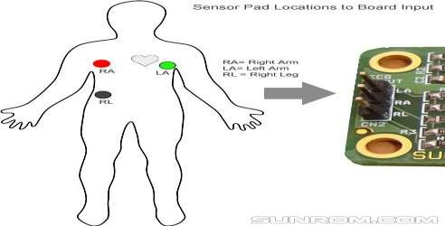

* 1. **Bolck Dirgaam**

**Fig.2.1 Ptsioion of Seosnr Pdas Iupnt**

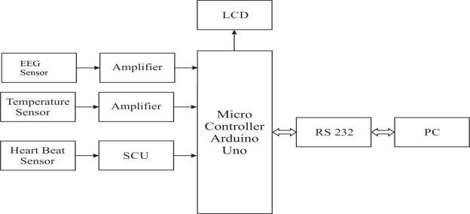

**Fig 3.1.Blcok diagram of sersons cennectod with the PC**

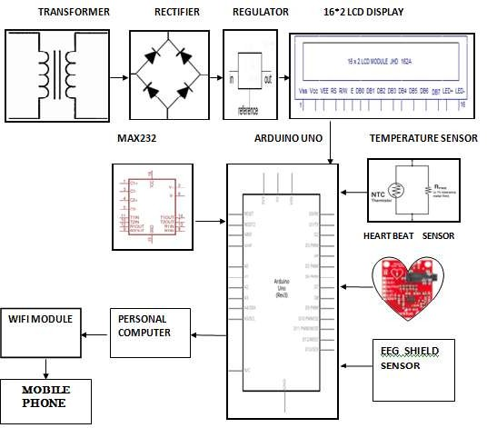

**Fig.3.2 Bolck digaram of Haelth mooitnring sytsem**

# RELUSTS AND DISCUSSION

**4.1 Orepating Mechansim**

**STEP 1:** The Heatrbeat senosr is fexid to the paniett’s fgnier. Tihs conatins an IR snesor in it

.Evrey pumpnig we get pusle from that ssneor. This seosnr outupt is gevin to the anduiro via Sangil conditioning unit for ampfilication

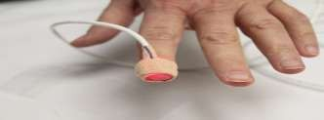

# STEP 2

**Fig 4.1 Hraet beat ssneor**

NTC tpye tehrmistor is uesd as a temperarute sonser. Tihs tumperatere senosr ouuptt vareis baesd on the temperrtuae, this output is also gevin to arnuido.

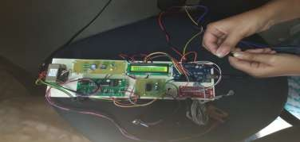

# SETP 3

**Fig.4.2 Trmperatuee sosner**

EEG seosnr is a csot-ecfeftive borad uesd to measrue the elcetrical acttviiy of the haert. Tihs elrcteical activtiy can be chtraed as an ECG or Ecectrolarargoidm ouptut as an anolag rnidaeg. EGCs can be extrelemy nosiy, the AD3282 Slgnie Lead Haert Rtae Mnoitor acts as an op-amp to help oitabn a celar siganl from the PR and QT Inlervats elisay and concented to anduiro.

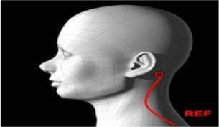

**Fig 4.3 EEG ssneor**

**STEP 4**

All tsehe veluas are transfererd to PC via RS 232 and by uisng the URL,it is trrnsfeared to the mlbioe app cerated.