A Project Report

On

NOTFLIX

Submitted in partial fulfillment of the requirement of

Project – V ()

Of

Bachelor's Degree in Computer Application

**Submitted to:**



Purbanchal University

Biratnagar, Nepal

**Submitted By**

Bhuwan Bhatt ()

Manish Mandar ()

Sanjeev Rai ()

KANTIPUR CITY COLLEGE

Putalisadak, Kathmandu

A Project Report

On

NOTFLIX

Submitted in partial fulfillment of the requirement of

Project – V ()

Bachelor's Degree in Computer Application

**Submitted to:**

Purbanchal University

Biratnagar, Nepal

**Submitted By**

Bhuwan Bhatt ()

Manish Mandar ()

Sanjeev Rai ()

Project Supervisor

Er. Ashim KC

KANTIPUR CITY COLLEGE

Putalisadak, Kathmandu

**Abstract**

The “Notflix - Online Video Streaming Platform" is a user-centered initiative aimed at providing a seamless and engaging video streaming experience. This project emphasizes intuitive design and accessibility, ensuring that users can easily explore, stream, and enjoy their favorite videos.

The user interface (UI) is meticulously crafted with a clean, visually appealing layout that simplifies navigation while showcasing key features prominently. Guided by user-centric design principles, Notflix prioritizes accessibility and convenience, catering to the preferences and behaviors of its diverse audience. Special focus is placed on effortless video discovery through intelligent search features, personalized content recommendations, and an intuitive browsing experience.

The platform integrates cutting-edge technology to deliver high-quality streaming while maintaining robust performance across various devices and screen sizes through a responsive design. By emphasizing transparency, free access, and user satisfaction, Notflix aspires to create a trusted and enjoyable streaming destination.

Through thoughtful design and innovative functionality, Notflix aims to redefine video streaming by making high-quality entertainment universally accessible.

# ACKNOWLEDGEMENT

We would like to take this opportunity to present our votes of thanks to all those guide post who really acted as lightening pillars to enlighten our way throughout this project that has led to successful and satisfactory completion of this study.

We are really thankful to Project Supervisor Ashim KC for his active support, valuable time and advice, sincere cooperation during the study and in completing the assignment of preparing the said project within the given time stipulated. We are also very grateful to our Principal Raju Kattel for providing us with an opportunity to undertake this project and providing us with all the facilities.

In the end, We are thankful to all those, particularly the various friends , who have been creating proper, and good environment and also including new and fresh innovative ideas for us during the project, their help, it would have been very difficult for us to prepare the project in a time bound framework.

**Preface**

In a world where entertainment is a cornerstone of our daily lives, online video streaming has emerged as an indispensable medium, connecting audiences of all ages and cultures. It’s a space where simplicity meets engagement, and where a thoughtfully designed user interface transforms browsing into an immersive journey.

Welcome to Notflix, an online video streaming platform reimagining how you enjoy entertainment. At the foundation of our project is the power of modern web technologies, utilizing php and javascript for dynamic, responsive interfaces and Firebase for secure, real-time data management.

The essence of our project is rooted in the art of user interface (UI) design, striving to make video discovery, navigation, and streaming a seamless and enjoyable experience. Developing Notflix calls for a unique blend of technical expertise, creative innovation, and precision. While we foresee challenges in delivering a flawless and intuitive interface, we are committed to exceeding user expectations by providing a smooth, engaging, and bug-free streaming environment.

**Declaration**

We affirm that this project report, titled “NOTFLIX”, presented for the fulfillment of the BCA-III, represents original work conducted under the guidance of Mr. Ashim KC. It has not been used to obtain any other degree or diploma from any institution or university. We have adhered to ethical standards by duly acknowledging the contributions of others whenever their findings were referenced.

Bhuwan Bhatt ( )

Manish Mandar ()

Sanjeev Rai ( )

# 

# TOPIC APPROVAL SHEET

It is hereby informed that for the semester project, the topic selected by Bhuwan Bhatt, Manish Mandar and Sanjeev Rai of BCA-III is found suitable and appropriate as per the credit assigned by Purbanchal University (PU), Biratnagar, Nepal.

The project committee has approved the following topic and assigned a supervisor for the above mentioned students.

Topic Approved: NOTFLIX

-------------------------------------

BCA & BIT Program Coordinator

# 

# CERTIFICATE FROM THE SUPERVISOR

This is to certify that the project entitled “NOTFLIX”, submitted by Bhuwan Bhatt, Manish Mandar and Sanjeev Rai to the Department of Information Technology and Engineering at Kantipur City College, Kathmandu, Nepal towards the requirement for BCA: Project-III, is an original work carried out by them under my guidance and supervision.

Signature:

-----------------------------------

Mr.Ashim KC

Project supervisor

Department of IT and Engineering

Kantipur City College

**Table of Content**

**Abstract** iii

ACKNOWLEDGEMENT iv

TOPIC APPROVAL SHEET iii

CERTIFICATE FROM THE SUPERVISOR iv

Chapter 1: Introduction 2

**1.1** **Overview** 2

**1.2** **Significance** 3

**1.3** **Objectives** 4

**1.4** **Features** 4

**1.5** **Problem Statement** 5

**1.6 Scope and limitation** 6

**1.7 Organization of the document** 7

Chapter 2: Literature Review 8

**2.1 System: Online Marketplaces** 8

**2.1.1 System: Pros** 8

**2.1.2 System: Cons** 9

**2.2 System: User-Focused Features** 9

**2.2.1 System: Pros** 9

**2.2.2 System: Cons** 9

Chapter 3: Methodology and Schedule 10

**3.1 Software Development Life Cycle** 10

**3.2 Assignment of roles and responsibilities** 12

**Chapter 4: System Analysis** 13

**4.1 Requirement Analysis** 13

**4.1.1 Functional Requirements** 13

**4.1.2 Non-Functional Requirements** 14

**4.2 Feasibility Study** 14

**4.2.1 Technical Feasibility** 14

**4.2.3 Schedule Feasibility** 15

Chapter 5: System Design 15

**5.1 Use Case Diagram** 15

**5.2 Class Diagram** 17

Chapter 6: System Development and implementation 18

**6.1 Tools and Technology Used** 18

Chapter 7: Testing and Debugging 20

7.1 Test case 20

Chapter 8: Conclusion 20

References 22

**List of figures**

|  |  |  |
| --- | --- | --- |
| Figure no. | Figure | Page no. |
| 1.1 | Waterfall model | 8 |
| 1.2 | Use-case diagram | 13 |
| 1.3 | Sequence diagram | 14 |
| 1.4 | Activity diagram | 15 |
| 1.5 | Combination diagram | 16 |

**List of Tables**

|  |  |  |
| --- | --- | --- |
| Table no. | Table | Page no. |
| 1 | Assignment of roles and responsibilities | 10 |
| 2 | Gantt chart | 12 |
| 3 | Test case | 18 |

# Chapter 1: Introduction

**Notflix** is an innovative, web-based video streaming platform inspired by Netflix, offering free access to a wide range of videos after user registration. Developed with a focus on accessibility and simplicity, Notflix ensures that users can enjoy high-quality video content anytime, anywhere, without the burden of subscriptions or hidden fees.

## **Overview**

Notflix is a free, user-centric streaming platform redefining online entertainment. Powered by HTML, CSS, JavaScript, PHP, and MySQL. It offers a seamless viewing experience with a diverse video library, high-quality streaming, and intuitive navigation. Designed for simplicity and accessibility. Notflix transforms video streaming into a personalized, ad-free journey, ensuring global access and endless entertainment without subscriptions.

## **Significance**

* **Accessible Entertainment**: Notflix provides free, unrestricted access to a wide range of video content, breaking barriers to digital entertainment.
* **Universal Access**: Notflix democratizes streaming by offering free, easy access to a diverse video library, making entertainment accessible to all.

## **Objectives**

**Here are some detailed objective of the proposed Big Deal :**.

* **Provide Free Access to Entertainment**: Offer users unrestricted access to a diverse collection of video content without subscription fees.
* **Ensure High-Quality Streaming**: Deliver a smooth streaming experience with minimal buffering and adaptive quality options.

## **Features**

**Here are some detailed features of the proposed Notflix :**

* **High-Quality Video Playback**: Provides adaptive streaming for uninterrupted viewing across different devices.
* **Advanced Search and Categorization**: Users can quickly locate desired videos through smart search tools and well-organized categories.

## **Problem Statement**

In today’s fast-paced world, people seek accessible, seamless ways to relax and unwind. However, most streaming platforms require paid subscriptions, feature intrusive ads, or have complex interfaces that detract from the viewing experience.

Notflix aims to address these issues by providing a free, ad-free streaming platform with a user-friendly interface and reliable performance. Existing streaming services often face challenges related to affordability, accessibility, and ease of use, limiting users’ access to quality content.

## **1.6 Scope and limitation**

The scope of the Notflix project is to create an accessible, ad-free streaming platform that brings a high-quality, free entertainment experience to users globally. Key areas include:

* **Developing a User-Friendly Platform**: Ensuring smooth navigation, easy content discovery, and intuitive user interactions for all age groups.
* **Offering Diverse, High-Quality Content:** Curating a broad range of videos across genres, with options for quality adjustments to support various internet speeds.

Here are some limitation of this project:

* Notflix requires a stable internet connection for optimal streaming, which may limit users in regions with poor connectivity.
* The platform may be available only in English at launch, limiting accessibility for non-English speakers.

## **1.7 Organization of the document**

The document is structured into nine chapters, each with its respective sub-chapters. The organization of the document is as follows:

|  |  |
| --- | --- |
| **Chapters** | **Heading** |
| Chapter 1 | Introduction |
| Chapter 2 | Literature Review |
| Chapter 3 | Methodology |
| Chapter 4 | System Analysis |
| Chapter 5 | System Design |
| Chapter 6 | System development and implementation |
| Chapter 7 | Testing and debugging |
| Chapter 8 | Conclusion |
| Chapter 9 | Reference |

# Chapter 2: Literature Review

As we embarked on the development of **Notflix**, a web-based video streaming platform, our team aimed to create a service that offered free and easy access to quality content, ensuring a high-performing and engaging experience. Through extensive research into existing video streaming platforms such as **Netflix, YouTube, Hulu**, and **Amazon Prime Video**, we sought to identify both strengths and weaknesses in their services. This literature review highlights insights drawn from these platforms that will guide the development of **Notflix.**

## **2.1 Case Studies: Existing Video Streaming Platforms**

**Introduction**

The video streaming industry has grown exponentially over the past decade, with major platforms offering diverse content, user-friendly interfaces, and various subscription models. We reviewed several prominent streaming platforms to understand what users value and where there is room for improvement in the context of **Notflix.**

### **2.1.1 Netflix**

Netflix is arguably the most well-known global streaming service, offering a vast library of TV shows, movies, and original content. While Netflix’s market presence and content variety are praised, user reviews reveal several areas for potential improvement.

**User Reviews:**

**Negative Feedback:**

Pricing and Subscription Tiers:

Users often complain about the rising subscription fees, with many feeling that the value offered does not match the increasing costs. Additionally, the introduction of multiple subscription tiers, which limit access to features like 4K streaming, has led to frustration among users who feel the platform has become more complex and less user-friendly.

**Positive Feedback:**

Original Content:

Netflix is lauded for its original content, including popular TV shows and movies. Users have expressed high satisfaction with the platform’s investment in unique and engaging content, which helps set it apart from competitors.

### **2.1.2 YouTube**

YouTube is the largest video-sharing platform globally, hosting both user-generated and professionally produced content. While it offers free access to a wide range of videos, YouTube has faced several challenges, particularly in terms of monetization and user experience.

**User Reviews:**

**Negative Feedback:**

**Ad Overload:**

One common complaint among users is the excessive number of ads, especially in the free version. Ads disrupt the viewing experience, and many users are frustrated by the number of interruptions, which often make it difficult to enjoy longer videos.

**Positive Feedback:**

Wide Content Range:

YouTube is lauded for its vast range of content, catering to a wide variety of interests, from entertainment to education. Users appreciate the diversity and accessibility of the platform.

### **2.1.3 Amazon Prime Video**

Amazon Prime Video offers an extensive library of movies, TV shows, and original programming. While it is bundled with Amazon’s Prime membership, user reviews highlight several features that could be improved.

**Weaknesses:**

User Interface Issues:

Many users have noted that the interface for Prime Video is not as polished or user-friendly as that of competitors like Netflix or Hulu. Navigation is often described as clunky and less intuitive, making it harder for users to find desired content.

**Strengths:**

Content Quality:

Amazon’s investment in original content, such as the The Boys and Jack Ryan, has earned praise for its high-quality productions and diverse content offerings.

## **2.2 Implications for Notflix**

The insights gathered from analyzing established video streaming platforms such as **Netflix, YouTube, Hulu**, and **Amazon Prime Video** provide valuable lessons for the development of **Notflix.**

* **High-Quality Content and Exclusive Originals:** Like **Netflix**, which is praised for its original content, **Notflix** should invest in producing or acquiring exclusive content to differentiate itself from other platforms.
* **Ad-Free Experience with Flexible Options:** The prevalence of ads on platforms like **YouTube** has led to user complaints. Although many streaming services have adopted freemium models with ads.

# Chapter 3: Methodology and Schedule

We selected the iterative waterfall method to create this project since the criteria were clear and we used the simple mechanics.

## **3.1 Software Development Life Cycle**

**Iterative Waterfall Model**

The iterative waterfall model is a software development approach that combines elements of both the waterfall model and iterative development. In this model, the software development process is divided into a series of iterations, or cycles and it provides feedback pathways from each step to the phases before.

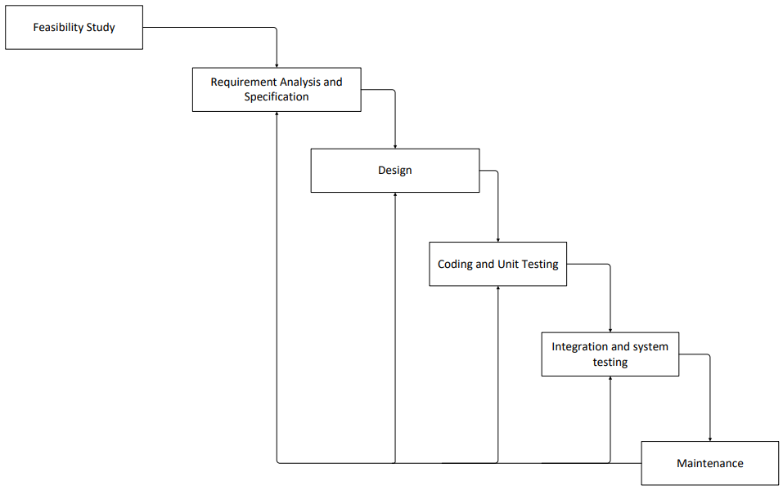

Fig 1.1: Steps of iterative waterfall model

**Requirements Gathering and Analysis:**

* Define User Requirements: Gather requirements related to user interactions, preferences, and ease of use in an online video streaming platform. Focus on features like seamless video playback, personalized recommendations, and intuitive navigation.
* Functional Requirements: Detail essential functionalities, such as user registration, video browsing, playlist creation, search capabilities, and account management. Ensure real-time video streaming and responsiveness.
* Technical Requirements: Identify the technology, **Firebase** for authentication, and hosting, and **CSS** for responsive and visually appealing design.

**Design:**

* User Interface (UI) Design: Develop wireframes and mockups focused on a clean, visually appealing layout and an intuitive UI for the **Notflix video streaming platform.** Emphasize seamless navigation, easy video discovery, and responsiveness across devices.

**Implementation:**

* Implement the user interface using **Html, Css, Php** for dynamic and responsive UI design. Integrate backend functionalities using **Firebase** for real-time, authentication, and hosting. Ensure alignment with the goal of creating a user-friendly and engaging streaming environment.

**Testing:**

* Unit Testing: Conduct unit tests to ensure individual components, such as video playback, search functionality, and user account management, perform as expected. Validate performance and responsiveness on various devices and screen sizes.

## **3.2 Assignment of roles and responsibilities**

|  |  |  |
| --- | --- | --- |
| **S.N** | **Team Members** | **Roles and Responsibilities** |
| 1 | Bhuwan Bhatt | Documentation, coding and testing |
| 2 | Manish Mandar | Documentation, coding and testing |
| 3 | Sanjeev Rai | Documentation, coding and testing |

## **Chapter 4: System Analysis**

## **4.1 Requirement Analysis**

### **4.1.1 Functional Requirements**

For Notflix, the following functional requirements have been identified:

* **User Registration and Authentication:** Notflix must support a user registration system that allows users to create accounts, log in, and personalize their preferences for a seamless streaming experience.
* **Streaming Quality:** Users must be able to stream content in high-quality formats, including HD and 4K, based on their internet speed and device capabilities.

### **4.1.2 Non-Functional Requirements**

Non-functional requirements for Notflix include:

Usability: The system should be highly usable, with an emphasis on a seamless user experience.

* Usability: The system must provide an intuitive, easy-to-navigate interface, allowing users of all technical skill levels to find and watch content effortlessly.
* Performance: The platform should support seamless streaming with fast content loading and buffering times.

## **4.2 Feasibility Study**

### **4.2.1 Technical Feasibility**

* Frontend: HTML, CSS, JavaScript, and React.js for a responsive UI.
* Backend: PHP for user authentication and video streaming.
* Database: MySQL for data management.

**4.2.2 Economic Feasibility**

Since the project aims to meet academic requirements, it is economically feasible. There are no additional expenses associated with its development.

### **4.2.3 Schedule Feasibility**

The progress of our project is shown in the gantt chart below:

|  |  |  |  |  |  |  |  |  |  |  |  |  |
| --- | --- | --- | --- | --- | --- | --- | --- | --- | --- | --- | --- | --- |
| PROCESS | September | | | | October | | | | November | | | |
| Week1 | Week2 | Week3 | Week4 | Week1 | Week2 | Week3 | Week4 | Week1 | Week 2 | Week 3 | Week 4 |
| Idea Presentation |  |  |  |  |  |  |  |  |  |  |  |  |
| Required  analysis |  |  |  |  |  |  |  |  |  |  |  |  |
| Documentation |  |  |  |  |  |  |  |  |  |  |  |  |
| System  design |  |  |  |  |  |  |  |  |  |  |  |  |
| Coding |  |  |  |  |  |  |  |  |  |  |  |  |
| Testing and  debugging |  |  |  |  |  |  |  |  |  |  |  |  |

# Chapter 5: System Design

## **5.1 Use Case Diagram**

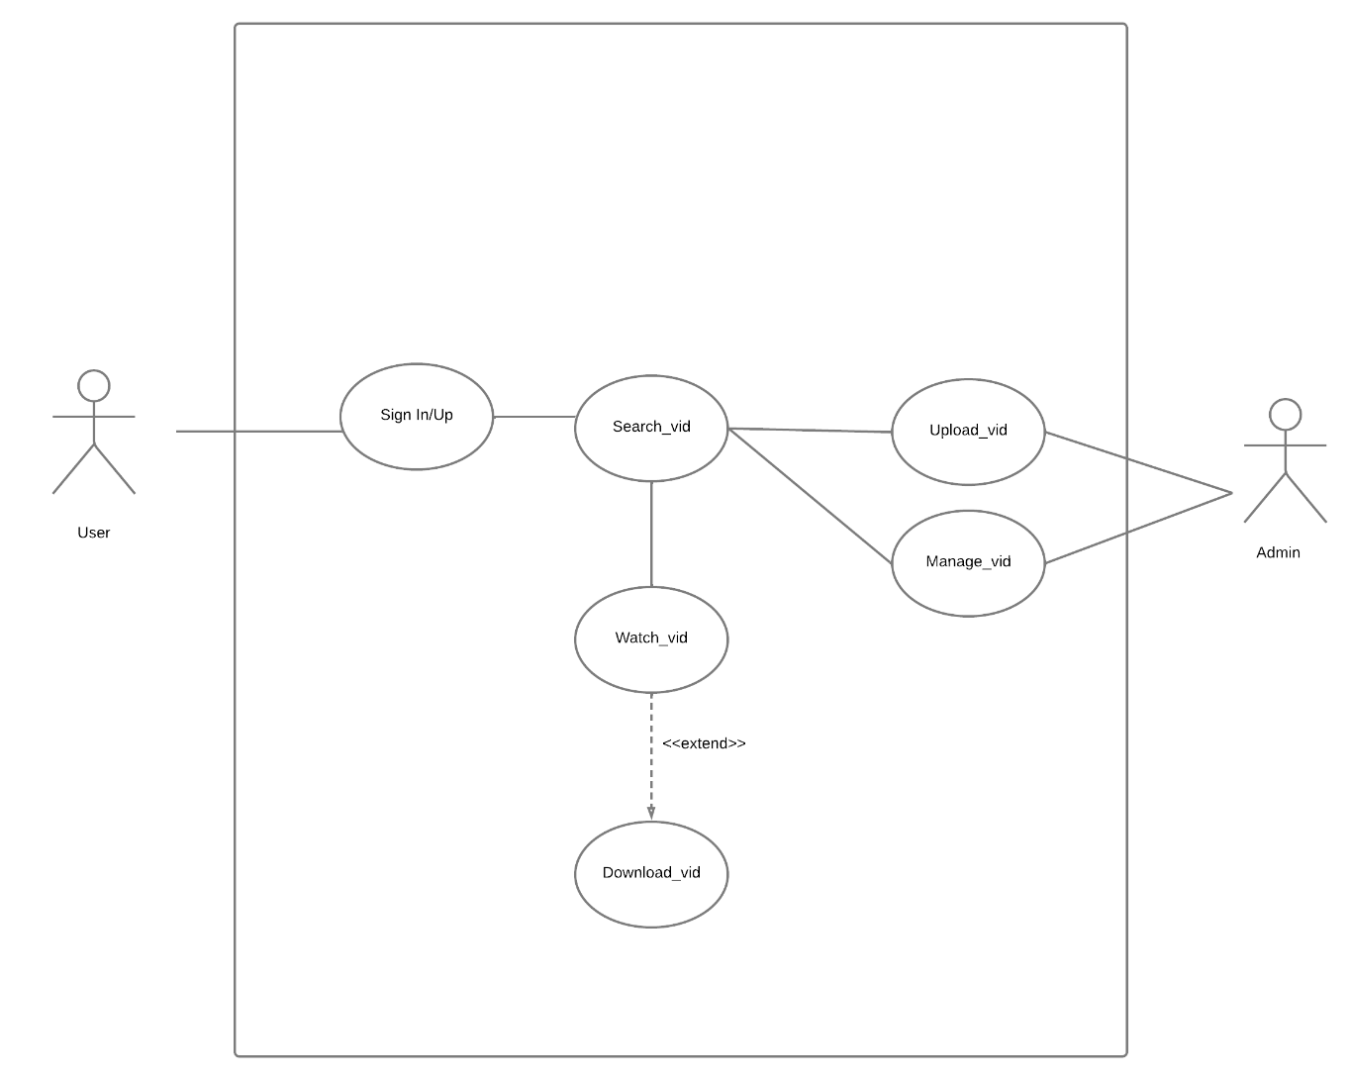

Fig 1.2 Use Case Diagram

**5.2 Sequence Diagram**

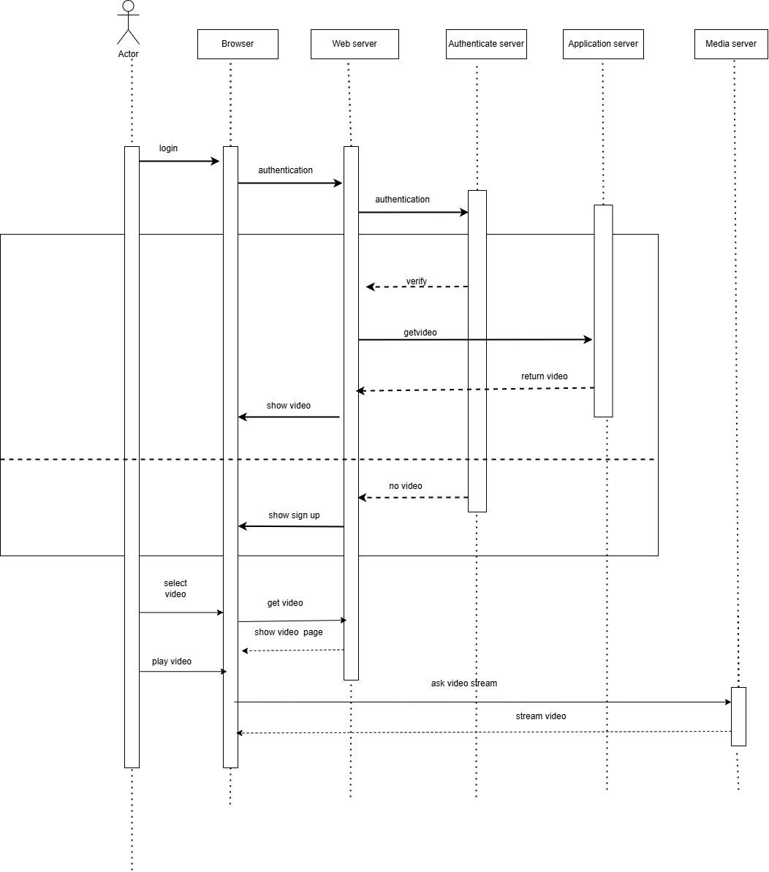

Fig 1.3 Sequence Diagram

**5.3 Activity Diagram**

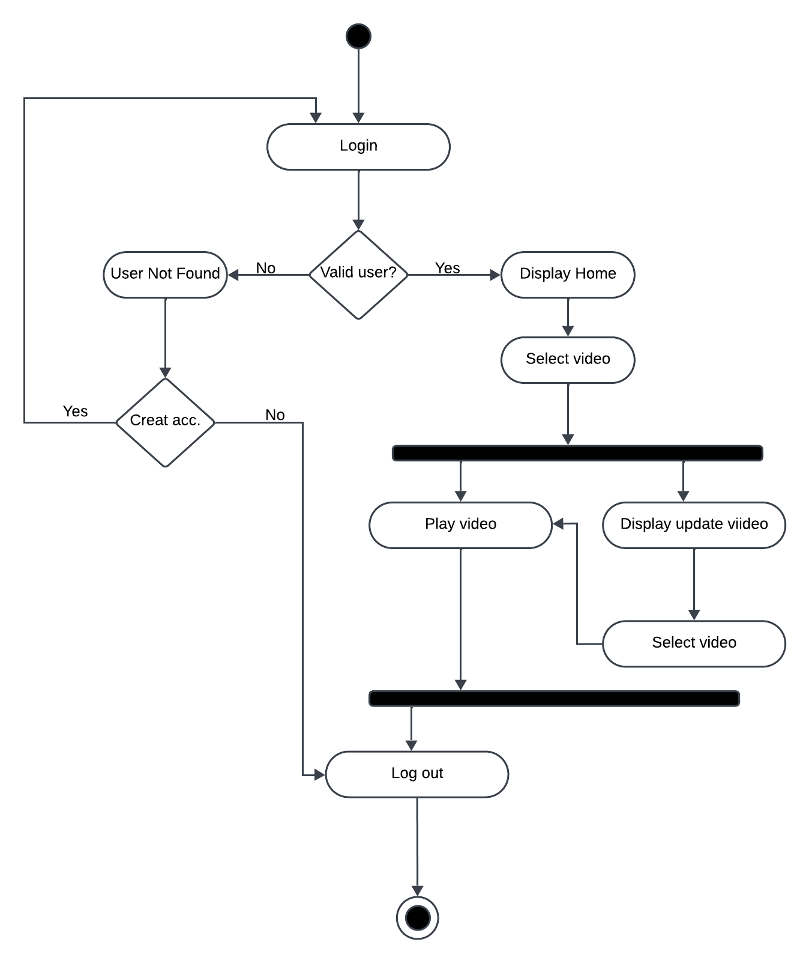

Fig 1.4 Activity Diagram

**5.4 Combination Diagram**

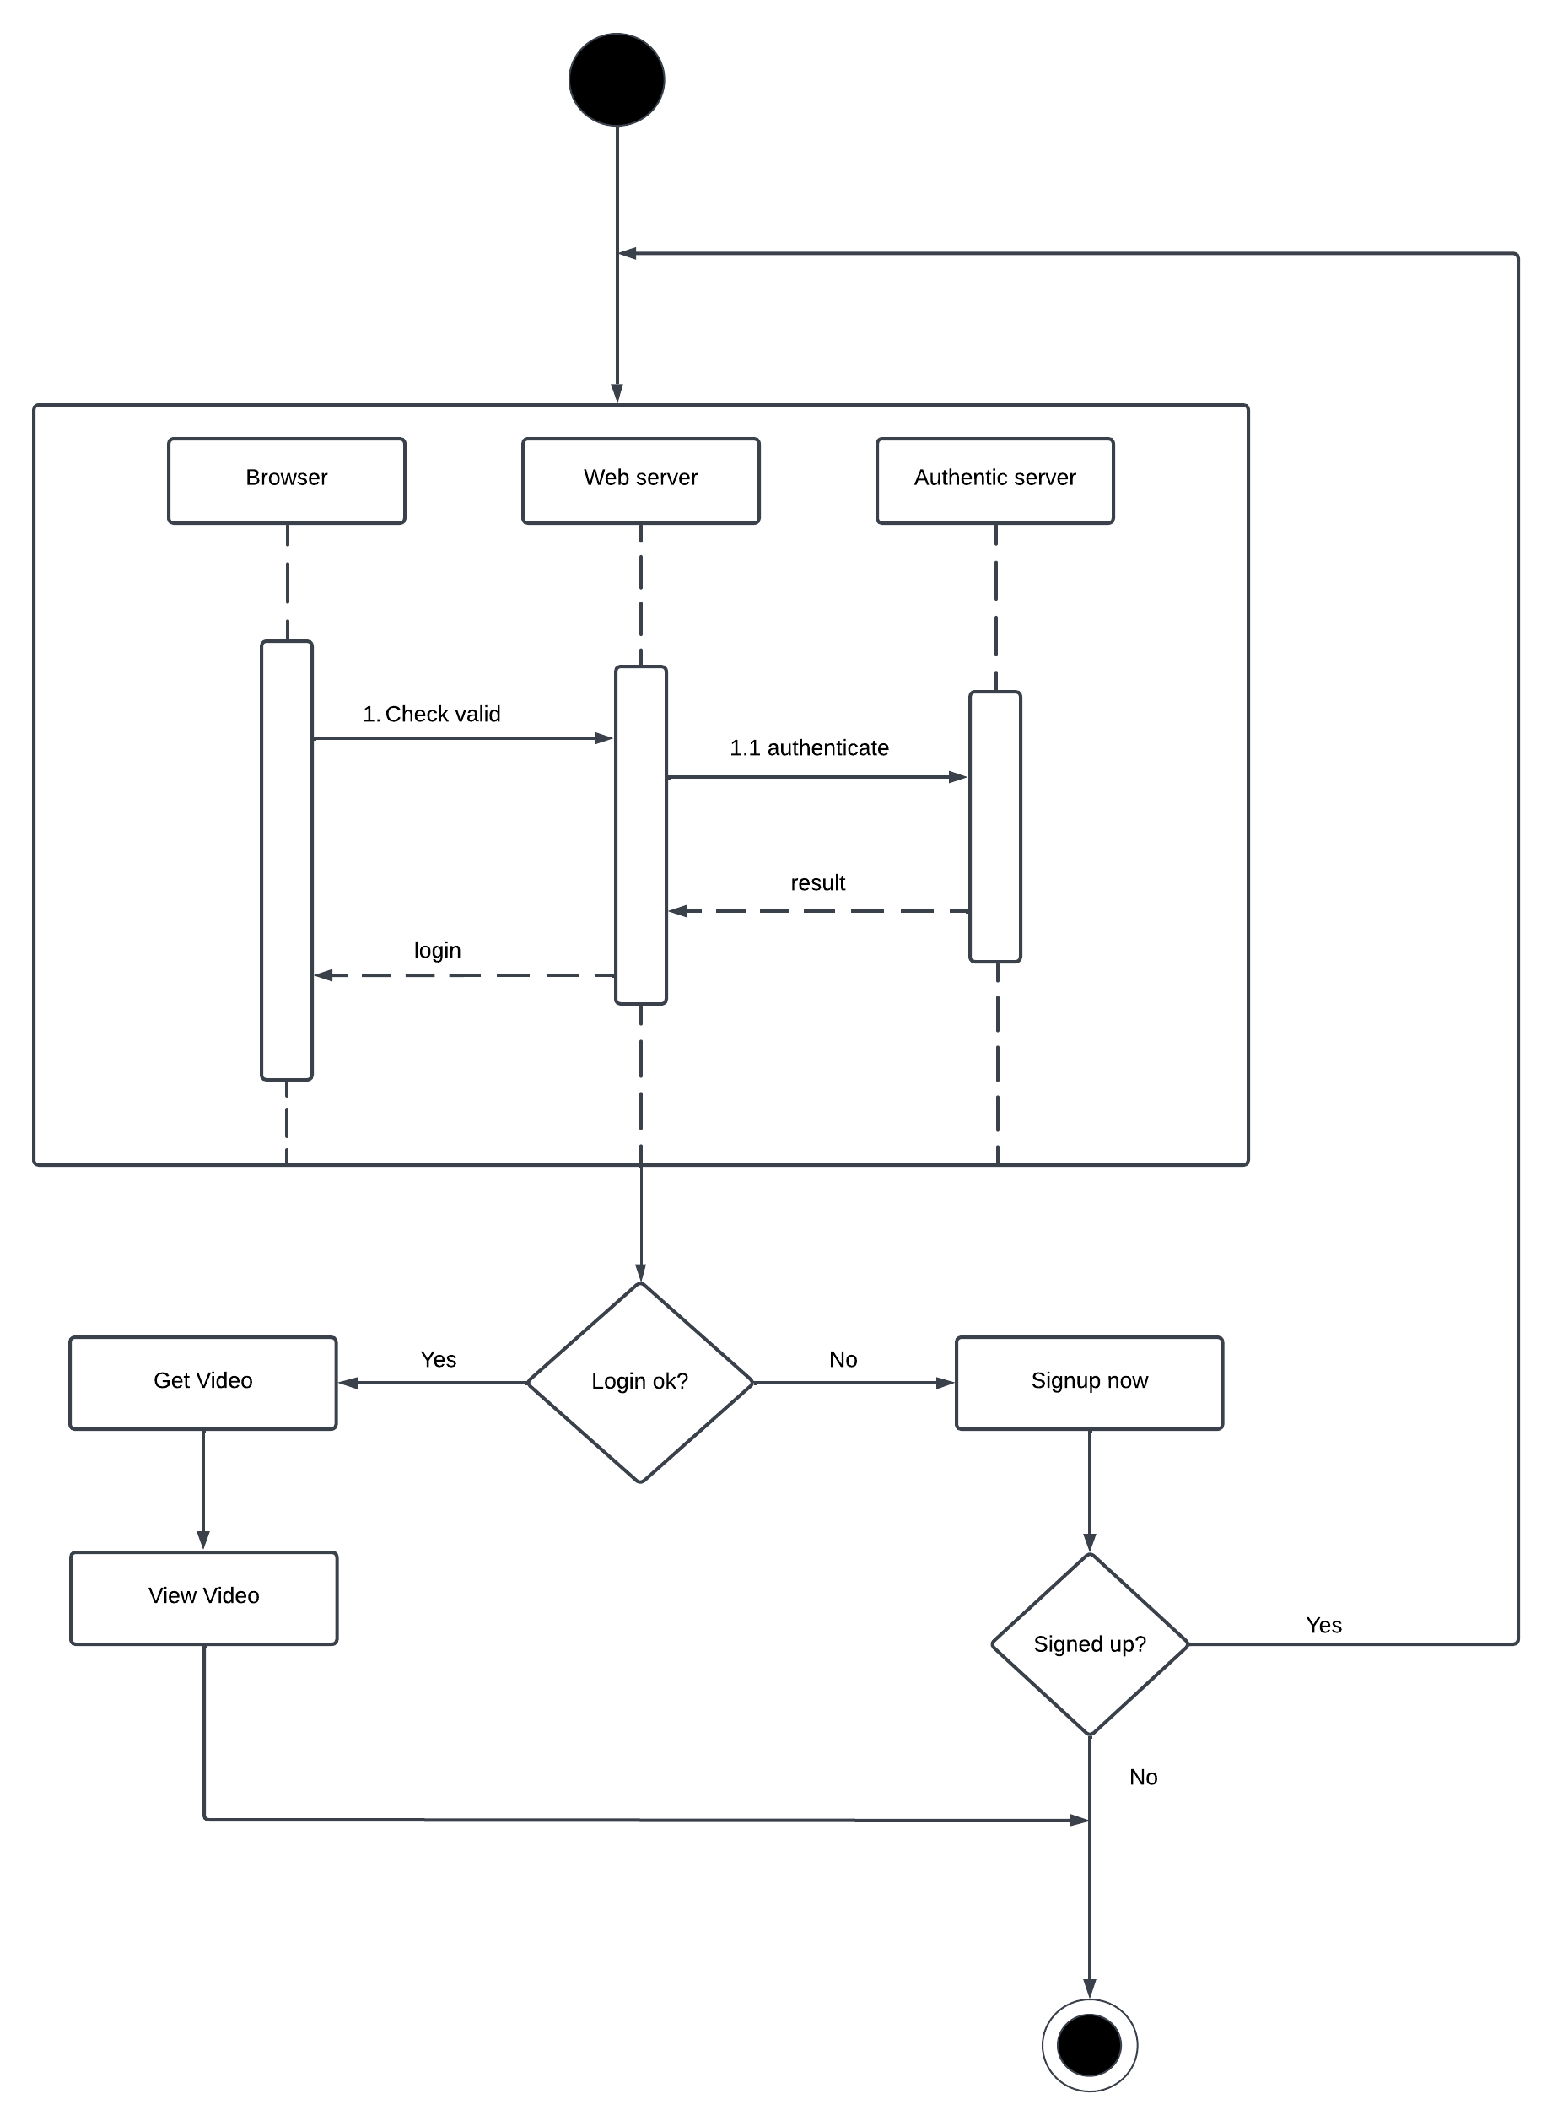

Fig 1.5 Combination Diagram

# Chapter 6: System Development and implementation

## **6.1 Tools and Technology Used**

The **Notflix** online streaming platform was developed using a variety of tools and technologies to create a high-performance, user-friendly experience for viewers.

**Frontend Development:**

**HTML/CSS**: HTML and CSS were used to structure and style the web pages.

**JavaScript**: JavaScript was used to handle interactions and make the site more dynamic, such as managing user inputs, fetching data, and updating the page content in real-time.

**Backend Development:**

PHP: PHP was used to build the server-side logic, manage user authentication, and process requests such as fetching content, managing subscriptions, and user preferences

MySQL: MySQL was used to store user data, content metadata, and user activity logs.

**Testing and Quality Assurance:**

Unit Testing Framework: Leveraged a unit testing framework to verify the functionality of individual components and features.

Usability Testing: Conducted usability testing with potential users to ensure the platform's ease of use and identify areas for improvement.

**Documentation:**

Microsoft Office Suite: Utilized for creating project documentation, including user manuals, technical documentation, and reports.

**Development Environment:**

**Visual Studio Code**: The IDE of choice for development, Visual Studio Code, was used to write and debug HTML, CSS, JavaScript, and PHP code. Its support for extensions and real-time collaboration enhanced productivity.

# Chapter 7: Testing and Debugging

# 7.1 Test case

|  |  |  |  |  |
| --- | --- | --- | --- | --- |
| Case | Test | Description | Excepted Result | Actual Result |
| 1. | Login | Verify admin login with username and password | System displays Admin homepage | Pass |
| 2. | Verify customer login with username and password | System displays Customer homepage | Pass |
| 3. | Register new user | User must have valid details required for registration .i.e. email-id, contact number. | All the required fields are filled | Pass |
| 4. | Search movie | Should show the searched movie, if not show unavailable. | Showed the search movie | Pass |
| 5. | Select from Category | Allows to select video from category. | Video | Pass |
| 6. | Logout | Verify user logout functionality. | User is redirected to the login page. | Pass |
| 7. | Responsive Design | Check UI functionality on different devices (desktop, tablet, mobile). | The platform adjusts and functions properly on all screen sizes. | Pass |
| 8. | Cross-Browser Compatibility | Verify video playback on multiple browsers (e.g., Chrome, Firefox). | Video plays without issues on all supported browsers. | Pass |
| 9. | Network Error Handling | Test behavior when a network error occurs during playback. | System displays an appropriate error message. | Fail |
| 10. | Preview Thumbnails | Verify if video preview thumbnails display correctly on hover or load. | Accurate thumbnails load without delays. | Pass |

# 

# Chapter 8: Conclusion

In conclusion, **Notflix**, developed using **PHP, MySQL,** and **Firebase**, is a modern, user-friendly online streaming platform. The project focused on creating an intuitive user interface, robust backend logic, and seamless video streaming capabilities, ensuring that users can enjoy a high-quality, ad-free viewing experience. The platform's ability to stream content for free, with a focus on accessibility and ease of use, makes it an attractive choice for users seeking a straightforward and enjoyable streaming experience.

The development process leveraged foundational web technologies like **HTML, CSS,** and **JavaScript** for the frontend, while **PHP** and **MySQL** provided a secure and efficient backend system. The platform's use of **Firebase** for hosting ensures that it is both scalable and easily accessible to users across different regions.

Notflix not only serves as a valuable academic project but also offers practical insights into building scalable and secure web applications. The system is designed to be easily expandable, with future enhancements such as personalized content recommendations, multi-platform support, and further optimizations for video streaming.

# 

# References

* <https://learningwebdesign.com/>
* [https://www.webfx.com/blog/web-design development/](https://www.webfx.com/blog/web-design%20development/)
* <https://www.php.net/docs.php>
* <https://www.w3schools.com/js/>
* <https://javascript.info/>
* <https://blog.hubspot.com/blog/tabid/6307/bid/5847/a-marketer-s-guide-to-html5.aspx>
* <https://www.w3schools.com/css/>
* <https://www.techtarget.com/whatis/definition/streaming-media>
* <https://www.uscreen.tv/blog/how-to-start-streaming-service/>

# Appendix