FinSight: Machine Learning-based Financial Intelligence System

Project Title
Smart Financial Intelligence & Tax Estimation System

Core Idea
A web application that analyzes a user's financial activity using machine learning to estimate annual income, predict the likely income tax slab, classify financial profiles, and visualize spending behavior. The system is intended as a financial analysis assistant, not a tax filing or fraud detection system.

Focus
Demonstrate practical applications of core Machine Learning algorithms taught in the Introduction to Machine Learning course through a real-world financial analytics product.
• Regression: Estimate annual income.
• Classification: Predict tax slab.
• Clustering: Group users by financial behavior.
• PCA: Visualize financial patterns.
• Model comparison using standard evaluation metrics.

Problem Statement
Many individuals and financial professionals spend significant time manually analyzing financial transactions to estimate taxable income and understand spending patterns. Existing tax calculators rely on manually entered values and cannot infer financial insights from transaction data. This project aims to automate financial analysis using machine learning models trained on a realistic synthetic dataset while maintaining transparency that predictions are estimates rather than legal tax advice.

Tech Stack
Frontend: Next.js / React
Backend: FastAPI (Python)
Machine Learning: scikit-learn, pandas, NumPy
Visualization: Plotly / Matplotlib
Database: SQLite
Synthetic Dataset Generation: Python
Deployment: Vercel + Render (optional)

Expected Outcome
• Upload bank statement (CSV or structured transaction data).
• Automatic feature extraction.
• Predicted annual income.
• Predicted tax slab.
• Financial behavior cluster.
• Spending analytics dashboard.
• Model evaluation dashboard (accuracy, RMSE, confusion matrix, feature importance).
• Clean, interactive web application demonstrating ML concepts.

Existing Methodologies / Tools
• Conventional income tax calculators require manual inputs.
• Spreadsheet-based financial analysis.
• Personal finance applications provide budgeting but generally do not demonstrate or compare machine learning models for prediction and classification in an educational setting.
• This project uses a synthetic dataset because real financial data is private and difficult to obtain.

Innovation and Difference
• Uses machine learning rather than only rule-based calculations.
• Combines regression, classification, clustering, and dimensionality reduction within one practical application.
• Employs a transparent synthetic dataset that mimics realistic financial behavior.
• Provides explainable predictions through feature importance and model comparison.
• Demonstrates multiple concepts from an Introduction to Machine Learning course in a single end-to-end product.

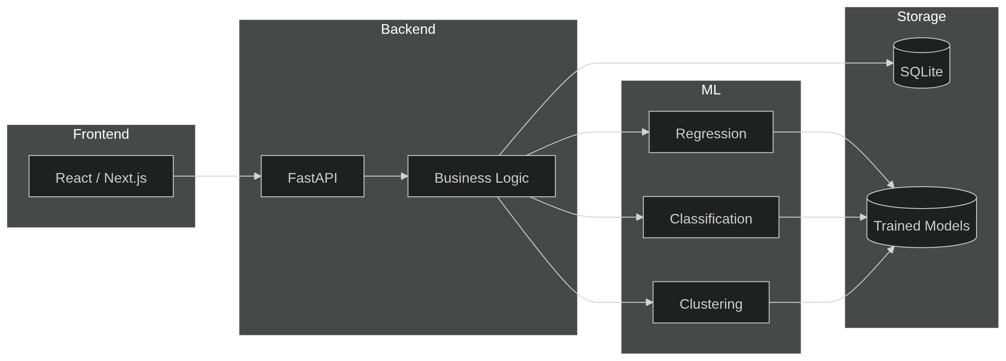
Architecture/Project overview:

