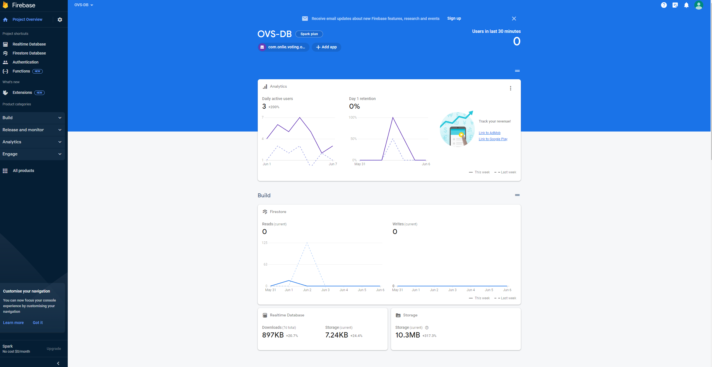

Firebase, developed by Google, is a powerful platform for mobile and web app development. It provides a suite of tools and services that simplify the creation and management of applications. Key features include a real-time database that enables synchronized data updates, authentication services for secure user management, cloud storage for storing and serving files, hosting for deploying web apps with ease, and additional tools for serverless computing, performance monitoring, and A/B testing. With Firebase, developers can accelerate their development process and build robust, scalable, and user-friendly applications. The window shown above displays the analytics of the database in realtime to monitor the data usage of the e-voting system

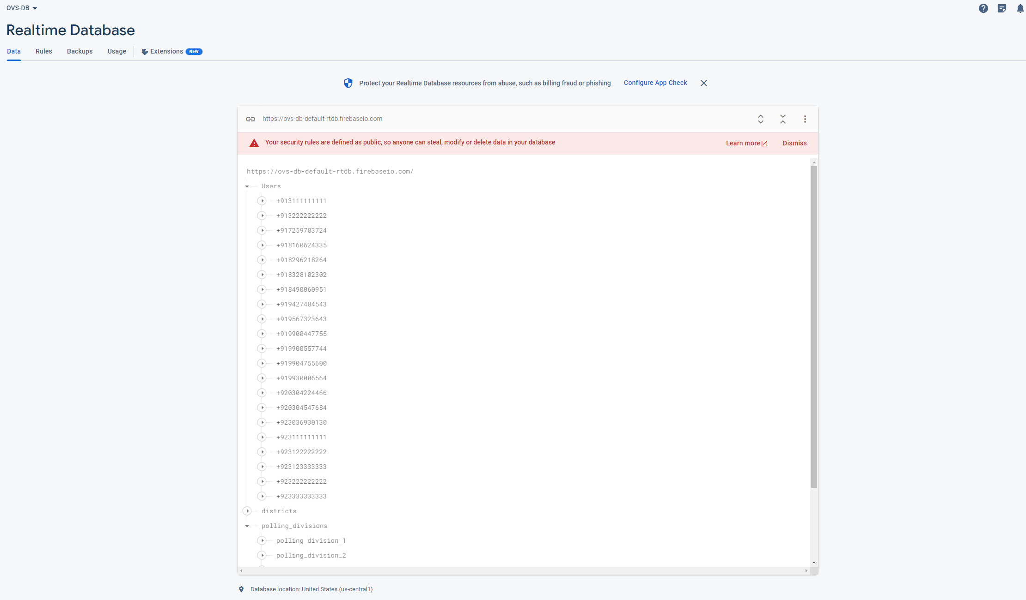

Firebase's real-time database is a cloud-based NoSQL database that offers real-time synchronization capabilities. It allows developers to store and retrieve data in a structured JSON format. The database automatically synchronizes changes across all connected devices in real-time, ensuring that data is consistently up to date. This feature is particularly useful for building applications that require real-time updates, such as chat apps, collaborative tools, or live data streaming. Developers can easily listen for changes in the database and update the user interface accordingly, providing a seamless and responsive user experience. For this purpose we have implemented it in our e-voting system to utilize the real time update system to ensure that any votes are immediately synced with the database and prevent any data loss from delays. It contains the following fields, Users, District and polling division.

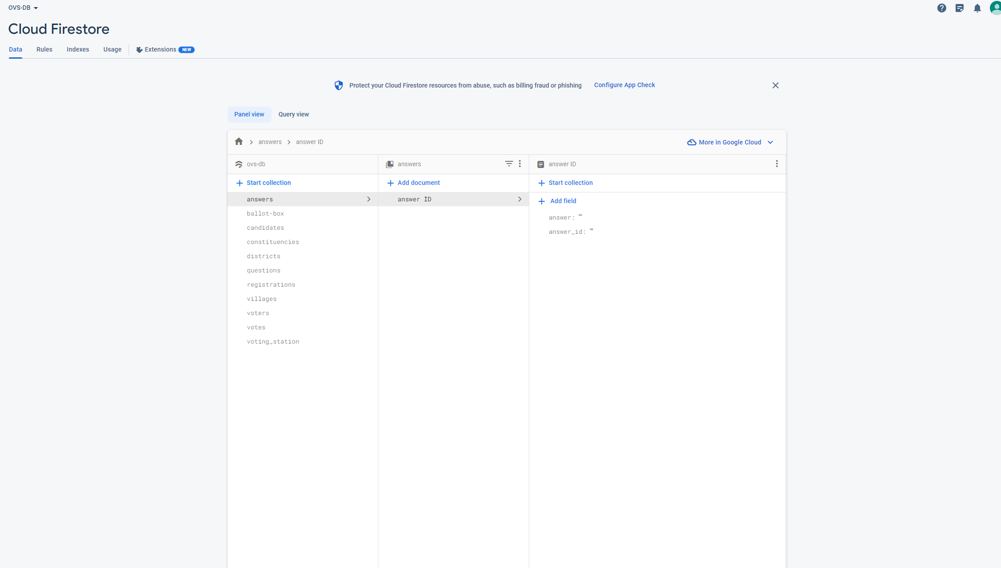

We have also utilized Firestore. Firestore is a serverless cloud database provided by Firebase for mobile and web applications. It is a NoSQL document database that offers real-time synchronization, allowing data changes to be instantly propagated to all connected clients. With Firestore, developers can organize data into collections and documents, and perform powerful queries based on various criteria. It automatically scales to handle large amounts of data and high traffic, making it suitable for applications with growing user bases. Firestore integrates seamlessly with other Firebase services and provides client SDKs for easy integration into different platforms. Overall, Firestore simplifies data management and enables developers to build scalable and responsive applications. Hence we have used it in our e-voting system for scalability and ensure fast responsiveness in our system in response to queries.