DAY_4_CLASS_EXERCISE

1)
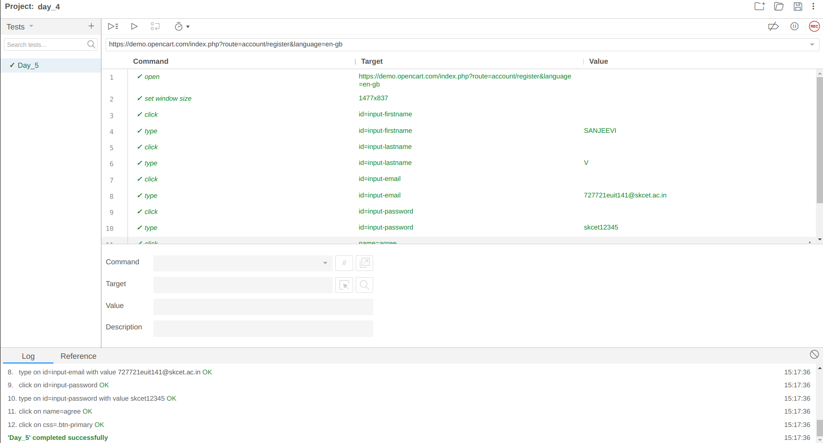
2)
package com.Test.Testing;

import org.openqa.selenium.By;
import org.openqa.selenium.WebDriver;
import org.openqa.selenium.WebElement;
import org.openqa.selenium.chrome.ChromeDriver;
import org.openqa.selenium.chrome.ChromeOptions;

import io.github.bonigarcia.wdm.WebDriverManager;

/**
* Hello world!
*
*/
public class App
{
public static void main( String[] args ) throws InterruptedException
{
ChromeOptions co=new ChromeOptions();
co.addArguments("--remote-allow-origins=*");
WebDriverManager.chromedriver().setup();
WebDriver driver =new ChromeDriver(co);
driver.get("https://demo.opencart.com/index.php?route=account/register&language=en-gb");
Thread.sleep(5000);
WebElement el= driver.findElement(By.name("firstname"));
el.sendKeys("Sanjeevi");
WebElement el2= driver.findElement(By.name("lastname"));
el2.sendKeys("V");
WebElement el3= driver.findElement(By.name("email"));
el3.sendKeys("727721euit141@skcet.ac.in");
WebElement el4= driver.findElement(By.name("password"));
el4.sendKeys("Sanjeevi");
WebElement el5= driver.findElement(By.name("agree"));
el5.click();
WebElement el6= driver.findElement(By.xpath("//*[@id=\"form-register\"]/div/div/button"));
el6.click();
// bt.click();

}
OUTPUT:
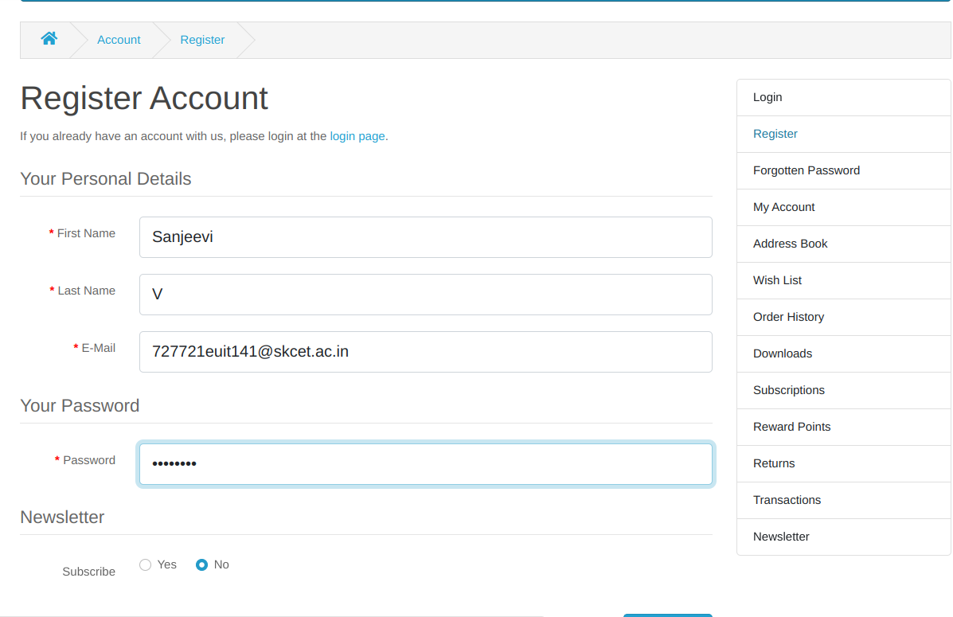

3)
package com.Test.Testing;

import org.openqa.selenium.By;
import org.openqa.selenium.JavascriptExecutor;
import org.openqa.selenium.WebDriver;
import org.openqa.selenium.chrome.ChromeDriver;
//import org.openqa.selenium.chrome.ChromeDriver;
import org.openqa.selenium.chrome.ChromeOptions;

import io.github.bonigarcia.wdm.WebDriverManager;

public class xpath {

public static void main(String[] args) throws InterruptedException {
ChromeOptions co=new ChromeOptions();
co.addArguments("--remote-allow-origins=*");
WebDriverManager.chromedriver().setup();
WebDriver driver=new ChromeDriver();
driver.get("https://demo.opencart.com/index.php?route=checkout/voucher&language=en-gb");
driver.findElement(By.xpath("//input[@id=\"input-to-name\"]")).sendKeys("Sanjeevi");
driver.manage().window().maximize();
JavascriptExecutor js=(JavascriptExecutor) driver;
js.executeScript("window.scrollBy(0,500)","");
Thread.sleep(5000);
driver.findElement(By.xpath("//input[@id=\"input-theme-6\"]")).click();
driver.findElement(By.xpath("//*[@id=\"form-voucher\"]/div[8]/div/div/input")).click();
driver.findElement(By.xpath("//*[@id=\"form-voucher\"]/div[8]/div/button")).click();
}

}OUTPUT:
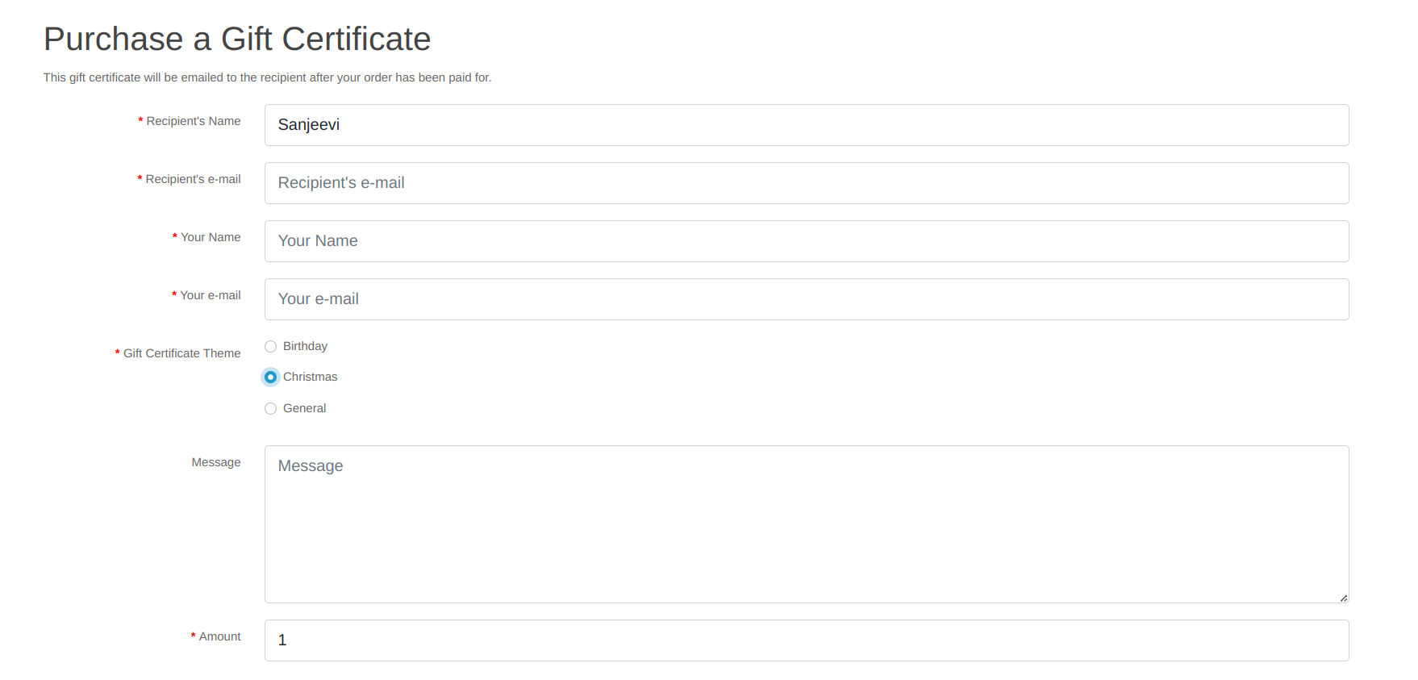

4)
package com.Test.Testing;

import org.openqa.selenium.By;
import org.openqa.selenium.WebDriver;
import org.openqa.selenium.WebElement;
import org.openqa.selenium.chrome.ChromeDriver;
import org.openqa.selenium.chrome.ChromeOptions;

import io.github.bonigarcia.wdm.WebDriverManager;

public class navigate {
public static void main( String[] args ) throws InterruptedException
{
ChromeOptions co=new ChromeOptions();
co.addArguments("--remote-allow-origins=*");
WebDriverManager.chromedriver().setup();
WebDriver driver =new ChromeDriver(co);
driver.get("https://j2store.net/free/");

Thread.sleep(5000);

WebElement el6= driver.findElement(By.xpath("//*[@id=\"Mod112\"]/div/div/ul/li[1]/a"));
el6.click();
driver. navigate(). back();
driver. navigate(). forward();
driver. navigate(). refresh();
driver. close();

}
}
5.1)package com.Test.Testing;

import org.openqa.selenium.By;
import org.openqa.selenium.WebDriver;
import org.openqa.selenium.WebElement;
import org.openqa.selenium.chrome.ChromeDriver;
import org.openqa.selenium.chrome.ChromeOptions;

import io.github.bonigarcia.wdm.WebDriverManager;

public class webDriverCommands {
public static void main(String []Args) {
ChromeOptions co=new ChromeOptions();
co.addArguments("--remote-allow-origins=*");
WebDriverManager.chromedriver().setup();
WebDriver driver =new ChromeDriver(co);
driver.get("https://j2store.net/free/");
String cUrl=driver.getCurrentUrl();
if(cUrl.equals("https://j2store.net/free/")) {
System.out.println("URL MATCHED");
}
else {
System.out.println("URL NOT MATCHED");
}
WebElement el6= driver.findElement(By.linkText("Clothing (5)"));
el6.click();
String cUrl1=driver.getCurrentUrl();
if(cUrl1.equals("https://j2store.net/free/index.php/shop?filter_catid=11")) {
System.out.println("URL MATCHED");
}
else {
System.out.println("URL NOT MATCHED");
}
}
}OUTPUT:
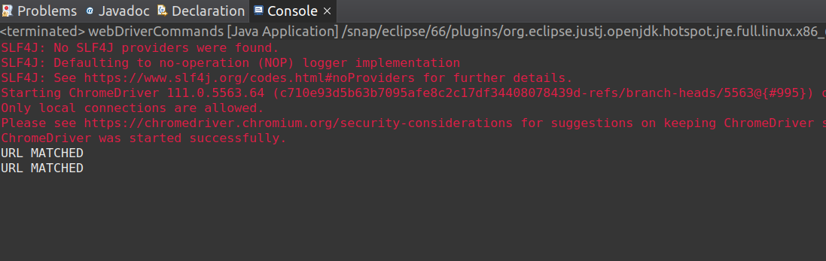

5.2)
package com.Test.Testing;

import org.openqa.selenium.By;
import org.openqa.selenium.WebDriver;
import org.openqa.selenium.WebElement;
import org.openqa.selenium.chrome.ChromeDriver;
import org.openqa.selenium.chrome.ChromeOptions;
import java.util.*;
import io.github.bonigarcia.wdm.WebDriverManager;

public class findingName {
public static void main(String []Args) {
ChromeOptions co=new ChromeOptions();
co.addArguments("--remote-allow-origins=*");
WebDriverManager.chromedriver().setup();
WebDriver driver =new ChromeDriver(co);
driver.get("https://j2store.net/free/");
WebElement el6= driver.findElement(By.linkText("Clothing (5)"));
el6.click();
List<WebElement> li=driver.findElements(By.xpath("//h2[@itemprop=\"name\"]"));
for(WebElement e:li) {
System.out.println(e.getText());
}
}
OUTPUT:
