DAY_5_CLASS EXERCISE

1)

package com.Test.Testing;

import java.awt.Desktop.Action;
import java.util.List;

import org.openqa.selenium.By;
import org.openqa.selenium.WebDriver;
import org.openqa.selenium.WebElement;
import org.openqa.selenium.chrome.ChromeDriver;
import org.openqa.selenium.chrome.ChromeOptions;
import org.openqa.selenium.interactions.Actions;

import io.github.bonigarcia.wdm.WebDriverManager;

public class dragAndDrop {

public static void main( String[] args )throws InterruptedException{
ChromeOptions co=new ChromeOptions();
co.addArguments("--remote-allow-origins=*");
WebDriverManager.chromedriver().setup();
WebDriver d=new ChromeDriver(co);
d.get("https://demoqa.com/droppable/");
d.manage().window().maximize();
WebElement fromElement =d.findElement(By.xpath("//*[@id=\"draggable\"]") );
WebElement toElement = d.findElement(By.xpath("//*[@id=\"droppable\"]"));
Actions act=new Actions(d);
act.dragAndDrop(fromElement,toElement).build().perform();
Thread.sleep(5000);
d.close();

}OUTPUT:
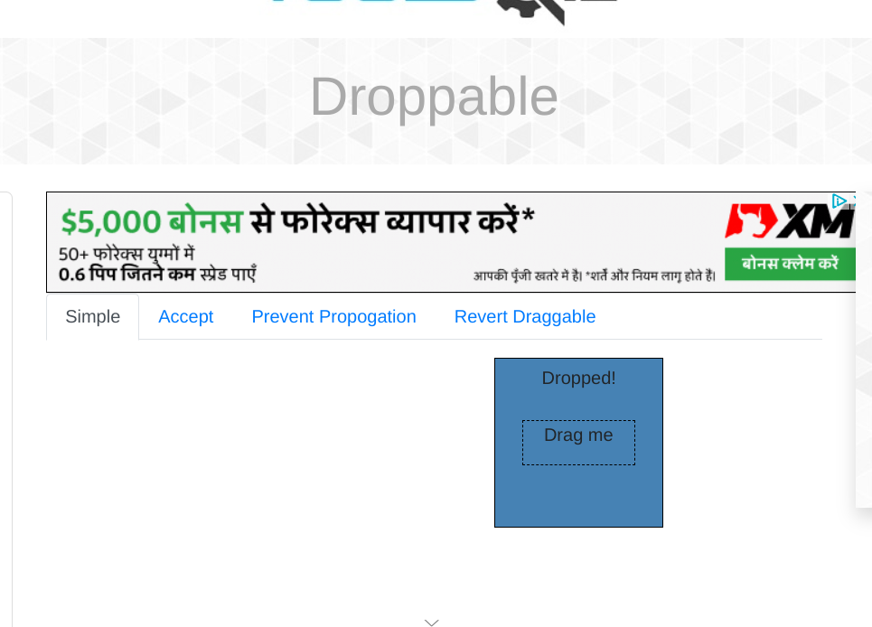

2)package com.Test.Testing;

// import java.awt.Desktop.Action;
// import java.util.List;

import org.openqa.selenium.By;
import org.openqa.selenium.WebDriver;
import org.openqa.selenium.WebElement;
import org.openqa.selenium.chrome.ChromeDriver;
import org.openqa.selenium.chrome.ChromeOptions;
import org.openqa.selenium.interactions.Actions;

import io.github.bonigarcia.wdm.WebDriverManager;

public class dragAndDrop_2 {

public static void main( String[] args )throws InterruptedException{
ChromeOptions co=new ChromeOptions();
co.addArguments("--remote-allow-origins=*");
WebDriverManager.chromedriver().setup();
WebDriver d=new ChromeDriver(co);
d.get("https://jqueryui.com/droppable/");
d.manage().window().maximize();
d.switchTo().frame(0);
WebElement fromElement =d.findElement(By.id("draggable") );
WebElement toElement = d.findElement(By.id("droppable"));
Actions act=new Actions(d);
act.dragAndDrop(fromElement,toElement).build().perform();
Thread.sleep(5000);
d.close();
}

}
OUTPUT:
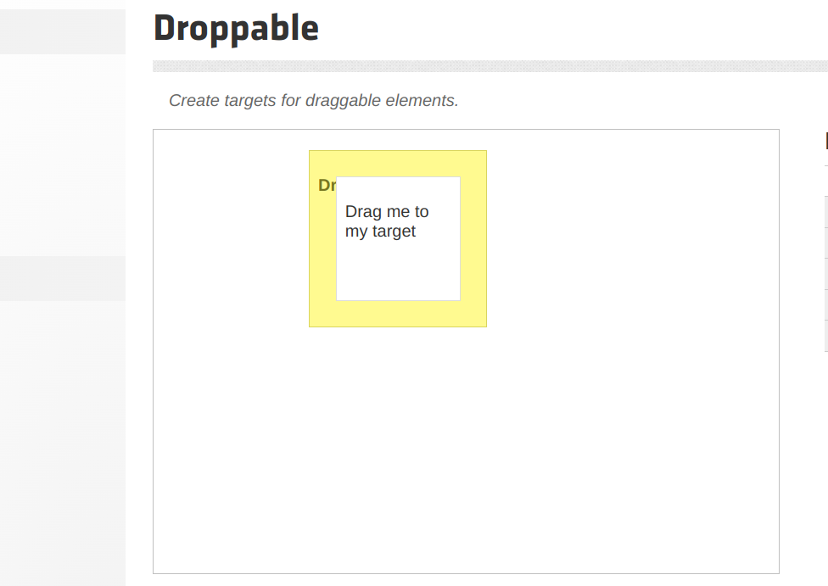
3)
package com.Test.Testing;

import org.openqa.selenium.Alert;
import org.openqa.selenium.By;
import org.openqa.selenium.WebDriver;
import org.openqa.selenium.WebElement;
import org.openqa.selenium.chrome.ChromeDriver;
import org.openqa.selenium.chrome.ChromeOptions;
import org.openqa.selenium.interactions.Actions;

import io.github.bonigarcia.wdm.WebDriverManager;
public class customerId {

public static void main(String[] args)throws InterruptedException {
WebDriverManager.chromedriver().setup();
ChromeOptions co=new ChromeOptions();
co.addArguments ("--remote-allow-origins=*");
WebDriver d=new ChromeDriver (co);
d.get("https://demo.guru99.com/test/delete_customer.php");
d.manage().window().maximize();
d.findElement(By.xpath("/html/body/form/table/tbody/tr[2]/td[2]/input")).sendKeys("401");
Thread.sleep(1000);
d.findElement(By.xpath("/html/body/form/table/tbody/tr[3]/td[2]/input[1]")).click();
Alert alert1=d.switchTo().alert();
Thread.sleep(3000);
alert1.dismiss();
d.findElement(By.xpath("/html/body/form/table/tbody/tr[3]/td[2]/input[2]")).click();
d.findElement(By.xpath("/html/body/form/table/tbody/tr[2]/td[2]/input")).sendKeys("402");
Thread.sleep(1000);
d.findElement(By.xpath("/html/body/form/table/tbody/tr[3]/td[2]/input[1]")).click();
Alert alert2=d.switchTo().alert();
Thread.sleep(3000);
alert1.accept();
Alert alert3=d.switchTo().alert();
String txt=alert3.getText();
alert3.accept();
System.out.println(txt);

}

}

OUTPUT:
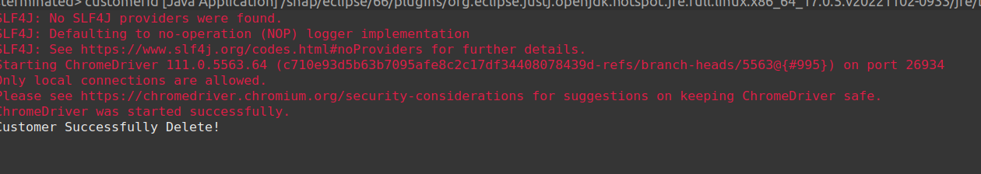
4)
package com.Test.Testing;

import org.openqa.selenium.Alert;
import org.openqa.selenium.By;
import org.openqa.selenium.WebDriver;
import org.openqa.selenium.chrome.ChromeDriver;
import org.openqa.selenium.chrome.ChromeOptions;

import io.github.bonigarcia.wdm.WebDriverManager;

public class abiBus {

public static void main(String[] args)throws InterruptedException {
WebDriverManager.chromedriver().setup();
ChromeOptions co=new ChromeOptions();
co.addArguments ("--remote-allow-origins=*");
WebDriver d=new ChromeDriver (co);
d.get("https://www.abhibus.com/bus-ticket-booking");
d.manage().window().maximize();
d.findElement(By.xpath("//*[@id=\"source\"]")).sendKeys("Coimbatore");
d.findElement(By.xpath("//*[@id=\"destination\"]")).sendKeys("Chennai");
Thread.sleep(5000);
d.findElement(By.xpath("//*[@id=\"datepicker1\"]")).click();
d.findElement(By.xpath("//*[@id=\"ui-datepicker-div\"]/div[2]/table/tbody/tr[4]/td[1]/a")).click();

OUTPUT:

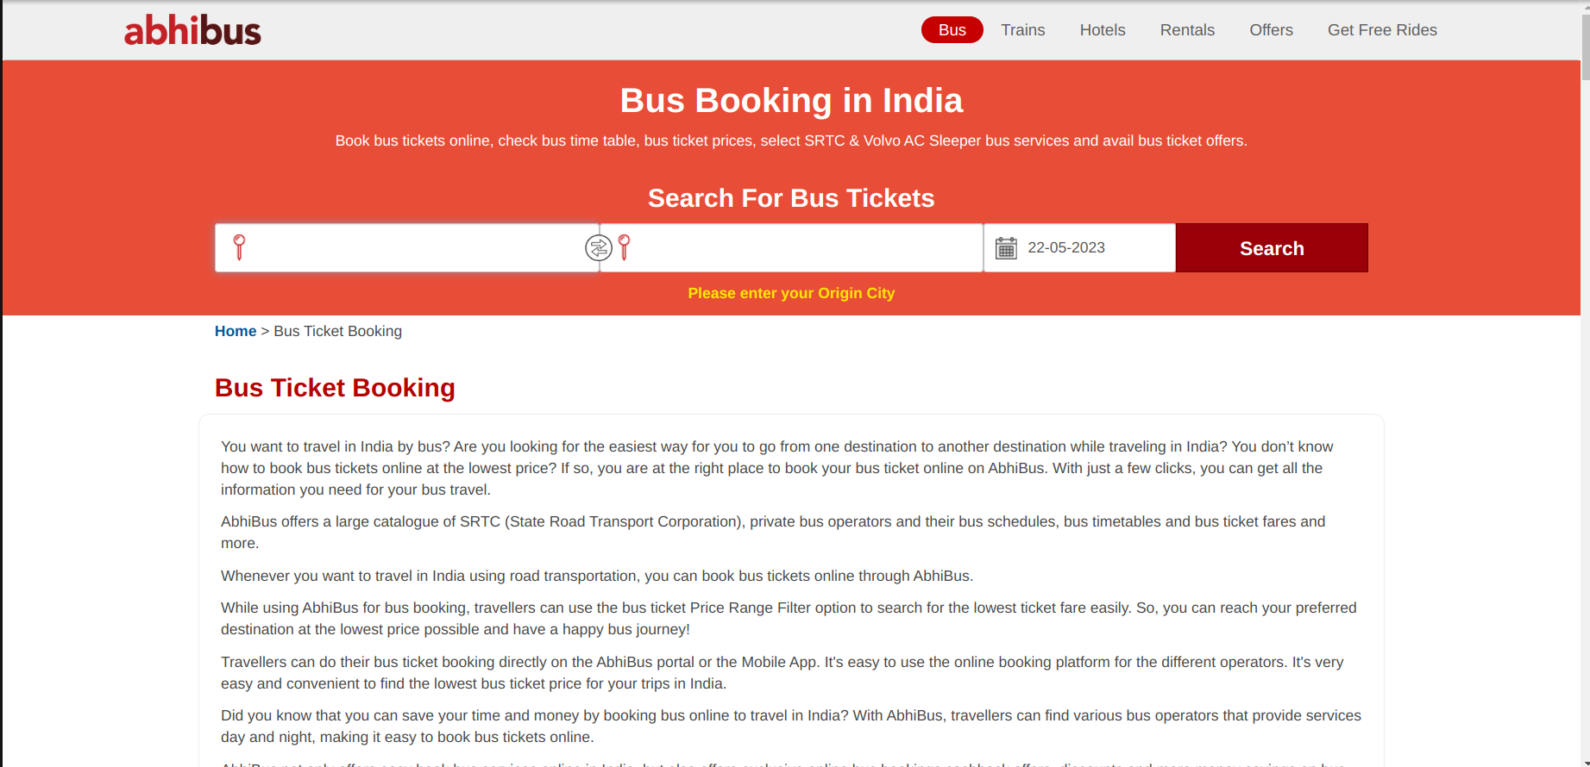

5)
package com.Test.Testing;

import org.openqa.selenium.By;
import org.openqa.selenium.Keys;
import org.openqa.selenium.WebDriver;
import org.openqa.selenium.WebElement;
import org.openqa.selenium.chrome.ChromeDriver;
import org.openqa.selenium.chrome.ChromeOptions;

import io.github.bonigarcia.wdm.WebDriverManager;

public class ASC {
public static void main(String [] args) throws InterruptedException {
WebDriverManager.chromedriver().setup();
ChromeOptions co=new ChromeOptions();
co.addArguments ("--remote-allow-origins=*");

WebDriver d=new ChromeDriver (co);
d.get("https://www.google.com");
WebElement fromElement =d.findElement(By.name("q") );
fromElement.sendKeys("Apple");
fromElement.sendKeys(Keys.ENTER);

WebDriver d1=new ChromeDriver (co);
d1.get("https://www.google.com");
WebElement fromElement1 =d1.findElement(By.name("q") );
fromElement1.sendKeys("Selenium");
fromElement1.sendKeys(Keys.ENTER);

WebDriver d2=new ChromeDriver (co);
d2.get("https://www.google.com");
WebElement fromElement2 =d2.findElement(By.name("q") );
fromElement2.sendKeys("Cucumber");
fromElement2.sendKeys(Keys.ENTER);
System.out.println(d.getWindowHandle());
System.out.println(d1.getWindowHandle());
System.out.println(d2.getWindowHandle());
System.out.println(d.getTitle());
System.out.println(d1.getTitle());
System.out.println(d2.getTitle());
}
}
OUTPUT:
