DAY_7

1)
package com.Test.Testing;

import org.junit.Assert;
import org.openqa.selenium.WebDriver;
import org.openqa.selenium.chrome.ChromeDriver;
import org.openqa.selenium.chrome.ChromeOptions;
import org.testng.annotations.Test;

import io.github.bonigarcia.wdm.WebDriverManager;

public class NewTest {
@Test
public void titleCheck() {
ChromeOptions co = new ChromeOptions();
co.addArguments("--remote-allow-orgins-*");
WebDriverManager.chromedriver().setup();
WebDriver driver = new ChromeDriver();
driver.get("https://demo.wpeverest.com/user-registration/guest-registration-form/");
driver.manage().window().maximize();
String actual = driver.getTitle();
String expected = "Gation";
Assert.assertEquals(actual, expected);
}
}

OUTPUT:
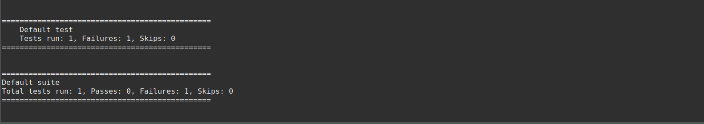
2)
package com.Test.Testing;

import org.testng.annotations.Test;
import org.testng.annotations.BeforeMethod;
import org.testng.annotations.AfterMethod;
import java.util.*;
public class Calculator {
Scanner sc=new Scanner(System.in);
int a;
int b;
@Test
public void a() {

System.out.print("First Number : ");
a=sc.nextInt();
System.out.println();
System.out.print("Second Number : ");
b=sc.nextInt();
}
@Test
public void add() {
System.out.println("Addition : "+ a+b);
}
@Test
public void sub() {
System.out.println("Subtraction : "+ (a-b));
}
@Test
public void mul() {
System.out.println("Multiplication :" +a*b);
}

@Test
public void div() {
System.out.println("Division : "+ a/b);
}

@BeforeMethod
public void beforeMethod() {

}

@AfterMethod
public void afterMethod() {
}

}
OUTPUT:
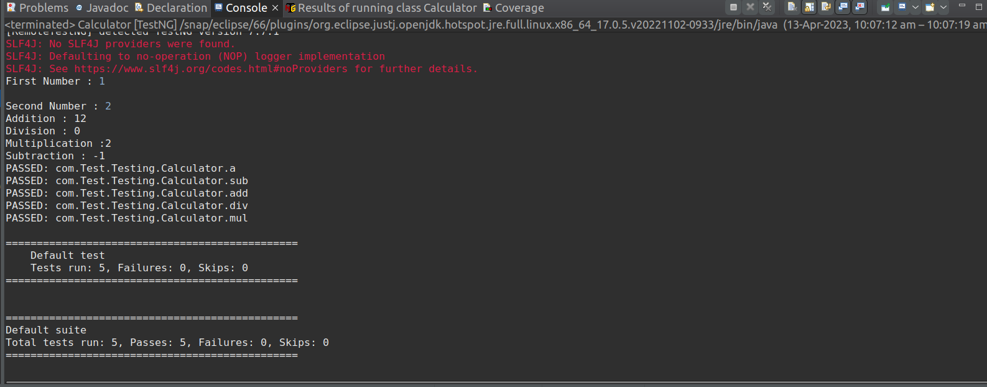
3)

OUTPUT:

4)

OUTPUT:

