CC_1
1)
package Test.CIA;

import org.openqa.selenium.By;

import org.openqa.selenium.WebDriver;

import org.openqa.selenium.chrome.ChromeDriver;

import org.openqa.selenium.chrome.ChromeOptions;

import io.github.bonigarcia.wdm.WebDriverManager;

public class cc_1_ex_1 {

public static void main(String[] args) throws InterruptedException {

ChromeOptions co=new ChromeOptions();

co.addArguments("--remote-allow-origins=*");

WebDriverManager.chromedriver().setup();

WebDriver driver=new ChromeDriver();

driver.get("https://www.saucedemo.com/");

//user login

driver.findElement(By.xpath("//*[@id=\"user-name\"]")).click();

driver.findElement(By.xpath("//*[@id=\"user-name\"]")).sendKeys("standard_user");

driver.findElement(By.xpath("//*[@id=\"password\"]")).click();

driver.findElement(By.xpath("//*[@id=\"password\"]")).sendKeys("secret_sauce");

driver.findElement(By.xpath("//*[@id=\"login-button\"]")).click();

//Adding to cart

Thread.sleep(2000);

driver.findElement(By.xpath("//*[@id=\"add-to-cart-sauce-labs-backpack\"]")).click();

String num=driver.findElement(By.xpath("//*[@id=\"shopping_cart_container\"]/a/span")).getText();

if(num.equals("1")){

System.out.println("Item added to cart");

}

//Viewing cart items

Thread.sleep(2000);

driver.findElement(By.xpath("//*[@id=\"shopping_cart_container\"]/a")).click();

String act=driver.findElement(By.xpath("//*[@id=\"header_container\"]/div[2]/span")).getText();

if(act.equals("Your Cart")) {

System.out.println("User can view contents in cart");

}

//checkout

Thread.sleep(2000);

driver.findElement(By.xpath("//*[@id=\"checkout\"]")).click();

String ac=driver.findElement(By.xpath("//*[@id=\"header_container\"]/div[2]/span")).getText();

if(ac.equals("Checkout: Your Information")) {

System.out.println("Your information is displayed");

}

//Filling form

driver.findElement(By.xpath("//*[@id=\"first-name\"]")).click();

driver.findElement(By.xpath("//*[@id=\"first-name\"]")).sendKeys("Shyam");

driver.findElement(By.xpath("//*[@id=\"last-name\"]")).click();

driver.findElement(By.xpath("//*[@id=\"last-name\"]")).sendKeys("Sundar");

driver.findElement(By.xpath("//*[@id=\"postal-code\"]")).click();

driver.findElement(By.xpath("//*[@id=\"postal-code\"]")).sendKeys("621005");

Thread.sleep(2000);

driver.findElement(By.xpath("//*[@id=\"continue\"]")).click();

String actu=driver.findElement(By.xpath("//*[@id=\"header_container\"]/div[2]/span")).getText();

if(actu.equals("Checkout: Overview")) {

System.out.println("Overview of the products displayed");

}

//Details of the products

String name=driver.findElement(By.xpath("//*[@id=\"item_4_title_link\"]/div")).getText();

System.out.println("Name of the product: "+name);

String price=driver.findElement(By.xpath("//*[@id=\"checkout_summary_container\"]/div/div[1]/div[3]/div[2]/div[2]/div")).getText();

System.out.println("Price of the product: "+price);

//Asserting the title

String actual=driver.getTitle();

if(actual.equals("Swag Labs")) {

System.out.println("Title of the page is asserted");

}

//Asserting the url

String a=driver.getCurrentUrl();

if(a.equals("https://www.saucedemo.com/checkout-step-two.html")) {

System.out.println("URL of the page asserted");

}

driver.findElement(By.xpath("//*[@id=\"finish\"]")).click();

System.out.print("Thanks for Ordering!!Come back soon");

}

}

}

OUTPUT:
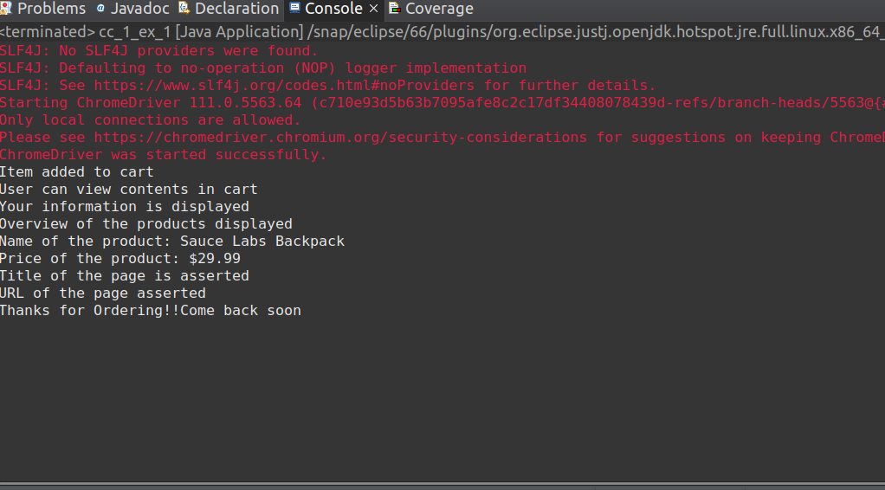

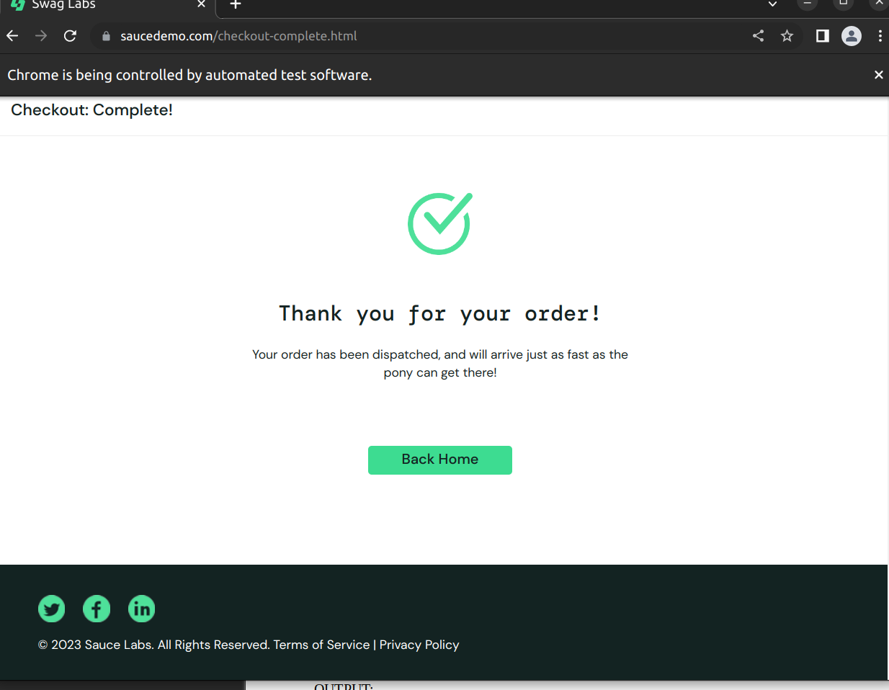

2)
package Test.CIA;

import org.openqa.selenium.By;
import org.openqa.selenium.WebDriver;
import org.openqa.selenium.chrome.ChromeDriver;
import org.openqa.selenium.chrome.ChromeOptions;

import io.github.bonigarcia.wdm.WebDriverManager;

public class cc_1_ex_2 {
public static void main(String [] args) {
ChromeOptions co=new ChromeOptions();
co.addArguments ("--remote-allow-origins=*");
WebDriverManager.chromedriver().setup ();
WebDriver driver=new ChromeDriver(co);
driver.get ("https://www.saucedemo.com/");
String currentTitle=driver.getTitle();
System.out.println(currentTitle);
//*[@id="user-name"]
driver.findElement(By.xpath("//*[@id=\"user-name\"]")).sendKeys("standard_user");
driver.findElement(By.xpath("//*[@id=\"password\"]")).sendKeys("secret_sauce");
//*[@id="login-button"]
driver.findElement(By.xpath("//*[@id=\"login-button\"]")).click();
System.out.println("From A-Z");
System.out.println(driver.findElement(By.xpath("//*[@id=\"item_4_title_link\"]/div")).getText());

driver.findElement(By.xpath("//*[@id=\"header_container\"]/div[2]/div/span/select")).click();
driver.findElement(By.xpath("//*[@id=\"header_container\"]/div[2]/div/span/select/option[2]")).click();
String t=driver.findElement(By.xpath("//*[@id=\"header_container\"]/div[2]/div/span/select/option[2]")).getText();
if(t.equals("Name (Z to A)")) {
System.out.println("Verified Success");
}
else {
System.out.println("Verified Failure");
}
System.out.println("From Z-A");
System.out.println(driver.findElement(By.xpath("//*[@id=\"item_3_title_link\"]/div")).getText());

driver.findElement(By.xpath("//*[@id=\"header_container\"]/div[2]/div/span/select")).click();
driver.findElement(By.xpath("//*[@id=\"header_container\"]/div[2]/div/span/select/option[3]")).click();
String t1=driver.findElement(By.xpath("//*[@id=\"header_container\"]/div[2]/div/span/select/option[3]")).getText();
if(t1.equals("Price (low to high)")) {
System.out.println("Verified Success");
}
else {
System.out.println("Verified Failure");
}
System.out.println("From low-high");
System.out.println(driver.findElement(By.xpath("//*[@id=\"item_2_title_link\"]/div")).getText());

driver.findElement(By.xpath("//*[@id=\"header_container\"]/div[2]/div/span/select")).click();
driver.findElement(By.xpath("//*[@id=\"header_container\"]/div[2]/div/span/select/option[4]")).click();
String t2=driver.findElement(By.xpath("//*[@id=\"header_container\"]/div[2]/div/span/select/option[4]")).getText();
if(t2.equals("Price (high to low)")) {
System.out.println("Verified Success");
}
else {
System.out.println("Verified Failure");
}
System.out.println("From high-low");
System.out.println(driver.findElement(By.xpath("//*[@id=\"item_4_title_link\"]/div")).getText());
//*[@id="header_container"]/div[2]/div/span/select/option[3]
}
}

OUTPUT:

