CIA_1:
1)
package Test.CIA;

import org.openqa.selenium.By;
import org.openqa.selenium.WebDriver;
import org.openqa.selenium.WebElement;
import org.openqa.selenium.chrome.ChromeDriver;
import org.openqa.selenium.chrome.ChromeOptions;

import io.github.bonigarcia.wdm.WebDriverManager;

public class App {

public static void main(String[] args) throws InterruptedException {
// TODO Auto-generated method stub
ChromeOptions co=new ChromeOptions();
co.addArguments ("--remote-allow-origins=*");
WebDriverManager.chromedriver().setup ();
WebDriver driver=new ChromeDriver(co);
driver.get ("https://www.amazon.in/Spigen-Urban-Fabric-Compatible-MacBook/dp/B09R2KCXD2/?_encoding=UTF8&pd_rd_w=hN3t9&content-id=amzn1.sym.e0e8ce89-ede3-4c51-b6ad-44989efc8536&pf_rd_p=e0e8ce89-ede3-4c51-b6ad-44989efc8536&pf_rd_r=10MH3SN3ES208H0RRNSQ&pd_rd_wg=wPWJi&pd_rd_r=13f23fa2-e355-40ad-a989-abace7275caf&ref_=pd_gw_ci_mcx_mr_hp_d");
driver.manage().window().maximize() ;
String currentTitle=driver.getTitle();
System.out.println(currentTitle);
String expectedTitle="Spigen Urban Fit Fabric Case Cover Compatible with MacBook Pro 14 inch (2021) - Black - Buy Spigen Urban Fit Fabric Case Cover Compatible with MacBook Pro 14 inch (2021) - Black Online at Low Price in India - Amazon.in";
if(currentTitle.equals(expectedTitle)) {
System.out.println("Title Matched");
}
else {
System.out.println("Title not Matched");
}
driver.findElement(By.xpath("//*[@id=\"add-to-cart-button\"]")).click();
driver.findElement(By.xpath("//*[@id=\"nav-cart\"]")).click();

driver.findElement(By.xpath("//*[@id=\"a-autoid-0-announce\"]")).click();
driver.findElement(By.xpath("//*[@id=\"quantity_4\"]")).click();
driver.findElement(By.xpath("//*[@id=\"sc-buy-box-ptc-button\"]/span/input")).click();
WebElement txtBoxl=driver.findElement(By.xpath("//*[@id=\"authportal-main-section\"]/div[2]/div/div[1]/form/div/div/div/h1"));
String currentTitle1=driver.getTitle();
if(currentTitle1.equals("Amazon Sign In")) {
System.out.println("Title Matched");
}
else {
System.out.println("Title not Matched");
}
System.out.println("Verified");
System.out.println("Verified");

}

}
OOUTPUT:
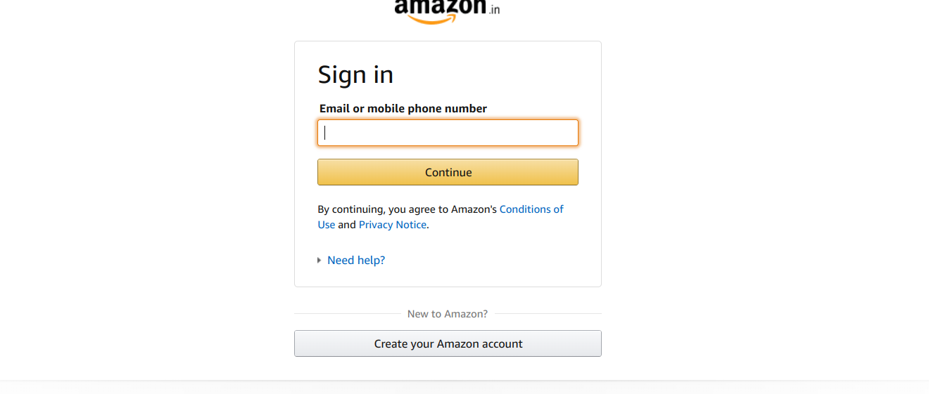
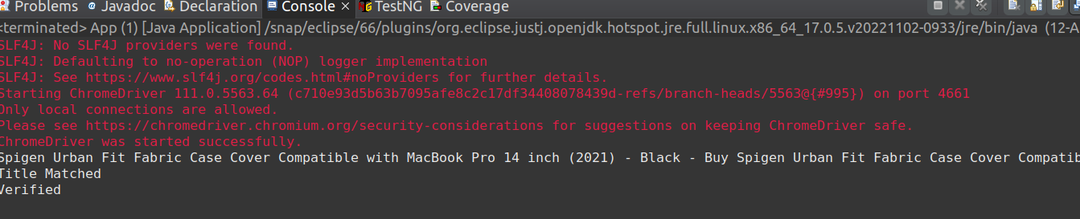
2)
package Test.CIA;

import org.openqa.selenium.By;
import org.openqa.selenium.WebDriver;
import org.openqa.selenium.WebElement;
import org.openqa.selenium.chrome.ChromeDriver;
import org.openqa.selenium.chrome.ChromeOptions;

import io.github.bonigarcia.wdm.WebDriverManager;

public class searchProduct {

public static void main(String[] args) {
// TODO Auto-generated method stub
ChromeOptions co=new ChromeOptions();
co.addArguments ("--remote-allow-origins=*");
WebDriverManager.chromedriver().setup ();
WebDriver driver=new ChromeDriver(co);
driver.get ("https://www.amazon.in/");
driver.manage().window().maximize() ;
String currentTitle=driver.getTitle();
System.out.println(currentTitle);
String expectedTitle="Online Shopping site in India: Shop Online for Mobiles, Books, Watches, Shoes and More - Amazon.in";
if(currentTitle.equals(expectedTitle)) {
System.out.println("Title Matched");
}
else {
System.out.println("Title not Matched");
}
WebElement txtBoxl=driver.findElement(By.xpath("//*[@id=\"twotabsearchtextbox\"]"));
txtBoxl.sendKeys("laptop");
driver.findElement(By.xpath("//*[@id=\"nav-search-submit-button\"]")).click();

String txt1=driver.findElement(By.xpath("//*[@id=\"search\"]/div[1]/div[1]/div/span[1]/div[1]/div[3]/div/div/div/div/div/div/div/div[2]/div/div/div[1]/h2/a/span")).getText();
System.out.println(txt1);
String txt2=driver.findElement(By.xpath("//*[@id=\"search\"]/div[1]/div[1]/div/span[1]/div[1]/div[4]/div/div/div/div/div/div/div/div[2]/div/div/div[1]/h2/a/span")).getText();
System.out.println(txt2);
String txt3=driver.findElement(By.xpath("//*[@id=\"search\"]/div[1]/div[1]/div/span[1]/div[1]/div[5]/div/div/div/div/div/div[2]/div/div/div[1]/h2/a/span")).getText();
System.out.println(txt3);
String txt4=driver.findElement(By.xpath("//*[@id=\"search\"]/div[1]/div[1]/div/span[1]/div[1]/div[6]/div/div/div/div/div/div[2]/div/div/div[1]/h2/a/span")).getText();
System.out.println(txt4);
String txt5=driver.findElement(By.xpath("//*[@id=\"search\"]/div[1]/div[1]/div/span[1]/div[1]/div[7]/div/div/div/div/div/div[2]/div/div/div[1]/h2/a/span")).getText();
System.out.println(txt5);

driver.findElement(By.xpath("//*[@id=\"p_89/HP\"]/span/a/div/label/i")).click();
driver.findElement(By.xpath("//*[@id=\"p_89/Lenovo\"]/span/a/div/label/i")).click();
System.out.println("Filtered successfully");

}
OUTPUT:

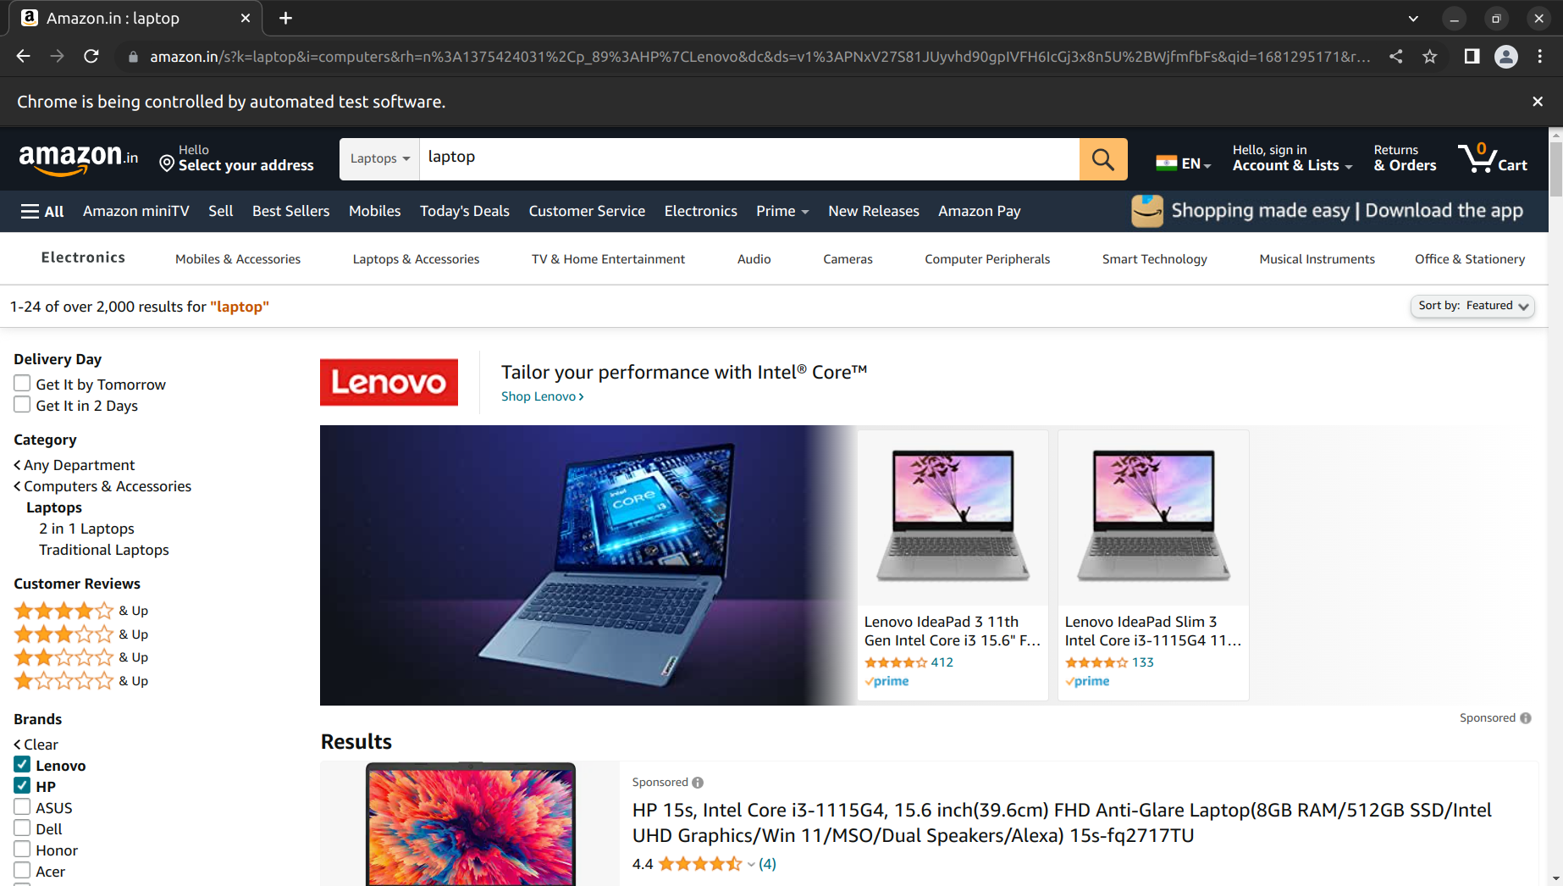

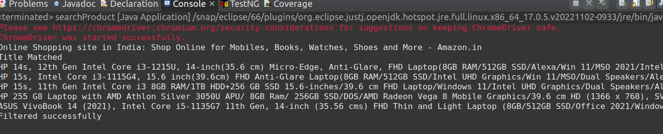
}

3)

package Test.CIA;

import org.openqa.selenium.By;
import org.openqa.selenium.WebDriver;
import org.openqa.selenium.WebElement;
import org.openqa.selenium.chrome.ChromeDriver;
import org.openqa.selenium.chrome.ChromeOptions;

import io.github.bonigarcia.wdm.WebDriverManager;

public class Account {

public static void main(String[] args) {

ChromeOptions co=new ChromeOptions();
co.addArguments ("--remote-allow-origins=*");
WebDriverManager.chromedriver().setup ();
WebDriver driver=new ChromeDriver(co);
driver.get ("https://www.amazon.in/");
driver.manage().window().maximize() ;
String currentTitle=driver.getTitle();
System.out.println(currentTitle);
String expectedTitle="Online Shopping site in India: Shop Online for Mobiles, Books, Watches, Shoes and More - Amazon.in";
if(currentTitle.equals(expectedTitle)) {
System.out.println("Title Matched");
}
else {
System.out.println("Title not Matched");
}

driver.findElement(By.xpath("//*[@id=\"nav-link-accountList\"]")).click();
WebElement txtBoxl=driver.findElement(By.xpath("//*[@id=\"ap_email\"]"));
txtBoxl.sendKeys("9345335722");
driver.findElement(By.xpath("//*[@id=\"continue\"]")).click();
WebElement txtBox2=driver.findElement(By.xpath("//*[@id=\"ap_password\"]"));
txtBox2.sendKeys("Dhon!777");
driver.findElement(By.xpath("//*[@id=\"signInSubmit\"]")).click();

driver.findElement(By.xpath("//*[@id=\"nav-link-accountList\"]")).click();
driver.findElement(By.xpath("//*[@id=\"a-page\"]/div[2]/div/div[2]/div[1]/a/div/div")).click();
System.out.println(driver.findElement(By.xpath("//*[@id=\"a-page\"]/section/div[1]/div[4]/form/label/span")).getText());

}

}

OUTPUT:
