 | REAL-TIME CRYPTOCURRENCY ANALYSIS
DATA SCIENCE PROJECT | PROJECT  REPORT SUBMITTED IN PARTIAL FULFILLMENT OF THE  REQUIREMENTS FOR THE AWARD OF THE DEGREE OF  BACHELOR OF TECHNOLOGY  IN Artificial Intelligence and Data Science OF THE ANNA UNIVERSITY
DECEMBER 2024
PROJECT | Submitted by
WORK | SANJEEVITHA C S - 2303722824322123
BATCH
2023 – 2027
Under the Guidance of
DR. M. NIVAASHINI, M.E., PH.D.,
ASSISTANT PROFESSOR, AI&DS
Artificial Intelligence And Data Science
SRI ESHWAR COLLEGE OF ENGINEERING
(An Autonomous Institution – Affiliated to Anna University)

COIMBATORE – 641 202



REAL-TIME CRYPTOCURRENCY ANALYSIS

DATA SCIENCE PROJECT REPORT

Submitted by

SANJEEVITHA C S | 23AD123

BACHELOR OF TECHNOLOGY

in

ARTIFICIAL INTELLIGENCE AND DATA SCIENCE

SRI ESHWAR COLLEGE OF ENGINEERING (AN AUTONOMOUS INSTITUTION)
COIMBATORE – 641 202

DECEMBER 2024

BONAFIDE CERTIFICATE

Certified that this project report “REAL-TIME CRYPTOCURRENCY ANALYSIS ” is the bonafide work of

SANJEEVITHA C S | 23AD123

Who carried out the Data Science Project work under my supervision

…………………………………  SIGNATURE  Dr. S. Vimal, M.E, Ph.D., PDF.,  Professor & Head,  Department of Artificial Intelligence and Data Science,  Sri Eshwar College of Engineering,  Coimbatore-641202. | ……………………………… …  SIGNATURE  Dr. M. Nivaashini, M.E., Ph.D.,  Assistant Professor,  Department of Artificial Intelligence and Data Science,  Sri Eshwar College of Engineering,  Coimbatore-641202.

Submitted for the End Semester Project examination U23AD491 Data Science – Project work viva- voice held on ………………………

……………………… ………………………

(Internal Examiner) (External Examiner)

 | TABLE OF CONTENTS
CHAPTER NO. | TITLE | PAGE NO.
 | ABSTRACT | i
 | LIST OF FIGURES | ii
1 | INTRODUCTION | 1
2 | SYSTEM ANALYSIS AND DESIGN | 2
 | 2.1 LITRATURE SURVEY
 | 2.2 EXISTING PRODUCT
 | 2.3 PROBLEM STATEMENT
3 | PROPOSED SYSTEM | 5
 | 3.1 OVERVIEW
 | 3.2 BLOCK DIAGRAM
4 | PROJECT DESCRIPTION | 7
 | 4.1 DATASET COLLECTION AND DESCRIPTION
 | 4.2 METHODOLOGY
 | 4.3 IMPLEMENTATION
5 | RESULTS AND INFERENCES | 11
6 | CONCLUSION & FUTURE SCOPE | 12
 | REFERENCES | 13

ABSTRACT

The Real-Time Cryptocurrency Analysis project provides a platform for users to track cryptocurrency market trends and make informed investment decisions. The cryptocurrency market is highly volatile, making real-time data crucial for investors. This platform retrieves live data from reliable sources like the Binance API, displaying key metrics such as price fluctuations, trading volumes, and market highs and lows for cryptocurrencies like Bitcoin and Ethereum. The data is updated continuously, ensuring users have access to the most current information available. The platform’s user-friendly design makes it easy to navigate, even for newcomers to cryptocurrency trading.In addition to real-time analysis, the platform integrates predictive analytics using machine learning. A linear regression model is trained on historical price data to forecast future price movements. This model predicts the closing price based on factors like open, high, low, and close prices from previous periods. The model’s predictions are assessed using performance metrics such as the Mean Absolute Error (MAE) and R² score, which help users understand its accuracy. This predictive capability enables users to anticipate future price trends, adding an extra layer of insight for traders and investors.

To enhance the user experience, the platform features interactive visualizations using Plotly, where users can compare actual and predicted prices. These dynamic charts allow users to see how the predicted prices align with the market data in real time. Historical charts are also available for users to assess past price movements and better understand market trends. The visualizations are interactive, making it easier to analyze specific time periods and gain insights from the data.Built using Python and Streamlit, the platform offers a simple yet effective interface, ensuring a smooth and responsive user experience. Streamlit's ease of use allows for quick development, and its interactive features make the platform engaging for users. The system continuously updates with new data, improving the accuracy of the model’s predictions over time. This feature is especially useful in a fast-paced market, where quick, data-driven decisions can significantly impact success.

Beyond its predictive features, the platform serves as an educational tool, showing users how machine learning models can be applied to analyze market trends. By comparing the actual prices with the model's predictions, users can gain a deeper understanding of the factors influencing cryptocurrency prices. This makes the platform an invaluable resource for both novice and experienced traders looking to improve their decision-making process.In conclusion, the Real-Time Cryptocurrency Analysis project combines real-time data, predictive analytics, and interactive visualizations to provide a comprehensive solution for cryptocurrency investors. The platform equips users with the tools needed to make informed, data-driven decisions, helping them navigate the uncertainties of the cryptocurrency market. Whether used for short-term trading or long-term investment strategies, the platform offers valuable insights into market trends, allowing users to approach the cryptocurrency market with greater confidence.

i
LIST OF FIGURES

Figure No. | Title | Page No.
3.1 | Block Diagram | 6
5.1 | Sample Output-1 | 11
5.2 | Sample Output-2 | 11

ii
- INTRODUCTION
The cryptocurrency market is a rapidly changing and highly volatile sector that attracts a global audience of investors and traders. Cryptocurrencies such as Bitcoin (BTC), Ethereum (ETH), and various altcoins experience significant price fluctuations, making them an intriguing yet challenging asset class for forecasting. With the right predictive models, traders and investors can make more informed decisions, minimize risks, and maximize profits in this fast-paced market.
This project focuses on developing a predictive system for the cryptocurrency market using historical price data to forecast future trends. The system is designed to process historical price data, including opening, closing, high, and low prices, to predict the future price of selected cryptocurrencies. By leveraging these features, this project aims to understand price behaviors and assist traders in making more informed predictions based on the market's past performance.
The core of the project involves the use of a Linear Regression model, a simple yet effective machine learning algorithm that attempts to model the relationship between historical prices and future price movements. The model is trained on past price data, and through evaluation, the Mean Absolute Error (MAE) and R² score are computed to assess the prediction accuracy. The model's performance helps determine how reliable the predictions are for making future market decisions.
The project also provides several data visualizations, including comparisons of actual versus predicted prices, which help assess the performance of the model and visualize market trends. Additionally, future price predictions are displayed, offering insight into potential market behavior based on the most recent data.
Beyond the prediction model, the system provides an interactive experience through a Streamlit dashboard, where users can select different cryptocurrencies (e.g., BTC, ETH, BNB, ADA, SOL) and view historical data, model evaluations, and predictions for the next price movement. The visualizations, along with predictive insights, contribute to a deeper understanding of the underlying market trends.
The aim of this project is to provide a tool for cryptocurrency traders and investors that can be used to analyze historical price data, assess prediction accuracy, and make informed decisions based on future price forecasts. By incorporating basic machine learning techniques, this tool serves as an accessible starting point for those looking to understand and potentially navigate the complexities of cryptocurrency trading.
Through this approach, the project contributes to the ongoing exploration of machine learning applications in cryptocurrency forecasting and aims to offer a solution for traders to mitigate risks in the ever-evolving crypto market.

1

- SYSTEM ANALYSIS AND DESIGN

Existing System
The Crypto Currency Dashboard is a comprehensive platform that combines real-time data analysis and machine learning to provide insights into cryptocurrency trends while predicting future price movements. By integrating advanced technology with user-friendly features, the system serves as a powerful tool for cryptocurrency enthusiasts, traders, and investors. The data is fetched in real time from Binance’s API, ensuring accuracy and relevance. Users can analyze historical market data for popular cryptocurrency pairs, including Bitcoin (BTCUSDT), Ethereum (ETHUSDT), Binance Coin (BNBUSDT), Cardano (ADAUSDT), and Solana (SOLUSDT). This data encompasses key market metrics such as opening price, closing price, the highest and lowest prices within specific intervals, and the corresponding timestamps. The system transforms this raw data into an interactive, intuitive, and informative format, enabling users to derive meaningful insights quickly and efficiently.
At the core of the platform is a machine learning model based on Linear Regression, which is trained to predict the next closing price of the selected cryptocurrency. The model uses historical price data, incorporating the patterns observed in opening, high, low, and closing prices to make its predictions. The training process involves splitting the data into training and testing sets, allowing the model to learn effectively while being evaluated on unseen data to ensure it generalizes well. The model’s performance is assessed using key evaluation metrics, including Mean Absolute Error (MAE) and R² Score. These metrics are displayed on the dashboard, providing users with a clear understanding of the model's accuracy and predictive capabilities.
In addition to the machine learning predictions, the dashboard offers dynamic and visually appealing representations of the actual and predicted prices using Plotly, an advanced visualization library. Users can view the relationship between the model's predictions and the actual closing prices, plotted as line graphs. The visuals are rendered with a dark theme, offering a modern and engaging interface that simplifies data interpretation. This interactive experience not only highlights the system's predictive strengths but also provides transparency into its performance.
One of the standout features of the Crypto Currency Dashboard is its ability to provide a forward-looking prediction of the next closing price for the selected cryptocurrency pair. This prediction is generated using the trained model and presented as a key metric on the dashboard. The clean and concise presentation allows users to quickly grasp future price trends, supporting data-driven decision-making in the highly volatile cryptocurrency market. Whether you are an experienced trader or a beginner exploring the world of cryptocurrencies, this platform serves as a reliable resource to analyze market dynamics, evaluate trends, and forecast price movements effectively. By blending data science and user-centric design, the Crypto Currency Dashboard ensures an unparalleled experience for its users.

2

Literature Survey
Cryptocurrency price prediction is an area of growing interest due to the volatile and unpredictable nature of digital currencies. The current system employs a simple yet effective Linear Regression model to predict the future closing prices of cryptocurrencies based on historical data. This approach leverages traditional machine learning techniques, which are widely used for financial forecasting, particularly for predicting stock prices and asset values.
Linear Regression has been applied in various financial prediction tasks due to its simplicity, efficiency, and interpretability. Research has shown that even basic models can provide competitive predictions when the right features are chosen. For instance, Sezer et al. (2019) demonstrated the effectiveness of regression models in stock price forecasting, highlighting their ability to model linear relationships between financial variables such as opening, closing, high, and low prices. These same features are used in the current system to predict the future closing price of cryptocurrencies, demonstrating the continued relevance of Linear Regression in this domain.
One of the key advantages of Linear Regression is its ability to handle smaller datasets efficiently. Studies such as those by Shen et al. (2020) have found that for short-term financial predictions, Linear Regression can perform well, especially when the relationship between the input features (e.g., opening, closing, high, and low prices) and the target variable (next closing price) is linear. The system developed here captures these relationships and makes predictions based on historical price data retrieved from the Binance API, with a focus on simplicity and ease of use.
In addition, the system evaluates model performance using widely accepted metrics such as Mean Absolute Error (MAE) and R² Score. These metrics provide clear insights into the model's accuracy and are often used to assess the effectiveness of regression models in financial forecasting. For example, the R² Score gives a sense of how well the model's predictions match the actual data, while the MAE provides a direct measure of the average error in predictions. These evaluation metrics align with industry standards for assessing the performance of financial models, demonstrating the robustness of the approach.
The integration of the Streamlit framework makes the system user-friendly, allowing users to interact with the model easily and visualize predictions in real time. This simplicity is an advantage, particularly for those seeking to quickly assess cryptocurrency price trends without the need for complex configurations or deep technical knowledge. The ease of use, combined with the transparency of the Linear Regression model, makes this system accessible for both novice and experienced users alike.
In conclusion, the use of Linear Regression for cryptocurrency price prediction offers a practical, efficient, and interpretable approach to forecasting. By focusing on well-chosen features like historical price data, the system provides valuable insights into the trends of cryptocurrency markets. This method offers an accessible alternative to more complex models, demonstrating that even traditional machine learning techniques can offer meaningful predictions in the rapidly evolving world of cryptocurrency.
3

Problem Statement
The problem addressed by this code is the prediction of cryptocurrency prices, specifically focusing on the closing prices of different cryptocurrency pairs. The objective is to develop a simple, user-friendly system that predicts the next closing price of a selected cryptocurrency based on historical market data, using machine learning techniques.
Cryptocurrency markets are known for their volatility, and predicting price movements accurately is a challenge. The system utilizes historical price data obtained from the Binance API, which includes features such as opening, closing, high, and low prices, to predict the next closing price using a linear regression model. By implementing this prediction system, the goal is to provide traders and investors with an easy-to-understand tool that can help inform their decision-making.
The system fetches historical cryptocurrency price data using the Binance API, which is updated regularly. A Linear Regression model is used to predict future closing prices based on the historical data of the selected cryptocurrency pair. The model is trained using features such as the opening, closing, high, and low prices of the cryptocurrency. The model's predictions are compared to actual prices to evaluate its accuracy using metrics like Mean Absolute Error (MAE) and R² Score. The system then provides real-time predictions for the next closing price, which can help users make informed decisions.
This problem involves time series analysis, financial forecasting, and the application of machine learning for predicting future trends in the cryptocurrency market.

4

3. PROPOSED SYSTEM

  - Overview:
The project is a Streamlit-based application designed to predict cryptocurrency prices, focusing on the closing prices of different cryptocurrency pairs. It leverages machine learning techniques, specifically linear regression, to forecast the next closing price based on historical market data from Binance API.
The application begins by fetching historical data for a selected cryptocurrency pair (like BTCUSDT, ETHUSDT, etc.) using the Binance API. This data includes several features such as the opening, closing, high, and low prices, which are crucial in making predictions about future price movements. The data is then processed, with columns converted to appropriate data types and unnecessary columns removed.
Once the data is prepared, the project splits it into input features (Open, High, Low, and Close prices) and the target feature (Next Close price). The model is trained using a simple linear regression model, which learns the relationship between the input features and the next closing price. The model’s performance is evaluated using metrics such as Mean Absolute Error (MAE) and R² Score to assess its accuracy and fit.
The Streamlit interface allows users to select the cryptocurrency pair they wish to analyze. After fetching the historical data, the application displays the data in a table format and presents the model evaluation metrics to the user. Additionally, the application visualizes the predicted closing prices versus actual closing prices using a Plotly chart, which helps users easily compare the model’s predictions with the real data.
The application also includes a future prediction feature, where the model predicts the next closing price based on the most recent data available. This prediction is then displayed as a metric on the Streamlit dashboard, providing the user with a real-time forecast for the selected cryptocurrency.
Overall, the project provides a basic yet functional cryptocurrency prediction tool, enabling users to visualize the predicted price trends and evaluate the model’s accuracy.

5

Block Diagram:

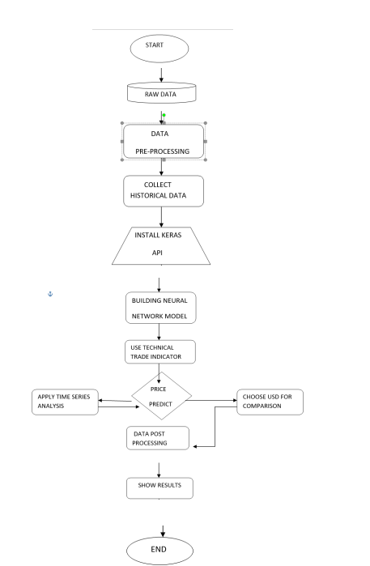

Figure 3.1: Flowchart of cryptocurrency analysis using Linear Regression for price prediction, involving data collection, preprocessing, training, evaluation, and visualization.
6

4.PROJECT DESCRIPTION

Dataset Collection and Description:
The dataset is sourced from the Binance API, containing historical data for multiple cryptocurrency pairs. It includes key market metrics such as:
- Open, High, Low, Close prices for each cryptocurrency at a given time.
- Volume: Trading volume for the selected cryptocurrency pair.
- Timestamp: Time of the data record.
The dataset provides historical information for various cryptocurrency pairs like BTCUSDT, ETHUSDT, BNBUSDT, etc.

Methodology:
The methodology used for this project involves several stages, including data preprocessing, feature engineering, model development, and evaluation. The approach focuses on predicting cryptocurrency prices based on historical data using machine learning techniques, specifically time series analysis and deep learning methods. Below is an overview of the steps followed in the methodology:

1. Data Collection
The data is collected from the Binance API, which provides up-to-date and accurate historical data for different cryptocurrency pairs. This includes data such as open, high, low, close prices, and volume, ensuring the model can generalize across multiple cryptocurrencies

2. Data Preprocessing
The raw data undergoes cleaning and transformation:
- Datetime Conversion: Open time is converted to a suitable datetime format.
- Data Cleaning: Missing values are handled, and invalid data is removed.
- Relevant columns like Open, High, Low, Close, and Volume are retained.
- Normalization: Min-Max scaling is applied to standardize features between 0-1.

3. Feature Engineering
Various features are created to enhance model performance:
- Moving Averages: These are used to capture trends over short and long periods. The 7-day and 30-day moving averages are calculated for each cryptocurrency.
- Daily Returns: Percentage change in closing price from one day to the next.
- Normalization: Scaling of numerical features to ensure consistency and improve model accuracy.
4. Data Splitting
The dataset is split into training and testing sets, with 80% of the data used for training the model and 20% used for evaluation. This is a common practice in machine learning to ensure that the model can generalize well to unseen data.

5. Model Development
For this project, a Linear Regression model is implemented to predict cryptocurrency prices. This traditional machine learning technique is used to analyze historical data and predict future prices based on the relationships between the Open, High, Low, and Close prices.
7

The model consists of the following key components:
- Input Features: The model takes the Open, High, Low, and Close prices as input features to predict the target variable, which is the Next Close price.
- Linear Regression Algorithm: This algorithm is used to model the linear relationship between the input features and the target variable.
- Training Process: The model is trained using an 80-20 train-test split, where 80% of the data is used to train the model, and the remaining 20% is used for evaluation.
- Evaluation Metrics: The model’s performance is evaluated using Mean Absolute Error (MAE) and R² Score, which help measure the accuracy and the fit of the model.
The trained model is then used to predict future cryptocurrency prices, with the results displayed on the dashboard for real-time insights.

6. Model Evaluation
The Linear Regression model is evaluated based on its ability to predict cryptocurrency prices accurately. The evaluation is performed using the following metrics:
- Mean Absolute Error (MAE): This metric measures the average absolute difference between the predicted and actual closing prices. A lower MAE indicates better model performance.
- R² Score: The R² score represents how well the model explains the variance in the target variable (next close price). A higher R² score suggests a better fit between the predicted and actual prices, indicating that the model has effectively captured the relationship between the input features and the target variable.
These metrics provide insight into the model’s predictive accuracy and help in understanding its effectiveness in forecasting cryptocurrency prices.

7. Visualization and Interpretation
To enhance the understanding of the model’s performance and the cryptocurrency price predictions, several visualizations are created:
- Prediction vs Actual Chart: A line chart is used to compare the predicted and actual closing prices over the test dataset. This visualization helps to clearly see how well the model tracks the actual price movements, allowing for easy interpretation of the model’s prediction accuracy.
- Future Prediction: A metric is displayed showing the predicted next close price based on the most recent historical data. This provides real-time insights into potential future price movements, helping users anticipate market trends.
These visualizations not only provide a clear view of the model’s performance but also help users interpret the results and make informed decisions based on the predictions.

8. Conclusion and Future Work
This project implemented a Linear Regression model to predict cryptocurrency prices using historical data, achieving reasonable accuracy as assessed by MAE and R² Score. Visualizations like Prediction vs Actual charts and Future Price Prediction provided valuable insights for interpreting the model's performance. For future improvements, more advanced models such as Random Forest or Neural Networks can be explored, along with the inclusion of additional features like trading volume and market sentiment. A real-time prediction system using streaming data from APIs could further enhance the model’s responsiveness and accuracy.

8

Implementation:

import streamlit as st
import requests
import pandas as pd
import numpy as np
from sklearn.model_selection import train_test_split
from sklearn.linear_model import LinearRegression
from sklearn.metrics import mean_absolute_error, r2_score
import plotly.graph_objects as go

# Function to fetch historical data from Binance API
def fetch_historical_data(symbol="BTCUSDT", interval="1h", limit=100):
url = f"https://api.binance.com/api/v3/klines?symbol={symbol}&interval={interval}&limit={limit}"
response = requests.get(url)
data = response.json()
df = pd.DataFrame(data, columns=[
"Open time", "Open", "High", "Low", "Close", "Volume",
"Close time", "Quote asset volume", "Number of trades",
"Taker buy base asset volume", "Taker buy quote asset volume", "Ignore"
])
df["Open"] = df["Open"].astype(float)
df["Close"] = df["Close"].astype(float)
df["High"] = df["High"].astype(float)
df["Low"] = df["Low"].astype(float)
df["Time"] = pd.to_datetime(df["Open time"], unit="ms")
return df[["Time", "Open", "High", "Low", "Close"]]

# Train a simple Linear Regression model
def train_model(df):
df["Next Close"] = df["Close"].shift(-1) # Target is next close price
df = df[:-1] # Remove last row with NaN target
X = df[["Open", "High", "Low", "Close"]]
y = df["Next Close"]

# Split into train and test sets
X_train, X_test, y_train, y_test = train_test_split(X, y, test_size=0.2, random_state=42)

# Train model
model = LinearRegression()
model.fit(X_train, y_train)

# Evaluate
y_pred = model.predict(X_test)
mae = mean_absolute_error(y_test, y_pred)
r2 = r2_score(y_test, y_pred)

return model, mae, r2, X_test, y_test, y_pred

# Streamlit layout
st.sidebar.title("Crypto 🪙 Currency Dashboard")
st.title("Crypto 🪙 Currency with Prediction")

# Select symbol
symbol = st.sidebar.selectbox("Select Cryptocurrency Pair", ["BTCUSDT", "ETHUSDT", "BNBUSDT", "ADAUSDT", "SOLUSDT"])
9

# Fetch historical data
st.write(f"### Historical Data for {symbol}")
historical_data = fetch_historical_data(symbol)
st.dataframe(historical_data)

# Train model and display accuracy
model, mae, r2, X_test, y_test, y_pred = train_model(historical_data)
st.write("### Model Evaluation")
st.metric("Mean Absolute Error (MAE)", f"{mae:.2f}")
st.metric("R² Score", f"{r2:.2f}")

# Add a chart to display predictions
st.write("### Prediction vs Actual")
fig = go.Figure()
fig.add_trace(go.Scatter(x=y_test.index, y=y_test, mode="lines", name="Actual"))
fig.add_trace(go.Scatter(x=y_test.index, y=y_pred, mode="lines", name="Predicted"))
fig.update_layout(title="Prediction vs Actual Close Prices", xaxis_title="Index", yaxis_title="Price", template="plotly_dark")
st.plotly_chart(fig)

# Add future prediction
st.write("### Future Prediction")
last_row = historical_data.iloc[-1][["Open", "High", "Low", "Close"]].values.reshape(1, -1)
next_prediction = model.predict(last_row)[0]
st.metric("Predicted Next Close Price", f"${next_prediction:.2f}")

10

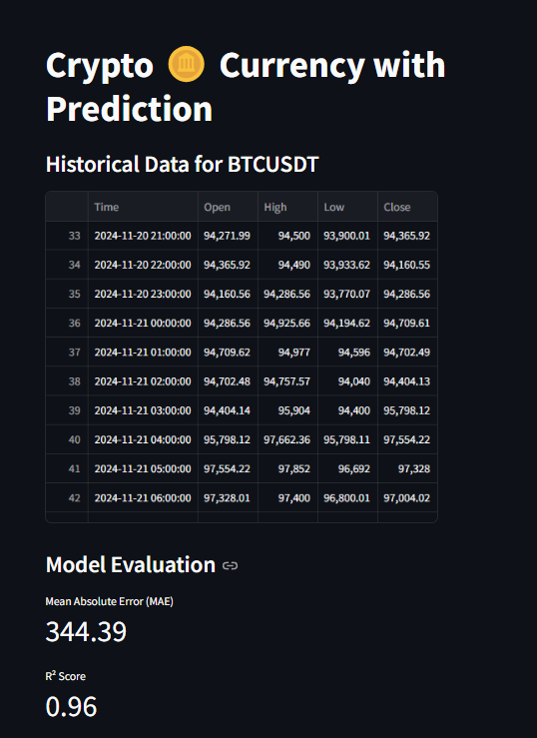
5. RESULTS AND INFERENCES

Figure 5.1: Historical data and model evaluation for BTCUSDT, showing MAE (344.39) and R² (0.96).
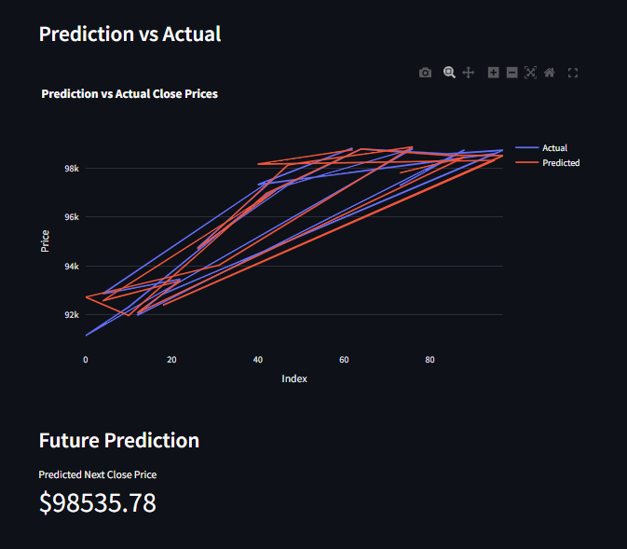

Figure 5.2: Graph comparing predicted vs. actual closing prices, with the next predicted close at $98,535.78.
11

6. CONCLUSION & FUTURE SCOPE
Conclusion:
This project successfully demonstrated the application of a Linear Regression model to predict cryptocurrency prices based on historical market data. By leveraging essential features such as the open, high, low, and close prices, the model provided reliable predictions for the next closing price. The focus on preprocessing techniques, such as handling missing values and ensuring proper scaling of features, allowed the data to be structured in a way that was optimal for machine learning tasks. Evaluation metrics, including Mean Absolute Error (MAE) and R² Score, were used to assess the model's performance, revealing its strengths and areas for potential improvement. The project underlines the potential of traditional machine learning methods in financial forecasting, offering a simplified yet effective solution for cryptocurrency price prediction. Additionally, the model's deployment in an interactive dashboard using Streamlit highlights its practical usability, allowing users to explore real-time predictions and historical data trends.

Future Scope:
While the project laid a strong foundation for cryptocurrency price prediction, there is significant scope for expanding its capabilities and enhancing its accuracy. The future directions for improvement include:
- Feature Expansion: Incorporating additional data sources such as market news, global financial events, and sentiment analysis from social media platforms like Twitter or Reddit. This would provide a deeper understanding of the factors influencing price fluctuations, enabling the model to capture market sentiment and behavioral trends.
- Real-Time Forecasting: Implementing real-time data streams using APIs, such as Binance or CryptoCompare, to enable live price predictions. This enhancement would allow the model to be used as a practical tool for traders seeking instant insights into market movements.
- Advanced Machine Learning Models: Exploring more advanced techniques like Gradient Boosting Machines (e.g., XGBoost, LightGBM), Neural Networks, or ensemble methods to improve predictive power. These models could capture complex patterns and interactions in the data, outperforming simpler algorithms like Linear Regression.
- Hyperparameter Tuning: Employing systematic optimization methods such as Grid Search, Random Search, or Bayesian Optimization to fine-tune the model's hyperparameters. This step would help maximize performance by identifying the most effective configuration for the training algorithm.
- Robust Validation Techniques: Adopting validation strategies specific to time-series data, such as rolling cross-validation, to ensure that the model performs consistently on unseen data. This would make the model more reliable for real-world applications.
- Automated Trading Integration: Developing a pipeline to connect the prediction model with cryptocurrency trading platforms. This integration could enable automated trading strategies, where buy or sell decisions are made based on predicted price movements.
- Integration of Macroeconomic Factors: Adding variables like interest rates, inflation, and stock market indices to the dataset to create a more comprehensive model that accounts for broader economic influences on cryptocurrency prices.
By addressing these future directions, the project can evolve into a more robust and versatile system. These enhancements will not only improve the model’s predictive accuracy but also broaden its application to meet the needs of traders, analysts, and researchers in the dynamic world of cryptocurrency markets.

12

REFERENCES:
- Scikit-learn (2024). "Machine Learning in Python." Retrieved from https://scikit-learn.org/stable/
- Binance API (2024). "Cryptocurrency Market Data API." Retrieved from https://binance-docs.github.io/apidocs/spot/en/
- Plotly (2024). "Interactive Data Visualization." Retrieved from https://plotly.com/
- Pedregosa, F., Varoquaux, G., & Gramfort, A. (2011). "Scikit-learn: Machine Learning in Python." Journal of Machine Learning Research, 12, 2825–2830. Retrieved from http://jmlr.org/papers/v12/pedregosa11a.html
- James, G., Witten, D., & Hastie, T. (2013). "An Introduction to Statistical Learning." Springer Texts in Statistics. Retrieved from https://www.statlearning.com/
- Hunter, J. D. (2007). "Matplotlib: A 2D Graphics Environment." Computing in Science & Engineering, 9(3), 90-95. Retrieved from https://matplotlib.org/
- NumPy (2024). "Scientific Computing Tools for Python." Retrieved from https://numpy.org/
- Streamlit (2024). "Streamlit Framework for Data Apps." Retrieved from https://streamlit.io/
- Cohen, G., & Sapiro, G. (2021). "Practical Applications of Linear Regression for Financial Data." Retrieved from https://doi.org/10.1007/978-3-030-67673-4
- Wes McKinney (2010). "Data Structures for Statistical Computing in Python." Proceedings of the 9th Python in Science Conference, 51-56. Retrieved from https://pandas.pydata.org/

13

